Ship Mounds Matter: The Referential Qualities of Earth-Sourced Materials in Viking Ship Mounds
Rebecca J.S. Cannell

Supplementary Material

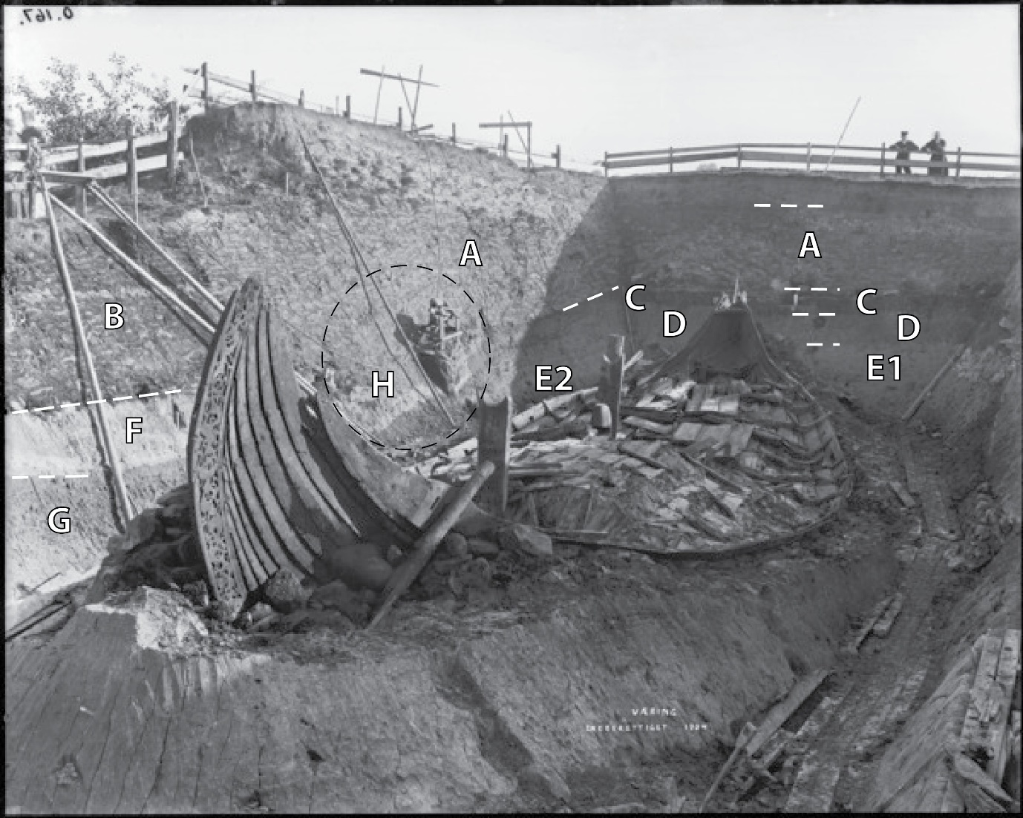

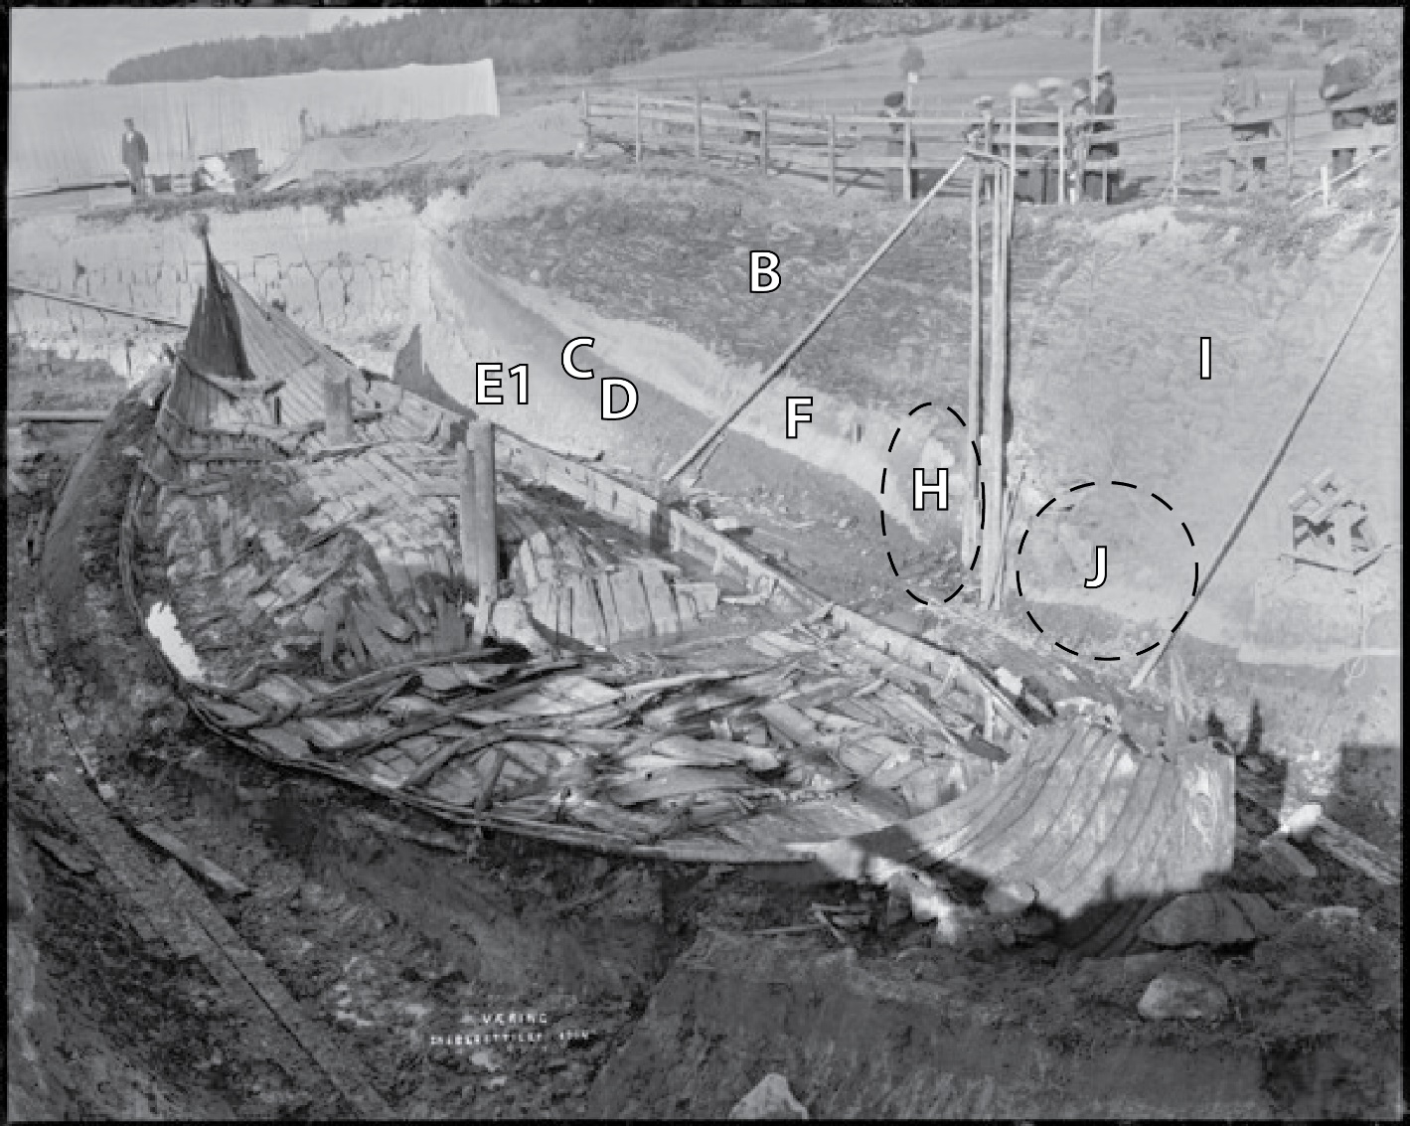

Figure 1. top and bottom: Annotated views of Oseberg. The letters refer to the key below:
A: Stacked turf.
B: Stacked turf: Humic turves, of regular size. In the upper part of the image a lens or layer of sediment midway was possibly used to stabilize the turf.
C: Buried surface: Humic horizon with abrupt upper boundary, and clear, slightly undulating lower boundary. Extends only partway, truncated midway in mound profile, with tip lines heading downwards. Together with D, this is potentially an intact soil buried beneath the mound.
D: Possible buried subsoil horizon (intact subsoil). Moderately humic, with humic content decreasing with depth, with clear lower boundary.
E1: Possible buried lower (B) subsoil horizon or upper C1 (which would be gleyed marine-sourced clay silt). If C, D, and E1 represent a buried surface, it is only present at the rear of the mound.
E2: Change in soils, as the horizon labelled E becomes laminated, and the C horizon deepens and its humic content alters. This may reflect alluvial processes from the nearby stream, i.e. this is an undisturbed soil.
F: Redeposited sediment with abrupt upper and lower boundaries. Tentatively a redeposited lower B horizon, given its low humic content.
G: Possibly a truncated lower subsoil (B) or redeposited C horizon (marine-sourced clay silt).
H: Tip lines in the lower turf layers (A) and horizons below. Possibly F continues here, but C and E2 are no longer present. This area differs from the overall mound stratigraphy, with. C and D sloping downwards and appearing more truncated, and F becoming thicker. The degree of truncation of C and D is unclear.
I: Stacked turf (possibly with lower water retention compared to A/B).
J: Disturbed area? Toward the fore, possibly the buried surface (C, D) but it sinks in area J and becomes unclear.
The central line is visible between two types of turf. Area B is clearly stratified and horizontal, zone I appears drier and with disconformities (from the mound’s break-in).
© University of Oslo, UiO / CC BY-SA 4.0, CfO0167 and CfO0166, by Olaf Væring.

