Learning from experiment: Unio freshwater mussel shells in fifth-millennium bc Romania

Monica Mărgărit, Valentin Radu and Valentina Voinea

Supplementary Materials

Table S1. Species identification of the freshwater mussel valves from the Cheia settlement.
Taxa | Quantity | Left valve | Right valve | Measurable valves
Anodonta sp. | 1 |  | 1
Unio tumidus | 40 | 17 | 23 | 30
Unio pictorum | 5 | 2 | 3 | 5
Unio crassus | 1 |  | 1
Unio sp. | 54 | 11 | 23
Total | 101 | 30 | 51 | 35

Supplementary Material 2
a: Processing of fresh vegetal matter;
b: Unio valve morphology after use;
c: valve structure on the interior face after use;
d: external face structure after use;
e–f: working edge morphology after thirty minutes of use (localized use-wear without striations not extending to the internal side);
g–h: working edge morphology after sixty minutes of use (use-wear characterized by shallow and longitudinal striations, arranged transversely to the active edge).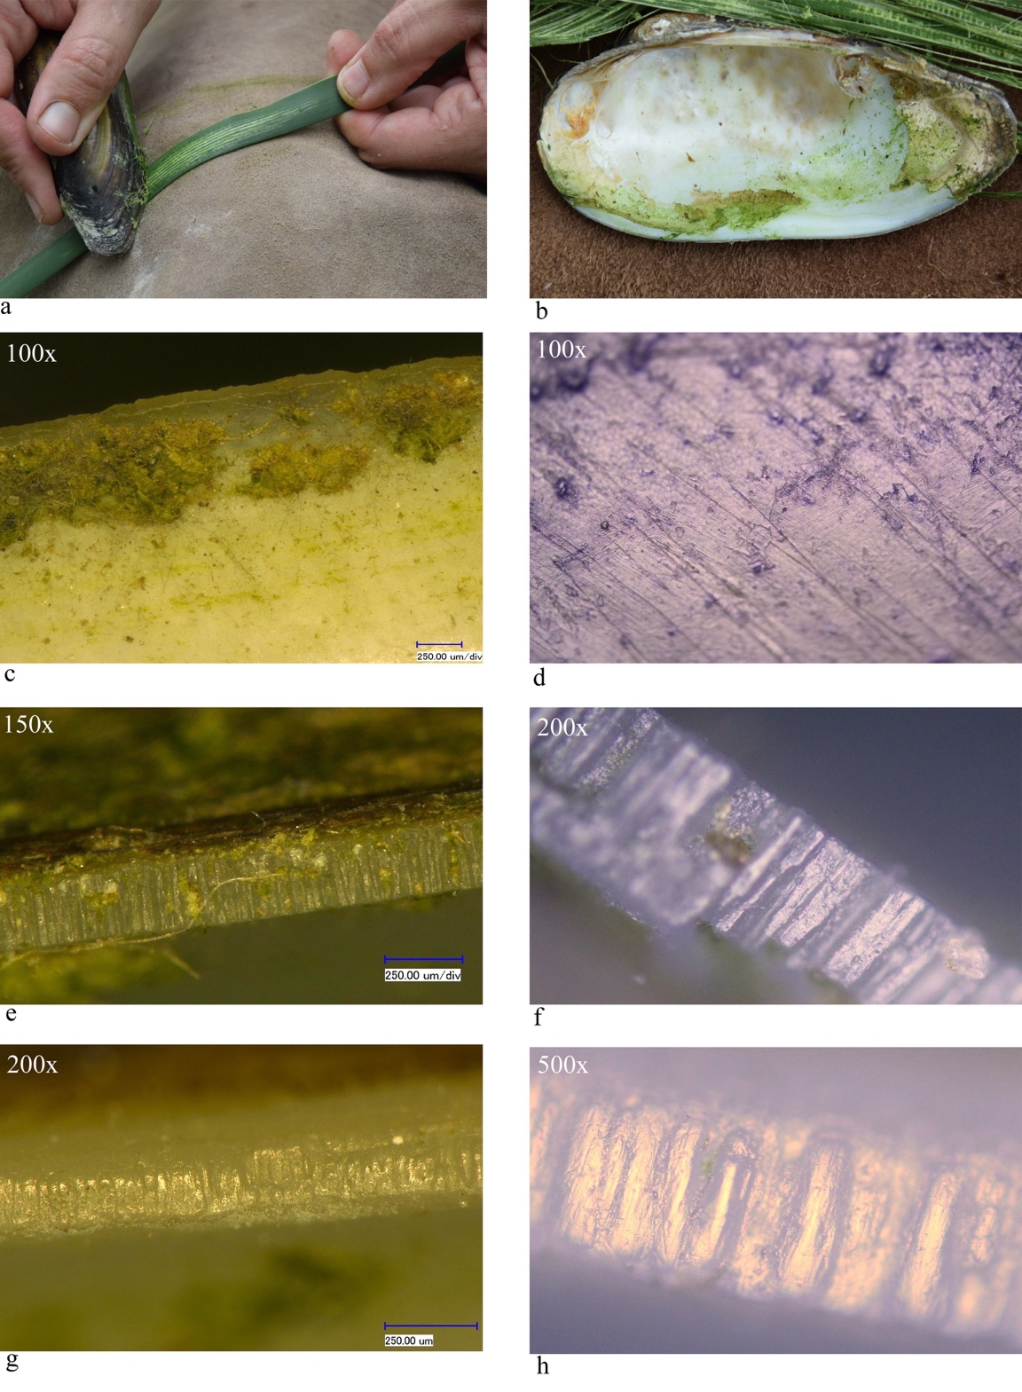
Supplementary Material 3
a: Processing of fresh wood;
b–c: Unio valve morphology after use;
d: valve structure on the internal face after use;
e–f: working edge morphology after twenty minutes of use (use-wear polish is present, but functional striations have not yet developed);
g–h: working edge morphology after fifty minutes of use (rounded and smoothed micro-reliefs, with discontinuous and superficial striations).
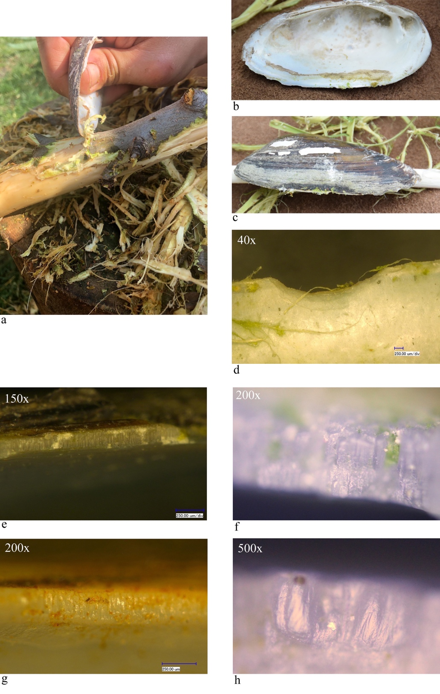
Supplementary Material 4
a: Processing of dry wood;
b: Unio valve morphology before use;
c: Unio valve morphology after use;
d: structure of the external side after use;
e: valve structure on the internal side after use;
f–g: working edge morphology after twenty minutes of use (lamellar structure is eliminated, developing deep and parallel striations);
h–i: ventral edge morphology after forty minutes of use (micro-topography of the active edge shows a continuous micro-relief on the median line).
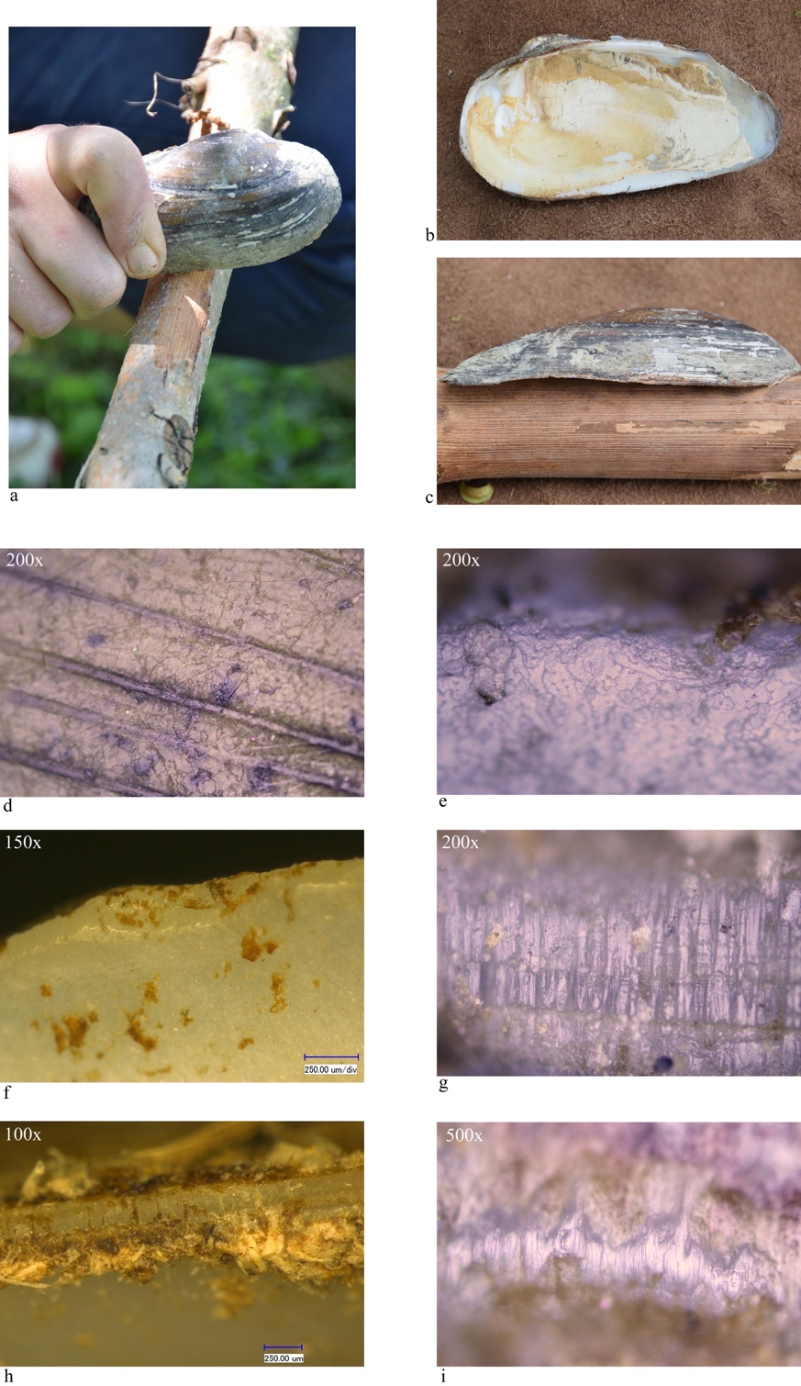

Supplementary Material 5
a: Processing of fresh skin;
b: Unio valve morphology after use;
c: valve structure on the internal side after use;
d: structure of the external side after use;
e–f: ventral edge morphology after forty minutes of use (lamellar structure is still evident with fine functional striations).
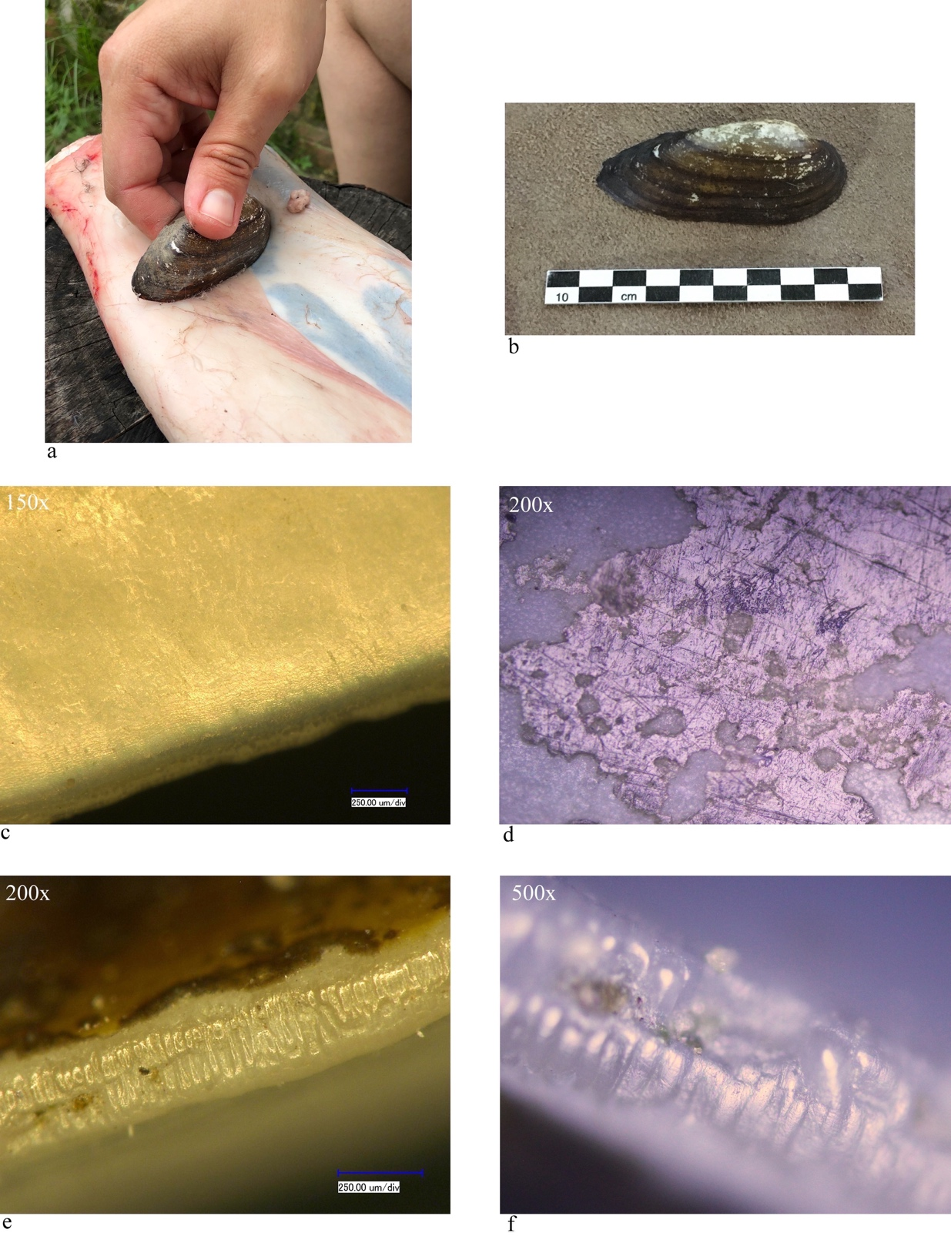
Supplementary Material 6
a, c: Processing of dry skin;
b: Unio valve morphology after use;
d–e: valve structure on the internal side after use;
e–f: working edge morphology after thirty minutes of use (homogeneous micro-topography characterized by the presence of functional striations).
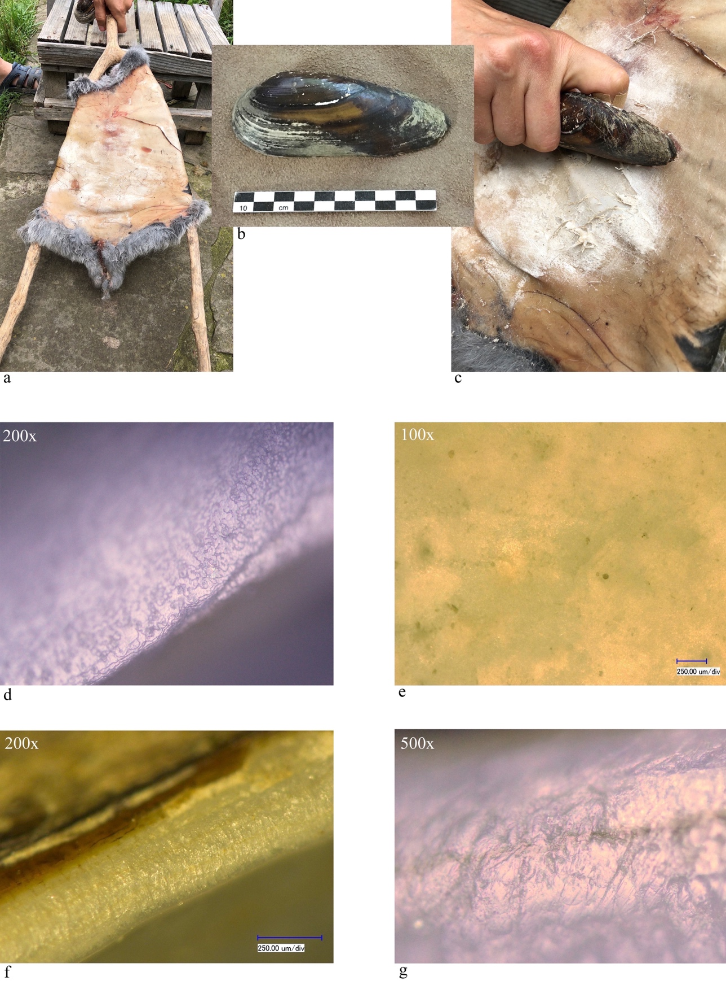
Supplementary Material 7
a: Processing of fresh bone;
b: Unio valve morphology after use;
c: valve structure on the external side after use;
d–e: working edge morphology after fifteen minutes of use (micro-reliefs associated with micro-pits, discontinuous functional striations).
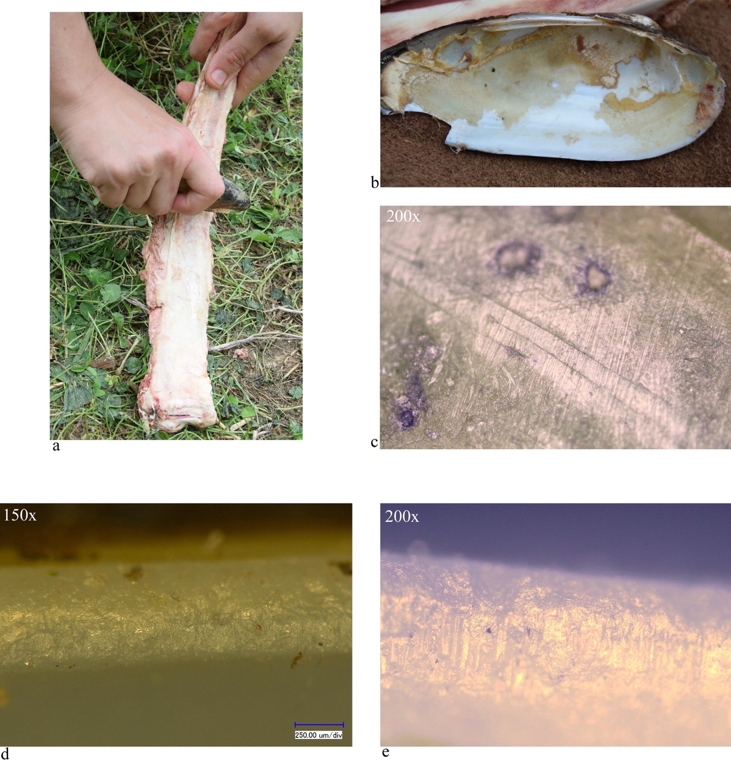

Supplementary Material 8
a: Processing of dry bone;
b: Unio valve morphology after use (the arrow shows the edge fracture);
c–d: working edge morphology after fifteen minutes of use (rounded micro-reliefs with polish and deep transverse striations).
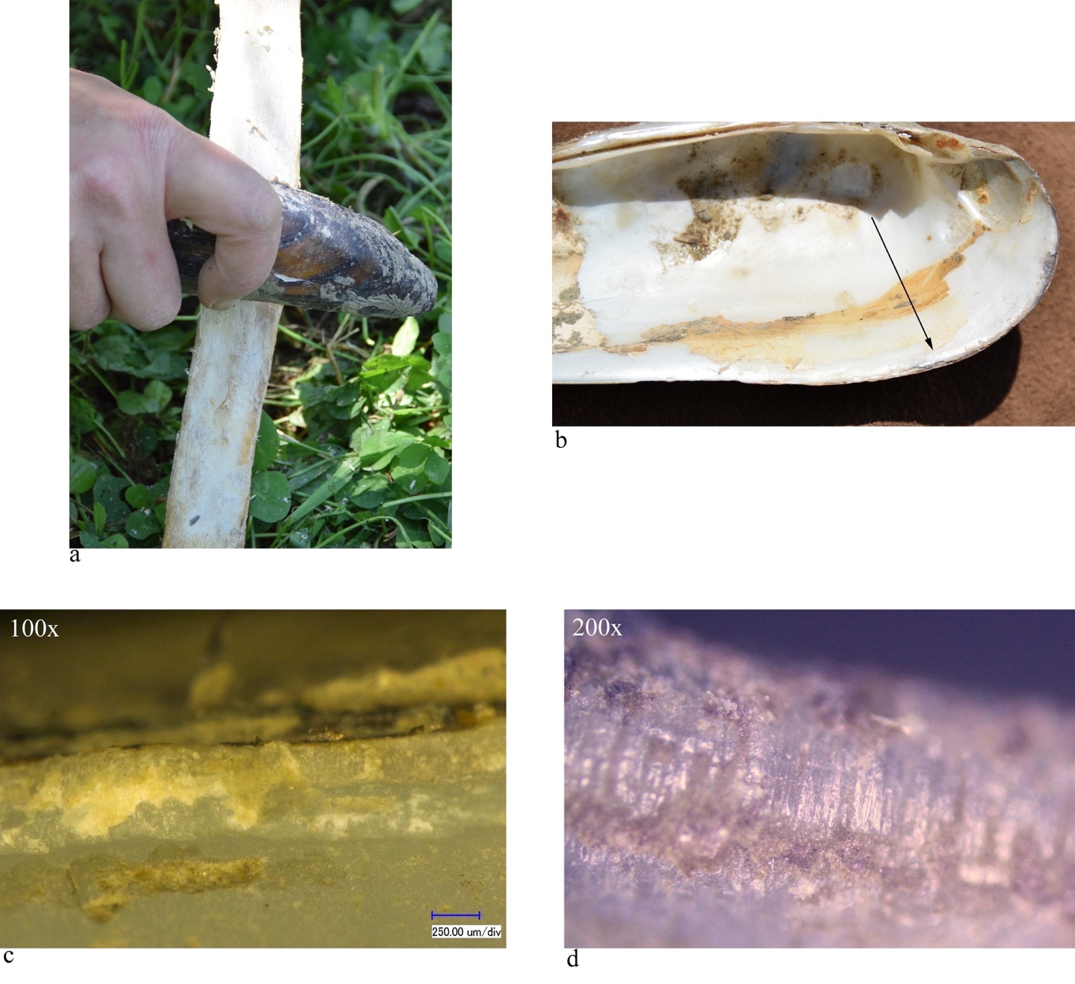

Supplementary Material 9
a: Processing of fish;
b: Unio valve morphology after use;
c–d: working edge morphology after thirty minutes of use (micro-reliefs in combination with micro-pits, without functional striations).
