Leather Shoes in Early Danish Cities: Choices of Animal Resources and Specialisation of Crafts in Viking and Medieval Denmark

Luise Ørsted Brandt, Jannie Amsgaard Ebsen and Kirstine Haase

Supplementary material

S1. Materials and method
The excavations that provided the material for this study took place under different circumstances. The excavation at Viborg Søndersø was a planned research excavation with the very specific aim of testing and developing excavation practices and documentation methods (Iversen, 2005). The excavations at Ribe and Odense were rescue excavations (Madsen & Mikkelsen, 1985; Petersen, 1985; Søvsø, 2004; Haase, 2017). These locations were not chosen for research reasons, but were carried out under limited time and financial conditions. In the following sections, the samples and their context are presented city by city.

Odense
The 23 Odense samples come from five different contexts. Three are deposits related to various phases of a road, and two are from a dwelling area. One is the backfill of a well, and the other is a fill in a midden (see Supplementary Material S3). It is likely that the material from the midden and the well is waste deposited by the household living in this part of the site. The material related to the road layers may come from elsewhere in the city; they are activity layers or levelling layers of waste material, mainly household waste, laid out before a new paving was laid. Other finds in these layers, such as ceramic sherds and animal bone, support this interpretation.
The site is located in the centre of the medieval city, south side of the main road. Written sources state that, in the late medieval period, the area was inhabited by wealthy citizens and their households. We do not know who lived here in the twelfth and thirteenth centuries, but the architecture and the location close to the city centre, the main road, and the cathedral suggest that the inhabitants also belonged to the upper strata of society. The material from the well and the midden may reflect this. What the material from the road represents is more open to question. Probably this material represents the preferences of the city dwellers at a more general level.

Ribe
The material from Ribe comes from three different excavations (ASR 420, ASR 1070, and ASR 1843. There are 73 samples, from two different types of deposits, street layers and a waste deposit (see Supplementary Material S3). The number of samples from Ribe exceeds that of samples from the other two sites. This is mainly because the material had greater potential, since there was a larger amount to choose from and it was better preserved. Since there is no quantitative comparison of the sites, the greater quantity from Ribe is not considered problematic regarding the analysis and its results.
All the samples from ASR 1843 are from street layers. Some were found in activity layers, but were probably redeposited with other types of waste, as in Odense. It is probable that all the samples come from shoes that had been used. The street was first constructed in the late eleventh century with a surface of animal bones. In the following 200 years, a 1.6-metre-thick deposit was built up from alternating levelling layers, activity layers, and wooden structures that served as a road surface. The most recent street surface was dated to the second half of the thirteenth century (Søvsø, 2004).
The samples from ASR 1070 were from excavations in the medieval street of Grønnegade. They are not as well documented as the samples from ASR 1843, but they are all remains of shoes that had been used, probably from redeposited medieval levelling layers.
The samples from ASR 420 are from a well recorded but very small excavation. They are from a layer in a pit filled with leather waste from the second half of the twelfth century. The pit was found under a timber building in a street called ‘Sudergade’ in the medieval times. ‘Suder’ comes from Old Norse and Latin, and refers to crafts related to tanning, shoemaking, and repair. More than 1500 leather fragments were found, probably waste from a shoemaker’s or cobbler's workshop. It contained both worn shoes to be reused and production waste from new goods; only material from finished shoes was sampled.

Viborg Søndersø
The 20 samples from Viborg Søndersø are from five different deposits (see Supplementary Material S3). They are all linked to activity around a workshop, as elements of waste deposits, activity layers, or levelling layers. It is assumed that the levelling layer contains redeposited earlier waste deposits and is therefore closely related to on-site activity. All activities took place within a very narrow time frame of around six years. The earliest activities that generated leather waste date to around ad 1018, and the latest to around ad 1024 (Linaa, 2015: 72). The area is interpreted as a seasonal workshop, and the activities in the phases from which the samples come, as a shoemaker’s or a cobbler’s workshop. The area has been described as inhabited by craftsmen at the bottom of society (Linaa ,2015). All samples are from finished shoes or parts of shoes.

ZooMS
For each of our selected shoe fragments, a sample of about 2×2 mm was taken for ZooMS analysis. Samples were not weighed, as the weight would differ between moist, freshly excavated, and dry and conserved leather, but we estimate that the final samples weighed less than 10 mg. Samples were taken in a way that would be least damaging to the items, i.e. where the items had no diagnostic or special stylistic features, and where they would be least noticeable if the items were to be subsequently exhibited.
Our samples were prepared according to previously published ZooMS protocols (Fiddyment et al., 2015), but modified for archaeological leather finds (see Ebsen et al., 2019). Samples were analysed using a MALDI-TOF MS instrument. Mass spectra were measured over the m/z range of 800–4000. Spectral analysis was undertaken using the open-source cross-platform software, mMass (www.mmass.org) (Strohalm et al., 2008). The three spectra generated for each sample were averaged, and the average spectrum was manually inspected for the presence of peptide markers designated A–G (Buckley et al., 2009), and P1 and P2 (Buckley et al. 2014). These peptide markers were compared to a list of markers for mammals presented by Michael Buckley et al. (2009).
Although Buckley et al.’s (2009) reference list does not include all possible species, it includes the species commonly used for leather in medieval northern Europe: cattle, sheep, and goats, and northern European species such as pigs, horses, fallow/red/roe deer, and various carnivores whose skins could have been used for leather. Taxonomic identifications were at the most conservative level (genus or family), based on the presence of unambiguous markers.
Bovids and cervids can be distinguished on specific markers (Buckley et al. 2009) if these are present. Sheep, goat, and cattle differ fallow, red, and roe deer with regards to marker C, whereas reindeer can be distinguished from sheep, goat and cattle on markers A and G.

S2. Table of excavations from which leather shoe elements were sampled

Site | Site code | No. of samples | Date
I. Vilhelm Werners Plads, Odense | OBM9776 | 23 | Twelfth–thirteenth centuries
Grønnegade II, Ribe | ASR1070 | 10 | Twelfth–thirteenth centuries
Skt. Catharinæ Kirkegård, Ribe | ASR420 | 16 | Twelfth–thirteenth centuries
Sønderportsgade, Ribe | ASR1843 | 46 | Twelfth–thirteenth centuries
Viborg Søndersø 2001, Viborg | VSM800F | 20 | ad 1018–1024

S3. Table of element type, context, and dating of leather finds sampled from Ribe, Odense, and Viborg Søndersø, as well as diagnostic peaks supporting species identifications.

Please see attached Excel Table.

Figure S1. A stained-glass window from Odense depicting a shoemaker’s workshop c. 1583. Photograph: Odense City Museums (reproduced by permission).

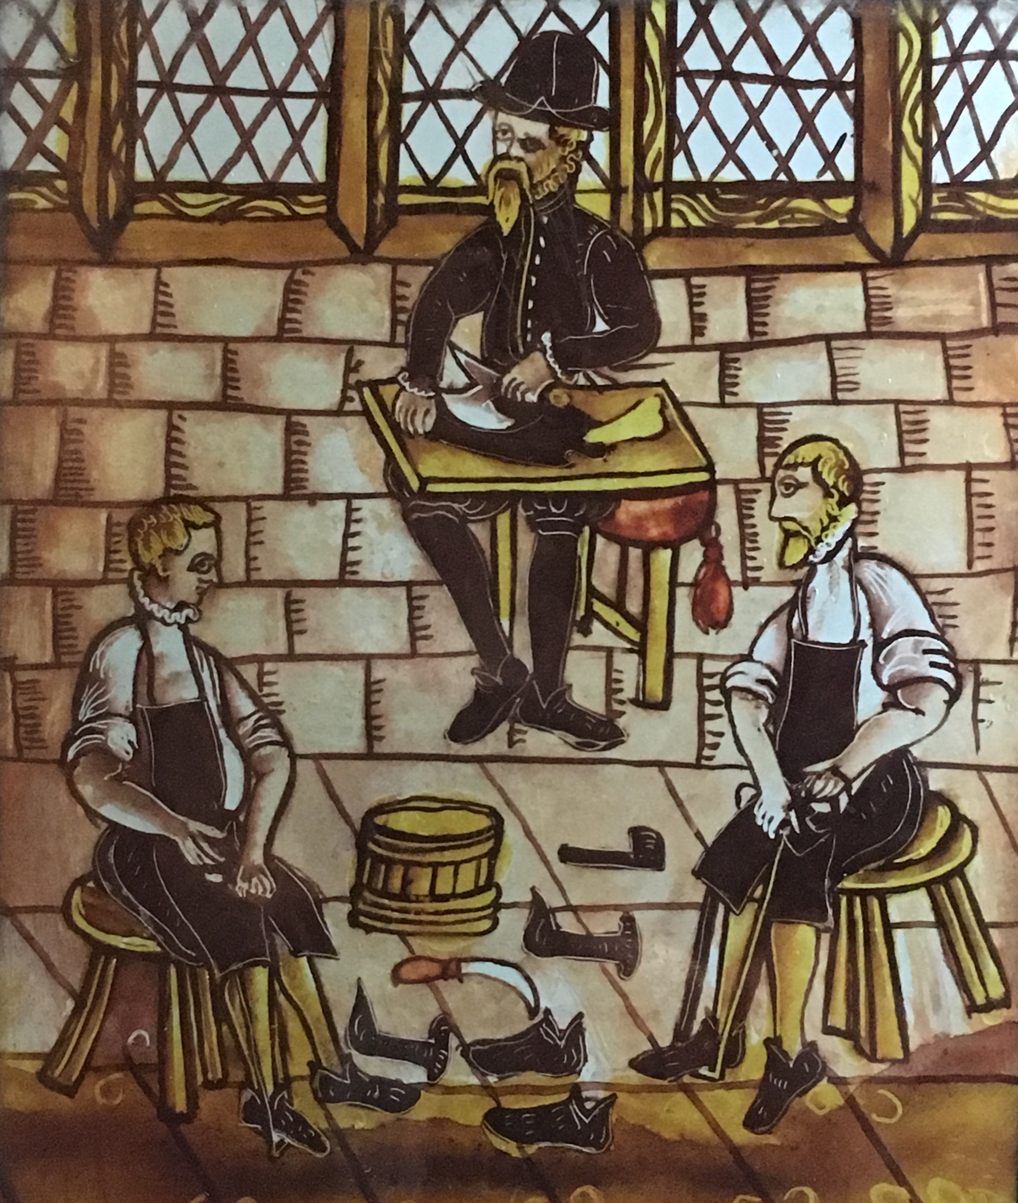

Figure S2. Identifications from A) Ribe, ASR 1070, 1843, and 420 (n=72), B) Odense, OBM9776 (n=23), and C) Viborg Søndersø, VSM800F (n=20).

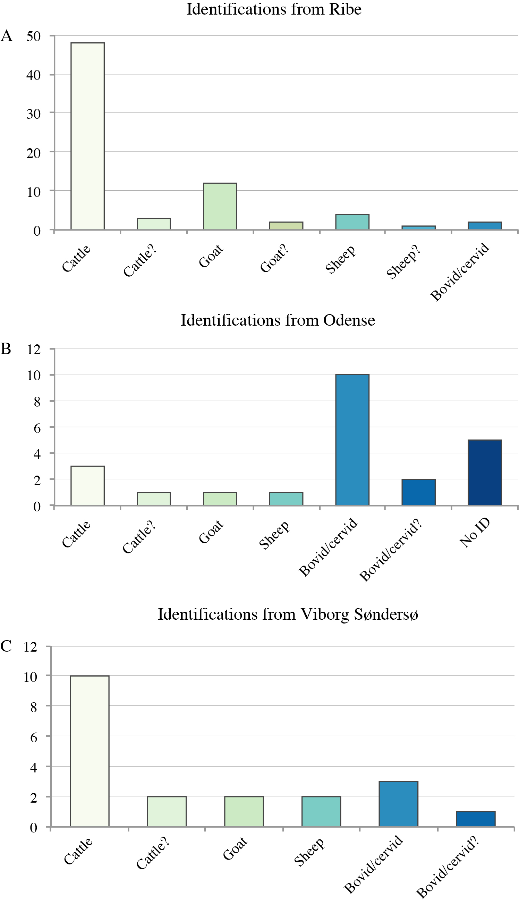

References cited in the Supplementary Material
Buckley, M., Collins, M., Thomas-Oates, J. & Wilson, J.C. 2009. Species Identification by Analysis of Bone Collagen Using Matrix-assisted Laser Desorption/Ionisation Time-of-flight Mass Spectrometry. Rapid Communications in Mass Spectrometry, 23: 3843–54.
Buckley, M., Fraser, S., Herman, J., Melton, N. D., Mulville, J. & Pálsdóttir, A. H. 2014. Species identification of archaeological marine mammals using collagen fingerprinting. Journal of Archaeological Science, 41: 631-41.
Ebsen, J., Haase, K., Larsen, R., Vestergaard Poulsen Sommer, D. & Ørsted Brandt, L. 2019. Identifying Archaeological Leather – Discussing the Potential of Grain Pattern Analysis and Zooarchaeology by Mass Spectrometry (ZooMS) through a Case Study Involving Medieval Shoe Parts from Denmark. Journal of Cultural Heritage, 39: 21–31. https://doi.org/10.1016/j.culher.2019.04.008
Fiddyment, S., Holsinger, B., Ruzzier, C., Devine, A., Binois, A., Albarella, U. et al. 2015. Animal Origin of 13th-century Uterine Vellum Revealed Using Noninvasive Peptide Fingerprinting. Proceedings of the National Academy of Sciences of the United States of America, 112: 15066–71. https://doi.org/10.1073/pnas.1512264112
Haase, 2017. OBM9776 I. Vilhelm Werners Plads Odense sogn, Odense herred, tidl. Odense amt. Sted nr.08.04.07 - Kampagne 16-05-2013. Excavation report [online] [accessed 7 January 2020]. Available at: <http://.kulturarv.dk/publicffdata/documentation/file/doc/185975/public>
Iversen, M. 2005. Viborg Søndersø 1018-1030: Arkæologi og naturvidenskab i et værkstedsområde fra Vikingetid. Højbjerg: Aarhus Universitetsforlag.
Linaa, J. 2015. Crafts in the landscape of the powerless. A combmaker´s workshop at Viborg Søndersø AD 1020-1024. In: G. Hansen, S. Ashby & I. Baug, eds. Everyday Products in the Middle Ages:L Crafts, Consuption and the individual in northern Europe c. AD. 800-1600: an introduction. Oxford: Oxbow Books, pp. 69-90.
Madsen, P. & Mikkelsen, H. 1985. Sudergade. Skalk, 6: 9–13.
Petersen, J. E. 1985. To somre i Ribes kloakker. Mark og Montre, 1985: 99-108.
Søvsø, M. 2004. ASR 1843 Sønderportsgade i Ribe. Unpublished excavation report, Museum of South Western Denmark.
Strohalm, M., Hassman, H., Kosata, B. & Kodícek, M. 2008. mMass data miner: an open source alternative for mass spectrometric data analysis. Rapid Communications in Mass Spectrometry, 22: 905-8.

