Supplementary Material 1

CQL Code for Modelled Dates from Odmut

Plot()
{
Sequence( "Odmut")
{
Boundary( "Start Odmut");
Phase("Early Mesolithic XD")
{
R_Date( "Layer XD, S. III, spit 17: SI-2225", 10045, 85)
{
color="green";
};
Interval("Duration Early Mesolithic XD");
};
Boundary( "Early Mesolithic XD to Early/Late Mesolithic Ia, Ib, XA");
Phase("Early/Late Mesolithic Ia, Ib, XA")
{
R_Date( "Layer Ib: SI-2228", 9135, 80)
{
color="green";
};
R_Date( "Layer Ia/Ib: SI-2224", 8590, 100)
{
color="green";
};
R_Date( "Layer ?: OxA-35002", 8207, 39)
{
color="magenta";
};
R_Date( "Layer Ib: OxA-34966", 7980, 50)
{
color="magenta";
};
R_Date( "Layer Ib: SI-2226", 7790, 70)
{
color="green";
};
R_Date( "Layer Ia: OxA-35003", 7770, 40)
{
color="magenta";
};
R_Date( "Layer Ib: SI-2221", 7720, 85)
{
color="green";
};
R_Date( "Layer XA: OxA-32283", 7757, 38)
{
color="magenta";
};
R_Date( "Layer Ib, block 5, spit 15: Z-411", 7440, 150)
{
color="green";
};
R_Date( "Layer Ia, block 5, spit 21: Z-413", 7350, 160)
{
color="green";
};
R_Date( "Layer Ib: SI-2220", 7150, 100)
{
color="green";
};
R_Date( "Layer Ib: SI-2227", 7080, 85)
{
color="green";
};
R_Date( "Layer Ib, block 1, spit 19: Z-457", 7030, 160)
{
color="green";
};
Interval("Duration Early/Late Mesolithic Ia, Ib, XA");
};
Boundary( "Early/Late Mesolithic Ia, Ib, XA to Early Neolithic IIa, IIb, XC");
Phase("Early Neolithic IIa, IIb, XC")
{
R_Date( "Layer XC: OxA-35001", 7035, 36)
{
color="magenta";
};
R_Date( "Layer IIa: SI-2219", 6995, 100)
{
color="green";
};
R_Date( "Layer IIa: SI-2217", 6985, 100)
{
color="green";
};
R_Date( "Layer IIa: SI-2222", 6900, 100)
{
color="green";
};
R_Date( "Layer IIb: Z-412", 6730, 160)
{
color="green";
};
R_Date( "Layer IIb: SI-2223", 6530, 75)
{
color="green";
};
Interval("Duration Early Neolithic IIa, IIb, XC");
};
Span("Odmut");
Boundary("End Odmut");
};
};

Vruća Cave

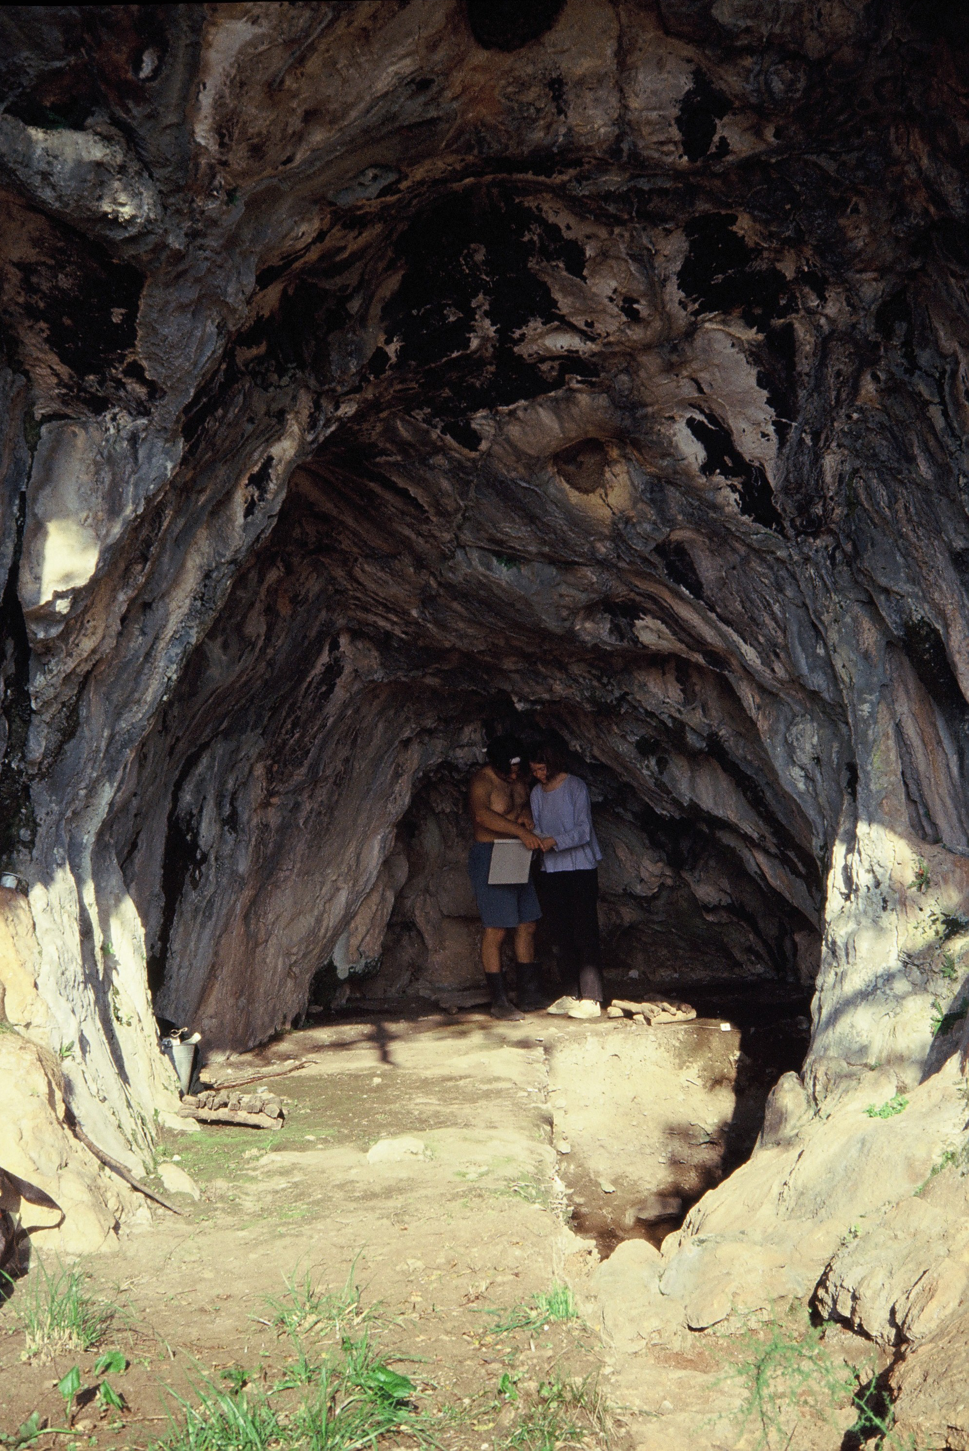 | 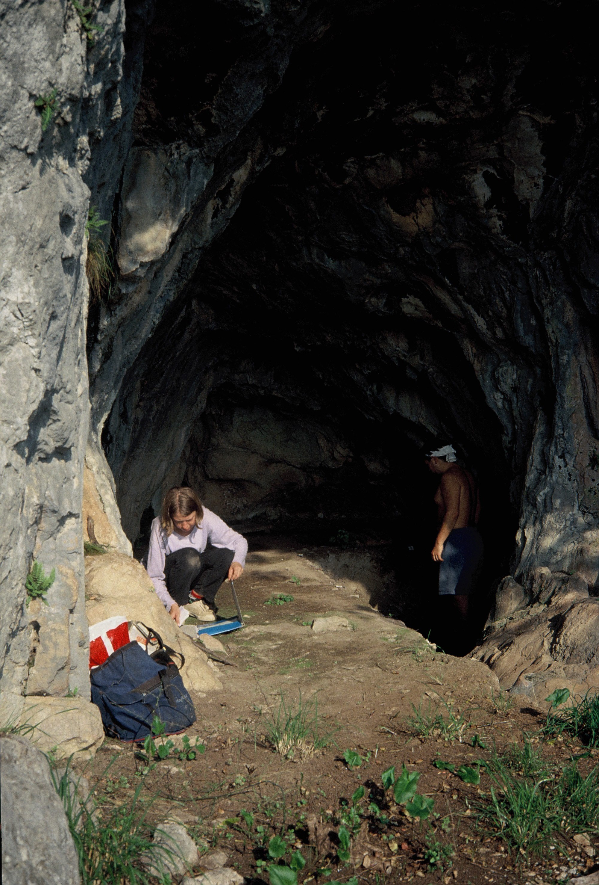

Supplementary Figure 1. View of Vruća cave during excavation.

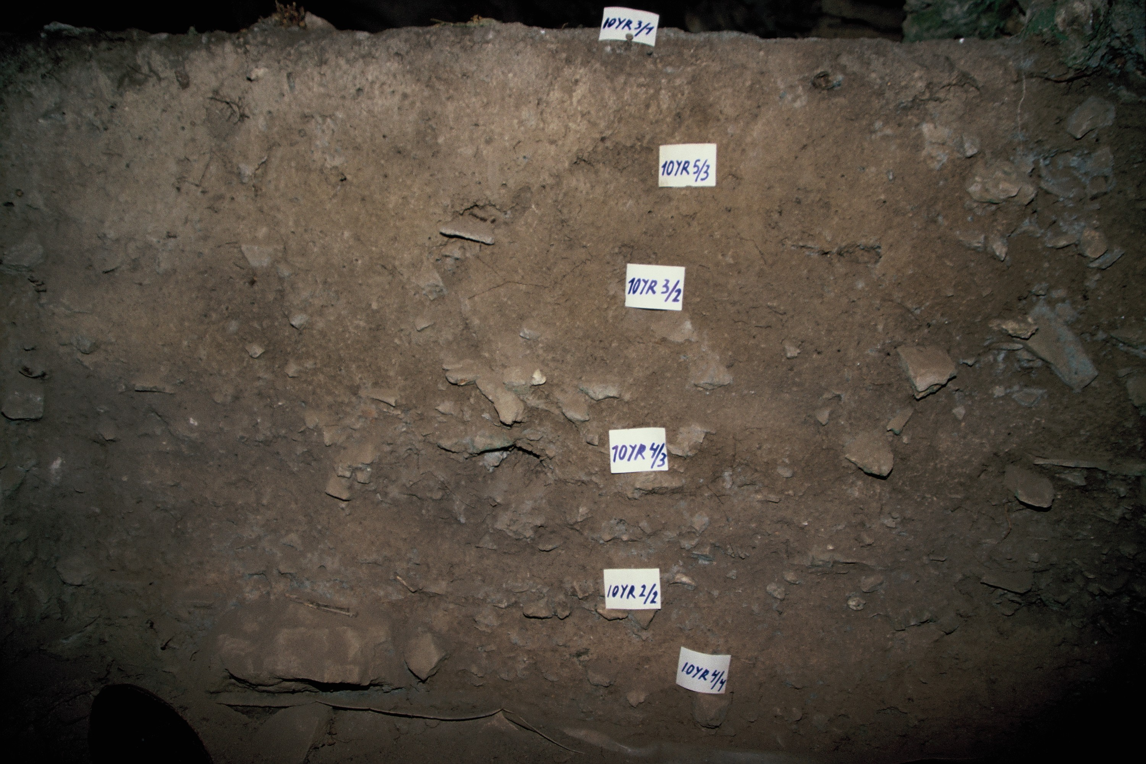

Supplementary Figure 2. A stratigraphic section at Vruća cave with marked layers.
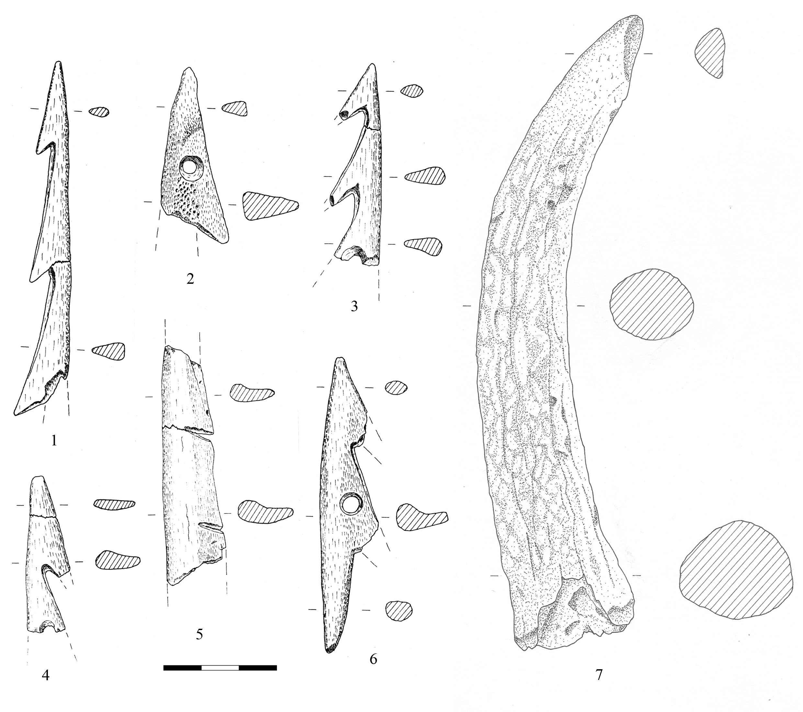

8

Supplementary Figure 3. Osseous tools from Vruća cave.
1–6: selection of harpoons found in Mesolithic and Neolithic levels; 7: an antler punch from the Neolithic levels; 8: a pointed bone tool AMS-dated by OxA-31133 (see main text, Table 1 ) found in the Mesolithic levels (spit 21).

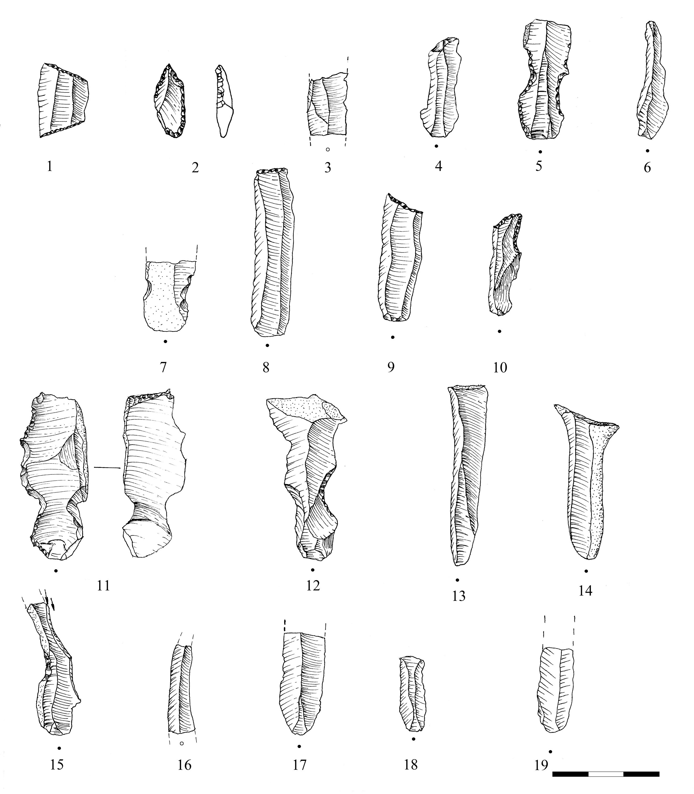
Supplementary Figure 4. A selection of flint tools found in the Neolithic levels of Vruća cave (inv. nos. 1: VP22; 2: VP18; 3: VP24; 4: VP17; 5: VP20; 6: VP4; 7: VP60; 8: VP94; 9: VP81; 10: VP23; 11: VP74; 12: VP69; 13: VP80; 14: VP79; 15: VP30; 16: VP78; 17: VP77; 18: VP50; 19: VP31).

Badanj Rockshelter

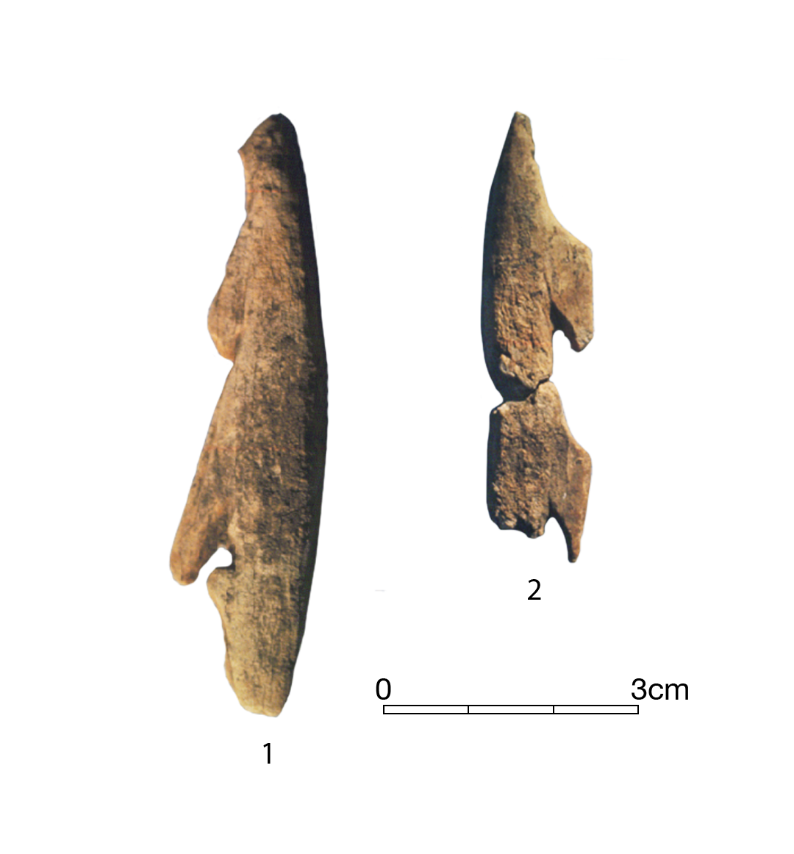
Supplementary Figure 5. Completely shaped unilateral antler harpoons with straight barbs found in Epipalaeolithic levels at Badanj, Bosnia and Herzegovina; 1: inv. 10016 (J5/B6); 2: inv. 10031 (I7/A2).
Photographs by Robert Whallon.

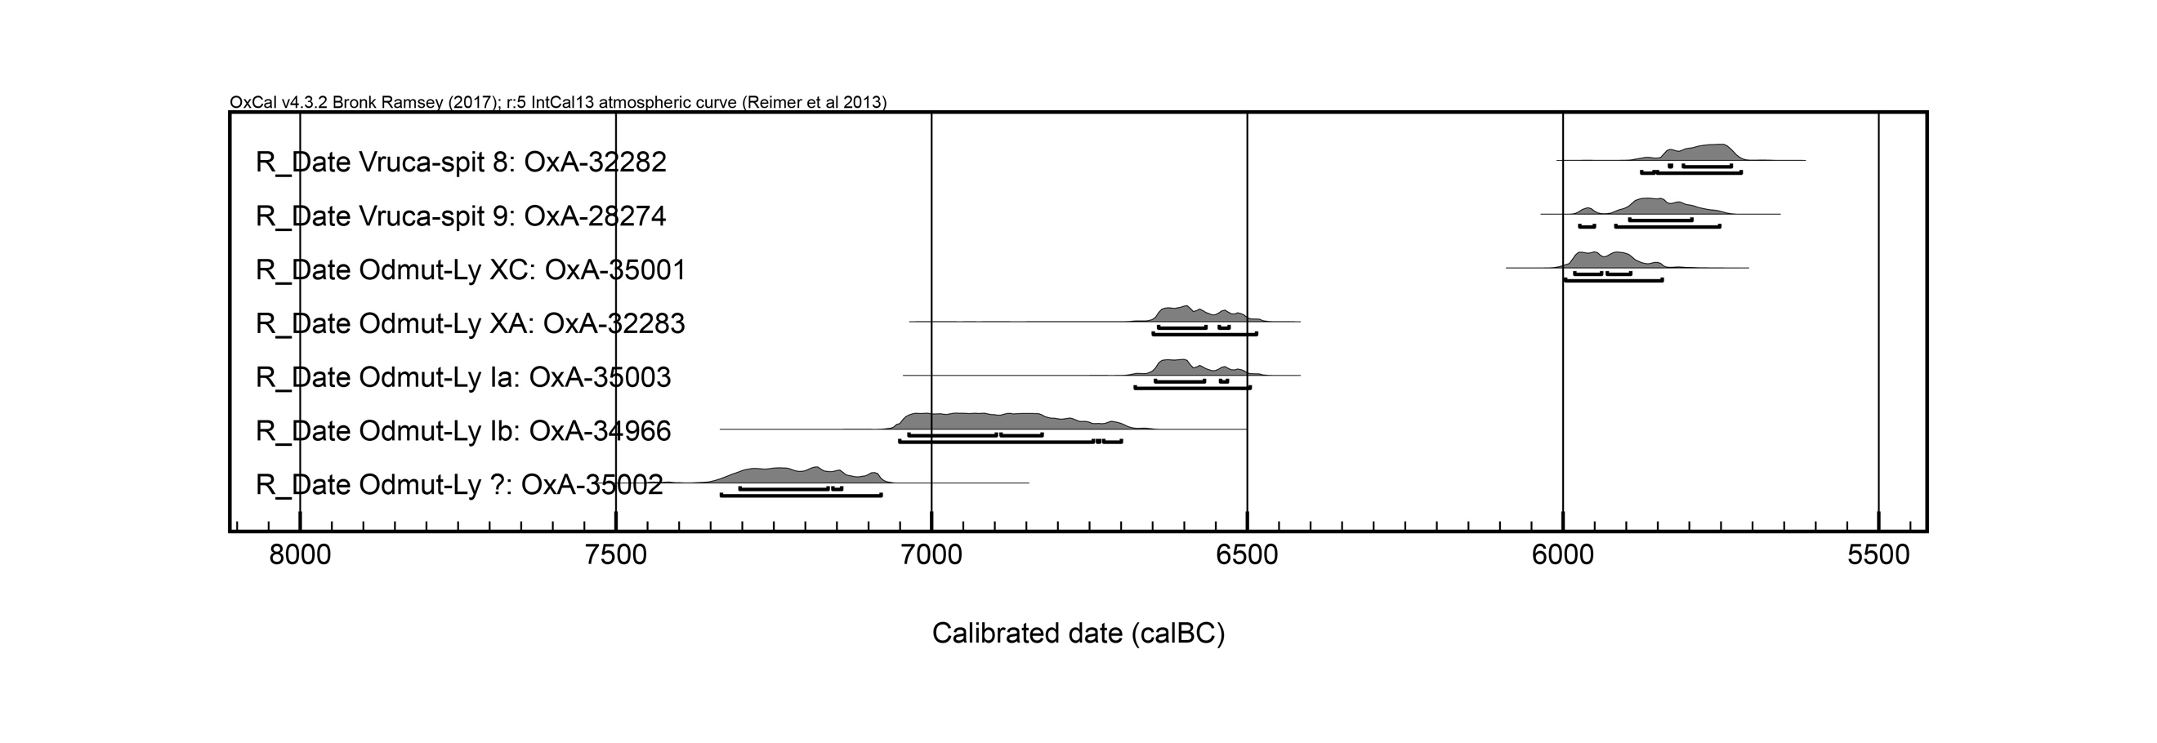
Supplementary Figure 6. Jointly plotted individually calibrated results of AMS-dated harpoon specimens from Odmut and Vruća. Dates are calibrated using OxCal v4.3.2.

Vrbička Cave: Stratigraphy and Micromorphological Analysis of Mesolithic Context (29)

By K. Gerometta

A monolith for micromorphological analysis was collected from the Mesolithic context (29) on the east-facing section in Trench 1/2013 as the most representative layer with Mesolithic cultural material. In order to observe the interface between the Mesolithic and the overlying Neolithic sediments, it includes the Neolithic context (26) at the top of the sample.
In the field, three main lithostratigraphic units were observed in the east-facing section:
- The lowermost unit comprises a Late Pleistocene sequence, context (32), characterized by very frequent boulders protruding from a reddish, compact silty sand matrix with fine aggregation. It is dark red at the top and light red, partially cemented, at the bottom, with a clear boundary in between.
- The Mesolithic layer, context (29), was deposited on top of an erosion surface that marks the boundary between the Holocene and the Late Pleistocene. The fine fraction of this unit is characterized by a very loose, homogeneous dark grey silt matrix, while the coarse fraction consists of a mix of very frequent angular to subangular limestone clasts (~1 cm being the most common), frequent charcoal fragments and few fine reddish pedorelicts.
- At the top of the stratigraphic sequence there is a group of Neolithic to Copper Age contexts, identified at the microscopic scale as herbivore (sheep or goat) dung accumulations. The Mesolithic context (29) is overlaid by a greyish brown, compact silt loam with discontinuous ashy lenses associated with Neolithic cultural material – context (26). The boundary between contexts (29) and (26) is clear and slightly undulating.
The micromorphological analysis of the Mesolithic context (29) shows a chaotic distribution of coarse components. At the microscopic scale, it consists of very frequent to dominant angular to subrounded limestone fragments, very few angular flint fragments, quartz grains, frequent quartzite particles, and mica (muscovite flakes). Charcoal fragments are frequent, as are bone (often burnt) fragments and mollusc shell fragments, while tissue and amorphous organic matter are very frequent. The microstructure is complex: medium to fine granular or vughy with compound packing voids, vughs, channels, and few vesicles. The related distribution is mostly single- to double-spaced porphyric, rarely chitonic. Calcitic crystallitic b-fabric is also present (Stoops, 2003). The pedofeatures have been identified as pedorelicts, and include several different types (Supplementary Figure 8). Two types are the most common: the first are reddish-brown rounded aggregates with fine quartz and muscovite skeleton; the second are reddish clay nodules with undulating extinction bands and without skeleton grains (clay papules sensu Brewer, 1976). The granostriated b-fabric is evident around skeleton grains or around pedofeatures (Brewer, 1976; Boschian, 1997). Small aggregates made of herbivore dung can be observed in the thin section where granular microstructure occurs. These aggregates were included in the Mesolithic sediment by admixture of the Neolithic sheep or goat dung layers directly above the Mesolithic deposits. Both the dung aggregates and granular microstructure suggest mixing and probably ab antiquo reworking due to human activity inside the cave. At the interface between the Mesolithic and Neolithic sediments, flattened vesicles and channels can be observed together with fragmented coarse components (flint, charcoal) which may be indicative of trampling (Supplementary Figure 7 c, d).
Supplementary Figure 7. Microphotographs of a sediment thin section from Vrbička cave. a: charcoal (ch) and burnt bone fragments (b), Plane polarised light (PPL). b: as in a, Cross-polarised light (XPL). c: fragmented chert artefact, PPL. d: as in c, XPL.

The large quantity of material of organic origin consists largely of domestic waste residues that includes abundant bone, shells, wood ash, decayed organic matter, and charcoal. It must be ascribed to human activity and suggests intensive human frequentation of the cave during the Mesolithic (Supplementary Figure 5 a, b).

Supplementary Figure 8. Microphotographs of a sediment thin section from Vrbička cave. a: clay aggregate (pedorelic), PPL. b: as in a, XPL. c: clay and Fe-oxide nodule (pedofeature), PPL. d: as in c, XPL.

The cave sediments also offer indirect evidence of environmental conditions. The large quantity of small stones could have been accumulated through freezing and thawing effects on the cave walls, which indicates a relatively cold and wet climate. It is worth noting that there is no evidence of deep seasonal frost in the Mesolithic sediments. The occurrence of pedorelicts and other pedofeatures that indicate ‘rolling’ (aggregates with granostriated b-fabric separated from the groundmass by sharp limits) is common. As fragments of a transported soil/sediment, pedorelicts can have relevant paleoenvironmental significance. Their presence suggests input of fine allochthonous sediments or soils, which penetrated inside the cave probably because of hillwash and runoff caused by the erosion of soils previously deposited outside the cave. In the field, this can also be indicated by the fact that sediments slope gently from the fissure in the western walls of the entrance hall towards the eastern, inner part of the cave. All these characteristics may indicate a degraded environment in which the hillslopes were not well forested (Boschian, 1997; Boschian & Montagnari-Kokelj, 2000).

Harpoons from Odmut and Vruća: Methodology and Technology
Morphological definitions of the harpoons are based on those defined by the Committee for the Nomenclature of Prehistoric Bone Industry (Averbouh et al., 1995). Osseous specimens were analysed directly without the use of silicon casts. The animal species and anatomical provenance of the blanks were recorded in order to identify specific aspects of raw material selection. The metrical information of the harpoons included length, width and thickness, invasiveness and symmetry of the distal and proximal parts (e.g. the pointed ends and the bases of the harpoons), together with the sections of the distal, mesial, and proximal parts. Manufacturing techniques and use-wear traces were recorded with regard to their development, location, and distribution on the tools.
Antler compact tissue was commonly preferred as raw material for producing harpoons, except for two specimens from Odmut and one specimen from Vruća cave, which were carried out on long bones, likely to be metapodial diaphyses. The chaîne opératoire for producing both antler and bone harpoons involved: (1) selection of the raw material; (2) extraction of regular blanks; (3) creation of barbs; (4) production of bevel bases; (5) creation of one or more symmetrical perforations; and (6) smoothing the surfaces. Antler and bone blanks were extracted from the main antler beam or bone diaphysis through longitudinal grooving. Lateral barbs were created by transversal lateral incision followed by prolonged chiselling and, subsequently, smoothing by scraping. In order to make perforations, mechanical drilling was applied as suggested by the symmetrical outlines of the perforations. One AMS-dated specimen (OxA-28274, see Table 1 in the article’s main text) from Vruća is a blank extracted and coarsely smoothed over by scraping with flint. Compression marks, linear features, and deformations of the outline were identified on the proximal parts of most harpoons. The invasiveness of these use modifications on the artefacts indicates that proximal parts were probably inserted into a shaft to a depth of c. 1–1.5 cm.

References
Averbouh, A., Bellier, C., Billamboz, A., Cattelain, P., Cleyet-Merle, J.J., Julien, M., et al. 1995. Fiche typologique, Cahier VII. Éléments barbelés et apparentés. Treignes: Centre d'études et de documentation archéologiques.
Boschian, G. 1997. Sedimentology and Soil Micromorphology of the Late Pleistocene and Early Holocene Levels of Grotta dell’Edere (North-East Italy). Geoarchaeology: An International Journal, 12: 227–49.
Boschian, G. & Montagnari-Kokelj, E. 2000. Prehistoric Shepherds and Caves in the Trieste Karst (Northeastern Italy). Geoarchaeology: An International Journal, 15: 331–71.
Brewer, R. 1976. Fabric and Mineral Analysis of Soils. Huntington: Krieger.
Bronk Ramsey, C. 2017. Methods for Summarizing Radiocarbon Datasets. Radiocarbon, 59: 1809–33.
Reimer, P., Bard, E., Bayliss, A., Beck, J., Blackwell, P., Bronk Ramsey, C., et al. 2013. IntCal13 and Marine13 Radiocarbon Age Calibration Curves 0–50,000 years cal BP. Radiocarbon, 55: 1869–87.
Stoops, G. 2003. Guidelines for Analysis and Description of Soil and Regolith Thin Sections. Madison, WI: Soil Science Society of America.

