Exploring Site Formation and Building Local Contexts through Wiggle-Match Radiocarbon Dating: Re-Dating of the Firth of Clyde Crannogs, Scotland

Piotr Jacobsson¹, Alex G.C. Hale², Gordon Cook¹ and Derek Hamilton¹
¹ Scottish Universities Environmental Research Centre, University of Glasgow, UK
² Historic Environment Scotland, Edinburgh, UK

Supplementary material
Supplementary Tables
Supplementary Table 1. Legacy radiocarbon dates from the Dumbuck and Erskine Bridge crannogs. Data from Sands & Hale (2002).

Site | Sample type | Species | GU- number | Age (¹⁴C years bp) | 1-σ error | δ¹³C (‰)
Dumbuck | Pile | Quercus | 7470 | 2090 | 50 | -27.2
 | Horizontal | Alnus | 7471 | 1910 | 50 | -27.6
 | Pile | Quercus | 7472 | 2040 | 50 | -26.1
 | Horizontal | Alnus | 7473 | 2060 | 50 | -27.9
Erskine Bridge | Horizontal | Alnus | 2186 | 2210 | 50 | -25.8
 | Pile | Quercus | 2187 | 1970 | 60 | -25.3
 | Pile | Quercus | 2328 | 1950 | 50 | -24.4
 | Pile | Quercus | 2383 | 2170 | 60 | -28

Supplementary Table 2. Age determinations for the wiggle-match dates from the Dumbuck crannog. P-001 and P-002 were oak (Quercus sp.) and the horizontals HT-001–HT- 003 were alder (Alnus sp.). Note that the ring numbers are counted from the bark edge.

Timber | Rings | SUERC - number | Age (¹⁴C years bp) | 1-σ error | δ¹³C (‰)
P-001 | 1-10 | 60780 | 1989 | 26 | –25.4
 | 11-20 | 60781 | 1982 | 29 | –25.5
 | 21-30 | 60782 | 1974 | 25 | –24.2
 | 31-40 | 60783 | 2068 | 29 | –22.9
 | 41-50 | 60784 | 2023 | 29 | –23.7
 | 51-60 | 60788 | 2021 | 29 | –24.9
P-002 | 4-13 | 60789 | 1958 | 26 | –25.2
 | 14-23 | 60790 | 1992 | 29 | –24.9
 | 24-33 | 60791 | 2072 | 26 | –26.1
 | 34-43 | 60792 | 1991 | 29 | –26.1
 | 44-53 | 60793 | 2016 | 28 | –25.9
HT-001 | 4-13 | 60762 | 2059 | 29 | –24.6
 | 14-23 | 60763 | 2019 | 29 | –25.2
 | 24-33 | 60764 | 2096 | 29 | –25.4
 | 34-43 | 60768 | 1992 | 29 | –24.5
 | 44-53 | 60769 | 1966 | 29 | –25.0
HT-002 | 1-10 | 60770 | 1961 | 29 | –24.1
 | 11-20 | 60771 | 2044 | 26 | –24.6
 | 21-30 | 60772 | 2059 | 29 | –24.1
 | 30-39 | 60773 | 2002 | 29 | –24.2
HT-003 | 1-10 | 60774 | 1970 | 29 | –25.0
 | 11-20 | 60778 | 2060 | 29 | –25.8
 | 20-29 | 60779 | 2228 | 27 | –27.1

Supplementary Table 3. Summary wiggle-match date results for the Dumbuck crannog. Posterior probabilities are displayed in Supplementary Figures 2–6.

Timber | 68.2% HPD area | 95.4% HPD area | Acombine (%) | χ2 | χ2 critical value (5%) | Supplementary Figure No.
P-001 | cal ad 5–40 | cal ad 1–60 | 87.5 | 3.145 | 11.071 | 6
P-002 | cal ad 15–35(63.1%) cal ad 40–45 (5.1%) | cal ad 1–55 | 86.9 | 1.781 | 5.991 | 7
HT-001 | cal ad 1–25 | 5 cal bc–cal ad 40 (90.5%) cal ad 45–65 (4.9%) | 37.7 | 6.625 | 7.815 | 8
HT-002 | cal ad 1–40 | 20 cal bc–cal ad 65 | 86.9 | 1.781 | 5.991 | 9
HT-003 | 40–5 cal bc (41.6%) cal ad 5–20 (26.6%) | 45 cal bc–cal ad 45 | 65.5 | 1.889 | 3.841 | 10

Supplementary Table 4. Individual radiocarbon determinations for the wiggle-match dates from the Erskine Bridge crannog. Note that the rings are counted from the outermost surviving ring.

Timber | Rings | SUERC - number | Age (¹⁴C years bp) | 1-σ error | δ¹³C (‰)
F-01 H-01 | 6–15 | 60810 | 2263 | 29 | –23.5
 | 26–35 | 60811 | 2274 | 26 | –24.8
 | 46–55 | 60812 | 2384 | 33 | –24.6
 | 66–75 | 60813 | 2434 | 29 | –24.4
 | 92–101 | 60814 | 2461 | 26 | –24.7
F-01 H-02 | 1–10 | 60818 | 2198 | 26 | –25.4
 | 21–30 | 60819 | 2130 | 29 | –26.6
 | 51–60 | 60820 | 2379 | 29 | –26.1
 | 71–80 | 60821 | 2544 | 29 | –25.7
 | Approx 95–100 | 60822 | 2520 | 29 | –25.6
F-02 H-01 | 2–11 | 60802 | 2342 | 30 | –25.3
 | 22–31 | 60803 | 2237 | 26 | –25.1
 | 42–51 | 60804 | 2247 | 26 | –25.1
 | 62–71 | 60808 | 2430 | 26 | –25.5
 | 82–91 | 60809 | 2486 | 29 | –25.3
F-02 H-02 | 4–13 | 60794 | 2330 | 26 | –25.8
 | 14–23 | 60798 | 2196 | 29 | –25.4
 | 34–43 | 60799 | 2271 | 26 | –24.8
 | 54–63 | 60800 | 2355 | 29 | –25.1
 | 64–73 | 60801 | 2253 | 29 | –24.9
F-03 H-01 | 1–10 | 60823 | 2141 | 25 | –26.1
 | 9–18 | 60824 | 2302 | 29 | –26.4
F-03 H-02 | 1–10 | 60828 | 2258 | 25 | –27.3
 | 9–18 | 60829 | 2240 | 29 | –27.2
F-03 H-03 | 1–10 | 60830 | 2313 | 29 | –27.4

Supplementary Table 5. Summary wiggle-match date results for the Erskine Bridge crannog.

Timber | 68.2% HPD area | 95.4% HPD area | Supplementary Figure
F-01 H-01 | 370–355 cal bc | 375–350 cal bc | 14
F-01 H-02 | 705–660 cal bc (21.7%) 605–590 cal bc (5.0%) 555–500 cal bc (15.1%) 495–465 cal bc (12.0%) 360–340 cal bc (10.5%) 320–300 cal bc (3.9%) | 720–635 cal bc (25.0%)  615–270 cal bc (66.1%)  230–195 cal bc (1.4%)  185–135 cal bc (2.6%)  105–90 cal bc (0.3%) | 15
F-02 H-01 | 355–340 cal bc | 355-335 cal bc | 16
F-02 H-02 | 350–325 cal bc | 360–320 cal bc | 17
F-03 H-01 | 395–320 cal bc (41.8%) 255–245 cal bc (1.2%) 205–150 cal bc (20.7%) 130–110 cal bc (4.5%) | 520–505 cal bc (0.3%)  500–475 cal bc (0.5%)  470 cal bc–10 cal ad (94.5%) | 18
F-03 H-02 | 375–350 cal bc (20.7%) 280–225 cal bc (47.5%) | 390–330 cal bc (30.0%)  315–190 cal bc (65.4%) | 19

Supplementary Table 6 Comparison of the alternative wiggle-match dates for the Erskine Bridge timbers based on different approaches to the problem of shifts towards older radiocarbon ages. Offsets are considered substantial if the posterior value of their P(outlier) exceeds 0.75.

Timber | No offset |  |  | Offest U(0,200)
 | 68.2% HPD |  | 95.4% HPD | 68.2% HPD | 95.4% HPD
F01 H01 | 370–355 cal bc |  | 375–350 cal bc | 370–355 cal bc | 375–345 cal bc
F01 H02 | 355–340 cal bc |  | 360–335 cal bc | 330–315 cal bc | 340–305 cal bc
F02 H01 | 360–345 cal bc |  | 360–340 cal bc | 355–340 cal bc | 355–335 cal bc
F02 H02 | 235–225 cal bc (19.4%) 220–200 cal bc (48.8%) |  | 340–315 cal bc (10.6%)  245–200 cal bc (84.8%) | 340–320 cal bc | 345–310 cal bc (91.8%)  220–200 cal bc (3.6%)
F03 H01 | 355–335 cal bc (43.1%) 230–215 cal bc (10.1%) 205–190 cal bc (15.0%) |  | 360–325 cal bc (48.6%)  305–285 cal bc (2.2%)  275–185 cal bc (44.7%) | 340–315 cal bc (10.9%)  205–145 cal bc (49.5%)  125–105 cal bc (7.8%) | 350–290 cal bc (18.0%)  225–215 cal bc (0.8%)  210–75 cal bc (75.1%)  65–45 cal bc (1.6%)
F03 H02 | 370–350 cal bc (19.3%) 275–230 cal bc (48.9%) |  | 380–340 cal bc (28.9%)  290–205 cal bc (66.5%) | 370–340 cal bc (15.2%)  290–205 cal bc (53.0%) | 380–95 cal bc
Timber | Offset U(0, 400) |  |  | Offset U(0, 800)
 | 68.2% HPD |  | 95.4% HPD | 68.2% HPD | 95.4% HPD
F01 H01 | 370–355 cal bc |  | 375–350 cal bc | 370–355 cal bc | 375–350 cal bc
F01 H02 | 325–290 cal bc (38.0%)  180–135 cal bc (30.2%) |  | 330–270 cal bc (46.6%)  210–90 cal bc (48.8%) | 330–280 cal bc (45.0%)  180–130 cal bc (21.0%)  105–95 cal bc (2.2%) | 335–265 cal bc (48.7%) 210–25 cal bc (46.7%)
F02 H01 | 355–335 cal bc |  | 355–335 cal bc | 355–340 cal bc | 355–335 cal bc
F02 H02 | 340–320 cal bc |  | 345–310 cal bc (92.%)  215–200 cal bc (2.9%) | 340–320 cal bc | 345–310 cal bc (93.0%) 215–205 cal bc (2.4%)
F03 H01 | 340–315 cal bc (8.3%)  205–100 cal bc (59.9%) |  | 350–300 cal bc (12.8%)  210 cal bc—cal ad 20 (82.6%) | 345–315 cal bc (9.5%) 205–105 cal bc (58.7%) | 355–290 cal bc (16.4%) 225–215 cal bc (1.0%) 210–5 cal bc (77.4%)  cal ad 5–20 (0.6%)
F03 H02 | 370–345 cal bc (17.6%)  285–220 cal bc (50.6%) |  | 385–155 cal bc (95.3%)  50–40 cal bc (0.1%) | 370–350 cal bc (17.3%) 280–225 cal bc (50.9%) | 380–335 cal bc (26.6%) 310–195 cal bc (68.8%)
Timber | Substantial Outliers removed
 | 68.2% HPD | 95.4% HPD
F01 H01 | 370–355 cal bc | 375–350 cal bc
F01 H02 | 325–285 cal bc | 335–265 cal bc (79.9%)  230–220 cal bc (0.7%)  210–155 cal bc (14.8%)
F02 H01 | 355–340 cal bc | 355–335 cal bc
F02 H02 | 335–320 cal bc | 345–310 cal bc (93.5%)  215–204 cal bc (1.9%)
F03 H01 | 340–315 cal bc (10.0%)  200–150 cal bc (47.3%)  130–110 cal bc (10.8%) | 350–290 cal bc (18.2%)  225–215 cal bc (0.6%)  210–85 cal bc (75.6%)  65–55 cal bc (1.0%)
F03 H02 | 370–350 cal bc (19.3%)  275–230 cal bc (48.9%) | 380–340 cal bc (28.9%)  290–205 cal bc (66.5%)

Supplementary Figures

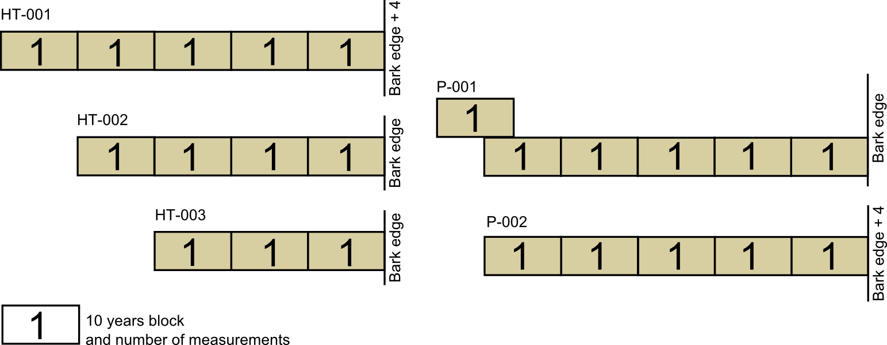
Supplementary Figure 1 Decadal blocks sampled from the timbers of the Dumbuck crannog.

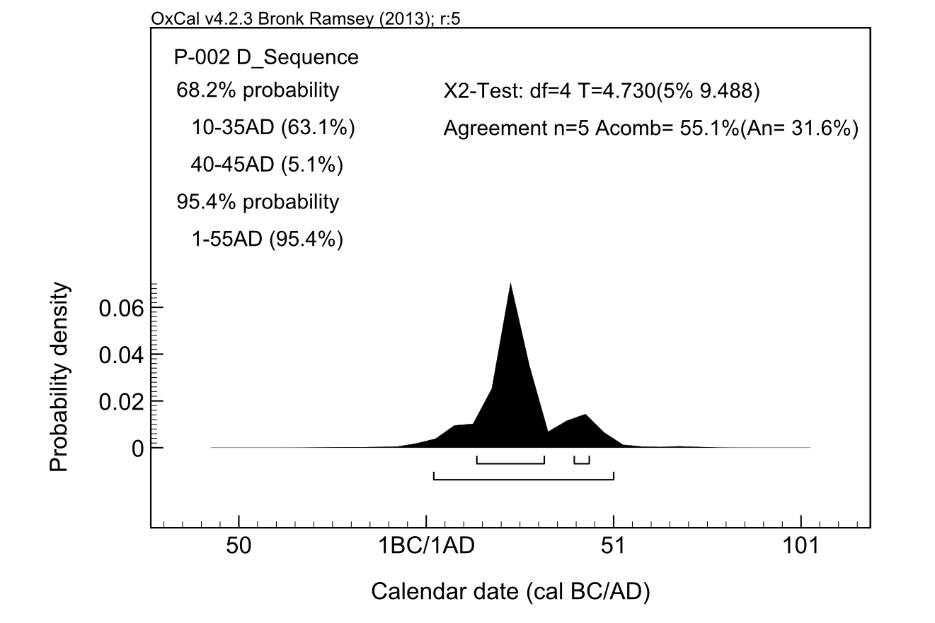
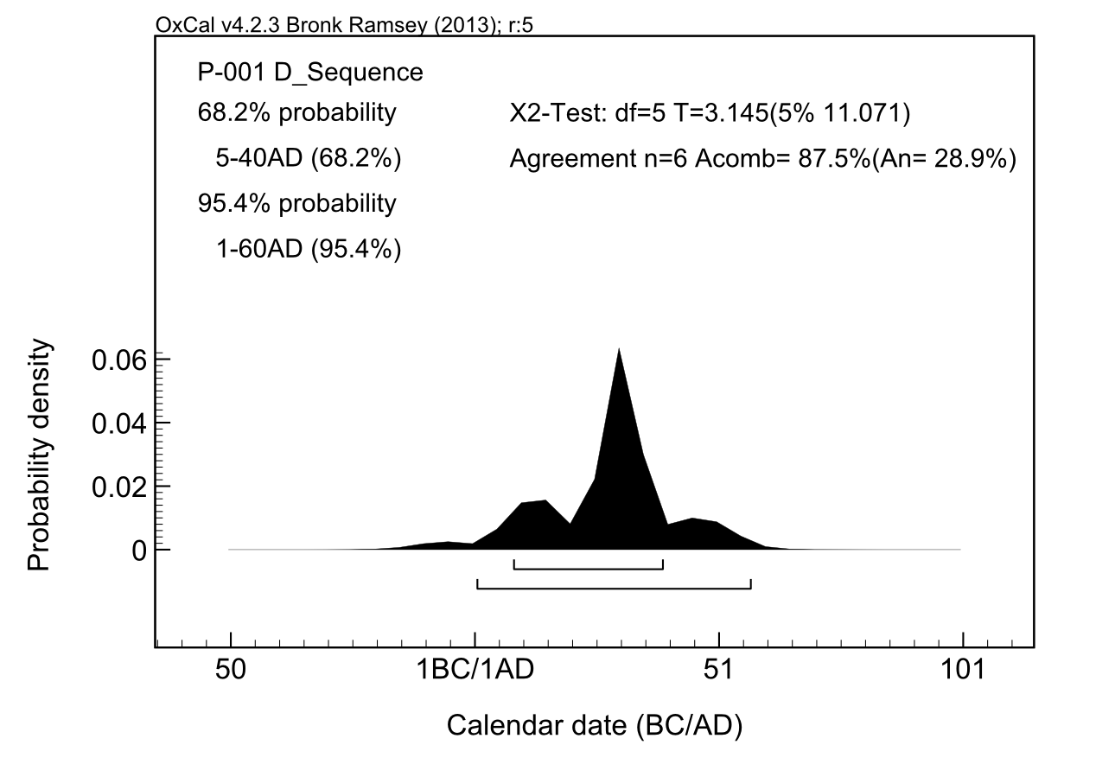
Supplementary Figure 2. Results of the wiggle-match on the Dumbuck crannog timber P-001: summary (top), and the individual determinations (bottom).

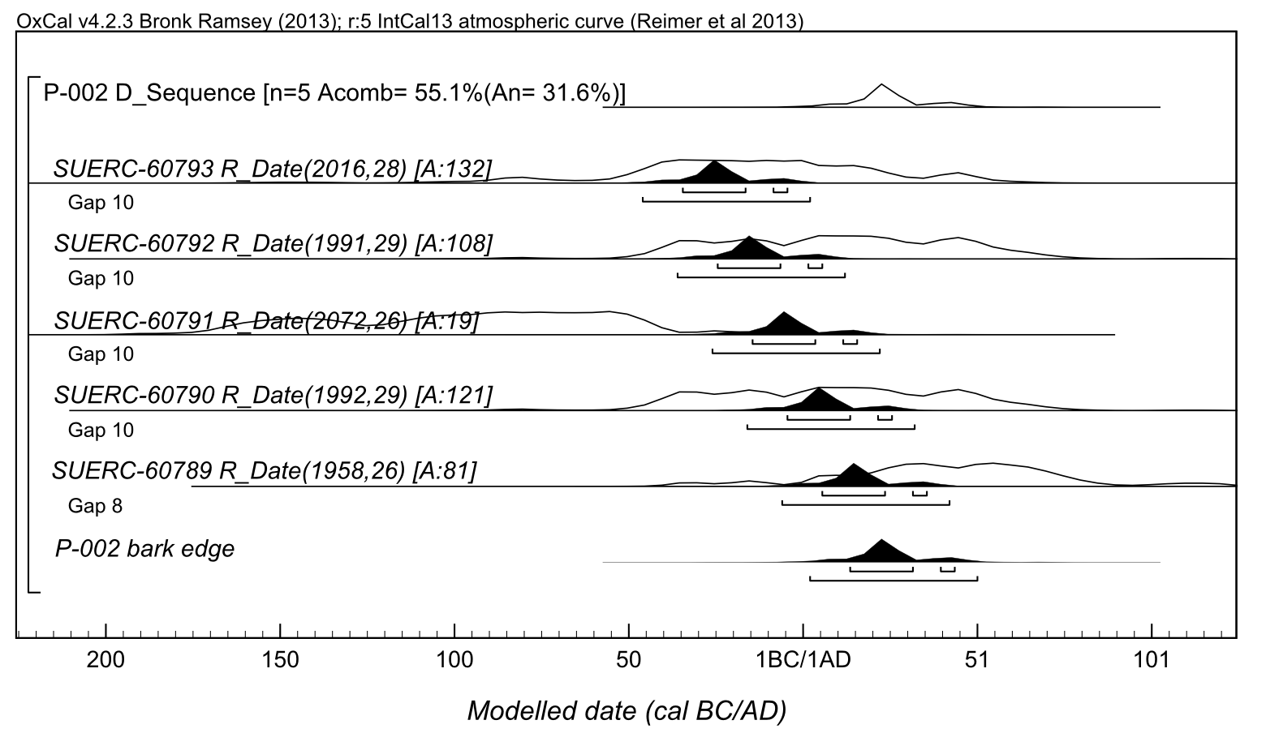
Supplementary Figure 3. Results of the wiggle-match on the Dumbuck crannog timber P-002: summary (top), and the individual determinations (bottom).

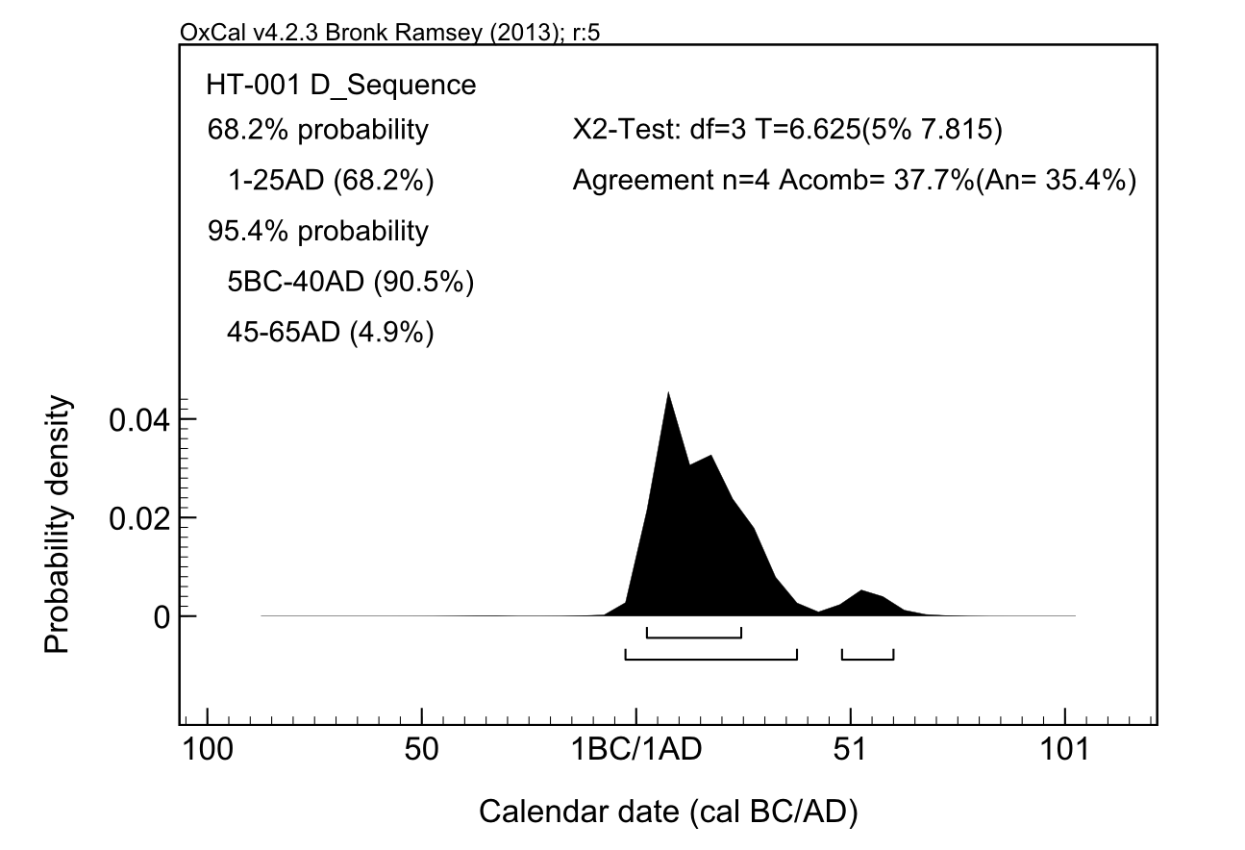
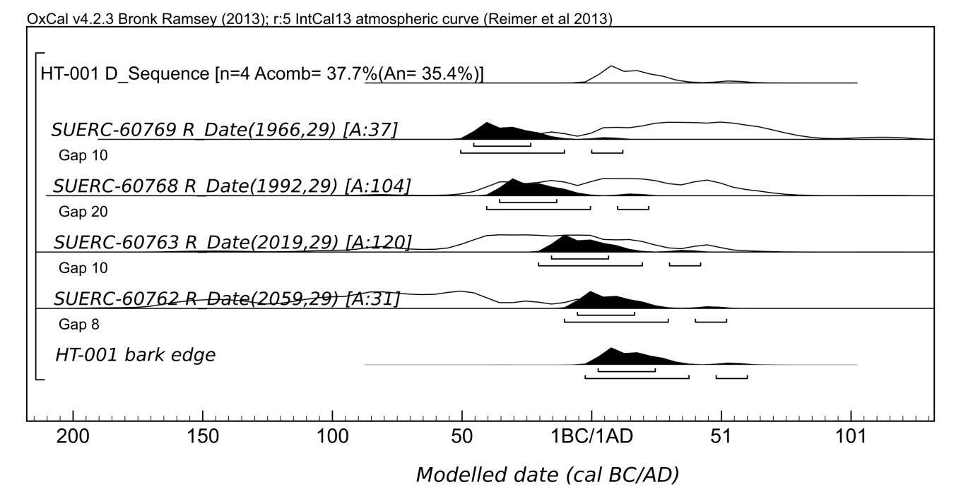
Supplementary Figure 4. Results of the wiggle-match on the Dumbuck crannog timber HT-001: summary (top), and the individual determinations (bottom).
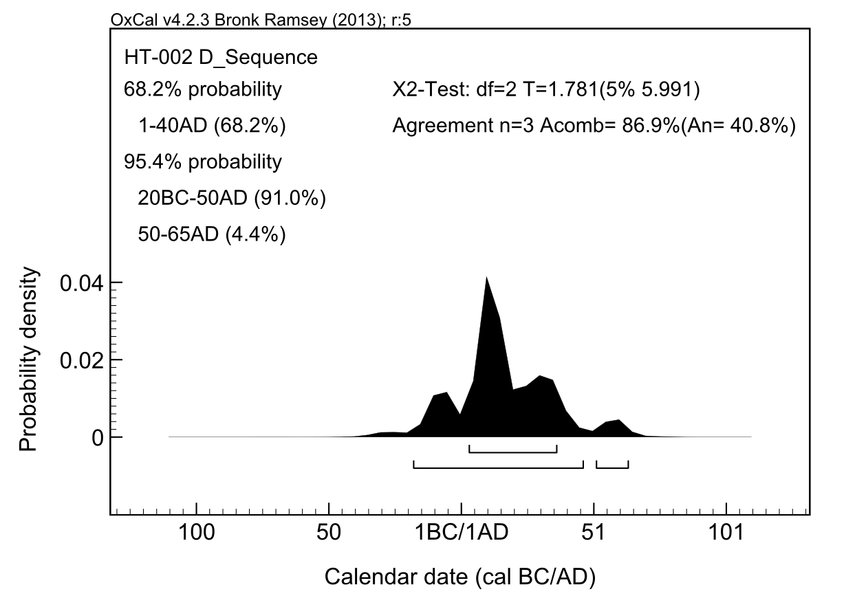
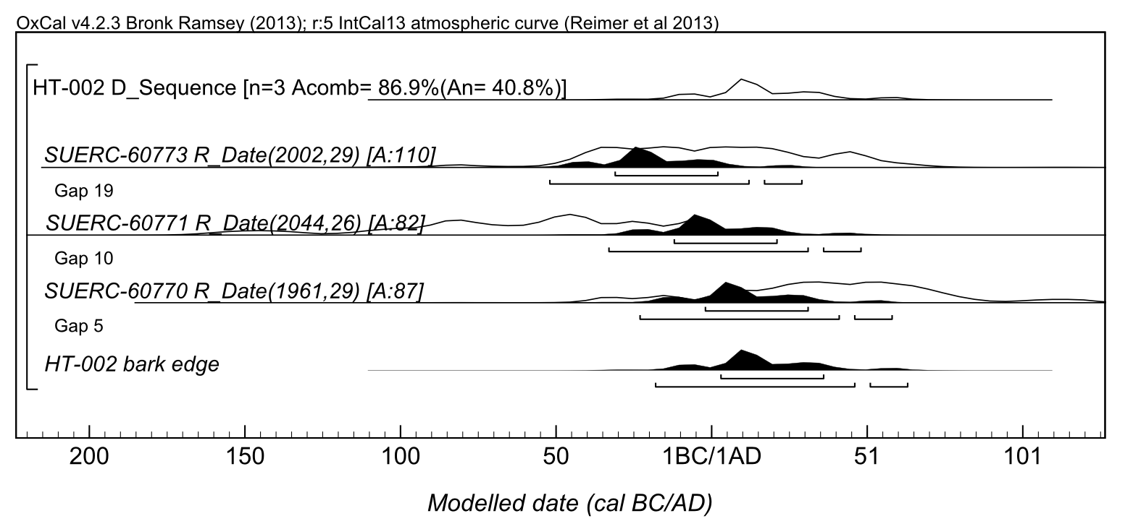
Supplementary Figure 5. Results of the wiggle-match on Dumbuck crannog timber HT-002: summary (top), and the individual determinations (bottom).
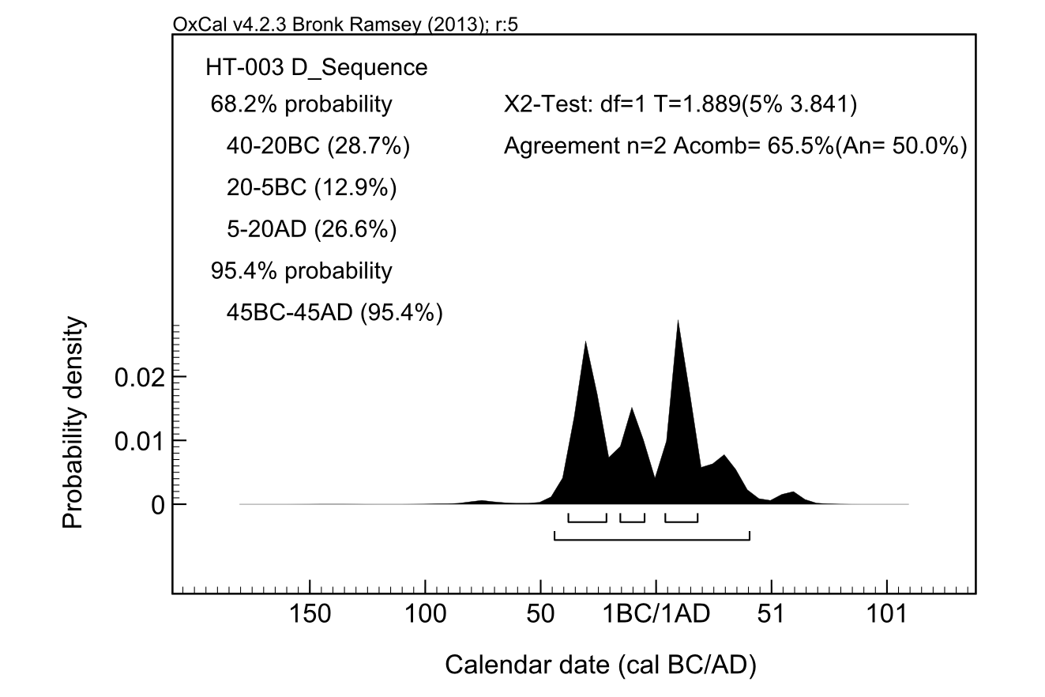
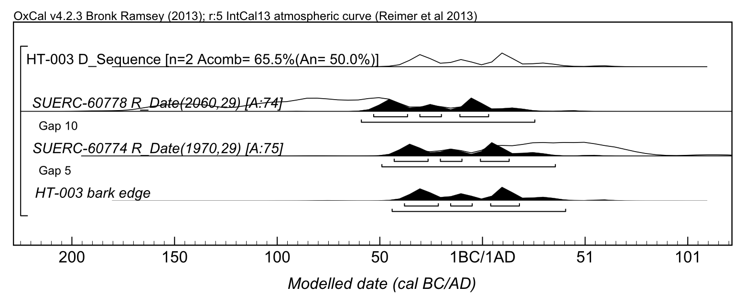
Supplementary Figure 6. Results of the wiggle-match on Dumbuck crannog timber HT-003: summary (top), and the individual determinations (bottom).
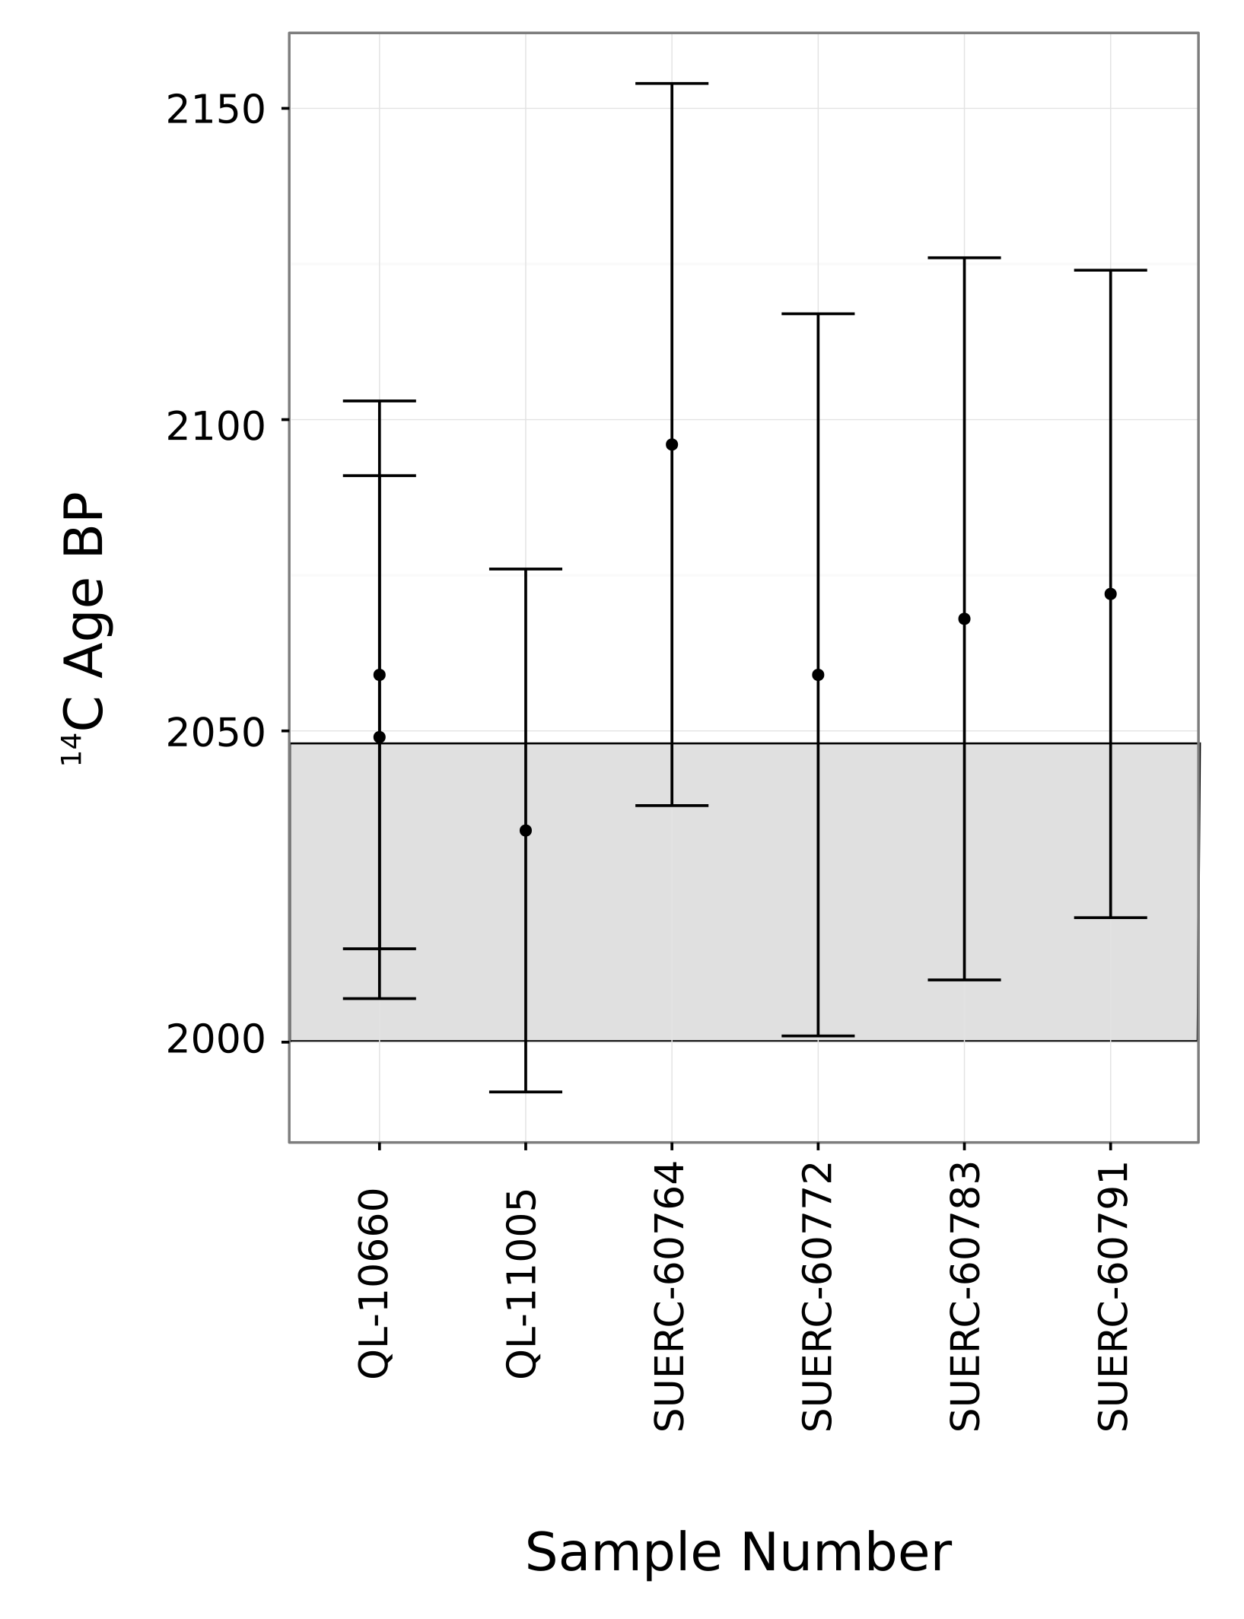

Supplementary Figure 7. The 2-σ envelope of the IntCal13 at 5 cal bc, the calibration measurements around 5 cal bc (QL-10660 and QL-11005) and the measurements from the Dumbuck crannog timbers believed to belong to that period (SUERC- ab codes). Error bars are 2-σ.

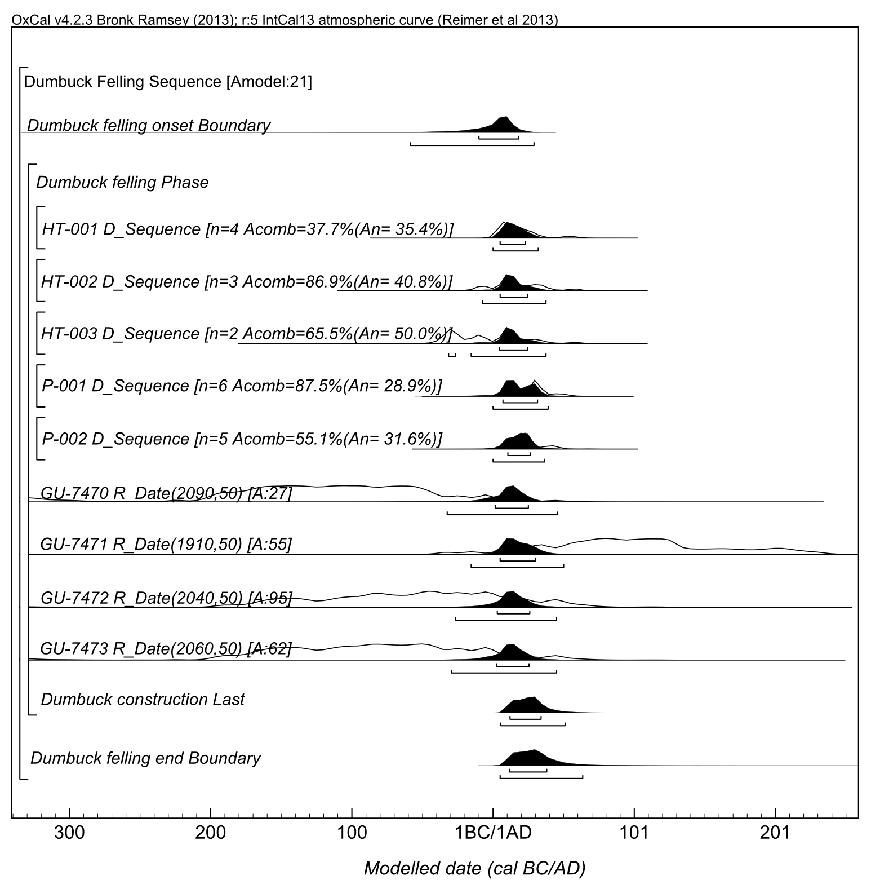
Supplementary Figure 8. Detailed results of the model for the date of construction of the Dumbuck crannog.

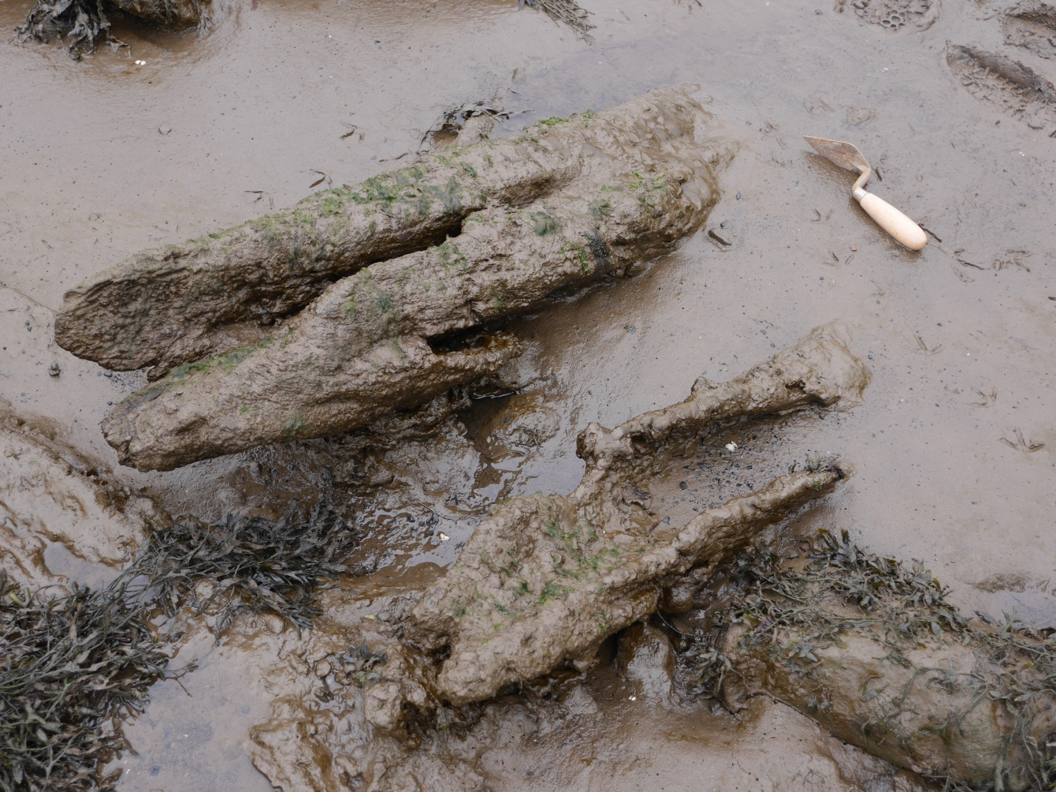
Supplementary Figure 9. Feature 01 at the Erskine Bridge crannog.
[© Crown Copyright Historic Environment Scotland].

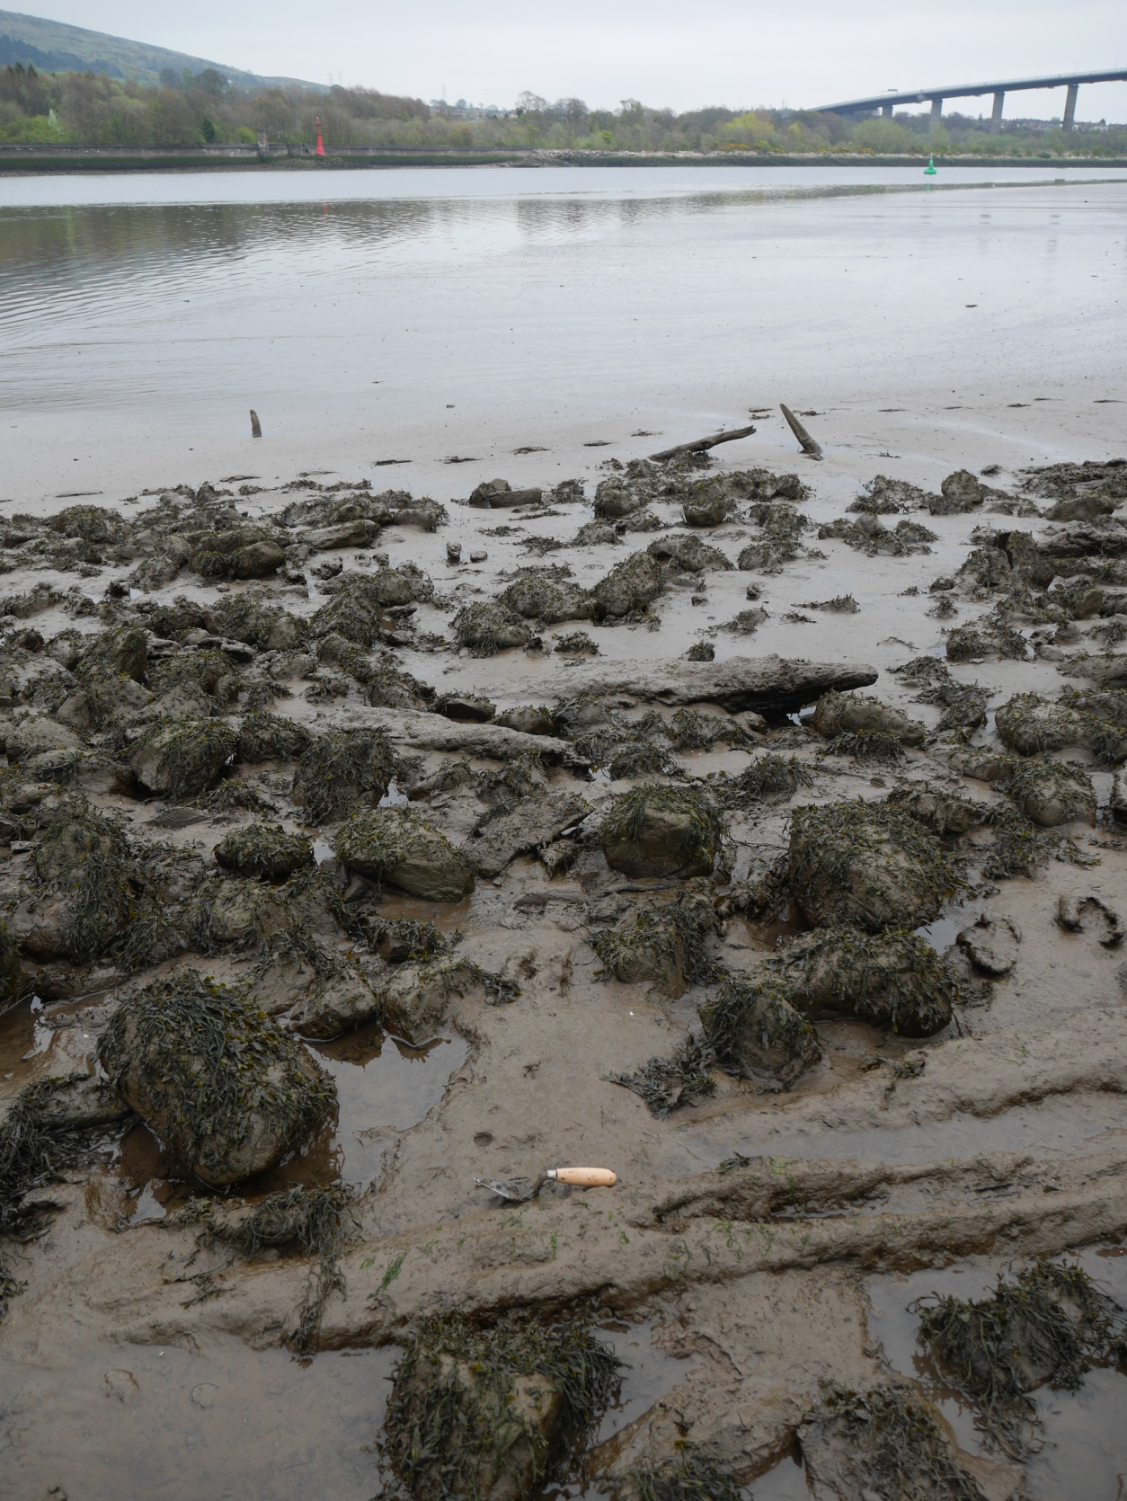

Supplementary Figure 10. Feature 02 at the Erskine Bridge crannog.
[© Crown Copyright Historic Environment Scotland].

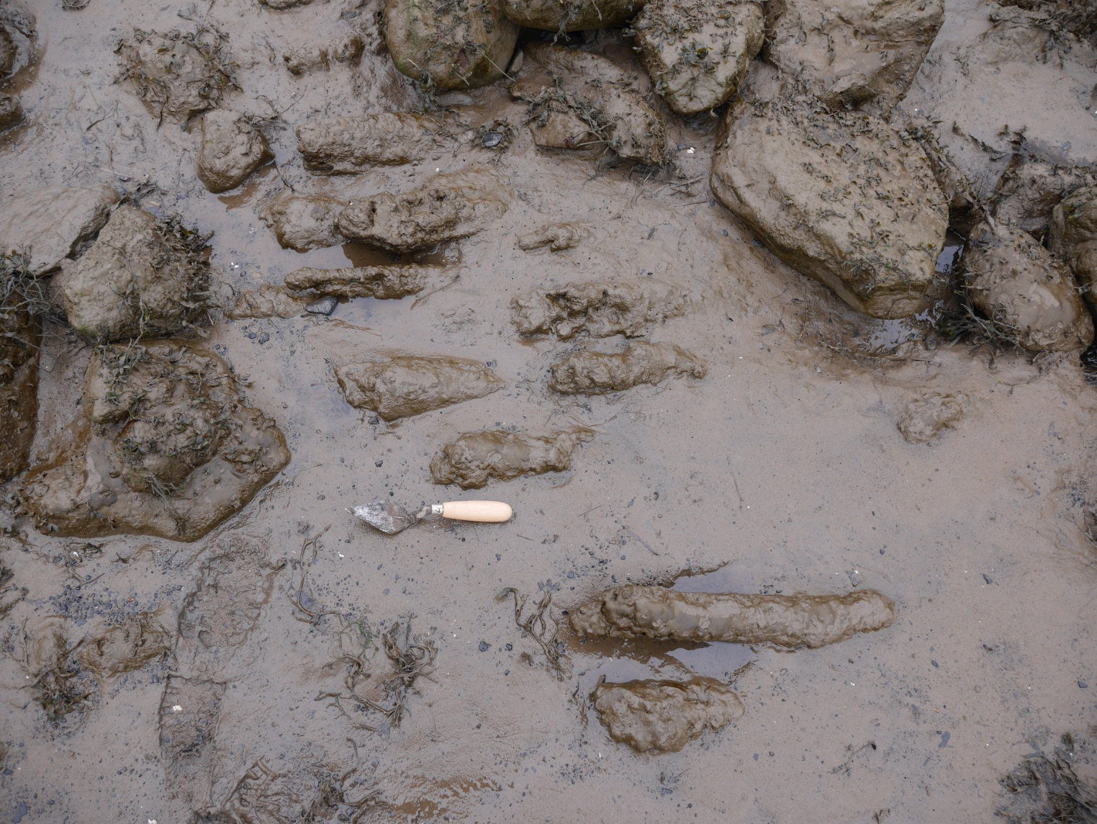
Supplementary Figure 11. Feature 03 at the Erskine Bridge crannog.
[© Crown Copyright Historic Environment Scotland].

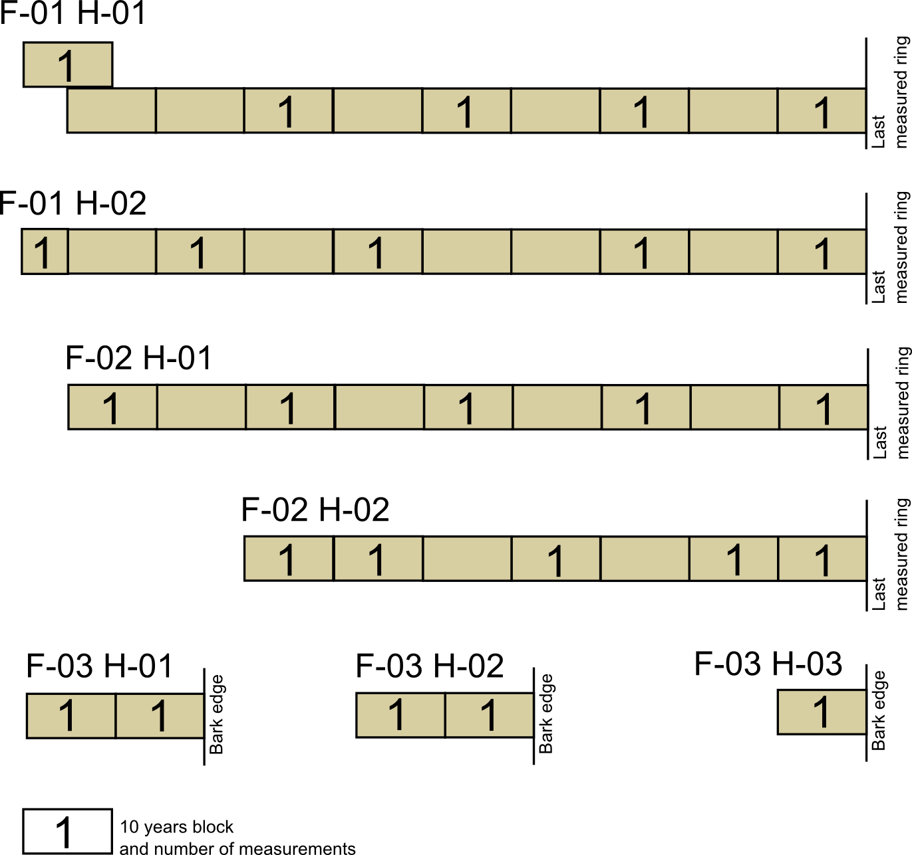
Supplementary Figure 12. Decadal blocks sampled from the timbers of the Erskine Bridge crannog.

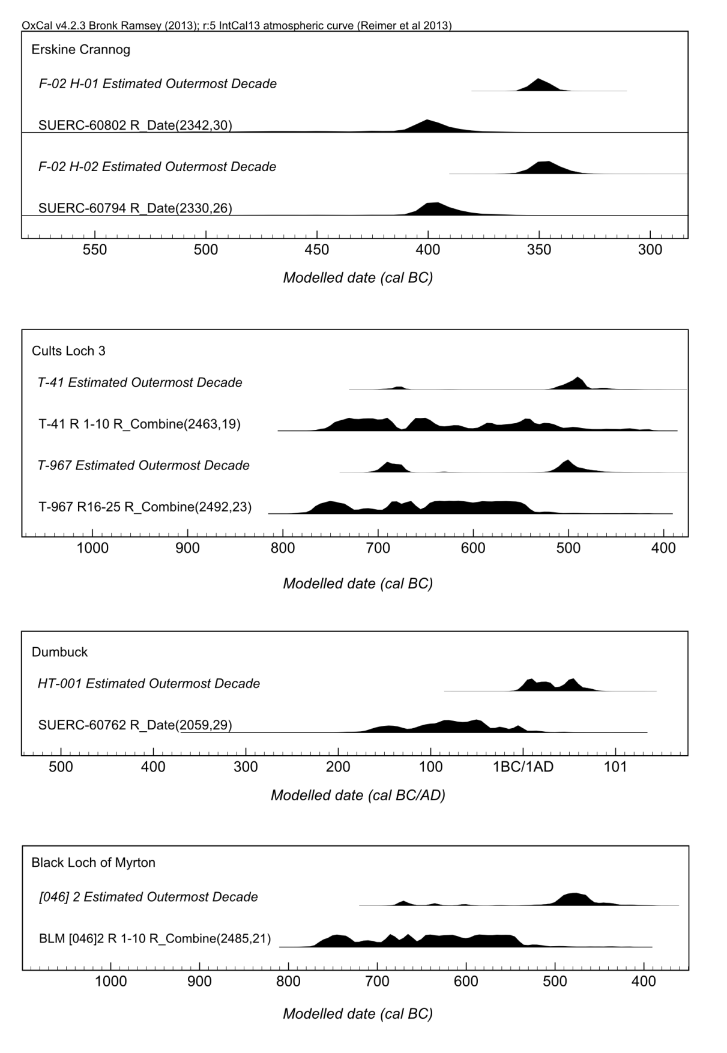

Supplementary Figure 13. Calibrated date ranges for the actual determinations on the affected outermost rings and their estimates based on the remainder of the constituent wiggle-matches, on a range of south-western Scottish wetland sites. Data for the Erskine Bridge and Dumbuck crannogs presented in this article. Data for Cults Loch 3 and Black Loch of Myrton from Jacobsson (2015).
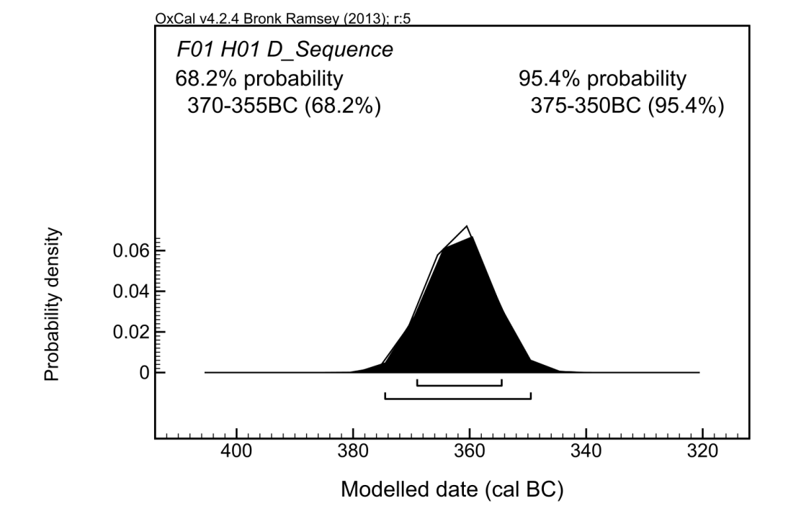
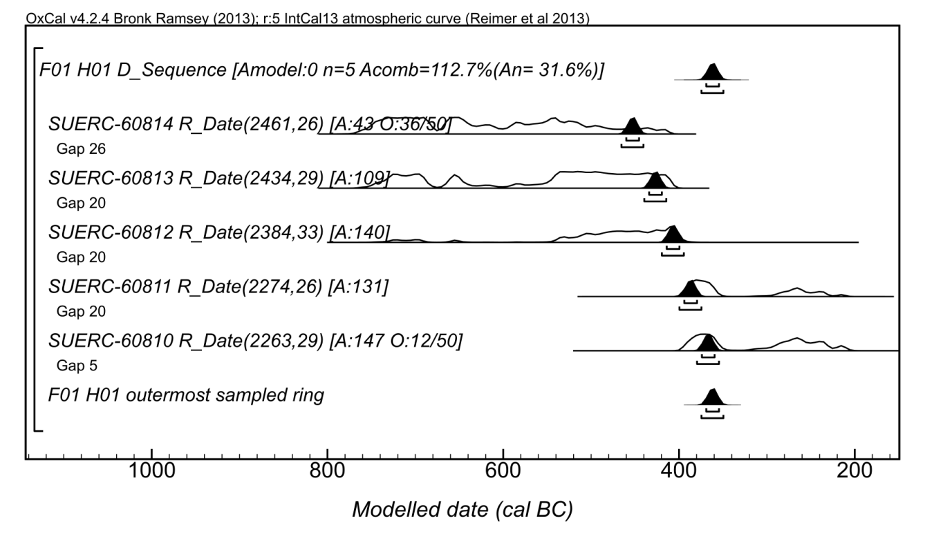

Supplementary Figure 14. Results of the wiggle-match of the Erskine Bridge crannog timber F-01 H-01: summary (top), and the individual determinations (bottom). The white outline on the summary estimate indicates the distribution of the wiggle-match without the application of the outlier model.
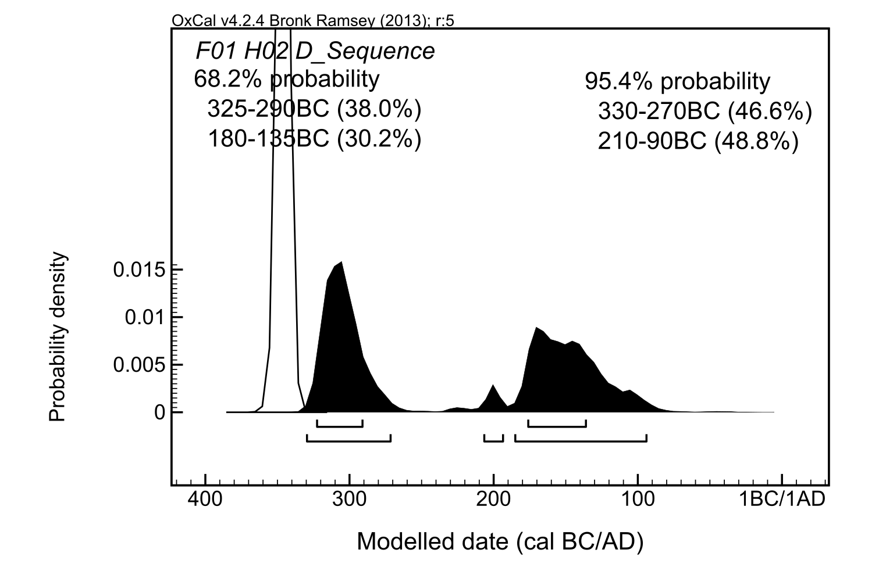

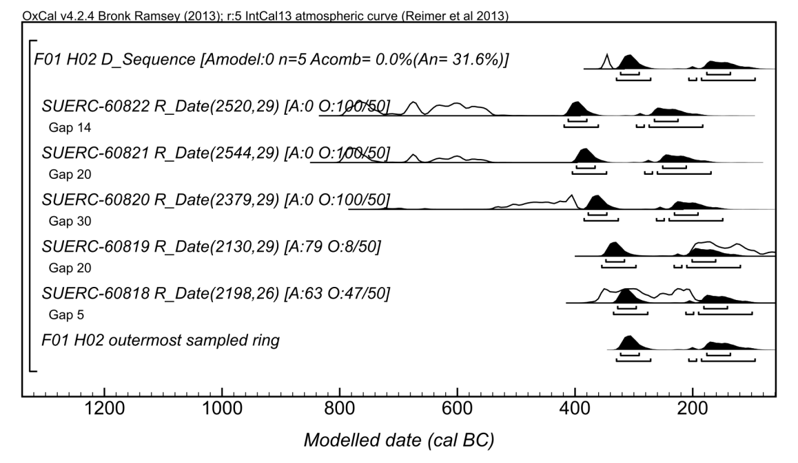
Supplementary Figure 15. Results of the wiggle-match of the Erskine Bridge crannog timber F-01 H-02: summary (top), and the individual determinations (bottom). The white outline on the summary estimate indicates the distribution of the wiggle-match without the application of the outlier model.

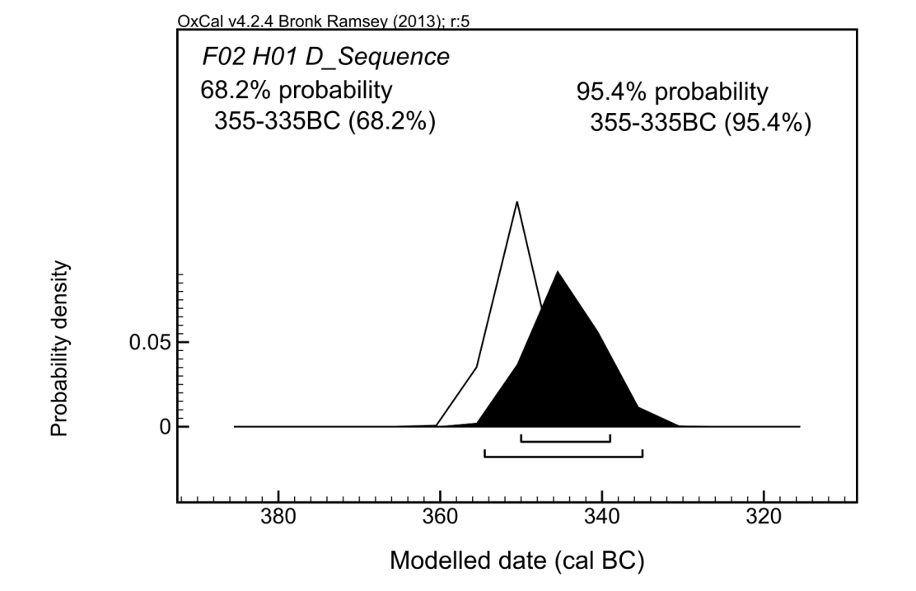
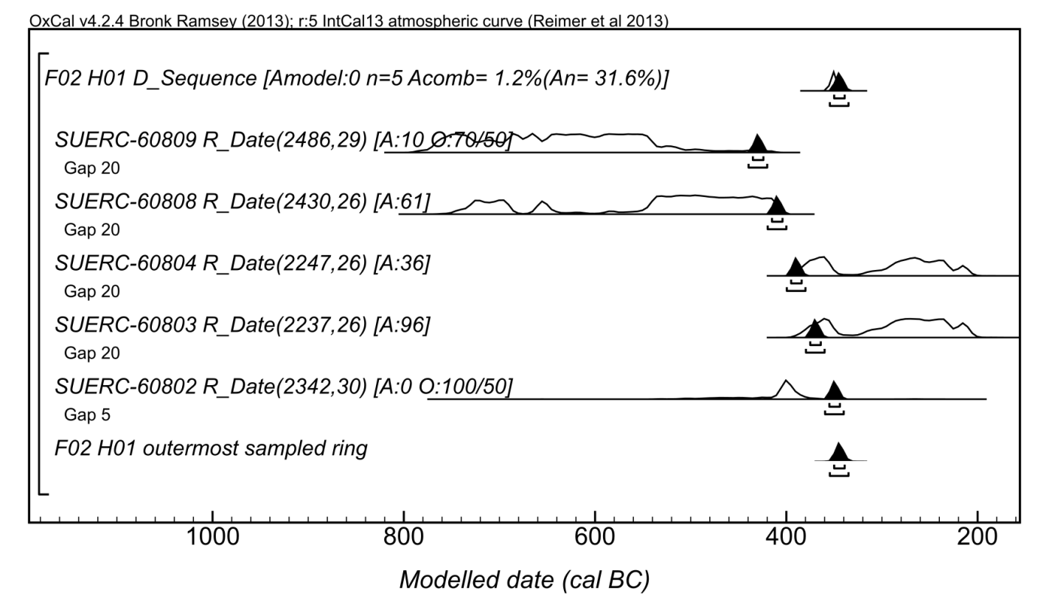
Supplementary Figure 16. Results of the wiggle-match of the Erskine Bridge crannog timber F-02 H-01: summary (top), and the individual determinations (bottom). The white outline on the summary estimate indicates the distribution of the wiggle-match without the application of the outlier model.
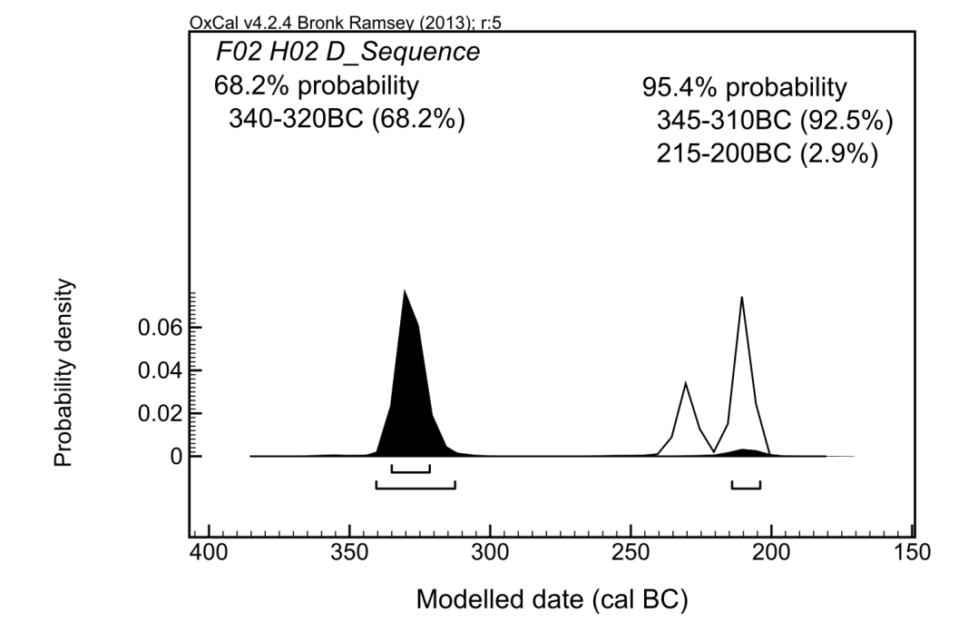
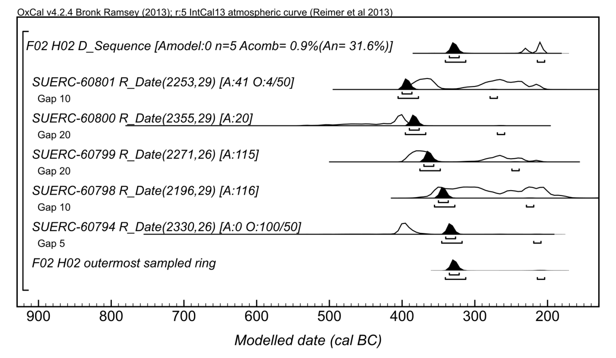
Supplementary Figure 17. Results of the wiggle-match of the Erskine Bridge crannog timber F-02 H-02: summary (top), and the individual determinations (bottom). The white outline on the summary estimate indicates the distribution of the wiggle-match without the application of the outlier model.
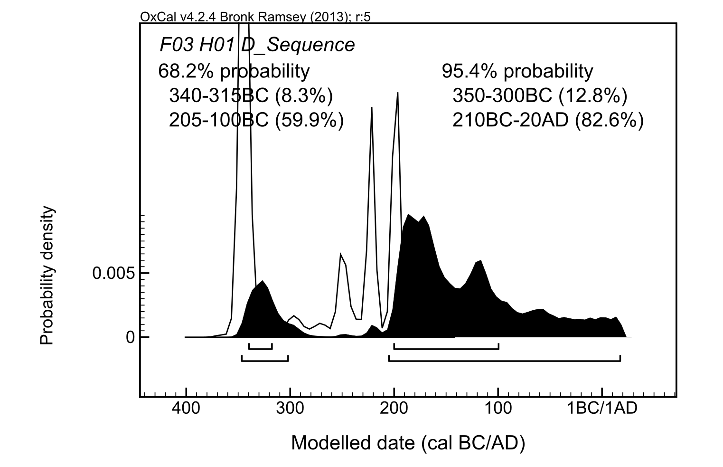
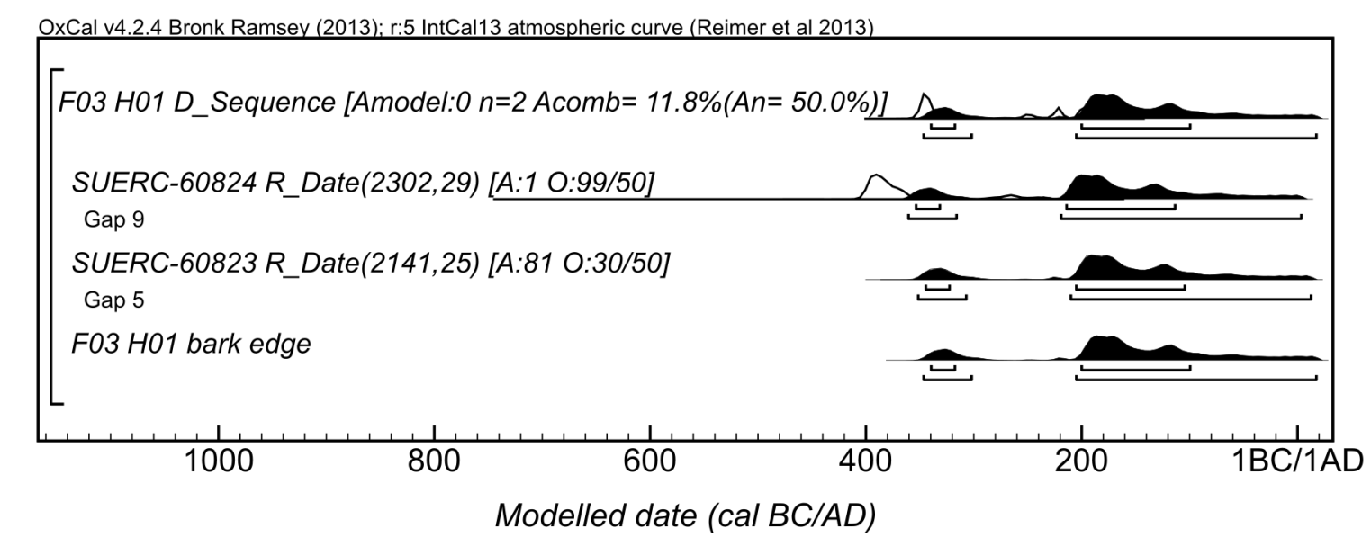
Supplementary Figure 18. Results of the wiggle-match of the Erskine Bridge crannog timber F-03 H-01: summary (top), and the individual determinations (bottom). The white outline on the summary estimate indicates the distribution of the wiggle-match without the application of the outlier model.
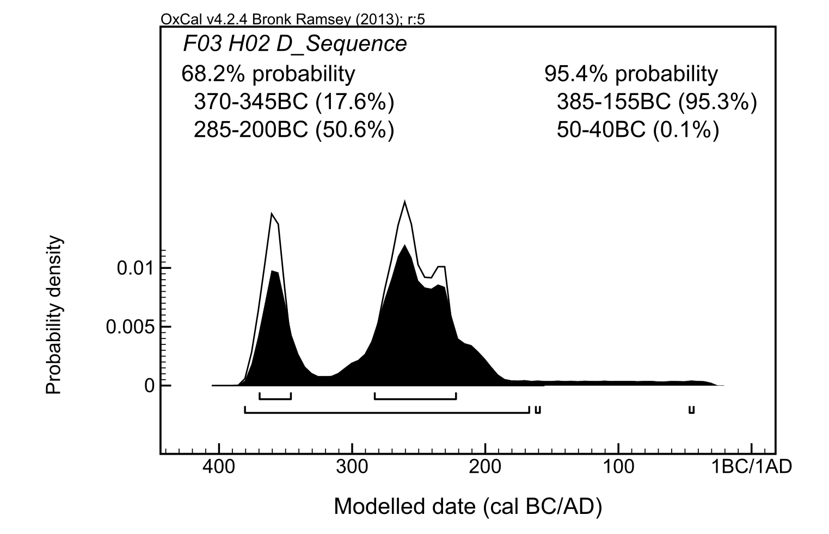
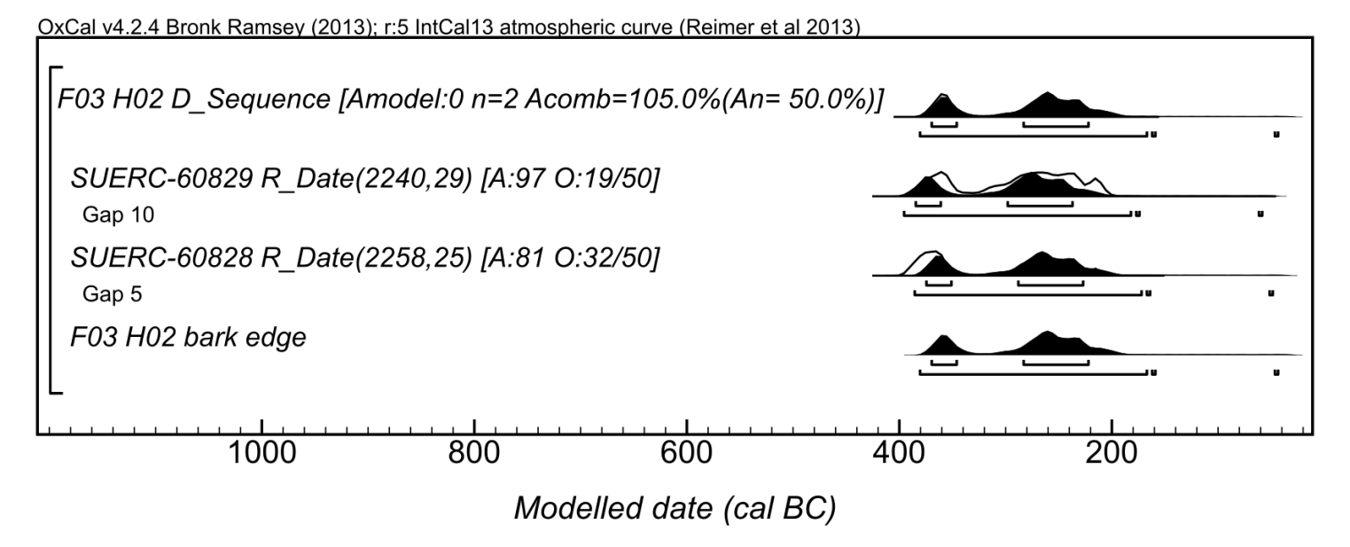
Supplementary Figure 19. Results of the wiggle-match of the Erskine Bridge crannog timber F-03 H-02: summary (top), and the individual determinations (bottom). The white outline on the summary estimate indicates the distribution of the wiggle-match without the application of the outlier model.

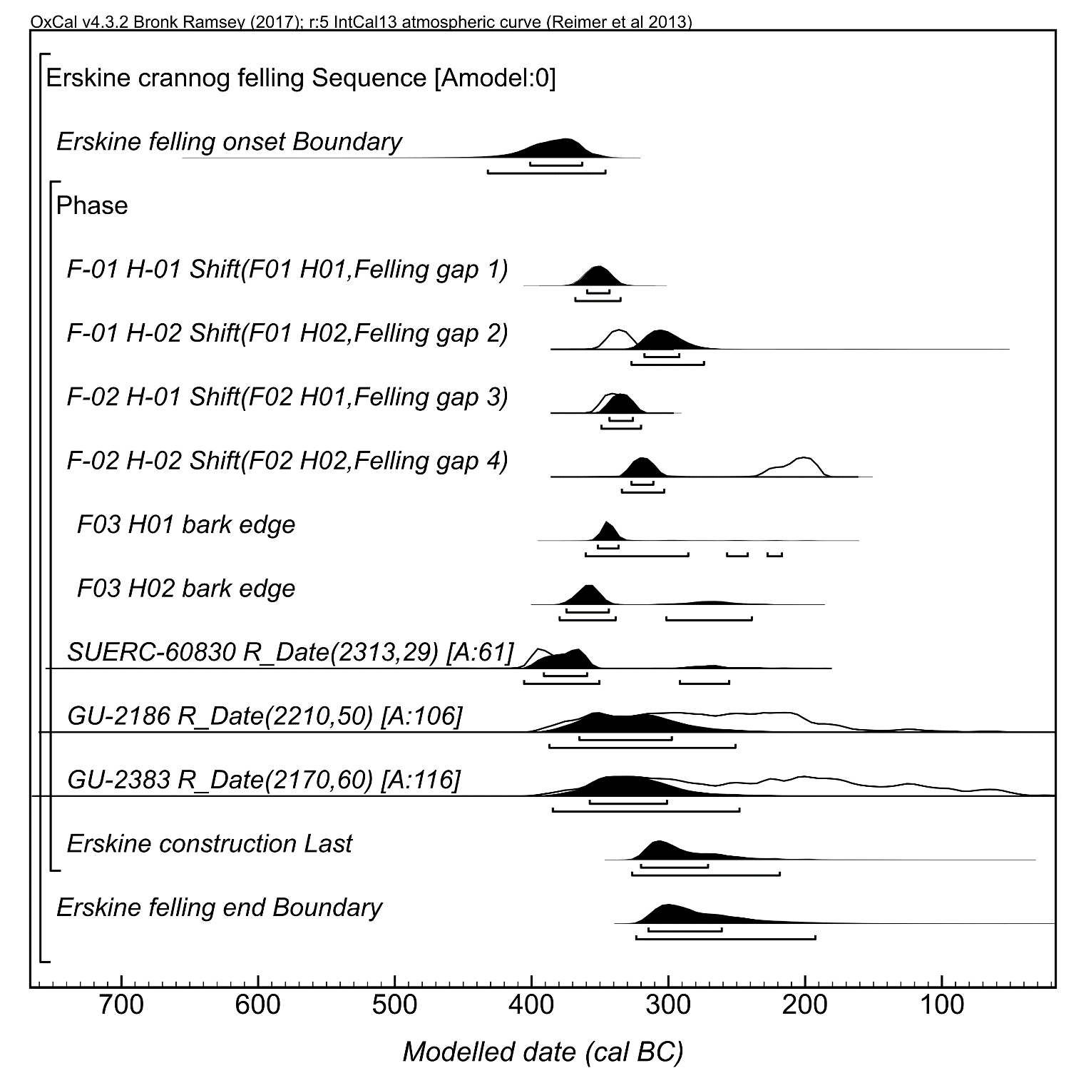
Supplementary Figure 20. Detailed results of the model for the date of construction of the Erskine Bridge crannog. The Shift() parameters mark the four large wiggle-matches. The shift was implemented to account for possible missing rings towards the bark edge. Note that the low A_{model} derives from the agreement index calculation not taking into account the effects of the outlier model.

