Questionnaire
Please complete the following questionnaire and deposit it in one of the collection boxes available in the radiotherapy waiting area or main reception.

Kindly note that filling in and returning this questionnaire constitutes giving consent to your participation in this study.

Section A- General Information

- Please specify your gender:
☐ Male | ☐ Female | ☐ Other

- Please indicate your age category:
☐ 18-25 | ☐ 26-35 | ☐ 36-45 | ☐ 46-55
☐ 56-65 | ☐ 66-75 | ☐ 76-85 | ☐ 86+

- Please indicate the body site to which you are currently receiving your radiotherapy treatment:
☐ Brain | ☐ Head and neck | ☐ Prostate | ☐ Colorectal
☐ Lungs | ☐ Gynaecology | ☐ Abdomen | ☐ Breast
☐ Other: _________________________________________________________________

- Please indicate the highest level of education achieved:
☐ Primary | ☐ Secondary | ☐ Post-secondary | ☐ Bachelor’s Degree
☐ Masters’ Degree | ☐ Doctorate | ☐ Other: ____________________________

Section B- Habits of smartphone usage

- Do you own a smartphone?
☐ Yes | ☐ No

(If you have answered no to this question, skip to Section C)
- At what intervals do you generally check your smartphone for notifications (SMS, missed calls, push notifications)?
☐ Once every 30 minutes | ☐ Once every 60 minutes | ☐ Once every 2 hours
☐ Once every 12 hours | ☐ Once every 2 days or longer

- What is the name of the manufacturer/operating system of your smartphone?
☐ iPhone (Apple) | ☐ Android (e.g., Samsung, Huawei, etc.) | ☐ Windows
☐ I don’t know | ☐ Other: ______________________________________________

- How do you connect to the internet on your smartphone
☐Mobile Data | ☐ Wi-Fi only | ☐ Both

- Please categorise your usage habits regarding your smartphone (multiple selections allowed):
☐ | Voice calls
☐ | Instant messaging
☐ | Taking pictures,  web browsing
☐ | Social media, Facebook Messenger, WhatsApp
☐ | Intensive app use, more than 10 apps downloaded and installed
☐ | Other: ________________________________________________________________

Section C- Use of mHealth technology

- Have you ever used your smartphone for health-related reasons?
☐ | Yes | Please specify: ___________________________________________
☐ | No | (Skip to question 12)
- Do you use any of the following mHealth devices/ applications? (Select all that apply)
☐ | Step-tracker mobile application
☐ | Smartwatch / wrist-worn fitness band
☐ | Medication reminder mobile application
☐ | Fitness application
☐ | Other: _____________________________________________________________

- Have you ever used the web portal myHealth to access your medical records?
☐ Yes | ☐ No | ☐ I never heard of it

Section D- Technical knowledge and abilities in smartphone usage
- How would you describe your skills in using your smartphone?
☐ I can’t use a smartphone | ☐ Basic | ☐ Average
☐ Above-average | ☐ Advanced

- Do you need assistance in using your smartphone?
☐ Never | ☐ Rarely | ☐ Sometimes | ☐ Frequently | ☐ Always

- Who assists you in using your smartphone?
☐ I do not need assistance | ☐ Children/ grandchildren | ☐ Partner/ family
☐ Friends/ acquaintances
☐ Others- please specify: ____________________________________________________

Section E- Readiness to use a smartphone app to assist you during your radiotherapy.

We are currently in the process of designing a mobile application to assist patients during radiotherapy. Some pictures of this application are available below.

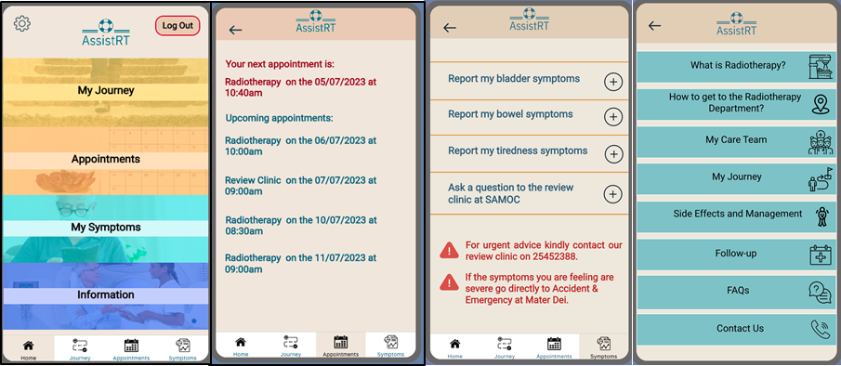

- Overall how useful would you regard a security-certified smartphone app to support you during radiotherapy?
☐ Very helpful | ☐ Helpful | ☐ Not sure
☐ Unhelpful | ☐ Very unhelpful
- Rate the usefulness of these features to assist you throughout your radiotherapy treatment.

a) Obtain information about radiotherapy and hospital services.
☐ Extremely useful ☐ Very useful ☐ Moderately useful ☐ Slightly useful ☐ Not useful

b) Keep track of my appointments
☐ Extremely useful ☐ Very useful ☐ Moderately useful ☐ Slightly useful ☐ Not useful

c) Communicate with my doctors via videoconferencing
☐ Extremely useful ☐ Very useful ☐ Moderately useful ☐ Slightly useful ☐ Not useful

d) Remind me to take medications or prepare for treatment
☐ Extremely useful ☐ Very useful ☐ Moderately useful ☐ Slightly useful ☐ Not useful

e) Report the symptoms experienced during and after my radiotherapy treatment to my doctor
☐ Extremely useful ☐ Very useful ☐ Moderately useful ☐ Slightly useful ☐ Not useful

f) Obtain advice on how to manage any side effects related to treatment
☐ Extremely useful ☐ Very useful ☐ Moderately useful ☐ Slightly useful ☐ Not useful

g) Alert my doctor if I’m experiencing severe or abnormal treatment side effects.
☐ Extremely useful ☐ Very useful ☐ Moderately useful ☐ Slightly useful ☐ Not useful

h) To keep in touch with my doctor after treatment
☐ Extremely useful ☐ Very useful ☐ Moderately useful ☐ Slightly useful ☐ Not useful
- If a healthcare professional notices that you are experiencing severe side effects based on the symptom data provided, how would you prefer to be contacted?
☐ Through the application | ☐ Phone call | ☐ Email | ☐ Text message
- If you are not proficient in the use of smartphones, would you be willing to have someone assisting you (e.g., a relative or friend) in accessing information related to your radiotherapy treatment?
☐ | Yes, I’m willing to ask for help
☐ | No, I’m not willing to ask for help
☐ | I do not need assistance to use a smartphone
- How often would you be willing to answer a short questionnaire regarding your well-being and possible symptoms during radiotherapy?
☐ Daily | ☐ Every other day | ☐ Weekly
☐ On the first and last day of radiotherapy |  | ☐ As required
- Would you trust the safety of your medical data when using a security-certified smartphone application?
☐ No reservations | ☐ Some reservations | ☐ Undecided
☐ Substantial reservations | ☐ Major reservations
- Would you agree to have your anonymised medical data collected via this application to be used for research purposes?
☐ Yes | ☐ No

