Appendix

The differences between the dose distributions measured by the Farmer chamber and calculated by the ISOgray TPS for the adjacent radiation fields with different field sizes (6 × 6, 10 × 10, and 20 × 20 cm²), source to surface distances (SSDs) (90, 100, and 110 cm), and beam angles (0º, 15º, 30º, and 45º) were evaluated using the gamma index method. The obtained results are illustrated in Supplementary Figures 1-40.
The effect of field size on the accuracy of dose calculations (tests A, B, and C) is shown in Supplementary Figures 1-12, the effect of the SSD on the accuracy of dose calculations (tests D, E, and F) is illustrated in Supplementary Figures 13-24, and the effect of beam angle on the accuracy of dose calculations (tests G, H, I, and J) was presented in Supplementary Figures 25-40.

- Evaluating the dose calculation accuracy of ISOgray TPS: effect of field size

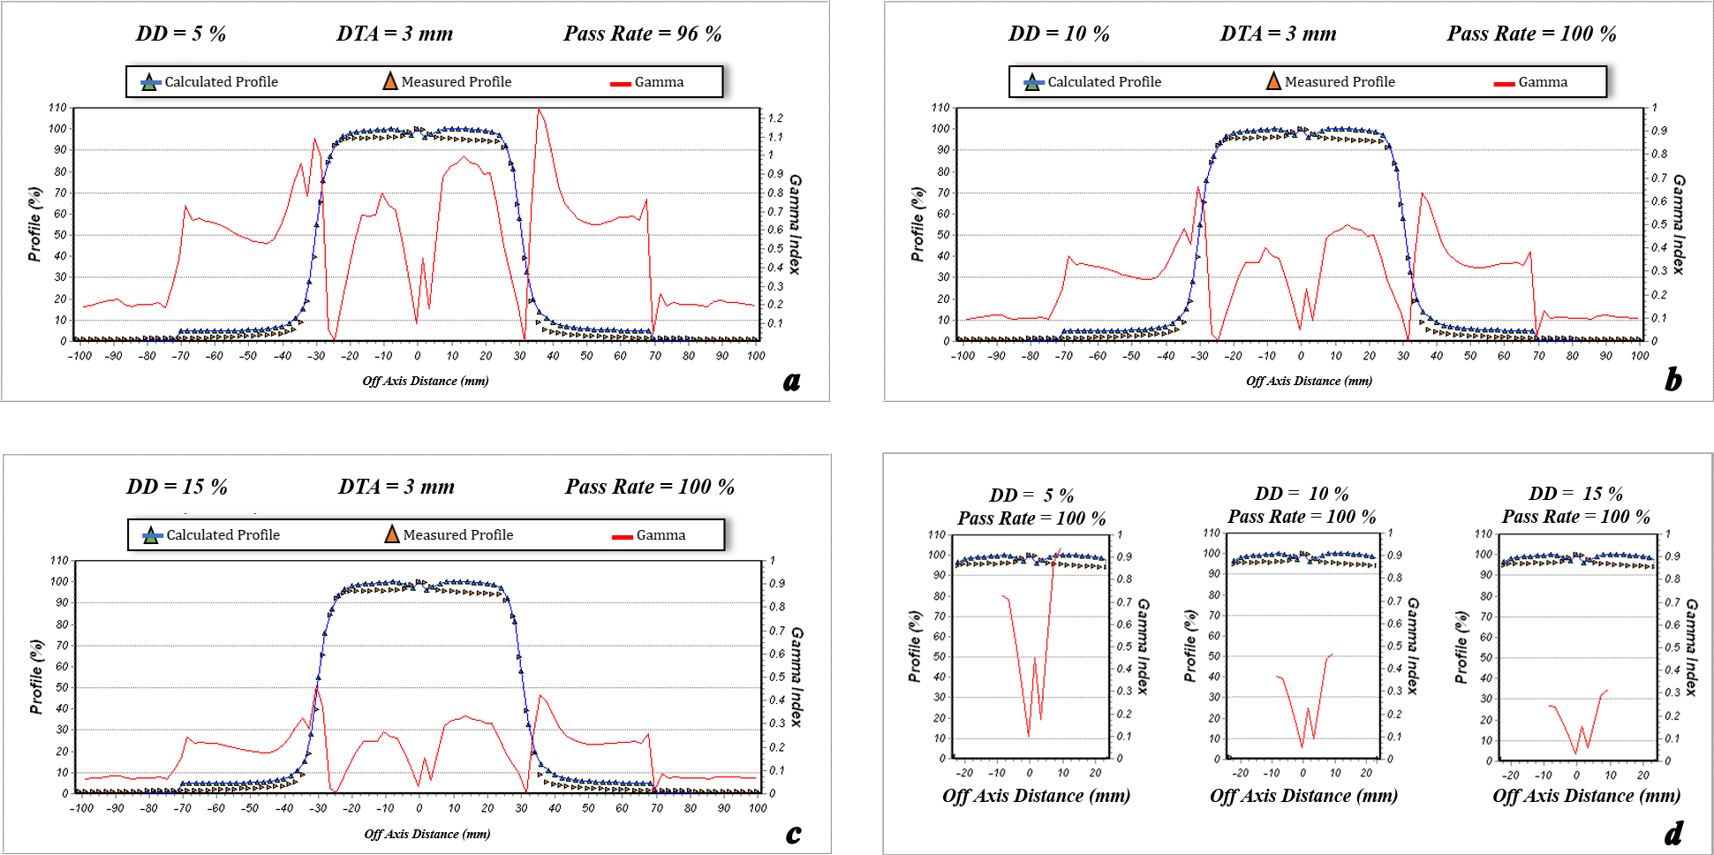
Figure 1. The dose profile data measured by the Farmer chamber and calculated by ISOgray treatment planning system for 6 cm × 6 cm field size, depth of 1 cm, beam angle of 0º, and source to surface distance = 100 cm (test A). Furthermore, the pass rate values of the gamma index analysis for acceptance criteria of dose difference (DD) = 3% and distance to agreement (DTA) =3 mm (a), DD = 4% and DTA =3 mm (b), DD = 5% and DTA =3 mm (c), and the match line regions (d) are shown.
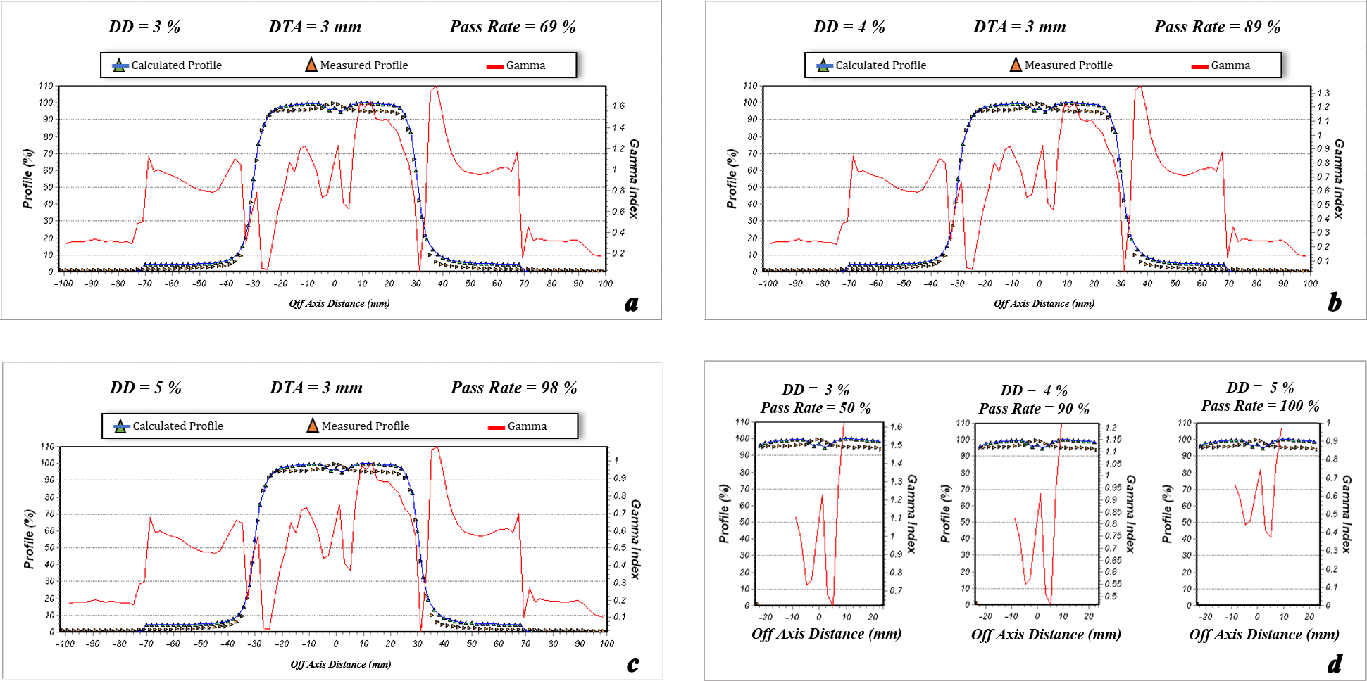
Figure 2. The dose profile data measured by the Farmer chamber and calculated by ISOgray treatment planning system for 6 cm × 6 cm field size, depth of 1.5 cm, beam angle of 0º, and source to surface distance = 100 cm (test A). Furthermore, the pass rate values of the gamma index analysis for acceptance criteria of dose difference (DD) = 3% and distance to agreement (DTA) =3 mm (a), DD = 4% and DTA =3 mm (b), DD = 5% and DTA =3 mm (c), and the match line regions (d) are shown.
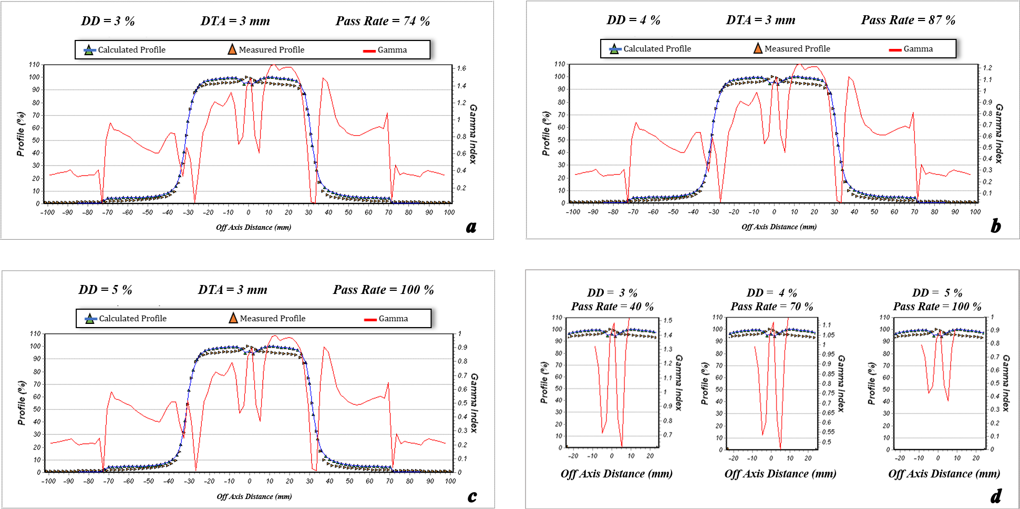
Figure 3. The dose profile data measured by the Farmer chamber and calculated by ISOgray treatment planning system for 6 cm × 6 cm field size, depth of 5 cm, beam angle of 0º, and source to surface distance = 100 cm (test A). Furthermore, the pass rate values of the gamma index analysis for acceptance criteria of dose difference (DD) = 3% and distance to agreement (DTA) =3 mm (a), DD = 4% and DTA =3 mm (b), DD = 5% and DTA =3 mm (c), and the match line regions (d) are shown.
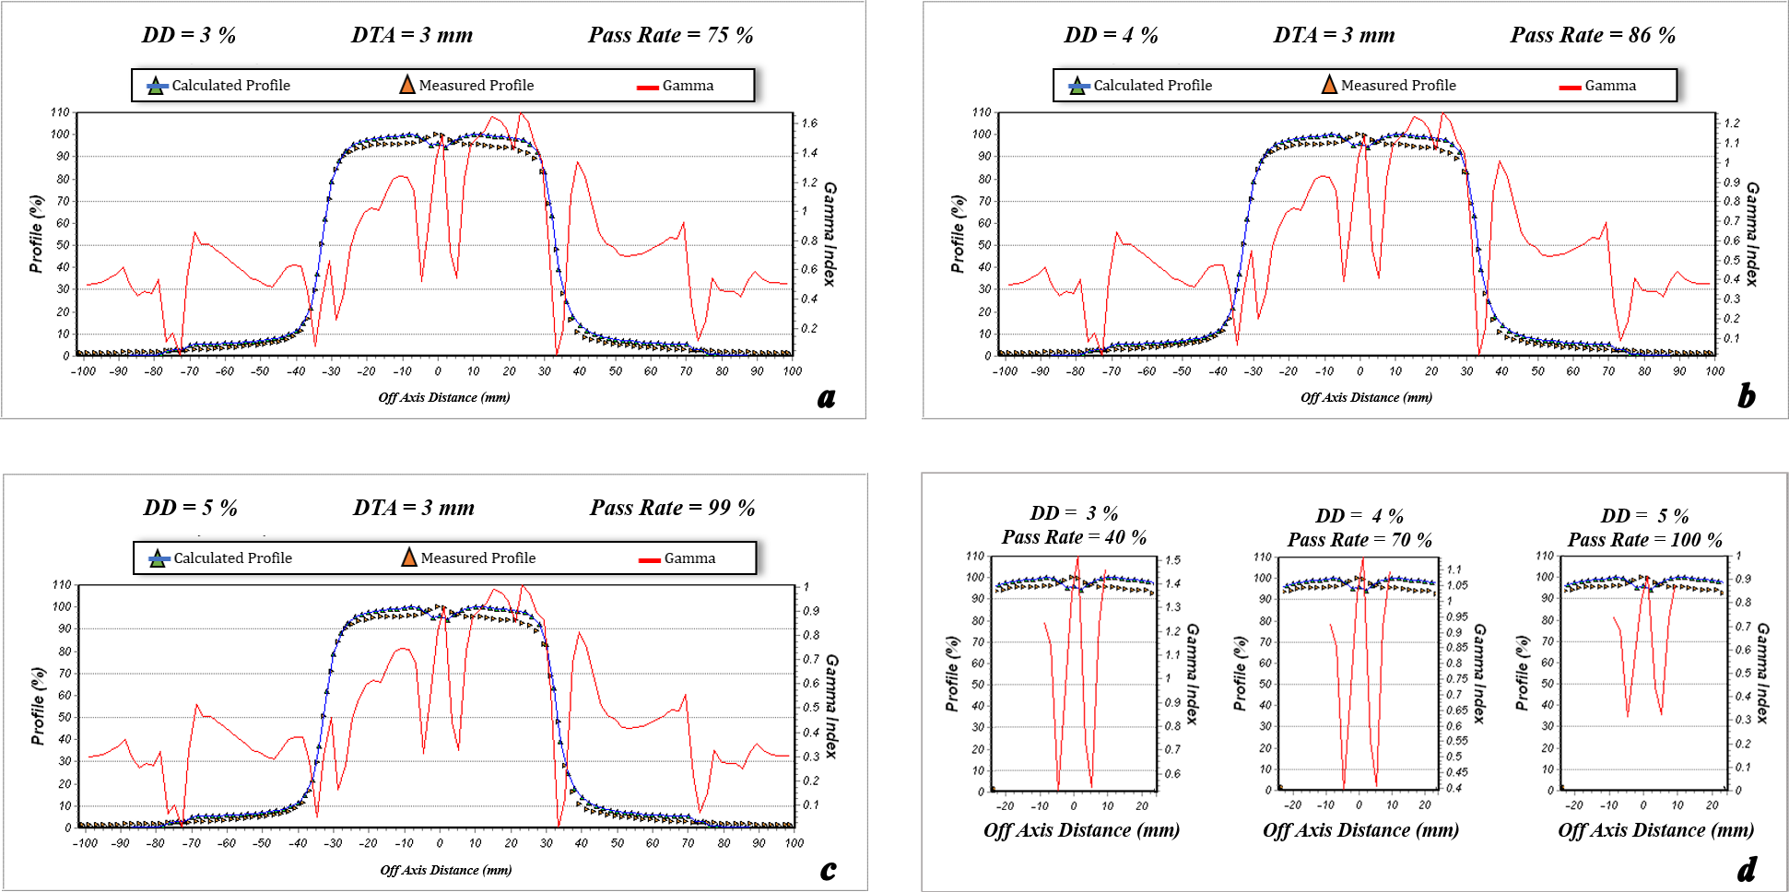
Figure 4. The dose profile data measured by the Farmer chamber and calculated by ISOgray treatment planning system for 6 cm × 6 cm field size, depth of 10 cm, beam angle of 0º, and source to surface distance = 100 cm (test A). Furthermore, the pass rate values of the gamma index analysis for acceptance criteria of dose difference (DD) = 3% and distance to agreement (DTA) =3 mm (a), DD = 4% and DTA =3 mm (b), DD = 5% and DTA =3 mm (c), and the match line regions (d) are shown.
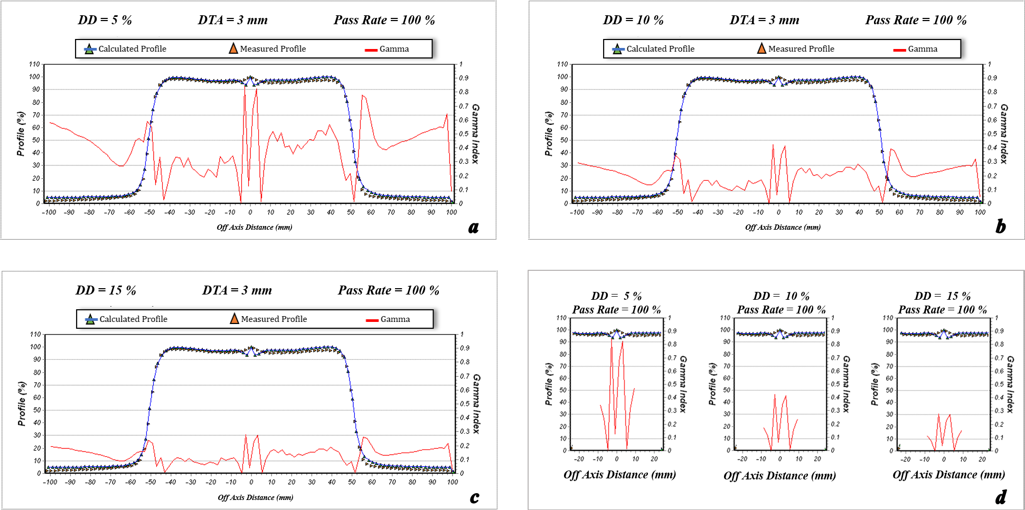
Figure 5. The dose profile data measured by the Farmer chamber and calculated by ISOgray treatment planning system for 10 cm × 10 cm field size, depth of 1 cm, beam angle of 0º, and source to surface distance = 100 cm (test B). Furthermore, the pass rate values of the gamma index analysis for acceptance criteria of dose difference (DD) = 3% and distance to agreement (DTA) =3 mm (a), DD = 4% and DTA =3 mm (b), DD = 5% and DTA =3 mm (c), and the match line regions (d) are shown.
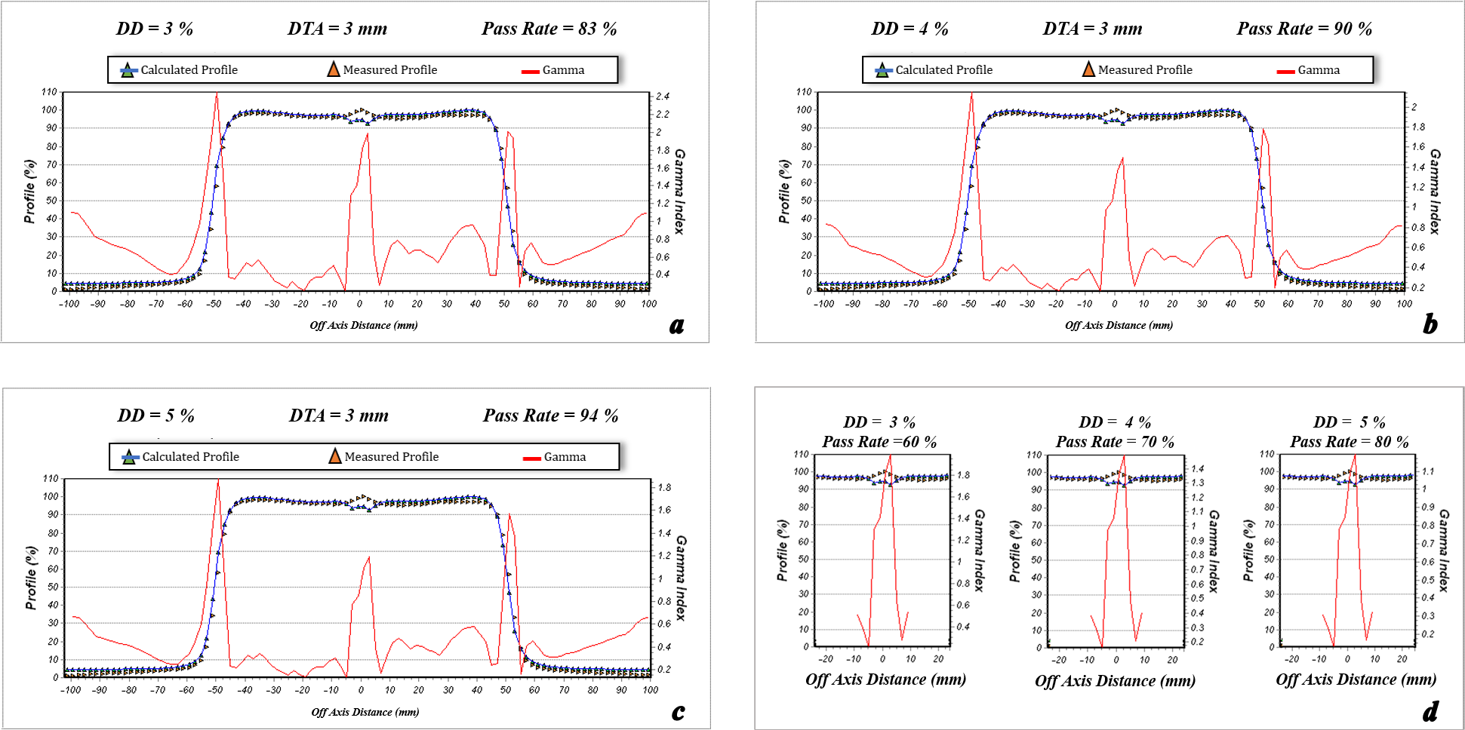
Figure 6. The dose profile data measured by the Farmer chamber and calculated by ISOgray treatment planning system for 10 cm × 10 cm field size, depth of 1.5 cm, beam angle of 0º, and source to surface distance = 100 cm (test B). Furthermore, the pass rate values of the gamma index analysis for acceptance criteria of dose difference (DD) = 3% and distance to agreement (DTA) =3 mm (a), DD = 4% and DTA =3 mm (b), DD = 5% and DTA =3 mm (c), and the match line regions (d) are shown.
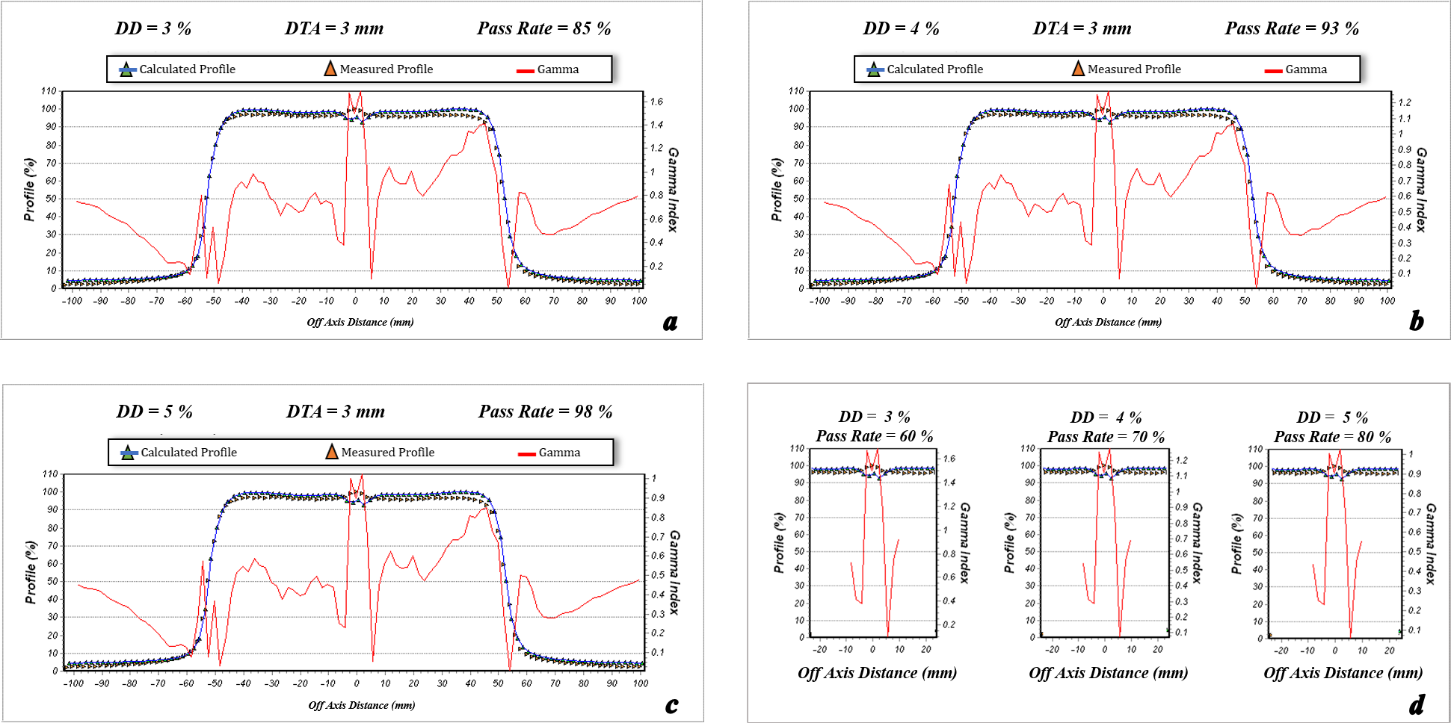
Figure 7. The dose profile data measured by the Farmer chamber and calculated by ISOgray treatment planning system for 10 cm × 10 cm field size, depth of 5 cm, beam angle of 0º, and source to surface distance = 100 cm (test B). Furthermore, the pass rate values of the gamma index analysis for acceptance criteria of dose difference (DD) = 3% and distance to agreement (DTA) =3 mm (a), DD = 4% and DTA =3 mm (b), DD = 5% and DTA =3 mm (c), and the match line regions (d) are shown.
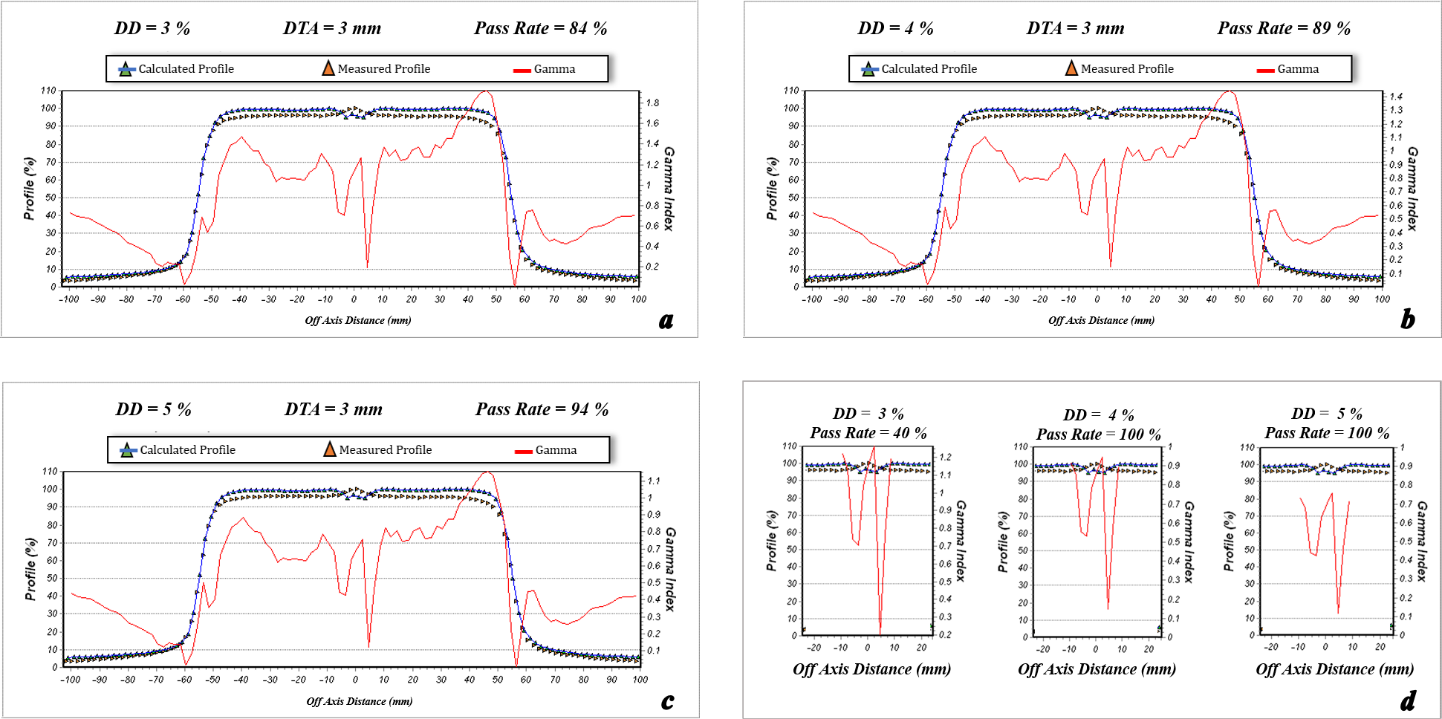
Figure 8. The dose profile data measured by the Farmer chamber and calculated by ISOgray treatment planning system for 10 cm × 10 cm field size, depth of 10 cm, beam angle of 0º, and source to surface distance = 100 cm (test B). Furthermore, the pass rate values of the gamma index analysis for acceptance criteria of dose difference (DD) = 3% and distance to agreement (DTA) =3 mm (a), DD = 4% and DTA =3 mm (b), DD = 5% and DTA =3 mm (c), and the match line regions (d) are shown.
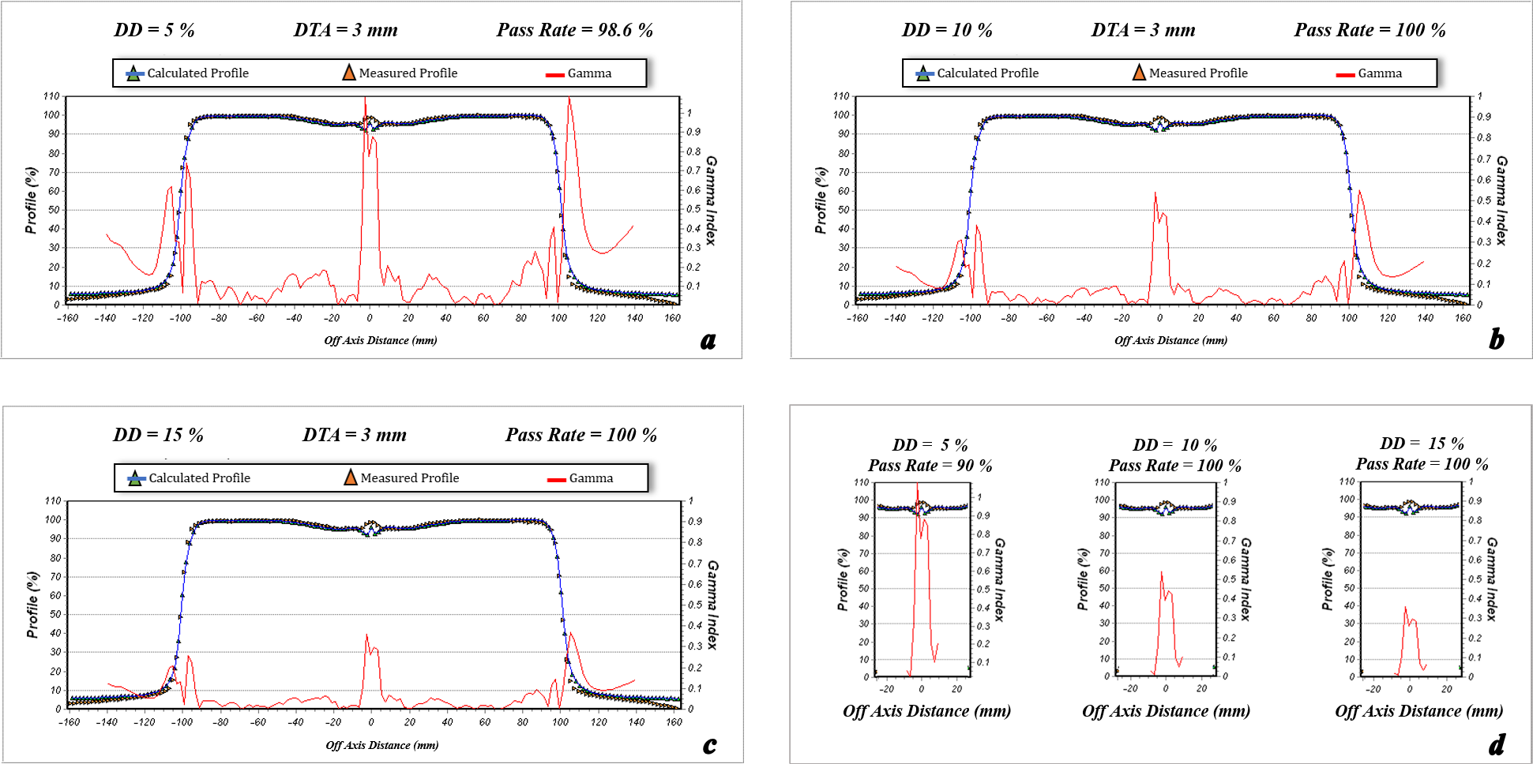
Figure 9. The dose profile data measured by the Farmer chamber and calculated by ISOgray treatment planning system for 20 cm × 20 cm field size, depth of 1 cm, beam angle of 0º, and source to surface distance = 100 cm (test C). Furthermore, the pass rate values of the gamma index analysis for acceptance criteria of dose difference (DD) = 3% and distance to agreement (DTA) =3 mm (a), DD = 4% and DTA =3 mm (b), DD = 5% and DTA =3 mm (c), and the match line regions (d) are shown.
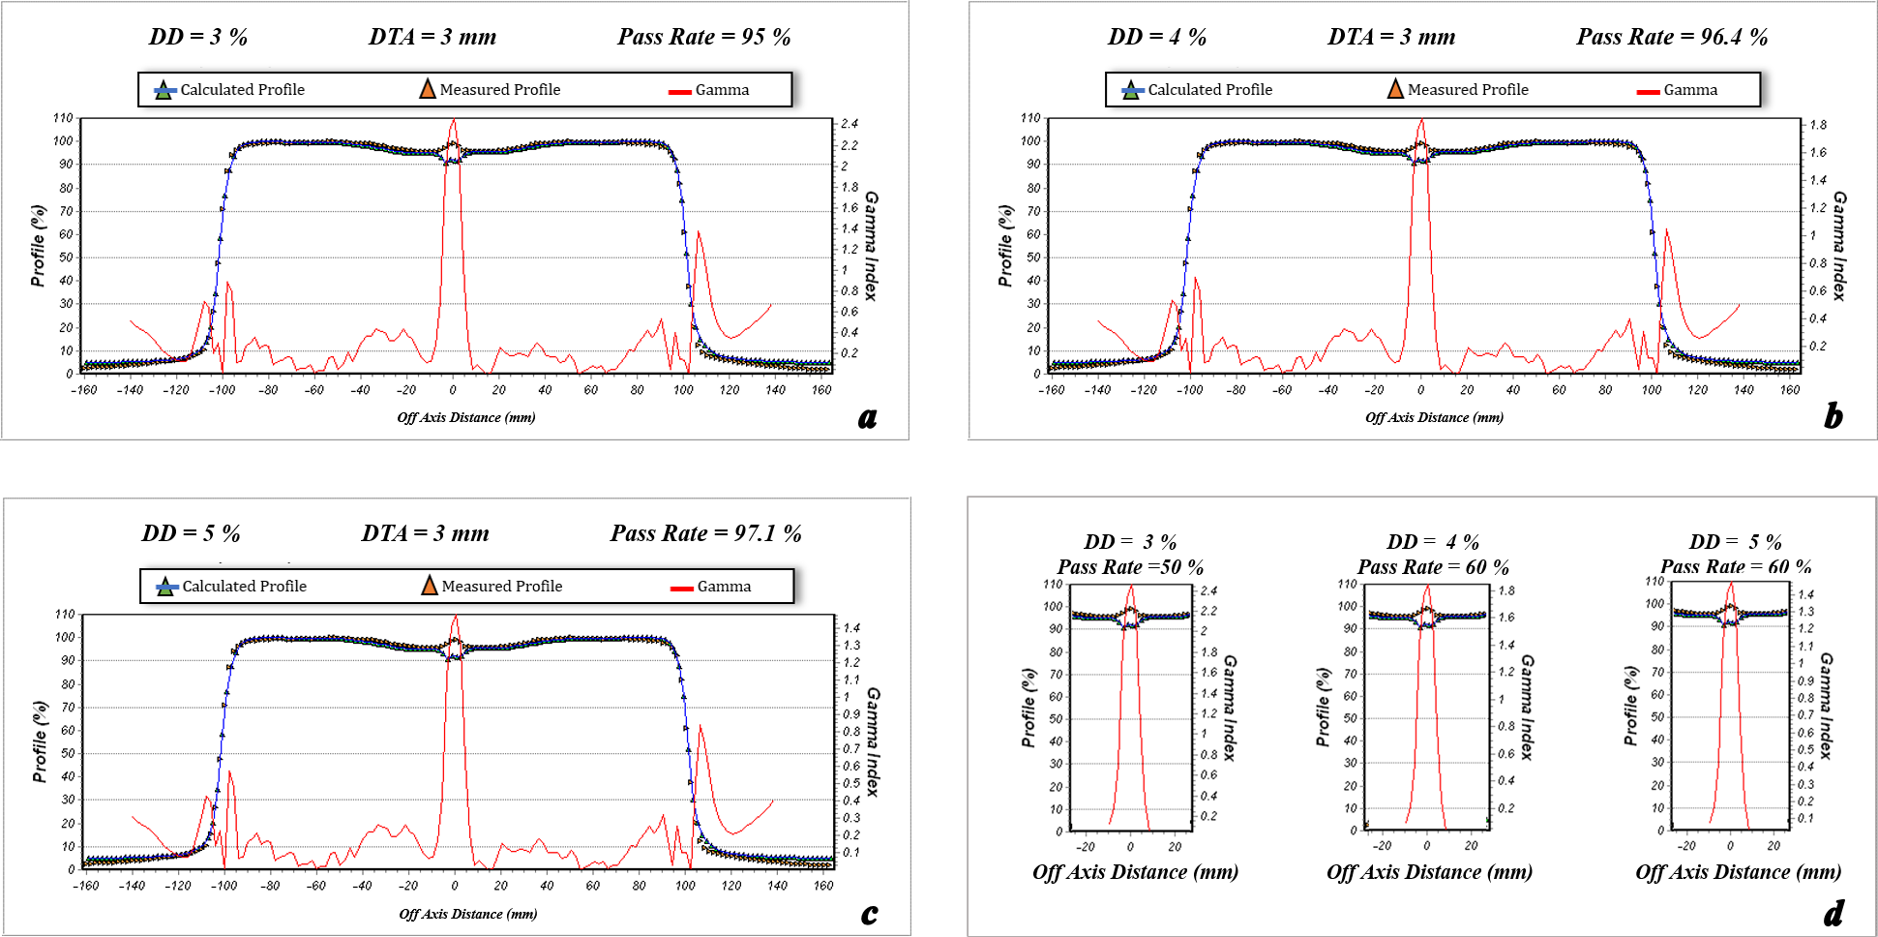
Figure 10. The dose profile data measured by the Farmer chamber and calculated by ISOgray treatment planning system for 20 cm × 20 cm field size, depth of 1.5 cm, beam angle of 0º, and source to surface distance = 100 cm (test C). Furthermore, the pass rate values of the gamma index analysis for acceptance criteria of dose difference (DD) = 3% and distance to agreement (DTA) =3 mm (a), DD = 4% and DTA =3 mm (b), DD = 5% and DTA =3 mm (c), and the match line regions (d) are shown.
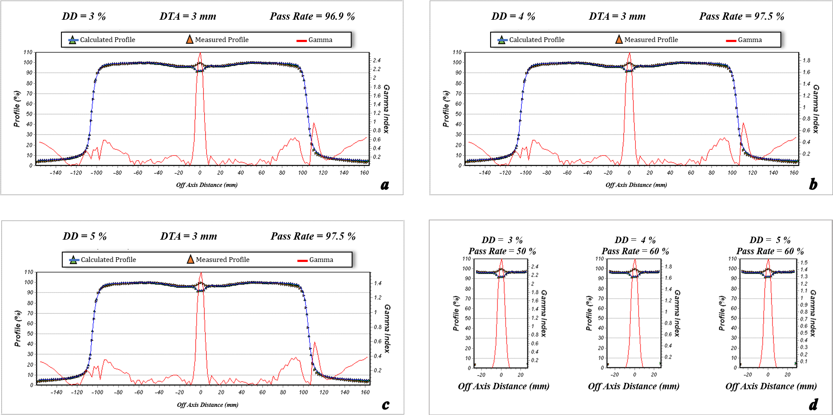
Figure 11. The dose profile data measured by the Farmer chamber and calculated by ISOgray treatment planning system for 20 cm × 20 cm field size, depth of 5 cm, beam angle of 0º, and source to surface distance = 100 cm (test C). Furthermore, the pass rate values of the gamma index analysis for acceptance criteria of dose difference (DD) = 3% and distance to agreement (DTA) =3 mm (a), DD = 4% and DTA =3 mm (b), DD = 5% and DTA =3 mm (c), and the match line regions (d) are shown.
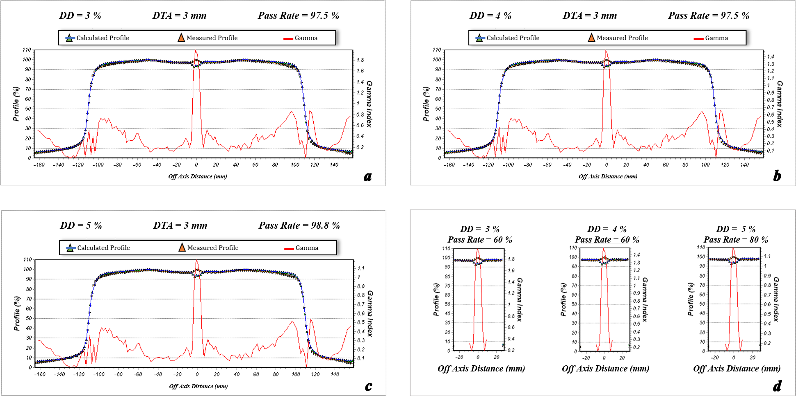
Figure 12. The dose profile data measured by the Farmer chamber and calculated by ISOgray treatment planning system for 20 cm × 20 cm field size, depth of 10 cm, beam angle of 0º, and source to surface distance = 100 cm (test C). Furthermore, the pass rate values of the gamma index analysis for acceptance criteria of dose difference (DD) = 3% and distance to agreement (DTA) =3 mm (a), DD = 4% and DTA =3 mm (b), DD = 5% and DTA =3 mm (c), and the match line regions (d) are shown.

- Evaluating the dose calculation accuracy of ISOgray TPS:
effect of source to surface distance

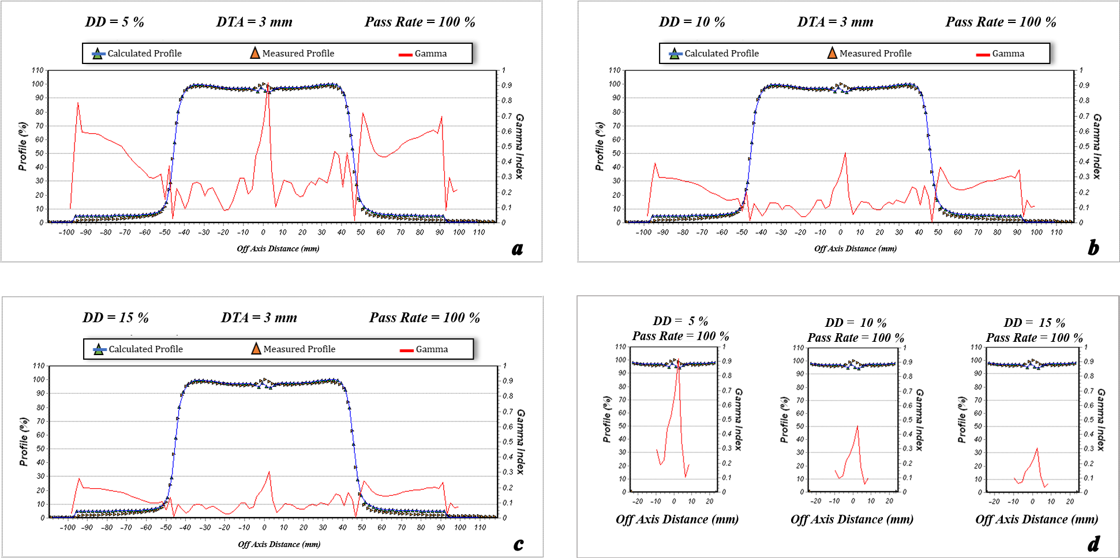
Figure 13. The dose profile data measured by the Farmer chamber and calculated by ISOgray treatment planning system for 10 cm × 10 cm field size, depth of 1 cm, beam angle of 0º, and source to surface distance = 90 cm (test D). Furthermore, the pass rate values of the gamma index analysis for acceptance criteria of dose difference (DD) = 3% and distance to agreement (DTA) =3 mm (a), DD = 4% and DTA =3 mm (b), DD = 5% and DTA =3 mm (c), and the match line regions (d) are shown.
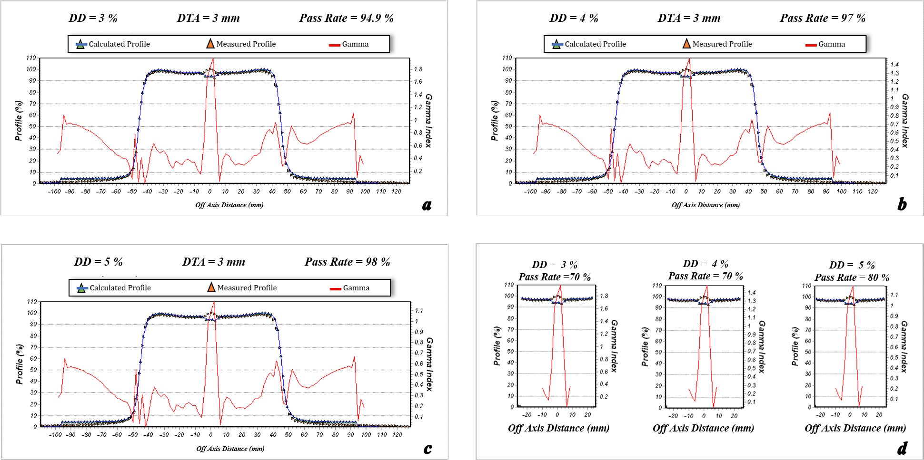
Figure 14. The dose profile data measured by the Farmer chamber and calculated by ISOgray treatment planning system for 10 cm × 10 cm field size, depth of 1.5 cm, beam angle of 0º, and source to surface distance = 90 cm (test D). Furthermore, the pass rate values of the gamma index analysis for acceptance criteria of dose difference (DD) = 3% and distance to agreement (DTA) =3 mm (a), DD = 4% and DTA =3 mm (b), DD = 5% and DTA =3 mm (c), and the match line regions (d) are shown.
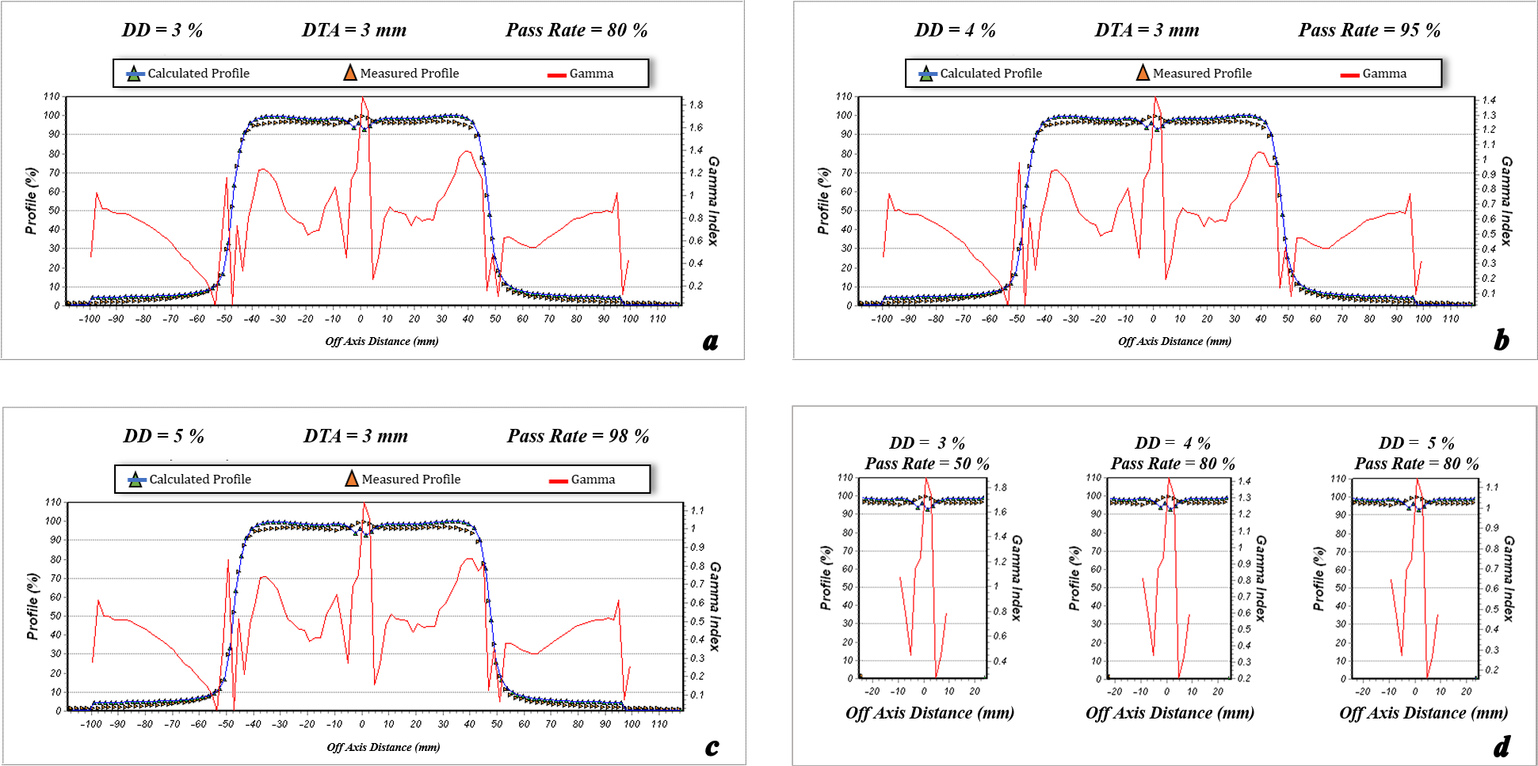
Figure 15. The dose profile data measured by the Farmer chamber and calculated by ISOgray treatment planning system for 10 cm × 10 cm field size, depth of 5 cm, beam angle of 0º, and source to surface distance = 90 cm (test D). Furthermore, the pass rate values of the gamma index analysis for acceptance criteria of dose difference (DD) = 3% and distance to agreement (DTA) =3 mm (a), DD = 4% and DTA =3 mm (b), DD = 5% and DTA =3 mm (c), and the match line regions (d) are shown.
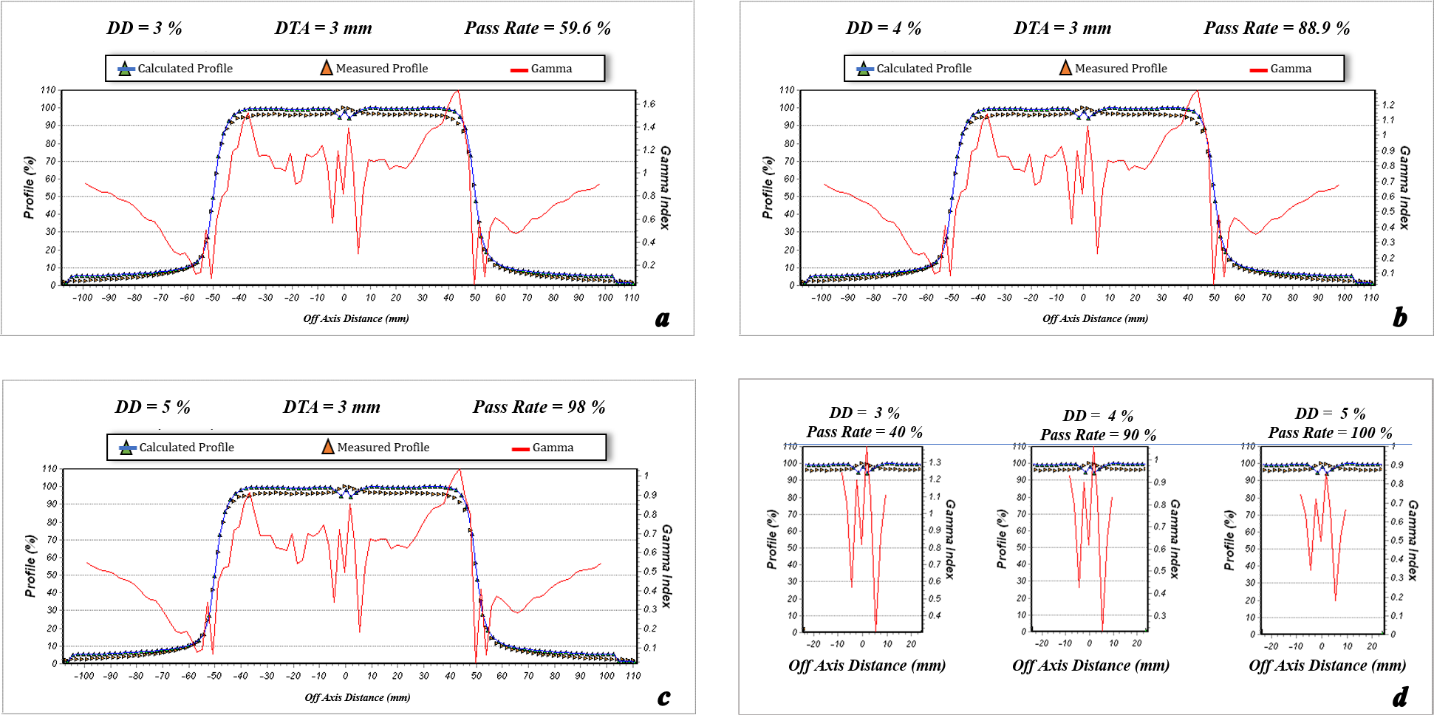
Figure 16. The dose profile data measured by the Farmer chamber and calculated by ISOgray treatment planning system for 10 cm × 10 cm field size, depth of 10 cm, beam angle of 0º, and source to surface distance = 90 cm (test D). Furthermore, the pass rate values of the gamma index analysis for acceptance criteria of dose difference (DD) = 3% and distance to agreement (DTA) =3 mm (a), DD = 4% and DTA =3 mm (b), DD = 5% and DTA =3 mm (c), and the match line regions (d) are shown.
Figure 17. The dose profile data measured by the Farmer chamber and calculated by ISOgray treatment planning system for 10 cm × 10 cm field size, depth of 1 cm, beam angle of 0º, and source to surface distance = 100 cm (test E). Furthermore, the pass rate values of the gamma index analysis for acceptance criteria of dose difference (DD) = 3% and distance to agreement (DTA) =3 mm (a), DD = 4% and DTA =3 mm (b), DD = 5% and DTA =3 mm (c), and the match line regions (d) are shown.
Figure 18. The dose profile data measured by the Farmer chamber and calculated by ISOgray treatment planning system for 10 cm × 10 cm field size, depth of 1.5 cm, beam angle of 0º, and source to surface distance = 100 cm (test E). Furthermore, the pass rate values of the gamma index analysis for acceptance criteria of dose difference (DD) = 3% and distance to agreement (DTA) =3 mm (a), DD = 4% and DTA =3 mm (b), DD = 5% and DTA =3 mm (c), and the match line regions (d) are shown.
Figure 19. The dose profile data measured by the Farmer chamber and calculated by ISOgray treatment planning system for 10 cm × 10 cm field size, depth of 5 cm, beam angle of 0º, and source to surface distance = 100 cm (test E). Furthermore, the pass rate values of the gamma index analysis for acceptance criteria of dose difference (DD) = 3% and distance to agreement (DTA) =3 mm (a), DD = 4% and DTA =3 mm (b), DD = 5% and DTA =3 mm (c), and the match line regions (d) are shown.
Figure 20. The dose profile data measured by the Farmer chamber and calculated by ISOgray treatment planning system for 10 cm × 10 cm field size, depth of 10 cm, beam angle of 0º, and source to surface distance = 100 cm (test E). Furthermore, the pass rate values of the gamma index analysis for acceptance criteria of dose difference (DD) = 3% and distance to agreement (DTA) =3 mm (a), DD = 4% and DTA =3 mm (b), DD = 5% and DTA =3 mm (c), and the match line regions (d) are shown.
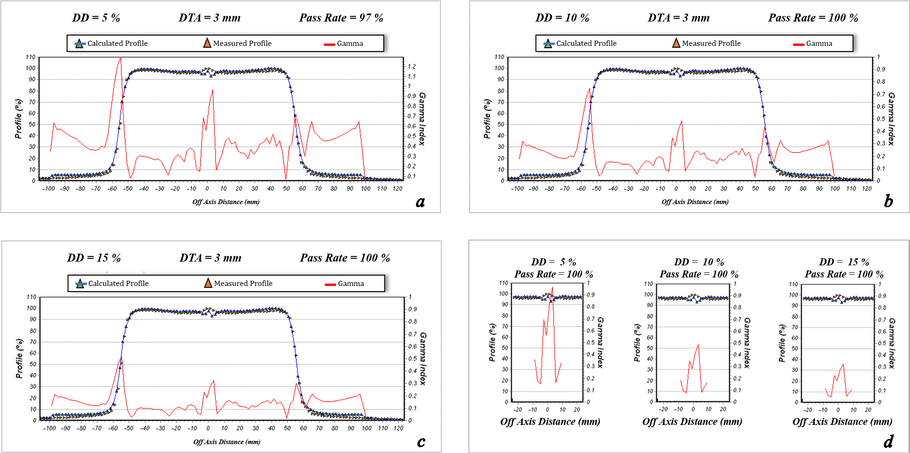
Figure 21. The dose profile data measured by the Farmer chamber and calculated by ISOgray treatment planning system for 10 cm × 10 cm field size, depth of 1 cm, beam angle of 0º, and source to surface distance = 110 cm (test F). Furthermore, the pass rate values of the gamma index analysis for acceptance criteria of dose difference (DD) = 3% and distance to agreement (DTA) =3 mm (a), DD = 4% and DTA =3 mm (b), DD = 5% and DTA =3 mm (c), and the match line regions (d) are shown.
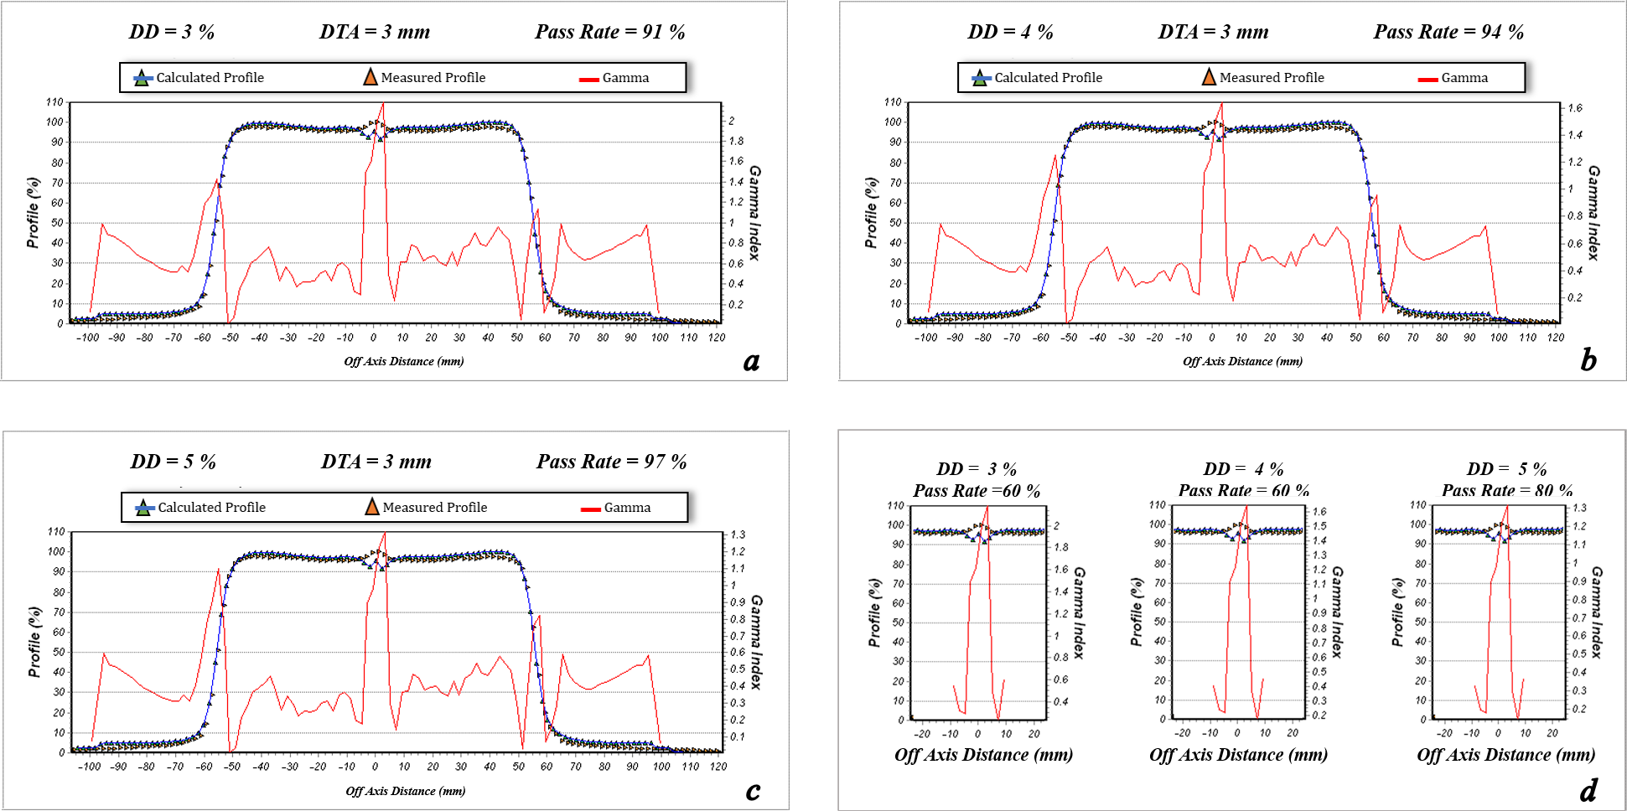
Figure 22. The dose profile data measured by the Farmer chamber and calculated by ISOgray treatment planning system for 10 cm × 10 cm field size, depth of 1.5 cm, beam angle of 0º, and source to surface distance = 110 cm (test F). Furthermore, the pass rate values of the gamma index analysis for acceptance criteria of dose difference (DD) = 3% and distance to agreement (DTA) =3 mm (a), DD = 4% and DTA =3 mm (b), DD = 5% and DTA =3 mm (c), and the match line regions (d) are shown.
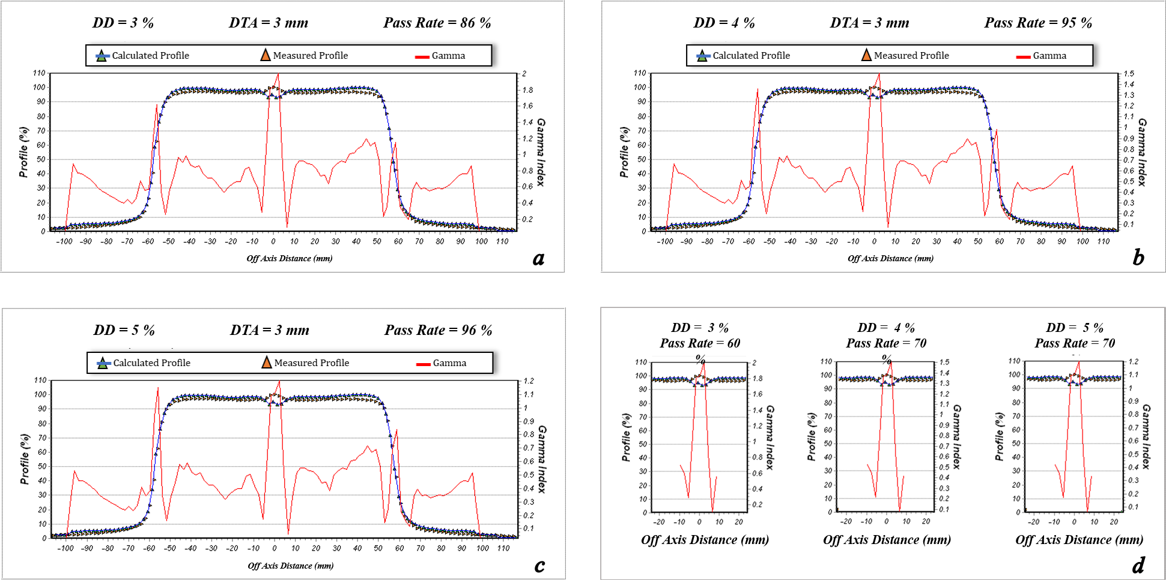
Figure 23. The dose profile data measured by the Farmer chamber and calculated by ISOgray treatment planning system for 10 cm × 10 cm field size, depth of 5 cm, beam angle of 0º, and source to surface distance = 110 cm (test F). Furthermore, the pass rate values of the gamma index analysis for acceptance criteria of dose difference (DD) = 3% and distance to agreement (DTA) =3 mm (a), DD = 4% and DTA =3 mm (b), DD = 5% and DTA =3 mm (c), and the match line regions (d) are shown.
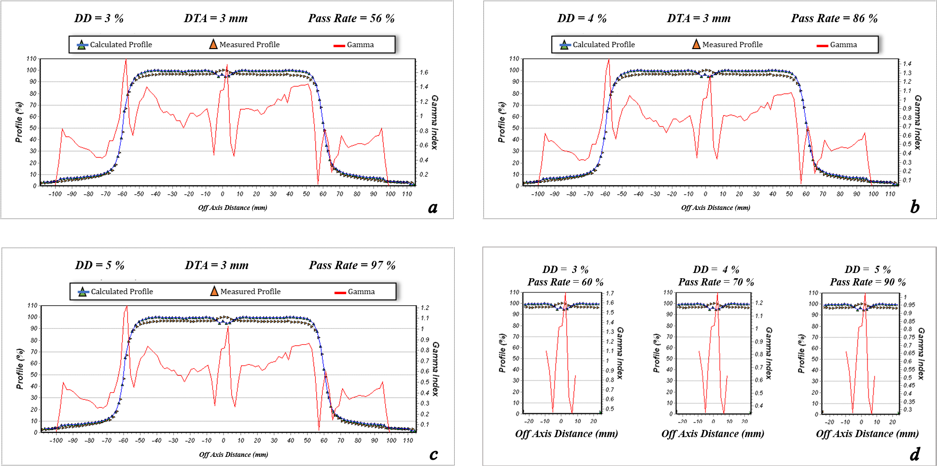
Figure 24. The dose profile data measured by the Farmer chamber and calculated by ISOgray treatment planning system for 10 cm × 10 cm field size, depth of 10 cm, beam angle of 0º, and source to surface distance = 110 cm (test F). Furthermore, the pass rate values of the gamma index analysis for acceptance criteria of dose difference (DD) = 3% and distance to agreement (DTA) =3 mm (a), DD = 4% and DTA =3 mm (b), DD = 5% and DTA =3 mm (c), and the match line regions (d) are shown.

- Evaluating the dose calculation accuracy of ISOgray TPS:
effect of beam angle

Figure 25. The dose profile data measured by the Farmer chamber and calculated by ISOgray treatment planning system for 10 cm × 10 cm field size, depth of 1 cm, beam angle of 0º, and source to surface distance = 100 cm (test G). Furthermore, the pass rate values of the gamma index analysis for acceptance criteria of dose difference (DD) = 3% and distance to agreement (DTA) =3 mm (a), DD = 4% and DTA =3 mm (b), DD = 5% and DTA =3 mm (c), and the match line regions (d) are shown.
Figure 26. The dose profile data measured by the Farmer chamber and calculated by ISOgray treatment planning system for 10 cm × 10 cm field size, depth of 1.5 cm, beam angle of 0º, and source to surface distance = 100 cm (test G). Furthermore, the pass rate values of the gamma index analysis for acceptance criteria of dose difference (DD) = 3% and distance to agreement (DTA) =3 mm (a), DD = 4% and DTA =3 mm (b), DD = 5% and DTA =3 mm (c), and the match line regions (d) are shown.
Figure 27. The dose profile data measured by the Farmer chamber and calculated by ISOgray treatment planning system for 10 cm × 10 cm field size, depth of 5 cm, beam angle of 0º, and source to surface distance = 100 cm (test G). Furthermore, the pass rate values of the gamma index analysis for acceptance criteria of dose difference (DD) = 3% and distance to agreement (DTA) =3 mm (a), DD = 4% and DTA =3 mm (b), DD = 5% and DTA =3 mm (c), and the match line regions (d) are shown.
Figure 28. The dose profile data measured by the Farmer chamber and calculated by ISOgray treatment planning system for 10 cm × 10 cm field size, depth of 10 cm, beam angle of 0º, and source to surface distance = 100 cm (test G). Furthermore, the pass rate values of the gamma index analysis for acceptance criteria of dose difference (DD) = 3% and distance to agreement (DTA) =3 mm (a), DD = 4% and DTA =3 mm (b), DD = 5% and DTA =3 mm (c), and the match line regions (d) are shown.
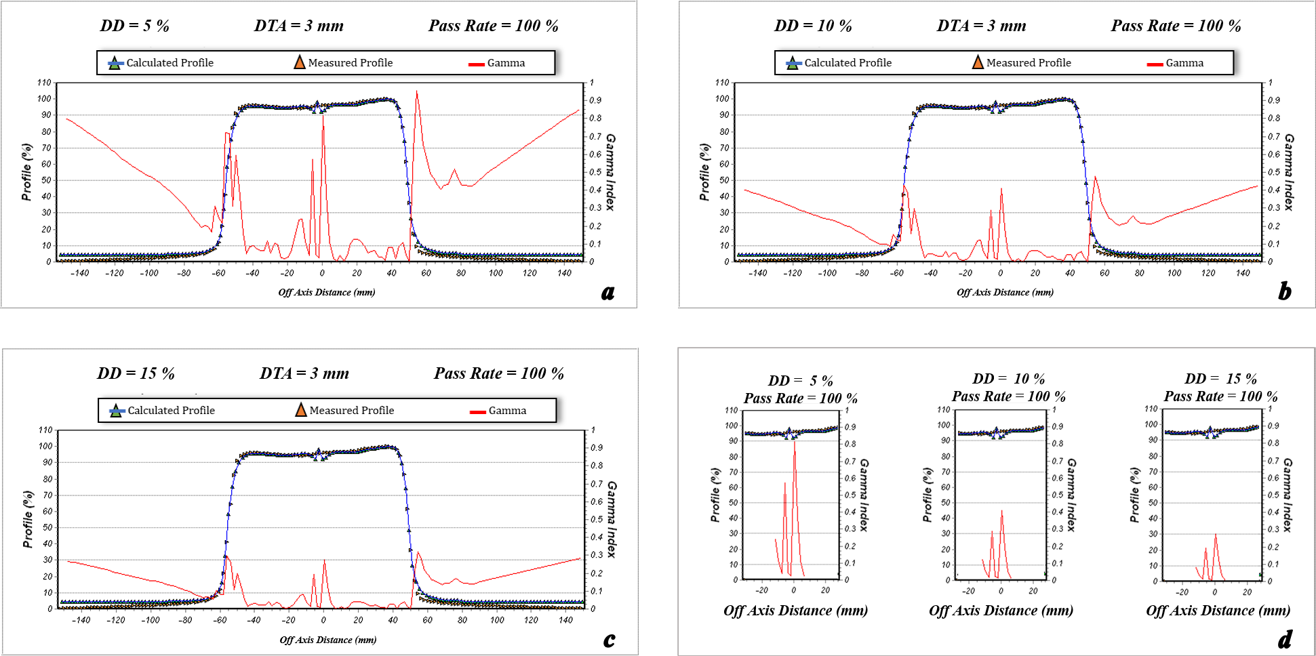
Figure 29. The dose profile data measured by the Farmer chamber and calculated by ISOgray treatment planning system for 10 cm × 10 cm field size, depth of 1 cm, beam angle of 15º, and source to surface distance = 100 cm (test H). Furthermore, the pass rate values of the gamma index analysis for acceptance criteria of dose difference (DD) = 3% and distance to agreement (DTA) =3 mm (a), DD = 4% and DTA =3 mm (b), DD = 5% and DTA =3 mm (c), and the match line regions (d) are shown.
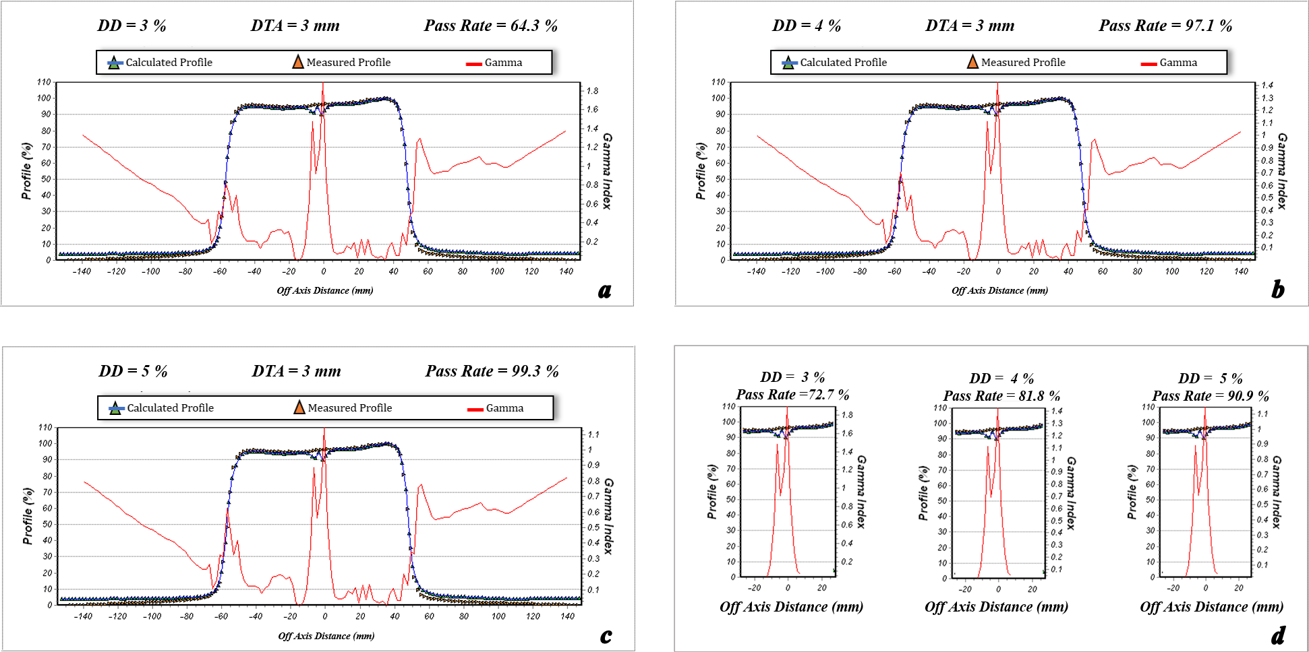
Figure 30. The dose profile data measured by the Farmer chamber and calculated by ISOgray treatment planning system for 10 cm × 10 cm field size, depth of 1.5 cm, beam angle of 15º, and source to surface distance = 100 cm (test H). Furthermore, the pass rate values of the gamma index analysis for acceptance criteria of dose difference (DD) = 3% and distance to agreement (DTA) =3 mm (a), DD = 4% and DTA =3 mm (b), DD = 5% and DTA =3 mm (c), and the match line regions (d) are shown.
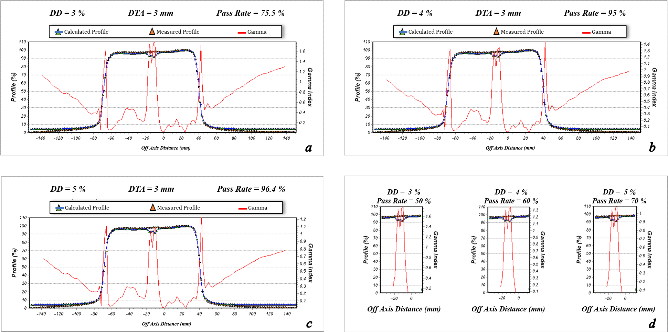
Figure 31. The dose profile data measured by the Farmer chamber and calculated by ISOgray treatment planning system for 10 cm × 10 cm field size, depth of 5 cm, beam angle of 15º, and source to surface distance = 100 cm (test H). Furthermore, the pass rate values of the gamma index analysis for acceptance criteria of dose difference (DD) = 3% and distance to agreement (DTA) =3 mm (a), DD = 4% and DTA =3 mm (b), DD = 5% and DTA =3 mm (c), and the match line regions (d) are shown.
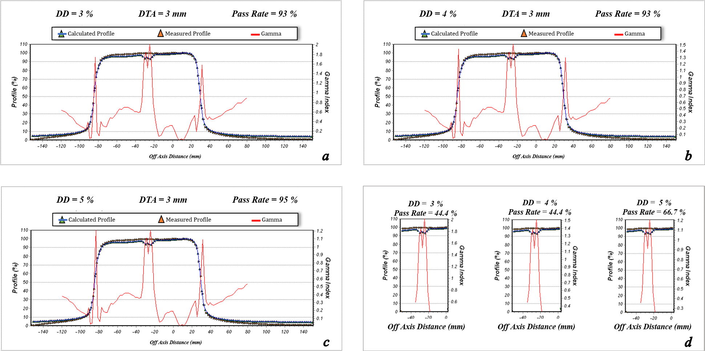
Figure 32. The dose profile data measured by the Farmer chamber and calculated by ISOgray treatment planning system for 10 cm × 10 cm field size, depth of 10 cm, beam angle of 15º, and source to surface distance = 100 cm (test H). Furthermore, the pass rate values of the gamma index analysis for acceptance criteria of dose difference (DD) = 3% and distance to agreement (DTA) =3 mm (a), DD = 4% and DTA =3 mm (b), DD = 5% and DTA =3 mm (c), and the match line regions (d) are shown.
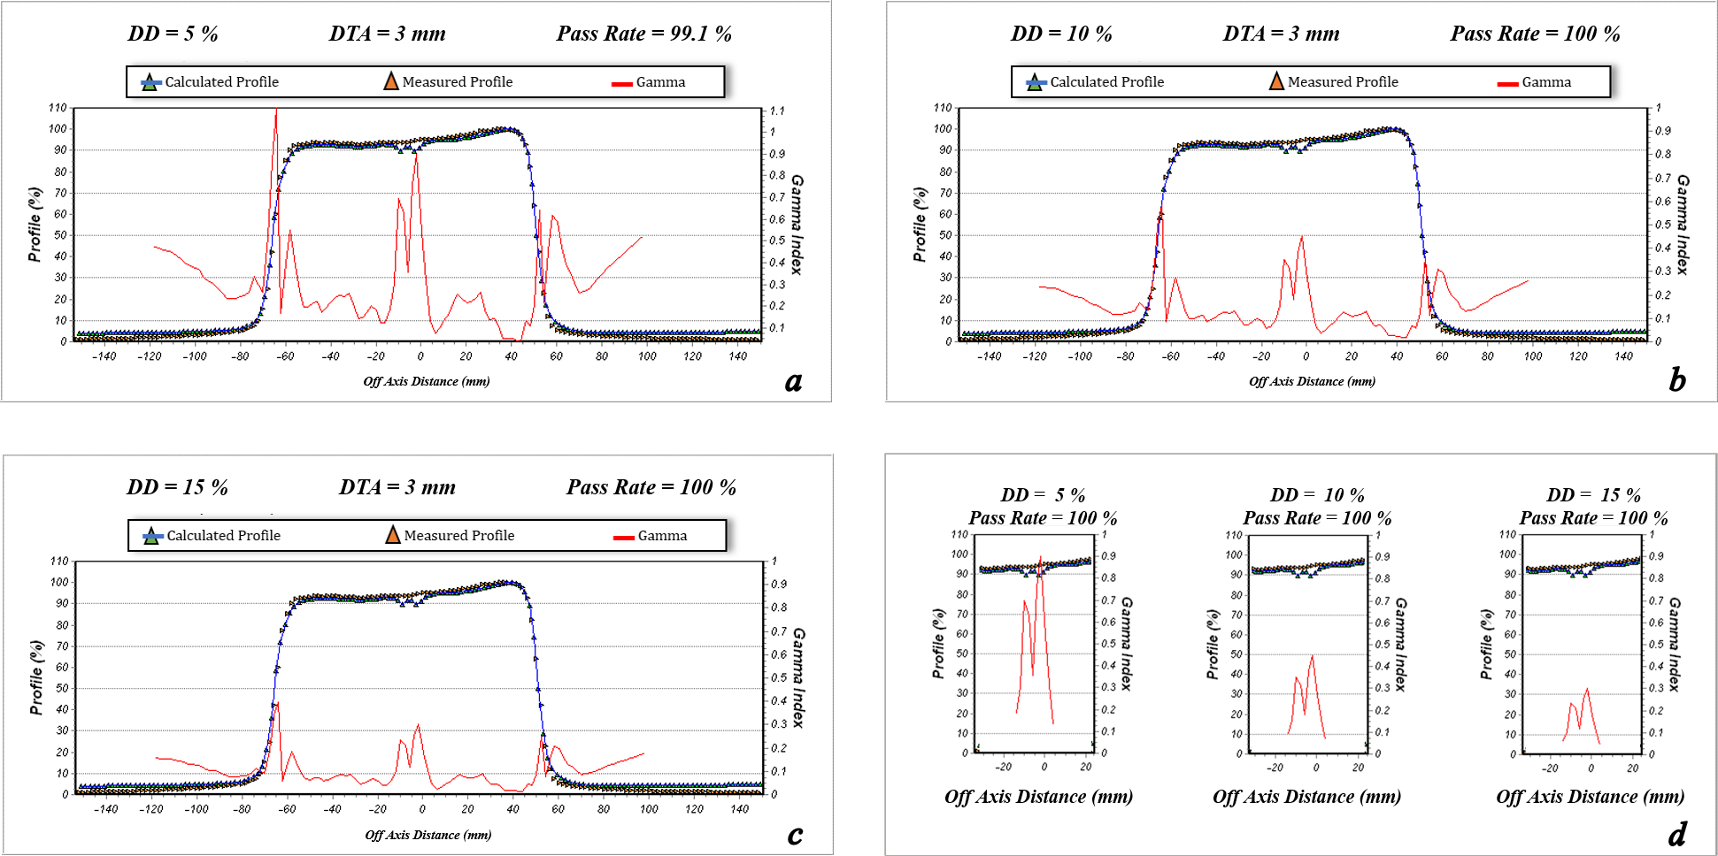
Figure 33. The dose profile data measured by the Farmer chamber and calculated by ISOgray treatment planning system for 10 cm × 10 cm field size, depth of 1 cm, beam angle of 30º, and source to surface distance = 100 cm (test I). Furthermore, the pass rate values of the gamma index analysis for acceptance criteria of dose difference (DD) = 3% and distance to agreement (DTA) =3 mm (a), DD = 4% and DTA =3 mm (b), DD = 5% and DTA =3 mm (c), and the match line regions (d) are shown.
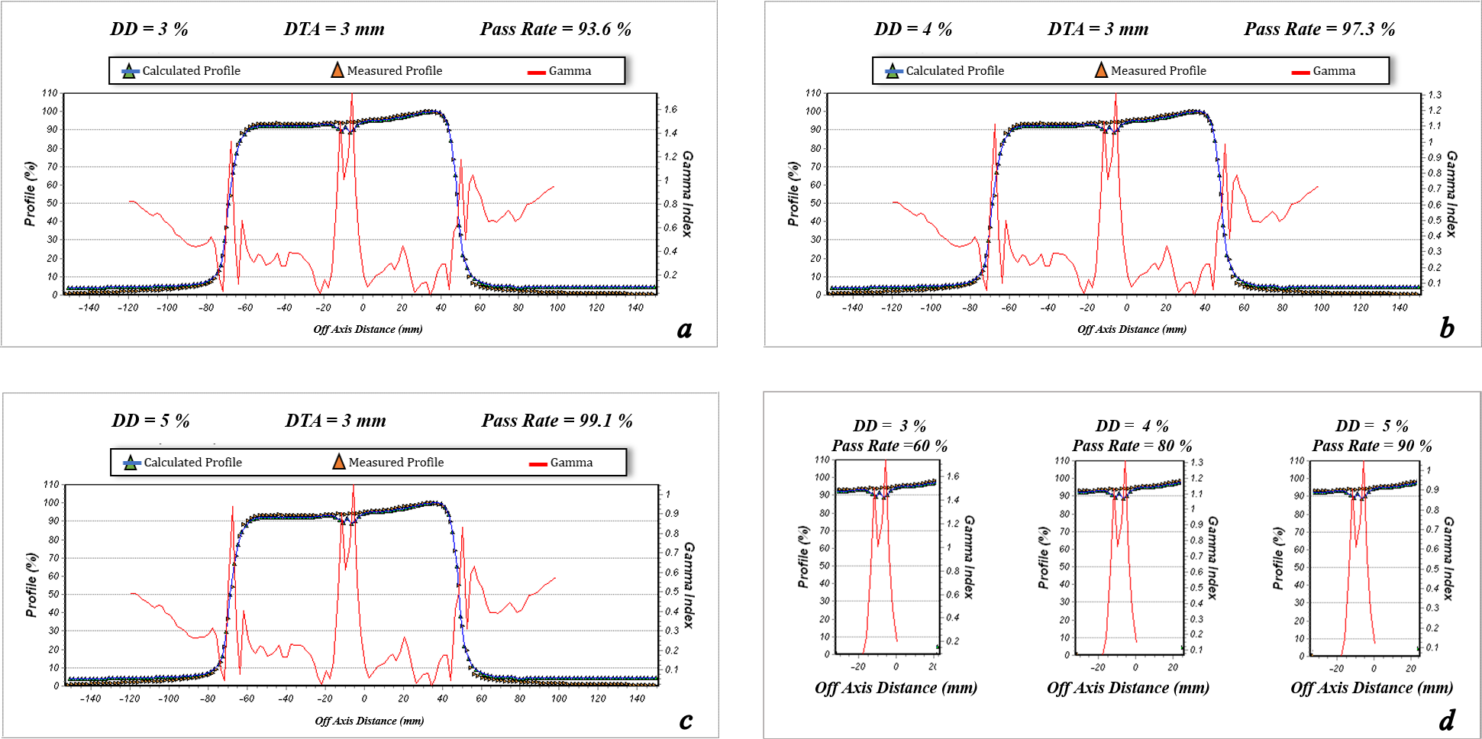
Figure 34. The dose profile data measured by the Farmer chamber and calculated by ISOgray treatment planning system for 10 cm × 10 cm field size, depth of 1.5 cm, beam angle of 30º, and source to surface distance = 100 cm (test I). Furthermore, the pass rate values of the gamma index analysis for acceptance criteria of dose difference (DD) = 3% and distance to agreement (DTA) =3 mm (a), DD = 4% and DTA =3 mm (b), DD = 5% and DTA =3 mm (c), and the match line regions (d) are shown.
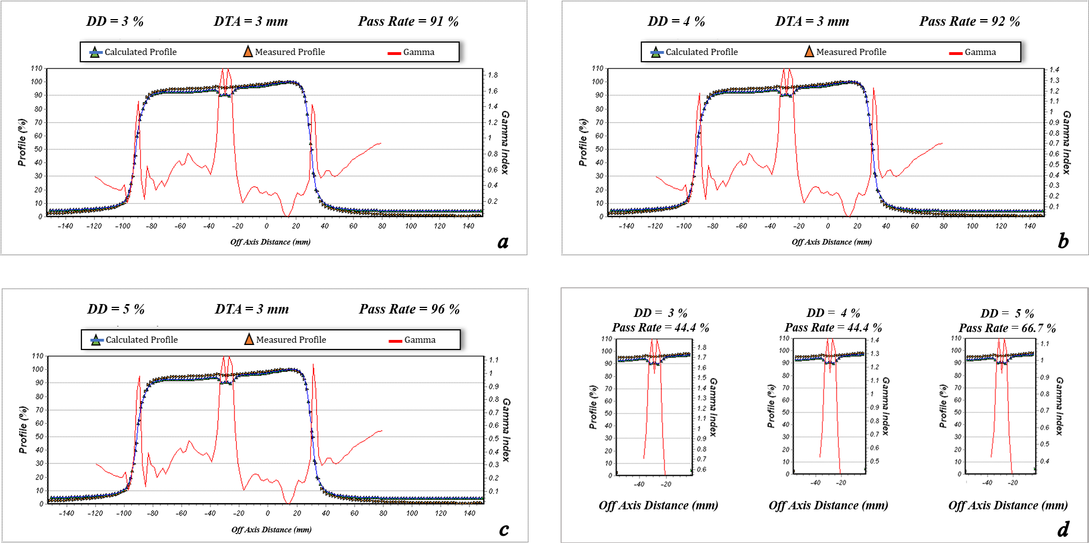
Figure 35. The dose profile data measured by the Farmer chamber and calculated by ISOgray treatment planning system for 10 cm × 10 cm field size, depth of 5 cm, beam angle of 30º, and source to surface distance = 100 cm (test I). Furthermore, the pass rate values of the gamma index analysis for acceptance criteria of dose difference (DD) = 3% and distance to agreement (DTA) =3 mm (a), DD = 4% and DTA =3 mm (b), DD = 5% and DTA =3 mm (c), and the match line regions (d) are shown.
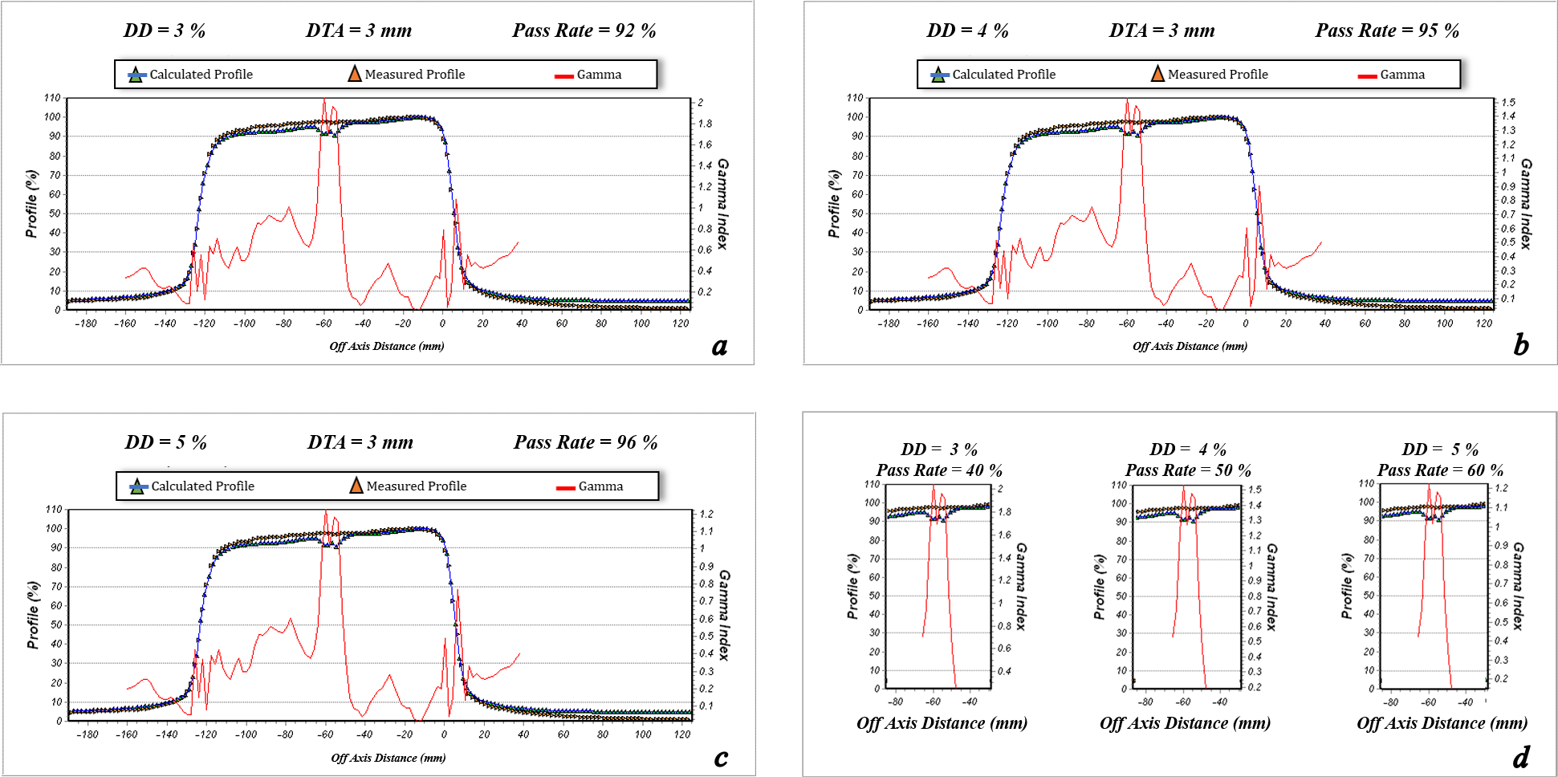
Figure 36. The dose profile data measured by the Farmer chamber and calculated by ISOgray treatment planning system for 10 cm × 10 cm field size, depth of 10 cm, beam angle of 30º, and source to surface distance = 100 cm (test I). Furthermore, the pass rate values of the gamma index analysis for acceptance criteria of dose difference (DD) = 3% and distance to agreement (DTA) =3 mm (a), DD = 4% and DTA =3 mm (b), DD = 5% and DTA =3 mm (c), and the match line regions (d) are shown.
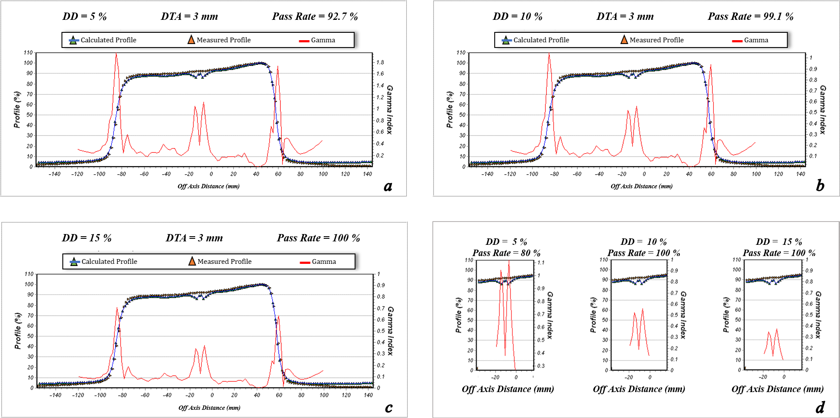
Figure 37. The dose profile data measured by the Farmer chamber and calculated by ISOgray treatment planning system for 10 cm × 10 cm field size, depth of 1 cm, beam angle of 45º, and source to surface distance = 100 cm (test J). Furthermore, the pass rate values of the gamma index analysis for acceptance criteria of dose difference (DD) = 3% and distance to agreement (DTA) =3 mm (a), DD = 4% and DTA =3 mm (b), DD = 5% and DTA =3 mm (c), and the match line regions (d) are shown.
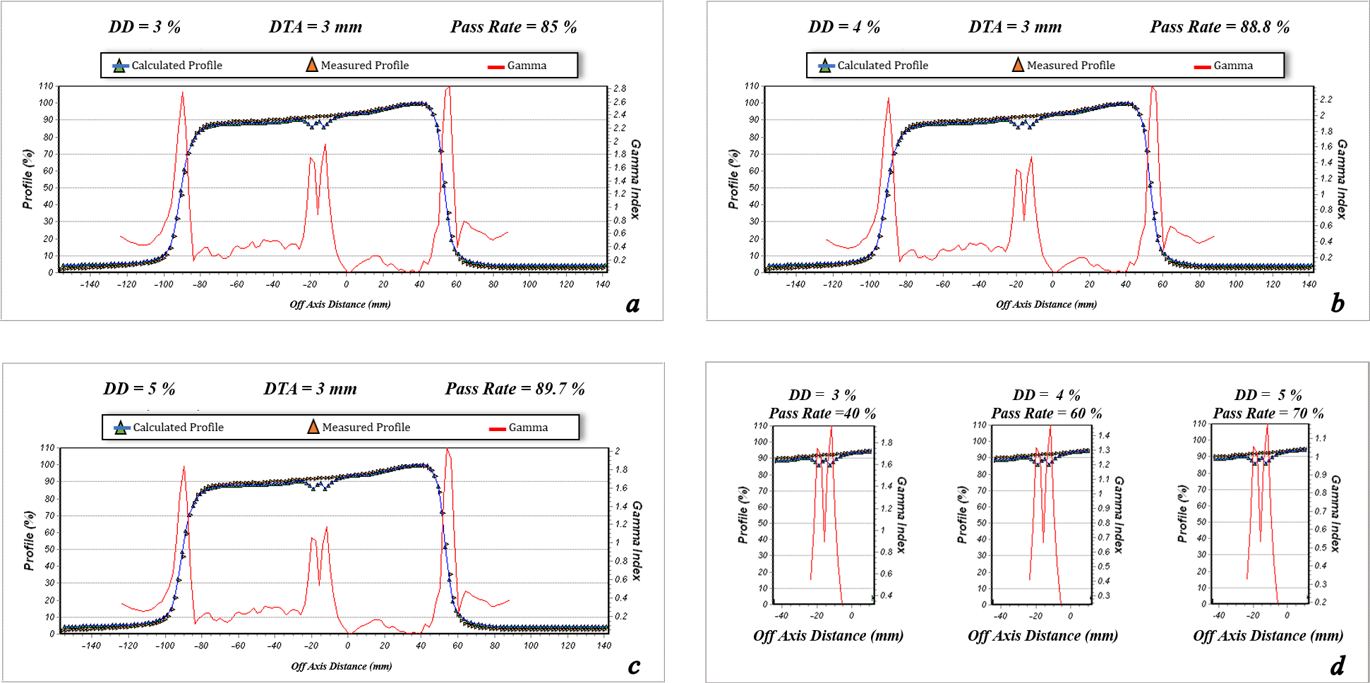
Figure 38. The dose profile data measured by the Farmer chamber and calculated by ISOgray treatment planning system for 10 cm × 10 cm field size, depth of 1.5 cm, beam angle of 45º, and source to surface distance = 100 cm (test J). Furthermore, the pass rate values of the gamma index analysis for acceptance criteria of dose difference (DD) = 3% and distance to agreement (DTA) =3 mm (a), DD = 4% and DTA =3 mm (b), DD = 5% and DTA =3 mm (c), and the match line regions (d) are shown.
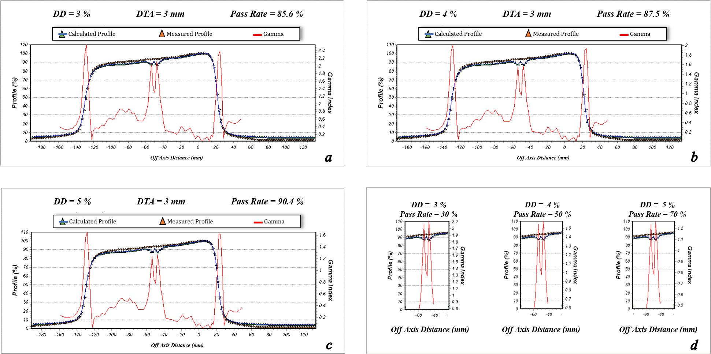
Figure 39. The dose profile data measured by the Farmer chamber and calculated by ISOgray treatment planning system for 10 cm × 10 cm field size, depth of 5 cm, beam angle of 45º, and source to surface distance = 100 cm (test J). Furthermore, the pass rate values of the gamma index analysis for acceptance criteria of dose difference (DD) = 3% and distance to agreement (DTA) =3 mm (a), DD = 4% and DTA =3 mm (b), DD = 5% and DTA =3 mm (c), and the match line regions (d) are shown.
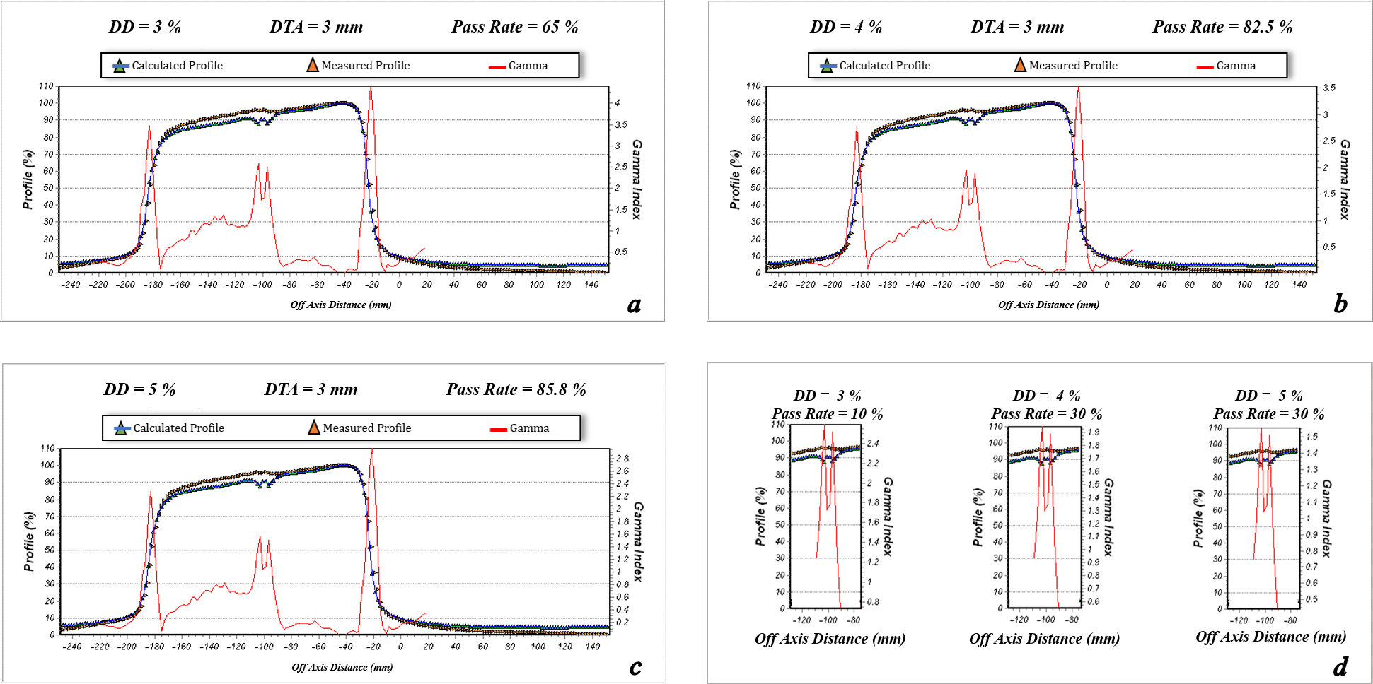
Figure 40. The dose profile data measured by the Farmer chamber and calculated by ISOgray treatment planning system for 10 cm × 10 cm field size, depth of 10 cm, beam angle of 45º, and source to surface distance = 100 cm (test J). Furthermore, the pass rate values of the gamma index analysis for acceptance criteria of dose difference (DD) = 3% and distance to agreement (DTA) =3 mm (a), DD = 4% and DTA =3 mm (b), DD = 5% and DTA =3 mm (c), and the match line regions (d) are shown.

