Supplementary Material:

Figures

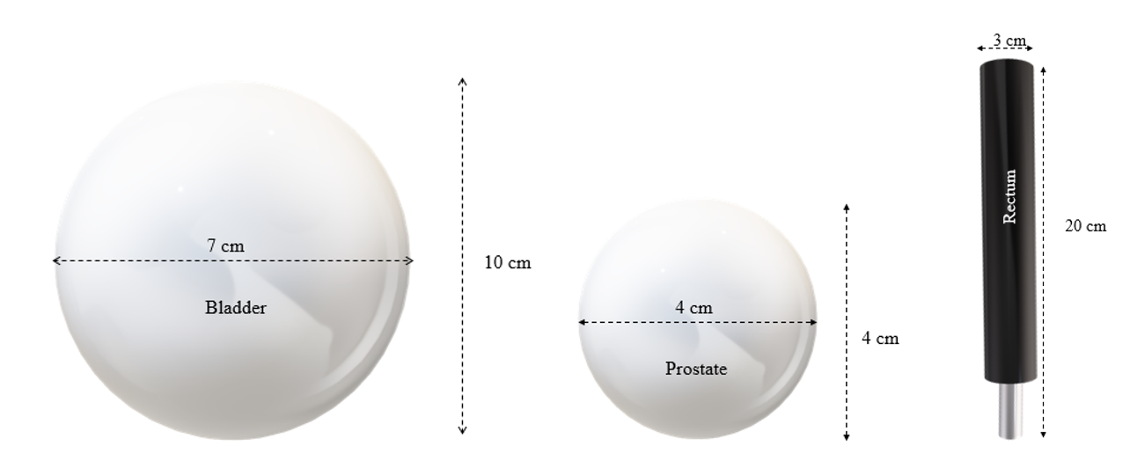
Fig A1. Measurement of pelvis organ constructed in this study (a) bladder (Lurie et al., 2014), (b) prostate (Zhang et al., 2013)and (c) rectum (Williams, Kenyon and Adamson, 2010).

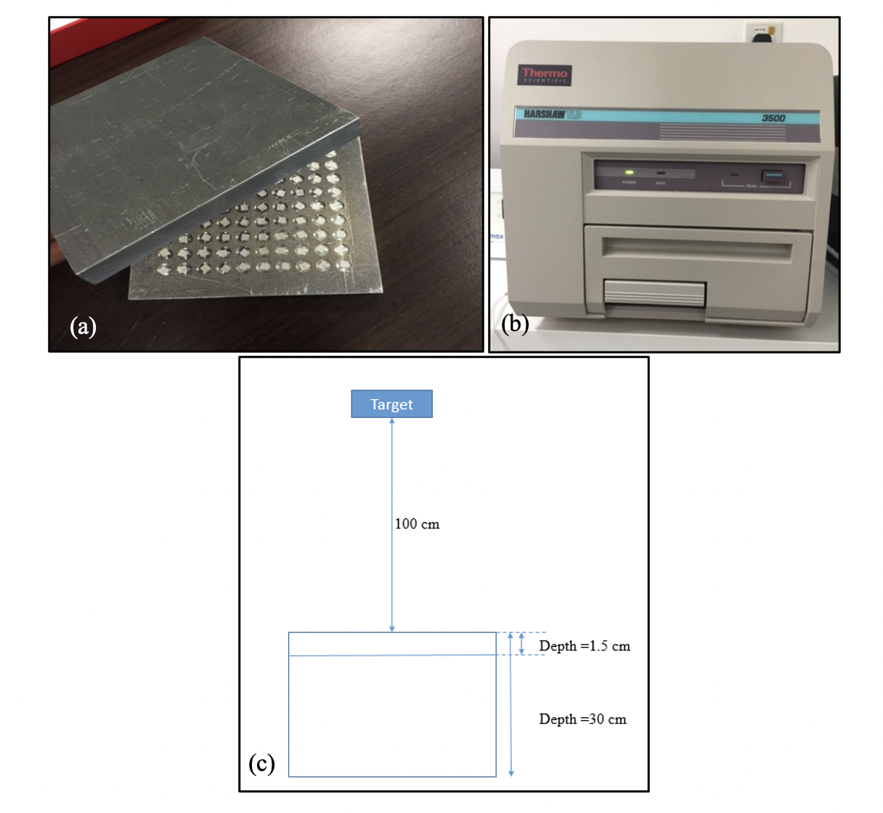

Fig A2. (a) 30 TLD-100 chips in a holder used during annealing procedure, (b) Harshaw reader for TLD-100 in Radiotherapy department, IPPT, USM, (c) Calibration of the TLD chips positioned at the depth 1.5 cm on the solid water phantom (PMMA).

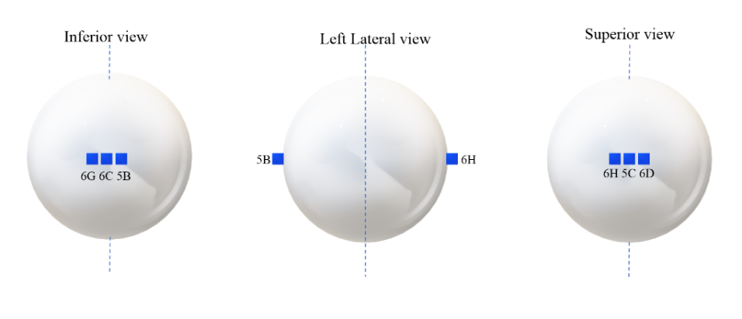
Fig A3. TLD-100 position on prostate, where three TLD-100 chips were positioned on the inferior view (6G, 6C, 5B) and another three TLD-100 chips were on the superior view (6H, 5C, 6D).

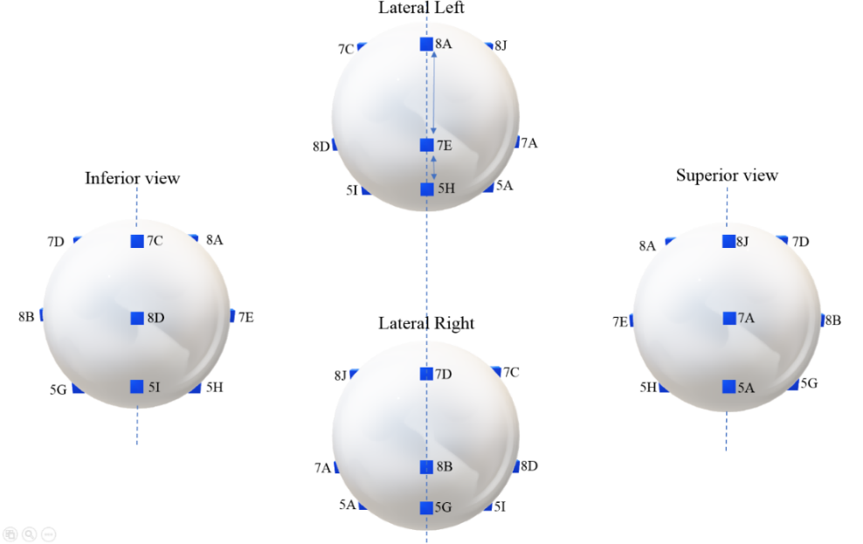
Fig A4. TLD-100 position on bladder consists of three TLD-100 chips on the superior (8J, 7A, 5A), three TLD-100 chips on the inferior (7C, 8D, 5I), three TLD-100s on the left lateral (8A, 7E, 5H) and three TLD-100 chips on the right lateral (7D, 8B, 5G).

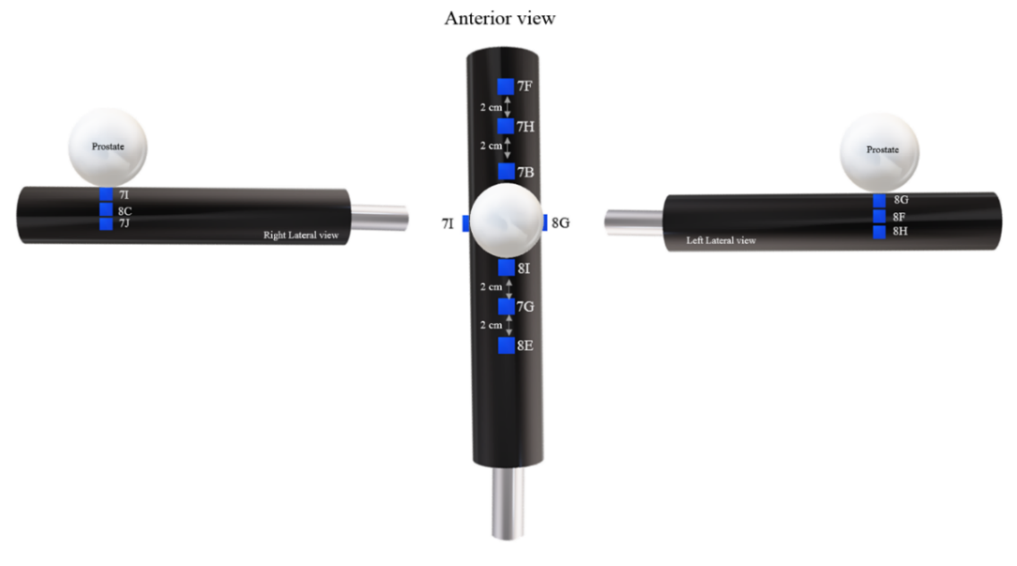
Fig A5. Six TLD-100 positioned on the anterior view (7F, 7H, 7B, 8I, 7G, 8E); three TLD-100 on right lateral (7I, 8C, 7J) and three TLD-100s on the left lateral (8G, 8F, 8H) in the rectum model.

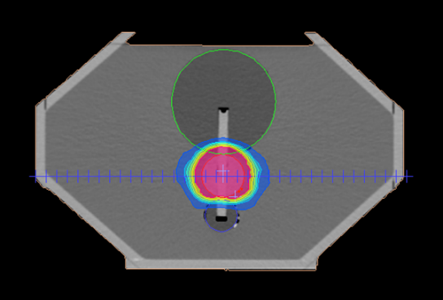
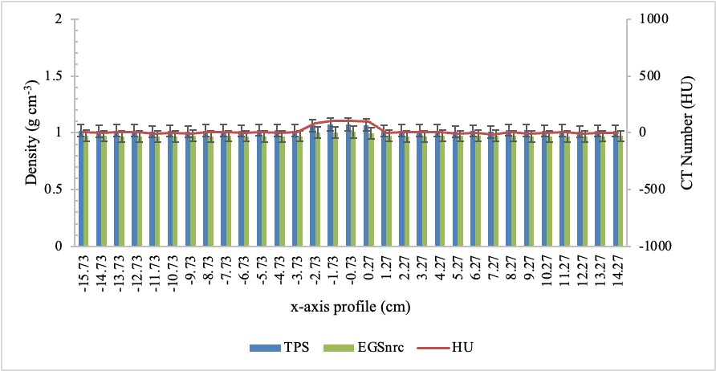
Fig A6. Density was analyzed along X-axis profile for the CT image in TPS and EGSnrc. CT number (HU) was plotted from the TPS. The CT number hike at the middle of the x-axis profile defines the prostate position in the phantom. The error bar indicates ± 5% percentage difference.

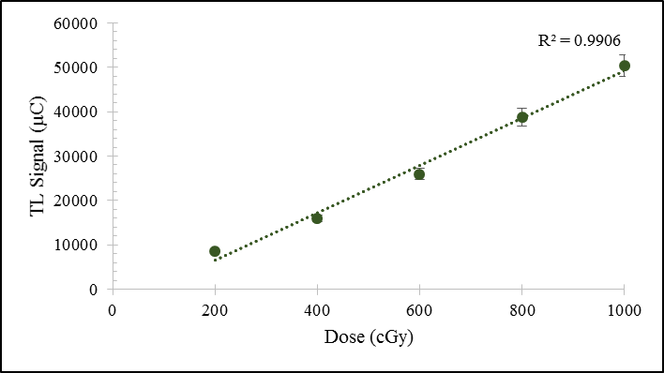
Figure A7. Calibration curve of TLD-100

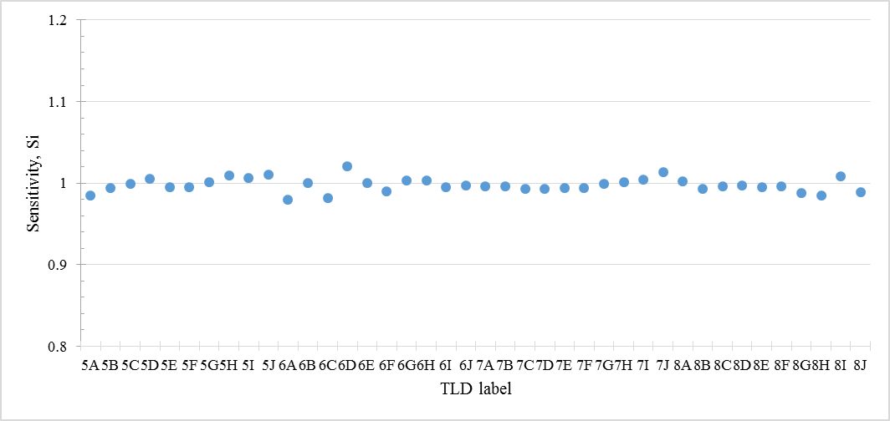
Figure A8. Individual sensitivity correction factor for all 40 TLD-100 chips

Table A1 . CT number and density range for materials used in the “.egsphant” file format
Medium | CT Number Intervals  (HU) | Density Intervals  (g cm⁻³)
AIR700ICRU | -2048: -484 | 0.001: 0.302
H20700ICRU | -484: 101 | 0.302: 1.131

Formulae:

Eq 1:
$S_{i}= \frac{R_{i}}{\overline{R}}$

S_{i} expresses the response variation of each individual dosimeter around the mean

$R_{i}$is the thermoluminescent response

$\overline{R}$ is the mean of the responses of all TLD-100 chips

Eq 2:

$$CI= \frac{V_{95\%}}{Volume of PTV}$$

V_{95%} is the volume of PTV covered by at least 95% of the prescribed dose

Eq 3:

$HI= \frac{D_{2\%}- D_{98\%}}{D_{50\%}}$

D_{2%}, D_{98%}, and D_{50%} are the received dose by 2%, 98%, and 50% of the target volume

Eq 4:

$\text{Percentage Change(\%) }\text{= }\frac{{\text{D}}_{\text{calc}}\text{- }{\text{D}}_{\text{meas}}}{{\text{D}}_{\text{meas}}}\text{ x 100\%}$

D_{calc} referred to the calculation doses in the TPS and MC
D_{meas} referred to the TLD-100 chips measurement

