Supplementary files

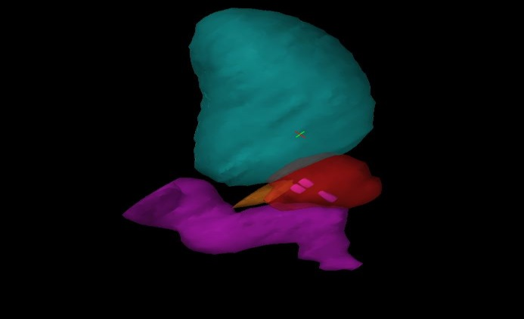

Figure 1 : Distribution of FM within the prostate. Displayed are rectum, bladder, prostate, seminal vesicles and the three fiducial markers inside the prostate.

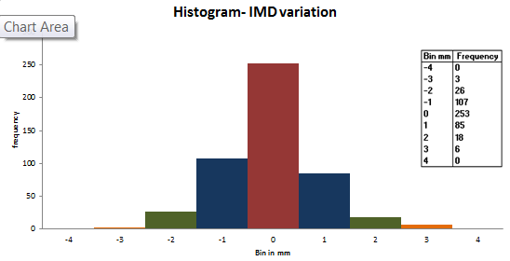
Figure 2: Histograms of IMD variations (mm)between fiducial markers (FM)in RL, AP & SI direction and as a whole. The range is set the same on the RL,AP, SI to allow visual comparison of the distributions. Stage1 Method1.

.

Fig3: Histogram- residual seed mismatch after seed (FM) match. X axis is in mm. The range is set the same on the RL,AP SI to allow visual comparison of the distributions. Stage1 Method2.

Fig4: Histogram – Prostate anatomy variation with respect to seeds. The X axis is in mm. The range is set the same on the RL,AP SI to allow visual comparison of the distributions.Stag2 study.

 | RL (mm) | AP(mm) | SI (mm)
Systematic Component (∑ setup ) | 0.40 | 0.63 | 0.80
Random Component (σ setup) | 0.41 | 0.59 | 1.04
Table 1 : Systematic and random components calculated for inter fractional FM localisation- method2 of stage1.

 | RL (mm) | AP(mm) | SI (mm)
SYS Component ( ∑ anatomy) | 0.65 | 1.27 | 1.32
Random Component (σ anatomy) | 0.74 | 1.25 | 1.57
Table 2 : Systematic and random components calculated for inter fractional prostate deformation -stage2 study.

The combined systematic error ∑² = ∑ _{setup} ² + ∑ _{anatomy} ² and the random error σ² = σ _{setup}² + σ _{anatomy} ²

