Figure S1: Representation of the estimated marginal means of LMI, LMII, VMI, VMII over time

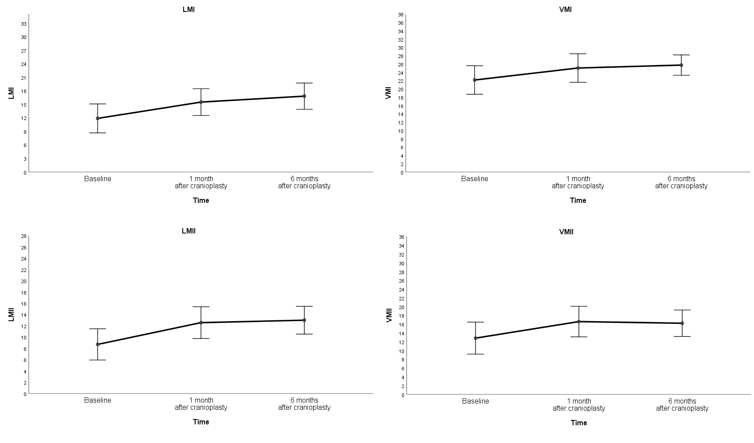

Figure S2: Representation of the estimated marginal means of measures A1, A2, A4, A5, A7 in the RAVLT (n = 34)
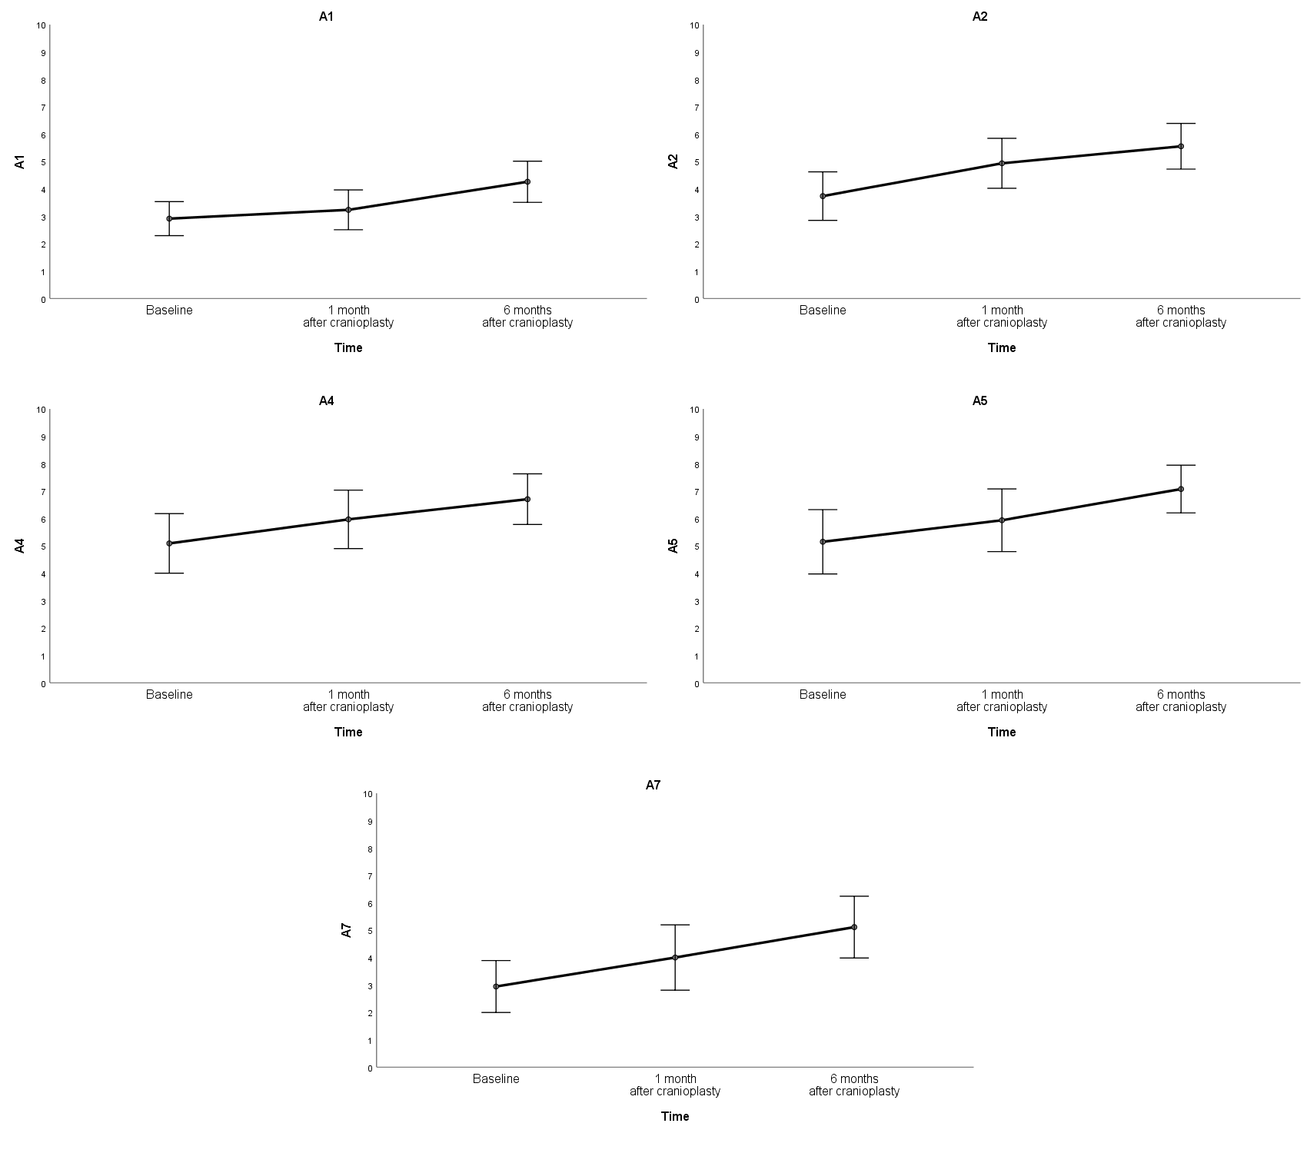

Figure S3: Estimated marginal means of phonemic and semantic verbal fluency measures.
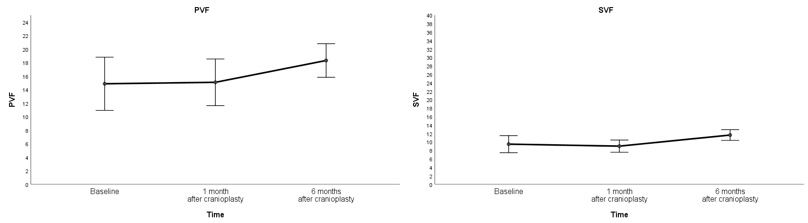

Figure S4: Representation of the estimated marginal means of the Cubes Test and the RCF over time

