Supplementary information
Accuracy of Local Polarization Measurements by Scanning Transmission Electron Microscopy
S. Calderon V, Stephen D. Funni, Elizabeth C. Dickey*
Department of Materials Science and Engineering, Carnegie Mellon University, Pittsburgh, PA 15213, USA

Table S1. Final probe size after convolution with the source size
Source Size  (pm) | Probe Size  (nm)
Point source | 59
60 | 85
70 | 94
80 | 102
90 | 112

Finite doses
iDPC and iCOM techniques have the advantage of a superior signal-to-noise ratio, when compare with other STEM imaging modalities, due to the integration of the signal that suppresses non-conservative fields, such as noise, as explain by Yücelen et al. (Yücelen et al., 2018). Thus, it is relevant to determine the effect of dose on the accuracy to measure the polarization using atomic resolution STEM comparing both iDPC and dDPC. Figure S1 shows iDPC and dDPC of ZnO observed along the [110] direction at different electron doses. The results evidence the superior capacity of iDPC to image the material at low electron doses compared to dDPC. However, although the fitting process for iDPC at 10⁴ e Å⁻² consistently locates all the atomic columns (Figure S2), the measured position error is still very large, as shown in Figure S3.
For typically used doses (10⁵ – 10⁶ e Å⁻²), measurements from dDPC are not degraded sufficiently to favor the accuracy of iDPC.

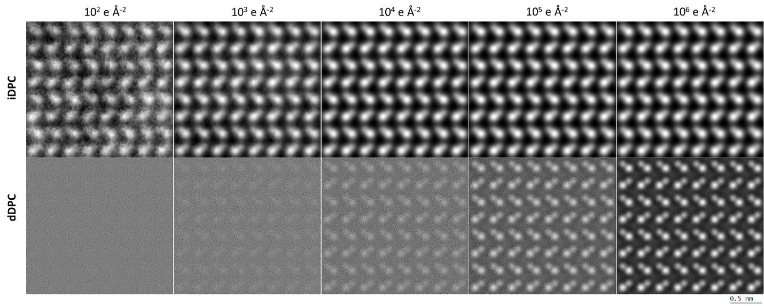
Figure S1. iDPC and dDPC images calculated at different electron doses.

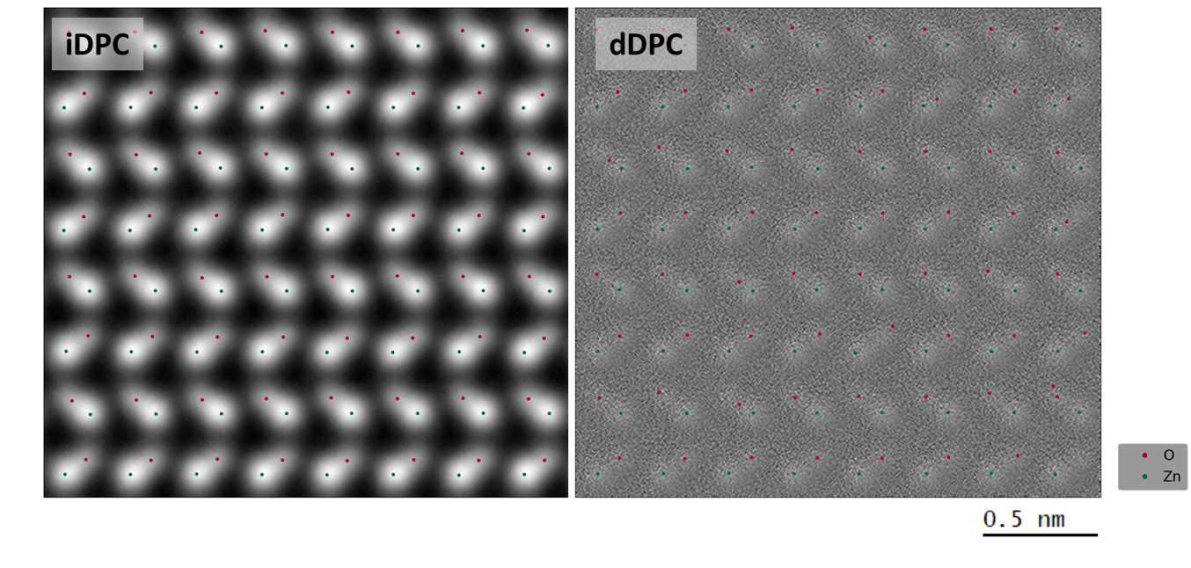
Figure S2. iDPC and dDPC images calculated at 10⁴ e Å⁻².

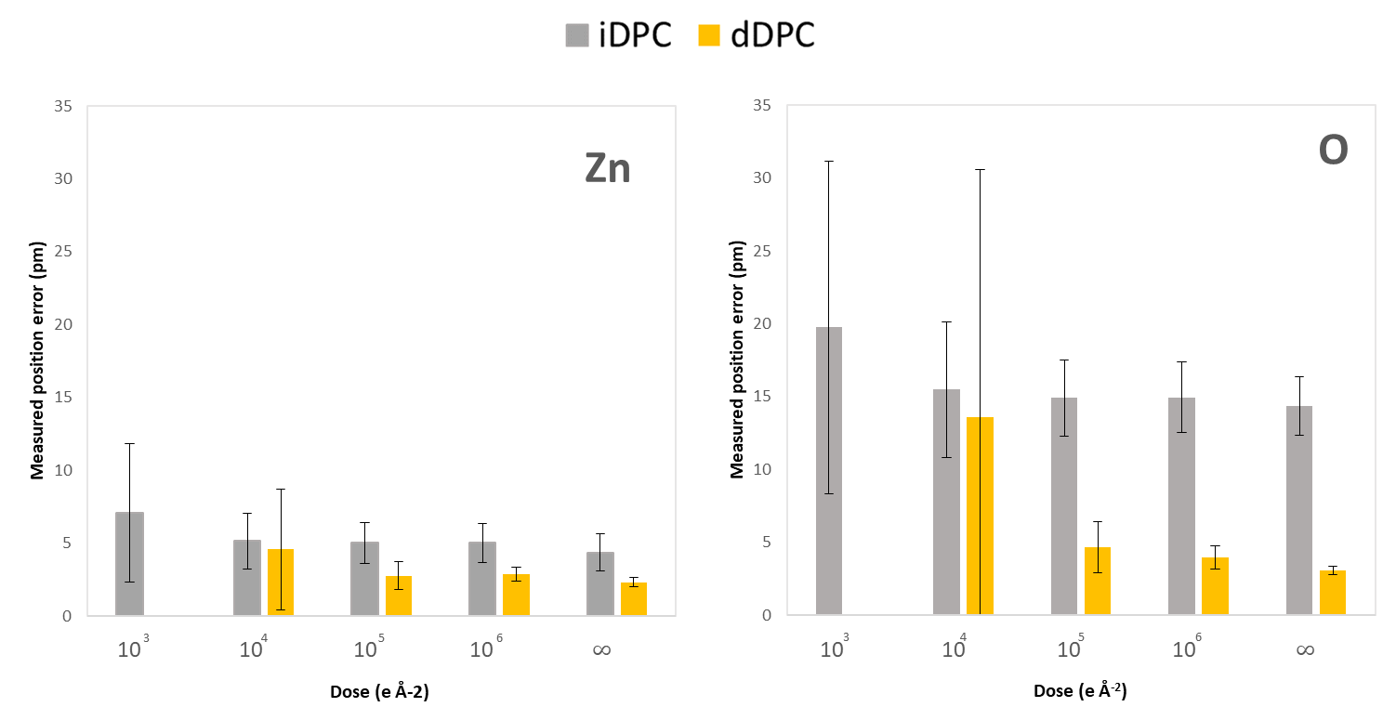
Figure 3. Measured position error for Zn and O atomic column as a function of the dose for iDPC and dDPC. Missing bars for dDPC at 10³ e Å⁻² are due to the high noise in the image, which impedes fitting the atomic columns.
Effect of thickness on the measured polarization
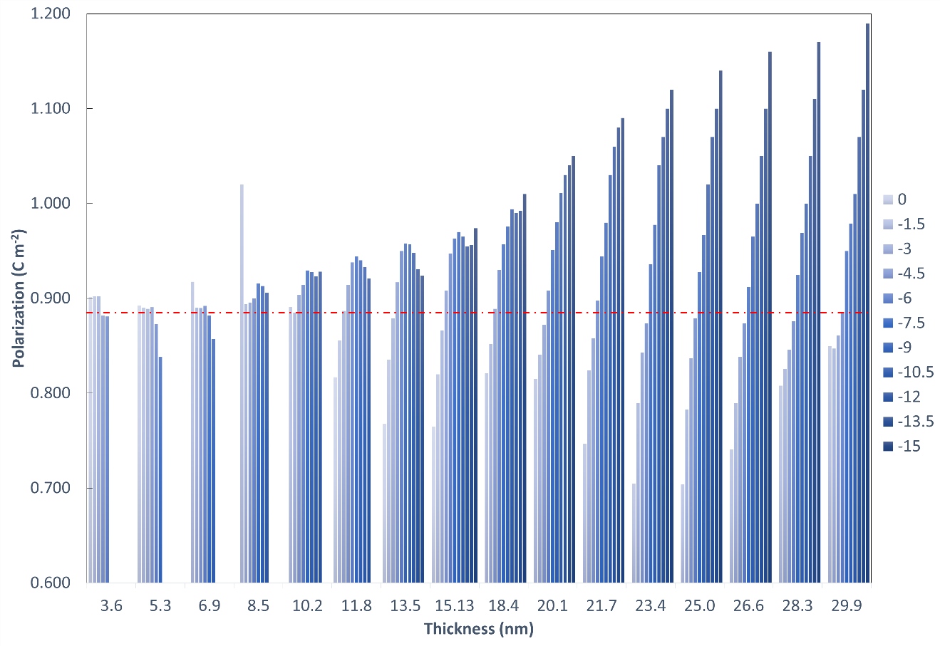
Figure S4. Measured polarization for ZnO as a function of thickness and defocus. The red dotted line represents the ground truth polarization.

