Supplementary information for

A novel cryogenic adhesive retaining fluidity at dry-ice temperature for low-temperature scanning electron microscopy

Satoshi Okada^{1,*}, Chong Chen¹
¹ Super-cutting-edge Grand and Advanced Research (SUGAR) Program, Institute for Extra-cutting-edge Science and Technology Avant-garde Research (X-star), Japan Agency for Marine-Earth Science and Technology (JAMSTEC), 2-15 Natsushima-cho, Yokosuka, Kanagawa 237-0061, Japan.

Figures S1–S8
Table S1–S4
Movie S1–S2

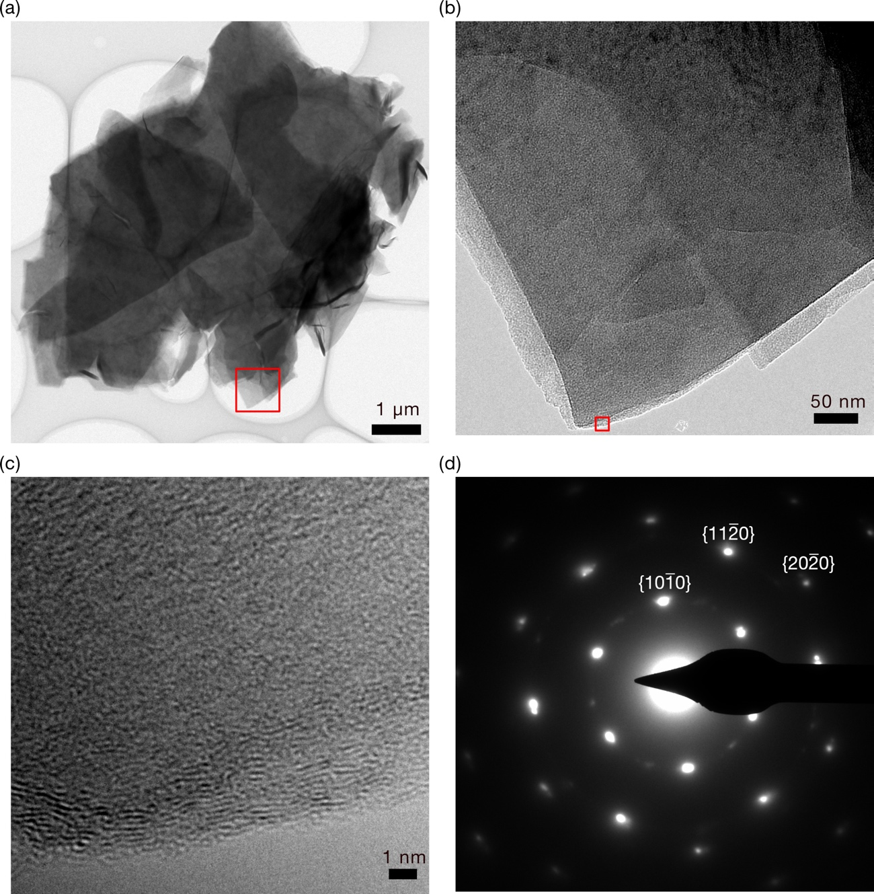
Figure S1. TEM images of GO. (a) Low-magnification image. (b) Magnified image of the red rectangle of (a). (c) Magnified image of the red rectangle of (c) showing graphitic lattice pattern on the edge. (d) Selected area electron diffraction of GO. Typical diffraction planes adopted from graphite is shown in white letters.

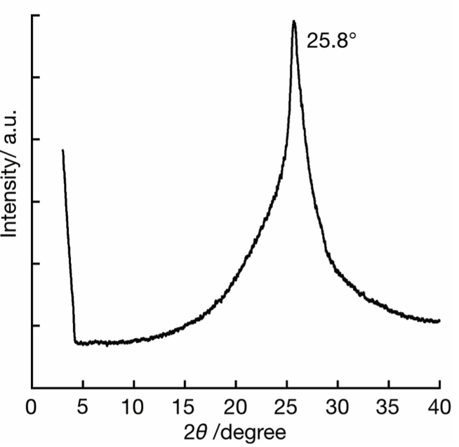
Figure S2. XRD pattern of GO.

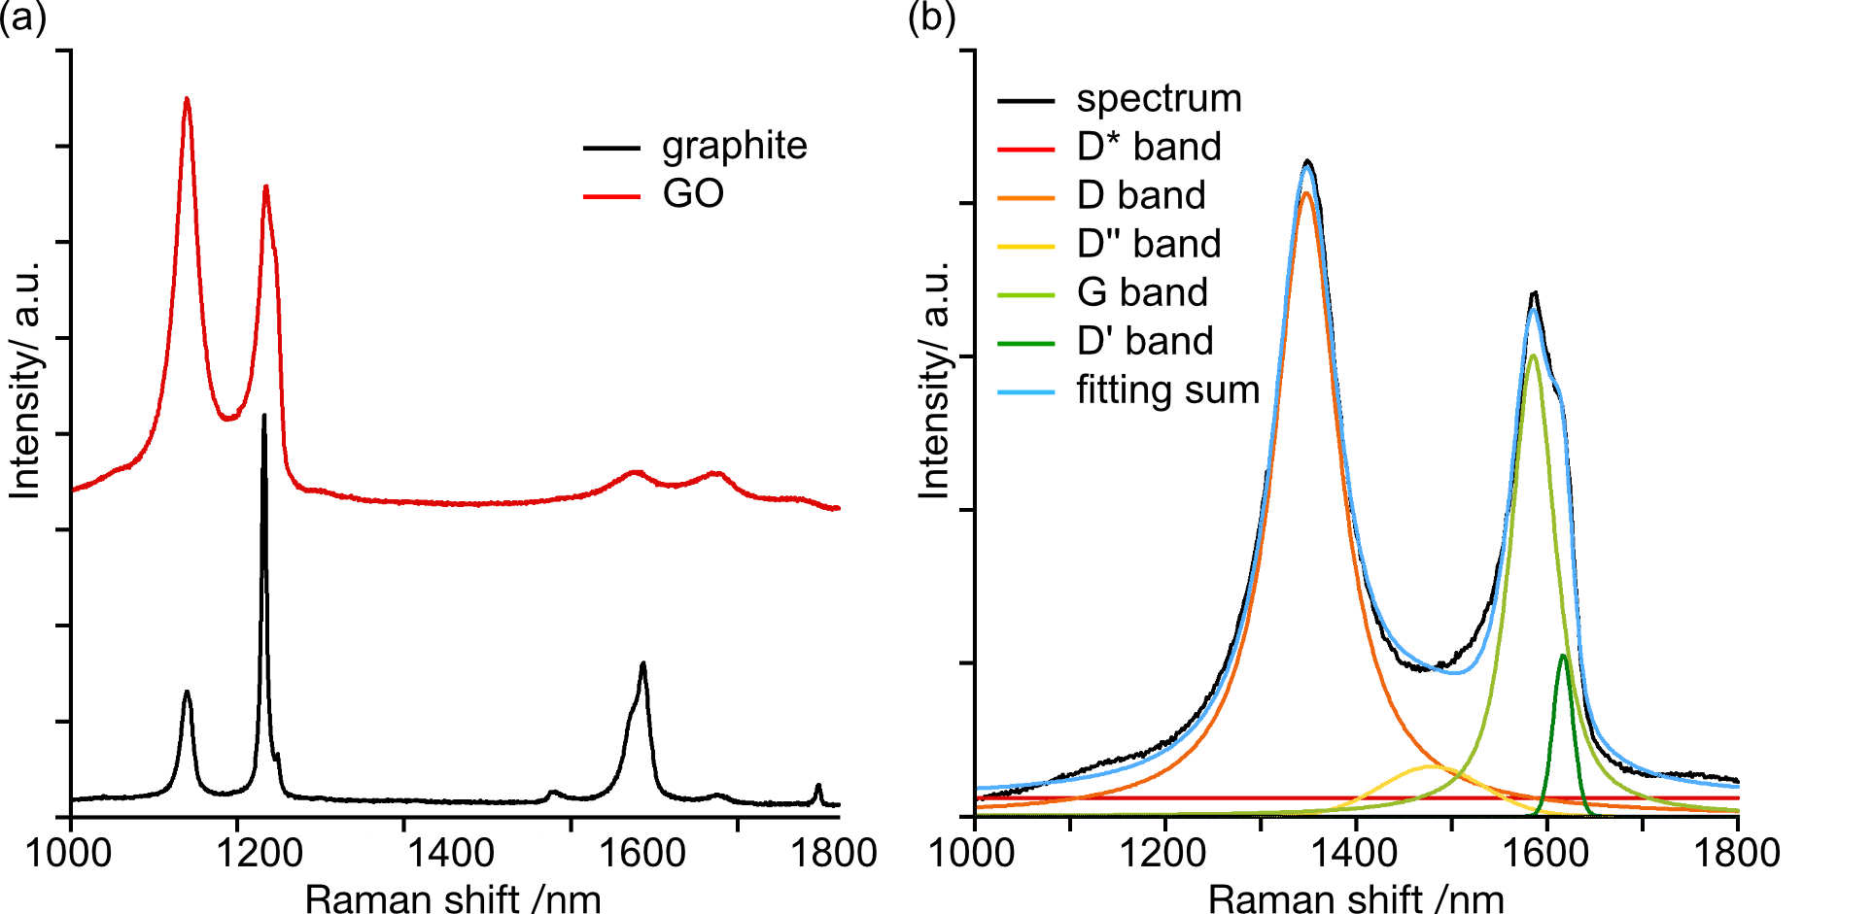
Figure S3. Raman spectrum. (a) Comparison of spectra of graphite (black) and synthesized GO (red). (b) Spectrum deconvolution of GO. (Black) Original spectrum, (red) D*, (orange) D, (yellow) D**, (light green) D’, (dark green) G bands, and (blue) sum of deconvoluted spectra.

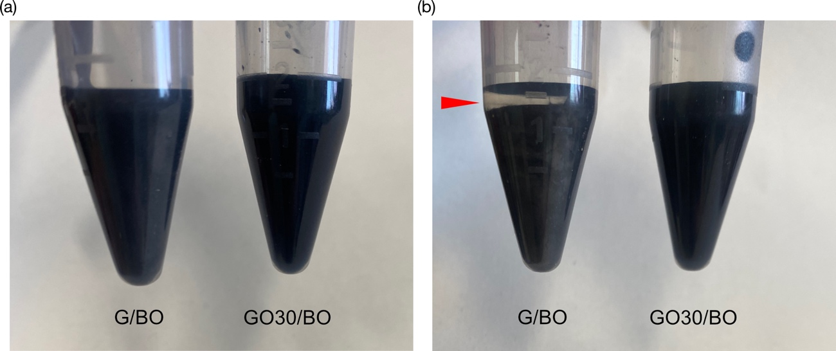
Figure S4. Stability of GO dispersion in BO. (a) Graphite and GO was dispersed in BO by sonication in 5 mL Eppendorf tubes at the concentration of 20 wt%. (b) After ten days storage at room temperature. Graphite/BO dispersion showed phase separation on the top, which is indicated by red triangle.

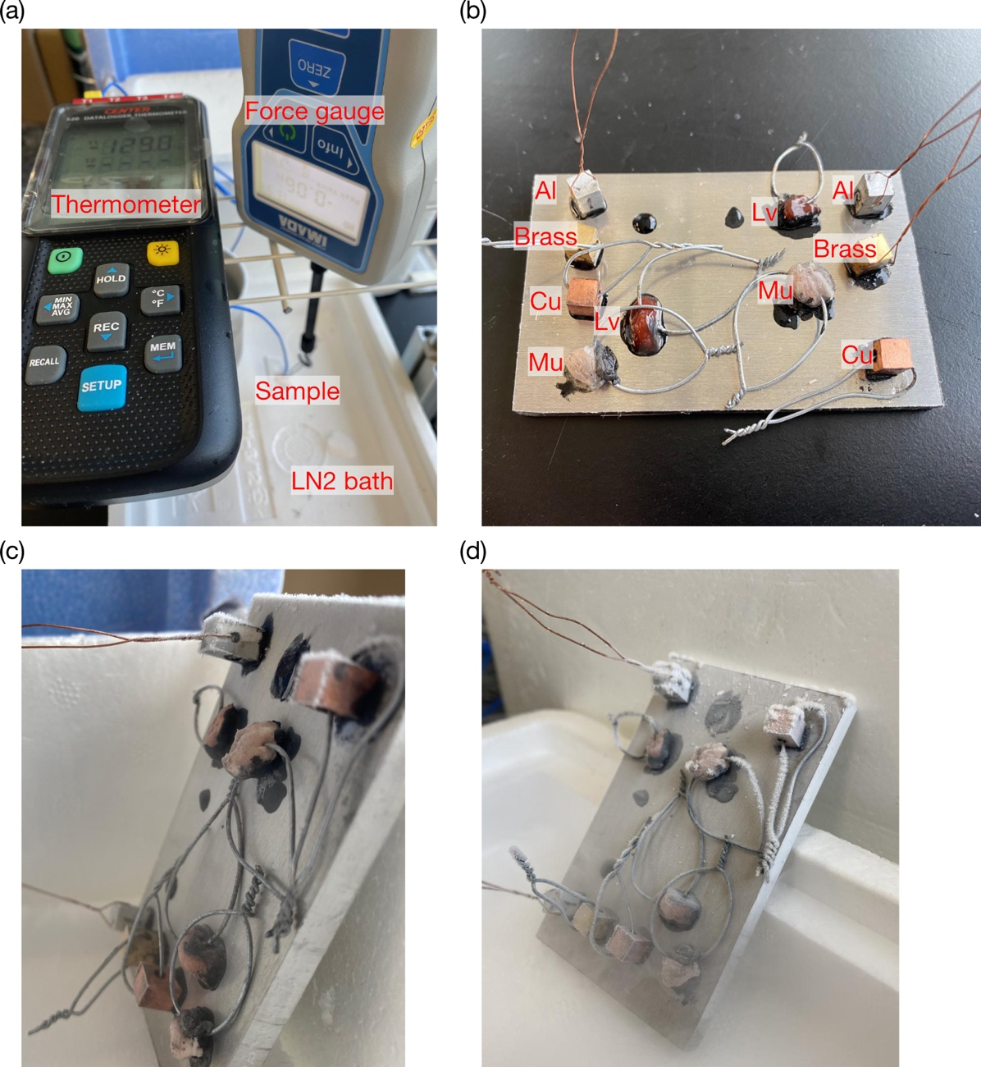
Figure S5. Photos of the setup for adhesion strength measurement. (a) Experimental setup for force measurement under liquid nitrogen temperature. (d) Samples mounted on an aluminum plate at room temperature. Al, aluminum; Cu, copper; Lv, chicken liver; Mu, pig muscle. (e) Tilted plate after cooling on a block of dry ice. (f) Tilted plate after cooling in liquid nitrogen. The samples did not fall by tilting after cooled down. The brass block on the center right was detached by strong lateral force during handling.

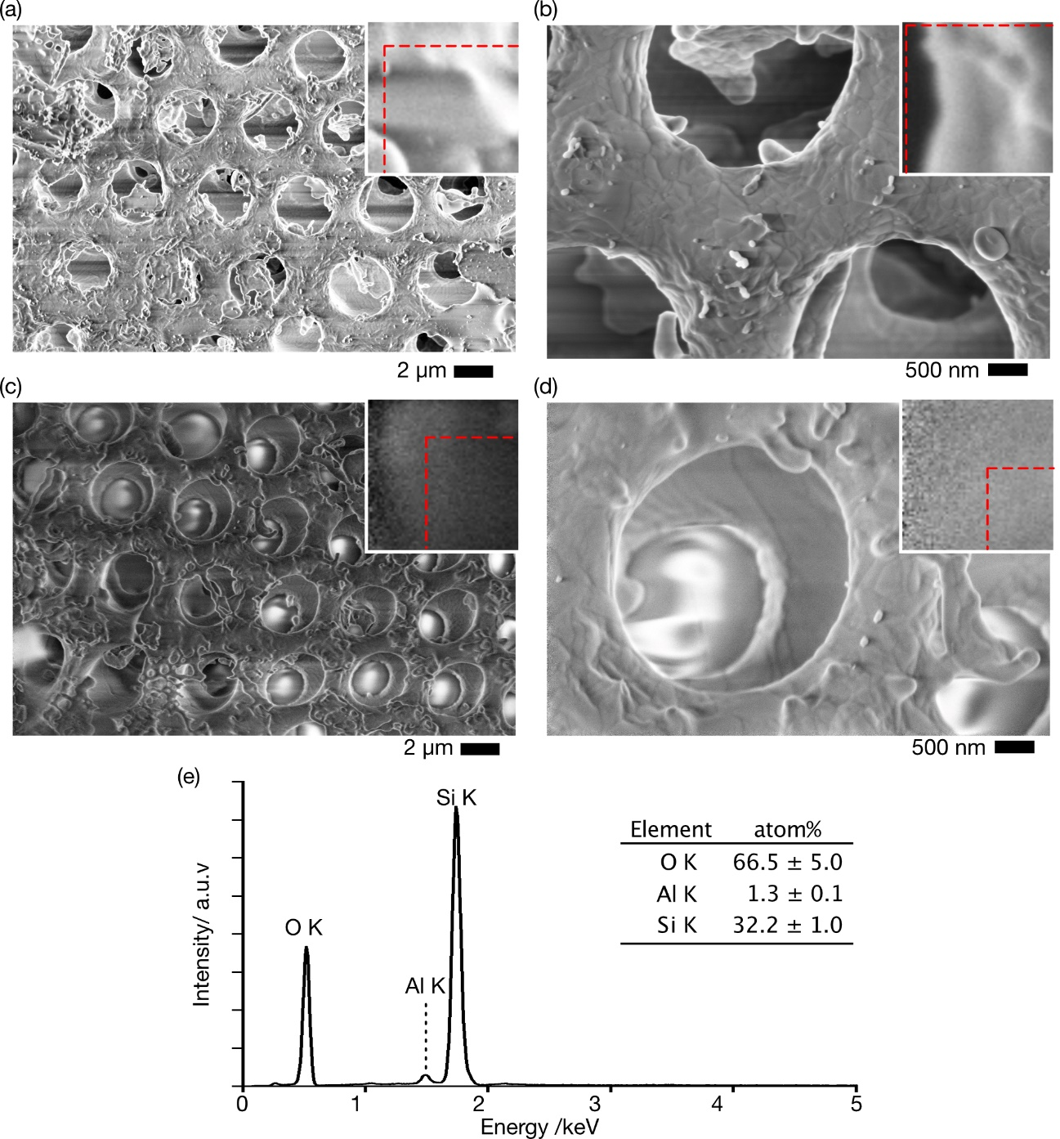
Figure S6. SEM/EDS analysis of diatomite. (a) SEM image of diatomite on BO, and (b) its high-magnification image. (c) SEM image of diatomite on GO30/BO, and (d) its high-magnification image. Insets showing the magnification of 25 x2 25 pixels of the top left in each image, and image drift was indicated by red dotted lines. (e) EDS spectrum of diatomite on GO30/BO. Inset table shows the atomic ratio. Images were acquired at 2 kV, 100 pA, and EDS spectrum was acquired at 20 kV, 0.4 nA.

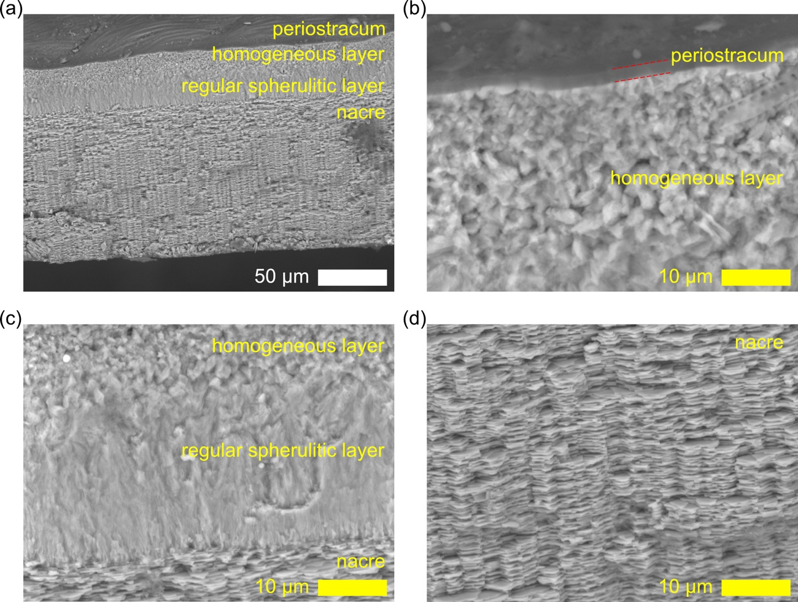
Figure S7. Cross sectional images of the mechanically fractured shell of ethanol-dried Margarites shinkai. (a) Low magnification image, (b) magnified image around the surface and cross section of periostracum and homogeneous layer, (c) magnified image around the regular spherulitic prismatic layer, (d) magnified image of nacreous layer.

Figure S8. XRD pattern of the shell of the prismatic deep-sea snail Margarites shinkai. (A) calculated XRD pattern of aragonite (black) and measured pattern of the snail’s shell (red), (b) the relative intensities of calculated aragonite divided by that of snail’s shell (bottom) and its ten times magnification (top). Up and bottom arrows indicate the high/low intensities of the pattern in snail’s shell against that of calculated aragonite, respectively and the red dotted lines show the threshold to pick peaks.

Table S1. Chemicals and their physical and safety properties with melting point around or lower than –78 °C, in alphabetical order. Safety information were collected from Safety Data Sheet from Tokyo Kasei Inc.

Chemicals | m.p. | b.p. | Safety Note
aziridine | –78 | 54 | Unstable, highly toxic
2-(benzyloxy)ethanol | <–75 | 256 | Irritant to eye
1,3-butanediol (BO) | –77 | 208 | Safe for human
2,2-diethoxyethylamine | –78 | 163 | Highly irritant to skin/eye
2,2-dimethoxyethylamine | –78 | 137 | Highly irritant to skin/eye
ethyl chloroformate | –81 | 91 | Reactive with water
ethyl formate | –80 | 54 | Low boiling point
nicotine | –79 | 246 | Highly toxic
2-nitroethanol | –80 | 195 | Irritant to eye
1,3-propanethiol | –79 | 173 | Unpleasant odor
triacetin | –78 | 259 | Low water solubility, safe for human
vinyl formate | –78 | 42 | Low boiling point

Table S2. Fitted results of the Raman spectra. x_{c}, w, and A denote center of peaks in cm^{–1}, full width half maximum (FWHM) in cm^{–1}, and peak intensity, respectively. D* band at ca. 1100 cm–1 was also fitted but not shown because FWHM became infinity, as shown in red line in Figure S3 (b).

D (pseudo-Voigt) |  |  | D’’ (Gaussian) |  |  | G (pseudo-Voigt) |  |  | D’ (pseudo-Voigt)
x_{c} | w | A | x_{c} | w | A | x_{c} | w | A | x_{c} | w | A
1348 | 3950 | 85 | 1480 | 303 | 119 | 1579 | 2666 | 54 | 1611 | 1353 | 34
1348 | 2084 | 82 | 1480 | 171 | 124 | 1582 | 1570 | 52 | 1614 | 604 | 26
1348 | 2400 | 84 | 1480 | 190 | 127 | 1582 | 18016 | 52 | 1614 | 733 | 27
1348 | 2034 | 84 | 1480 | 162 | 126 | 1586 | 1504 | 57 | 1617 | 526 | 24
1349 | 2316 | 83 | 1480 | 149 | 137 | 1582 | 1713 | 48 | 1612 | 862 | 30

Table S3. Adhesion force of GO30/BO between the aluminum base plate and sample blocks.

Sample | Compo-sition | Temp  /°C | Tension /N cm^{–2}
Al | BO | -77 | 35.53, 034.79, 035.97, 037.58, 033.79
brass | BO | -77 | 40.69, 049.92, 041.19, 038.03
Cu | BO | -77 | 057.61, 056.56, 051.79, 035.39, 041.91
Al | GO30/BO | -77 | 83.91, 076.59, 089.54, 103.79, 106.51
brass | GO30/BO | -77 | 94.76, 124.13, 147.63, 131.96, 193.65
Cu | GO30/BO | -77 | 193.65, 146.87, 144.65, 097.53, 126.86
Chicken liver | GO30/BO | -77 | 1.91, 004.85, 042.87
Pig muscle | GO30/BO | -77 | 9.24, 010.36, 004.78, 003.05
Al | GO30/BO | -196 | 18.19, 015.74, 010.57, 025.91
brass | GO30/BO | -196 | 11.75, 008.91, 006.24, 050.81
Cu | GO30/BO | -196 | 18.66, 036.83, 099.96
Chicken liver | GO30/BO | -196 | 0.64, 000.25, 000.85
Pig muscle | GO30/BO | -196 | 0.17, 000.68, 008.90, 001.06, 000.62,  0.80, 001.11

Table S4. Freeze-fracture force required to expose a cross-section of biological tissues fixed by GO30/BO.

Sample | Area  /mm² | Force  /N | Force per area  /N mm^{–2}
Chicken liver | 9.43 | 19.49 | 2.07
 | 6.83 | 22.05 | 3.23
 | 7.35 | 34.02 | 4.63
 | 5.03 | 8.07 | 1.61
 | 4.56 | 4.06 | 0.89
Pig muscle | 2.75 | 3.41 | 1.24
 | 3.34 | 9.24 | 2.76
 | 10.18 | 5.46 | 0.54
 | 6.84 | 16.6 | 2.43
 | 5.09 | 10.56 | 2.08

Movie 1. Sequential SEM images of diatomite on BO.

Movie 2. Sequential SEM images of diatomite on GO30/BO.

