Supplementary Information for
Precisely picking nanoparticles by ‘Nano-scalpel’ for 360⁰ Electron Tomography
Xiaohui Huang^{1,2}, Yushu Tang¹*, Christian Kübel^{1,2,3} and Di Wang^{1,3}*
¹ Institute of Nanotechnology, Karlsruhe Institute of Technology, Hermann-von-Helmholtz-Platz 1, 76344, Eggenstein-Leopoldshafen, Germany.
² Karlsruhe Nano Micro Facility (KNMF), Karlsruhe Institute of Technology, Hermann-von-Helmholtz-Platz 1, 76344, Eggenstein- Leopoldshafen, Germany.
³ Department of Materials and Earth Sciences, Technical University Darmstadt, Alarich-Weiss-Straße 2, 64287, Darmstadt, Germany.
Corresponding: di.wang@kit.edu; yushu.tang@kit.edu

Figure S1. Tungsten preparation by electrochemical etching.

Figure S2. Scanning electron micrographs of etched tips.

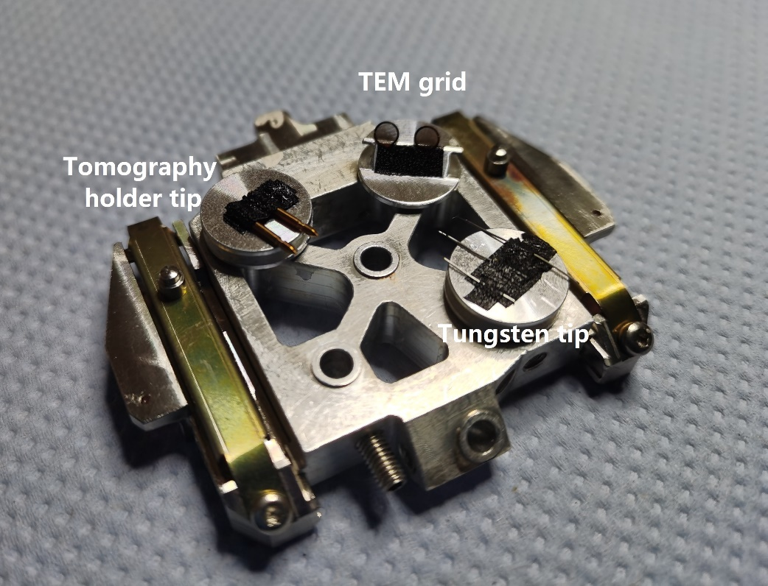
Figure S3. Initial FIB stage setup with tungsten tip, TEM grid and 360° tomography holder tip loaded on it.

Figure S4. Three commercial TEM grids covered by different carbon films including (a) 100×400 mesh carbon film (thickness: 10-20 nm), (b) 200 mesh holey carbon film (thickness: ~12 nm) with patterned holes and (c) 200 mesh lacey carbon film (thickness: ~20 nm) with irregular holes used for transferring tomography samples.

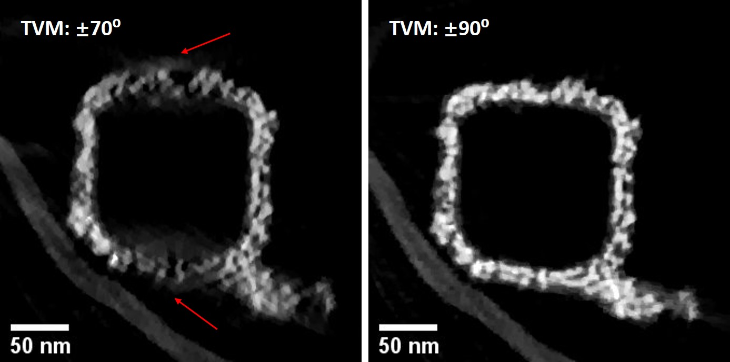
Figure S5. The representative yz slices from the dataset with limited angle range and full rotation using TVM reconstruction.

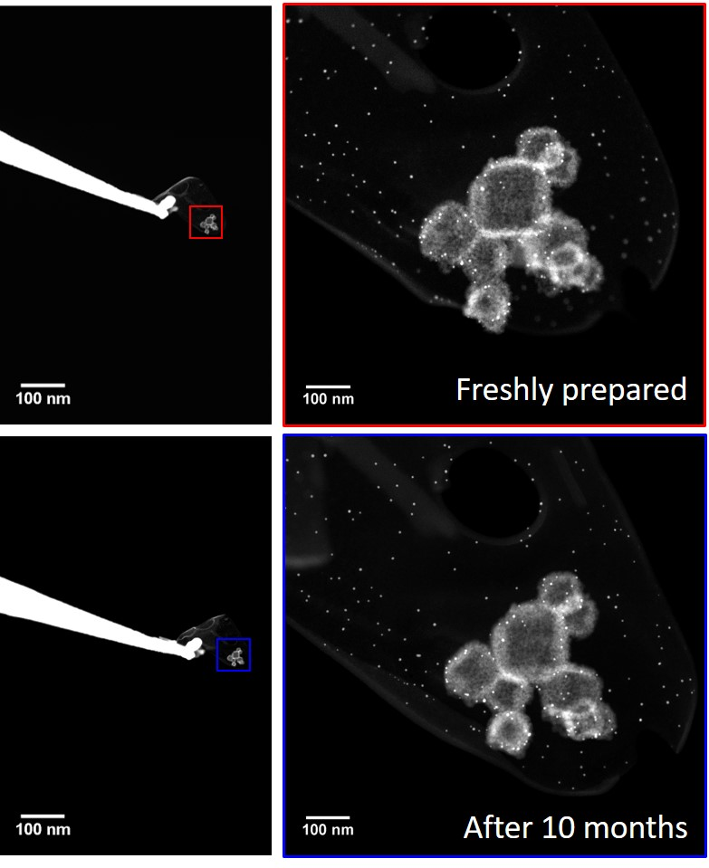
Figure S6. STEM images showing stable sample form by comparing the freshly prepared sample and that after 10 months.

Figure S7. Representative slices from the aligned sinogram.

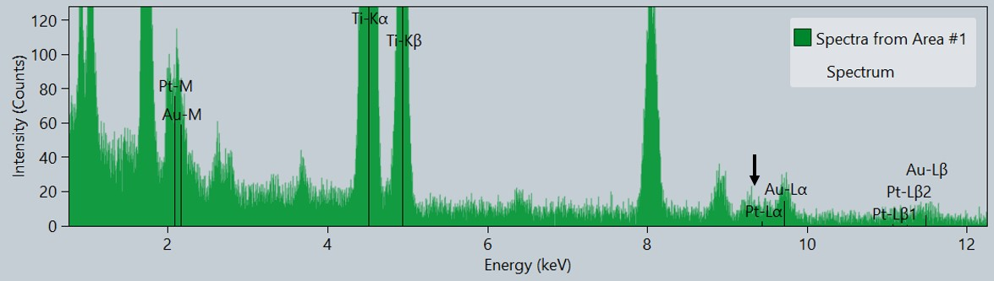
Figure S8. EDX spectrum acquired from the sample area after finishing the preparation.

