Supplementary information
H.R. Lee et al.
High-performance compact pre-lens retarding field energy analyzer for energy distribution measurements of an electron gun
This PDF File includes:
Supplementary Note 1-2
Supplementary Figure S1
Supplementary Reference

Supplementary Note 1 – Theory of Schottky electron emission

Schottky electron emission is linked to a thermally assisted field emitter, which is suitable for analyzing electron emission properties by both heat and the electric field. In this supplementary material, we review the Schottky electron emission theory for total energy distribution (TED) and emission current density. The emitter protrudes through a suppressor, and it works in the extended Schottky region by means of a high electric field as a non-crossover type of cathode. The height of the potential barrier is lowered and the width is narrowed by the high electric field, increasing the electrons emitted due to the tunnel effect. The current density ($J_{ES}$) of the extended Schottky (ES) model is expressed as follows (Schwind et al., 2006) (Fransen, 1998):
$J_{S}=\frac{4πm_{e}{\left(kT\right)}^{2}}{h^{2}}exp\left(\frac{e^{3/2}F^{1/2}}{{\left(4πε_{0}\right)}^{1/2}}-\frac{∅}{kT}\right)$ (1)

$J_{ES}=J_{s}\frac{πq}{sin\left(πq\right)}$ (2)

where $J_{S}$ is the current density in the Schottky emission (SE), the work function is $∅$, the effective mass of an electron is $m_{e}$, the Plank constant is $h$, the permeability of a vacuum is $ε_{0}$, the Boltzmann constant $k$, the temperature $T$, and the electric field $F$ in the SE model, with all parameters following SI units. One of the measures representing the ratio of the tunnel current is expressed by the following equation, referred to as the dimensionless parameter $q$ (Hawkes, 2013):
$q=\frac{h{\left(4πε_{0}e\right)}^{1/4}F^{3/4}}{2π^{2}{m_{e}}^{1/2}kT}=1.656×{10}^{-4}\frac{F^{3/4}}{T}$ (3)
In these SE regions, the current density is valid in the range of 0.3 < $q$ <0.7, and the boundary that separates the SE and ES regions exists at about $q$ = 0.3. The following relationship applies to the electric field $F$ of the extraction voltage (V_{E}) and the emitter surface:
$F=βV_{E}$ (4)

$β=3.5×{10}^{9}D^{-0.632}r^{-0.96}$ (5)

The field factor $β$ is determined by the emitter tip radius (r) and the geometric parameter ($D$) of the electron gun, which is the distance between the tip and the extractor. The factor $β$ was measured and calculated experimentally (Hawkes, 2013).

Supplementary Note 2 – Schematic of the pre-lens RFEA system

In this study, we constructed a test bench for energy distribution measurements, as shown in Figure S1, to evaluate the performance of the pre-lens RFEA. The ultra-high vacuum chamber is fixed on an optical table that minimizes vibration noise and maintains level (horizontality). To avoid vibration noise such as rotary and turbo molecular pumps, this system can maintain a base vacuum of under 2.3 $×$ 10⁻¹⁰ Torr using an ion and non-evaporable getter (NEG) pump. The pre-lens RFEA was fixed to the X-Y-Z translation stage in the chamber for easy optical axis alignment with the Schottky electron gun.
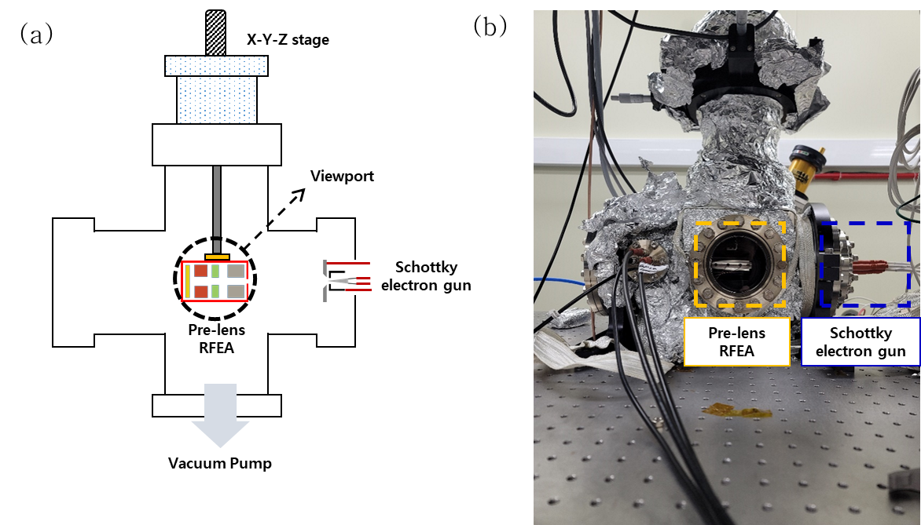
Figure S1. Experimental setup for pre-lens RFEA system. (a) Schematic diagram. (b) Photograph image.

Supplementary References:
Schwind, G. A., Magera, G. & Swanson, L. W. (2006). Comparison of parameters for Schottky and cold field emission sources. Journal of Vacuum Science & Technology B: Microelectronics and Nanometer Structures 24, 2897.
Fransen, M. J. (1998). Experimental evaluation of the extended Schottky model for ZrO/W electron emission. Journal of Vacuum Science & Technology B: Microelectronics and Nanometer Structures 16, 2063.
Hawkes, P. (2013). Charged Particle Optics, CRC, Boca Raton, Chap. 1. pp. 1-22

