Supplementary Information
Tracking the Mn diffusion in the carbon-supported nanoparticles through the collaborative analysis of atom probe and evaporation simulation

Chanwon Jung ^{a,b,†}, Hosun Jun ^{a,†}, Kyuseon Jang ª, Se-Ho Kim^{b}, Pyuck-Pa Choi ^{a,*}

ª Department of Materials Science and Engineering, Korea Advanced Institute of Science and Technology (KAIST), 291 Daehak-ro, Yuseong-gu, Daejeon 34141, Republic of Korea
^{b} Max-Planck-Institut für Eisenforschung GmbH, Düsseldorf 40237, Germany

† These authors contributed equally to this work
* Corresponding Author: p.choi@kaist.ac.kr

Key words
Atom probe tomography, local magnification effect, carbon-supported nanoparticles, field evaporation simulation, intermetallic compounds
Fabrication of APT specimen including carbon-supported nanoparticles
Figure S1a shows SEM image of the electrodeposited composite film of the nano-catalysts and the Co matrix. As backscattered electron (BSE) mode has a moderately high sensitivity in terms of atomic number, distinguished brightness indicates the different materials of the carbon containing nano-catalysts (dark area) and the matrix (bright area). Co matrix containing a relatively high density of the nano-catalysts (Figure S1b) is selected and sliced using FIB for lift-out. Figure S1c shows a composite lamella before lift-out process with the completely embedded nano-catalysts. After annular milling, sharpened APT specimen containing nano-catalysts was obtained, as shown in Figure S1d.
The final APT specimens were measured with bright-field TEM to first confirm possible existence of pores that result abruptly fracture during high-field evaporation process. No noticeable crack or voids were observed in the specimen (see Figure S1e). In bright-field mode, elements with lower atomic mass show brighter contrast than elements with higher atomic mass. Thus, bright features showing sphere shape are the supporting carbon, while darker region is the Co matrix. Figure S1f shows HAADF-STEM image of sharpened APT specimen showing different contrast. In addition, even brighter spheres in size of few nanometers representing PtMn nanoparticles were observed without shape change, indicating the electrodeposition process has successfully captured the PtMn nanoparticles within matrix, without affecting the morphology of nano-catalysts (see Figure S1g).
Figure S1. SEM images of (a) electrodeposited composite film of nano-catalysts and matrix (yellow arrows indicating embedded nano-catalysts and yellow box representing the area in b), (b) close-up image of region of interest (dotted line showing the nano-catalysts), (c) cross-sectional view after lift-out process and (d) sharpened APT tip. (e) BF-TEM and (f-g) STEM images of prepared APT tip.

Figure S2. XRD patterns of Pt/C, PtMn/C, and Pt₃Mn/C (Pt standard: PDF no. 01-087-0647, Pt₃Mn standard: PDF no. 03-065-3260, and Mn₂O₃ standard: PDF no. 01-078-0390)

Calculation of average particle size from XRD results
The 2-theta peaks from FCC (111) were centered at 39.71˚, 39.77˚, and 40.00˚ for Pt/C, PtMn/C, and Pt₃Mn/C, respectively. No shift between Pt/C and PtMn/C indicates that enough mixing between Pt and Mn did not occur during the synthesis of PtMn/C. By contrast, 2-theta of Pt₃Mn/C shows larger than PtMn/C indicating a reduction of the lattice constant. The average particle size was estimated by using the Scherrer equation as below [1].
$$D_{hkl}=\frac{K }{B_{hkl} cosθ}$$
Here, D_{hkl} is the average crystallite size in direction of hkl plane, K is crystallite shape factor which we used 0.9 (sphere shape) in this study [2], λ is the wavelength of the X-ray, B_{hkl} is the full-width at half-maxium of the X-ray diffraction peak from hkl and θ is the Bragg angle. The estimated average particle size of Pt/C, PtMn/C, and Pt₃Mn/C were 2.1, 2.5, and 6.7 nm, respectively.

Figure S3. BF-TEM images of (a) Pt/C, (b) PtMn/C, and (c) Pt₃Mn/C. STEM-EDX maps of (d) High-resolution STEM images and EDX maps of Pt₃Mn/C in atomic resolution.

Figure S4. Acquired mass spectra from (a-c and g-h) PtMn/C and (d-f and i-j) Pt₃Mn/C for closer inspection.

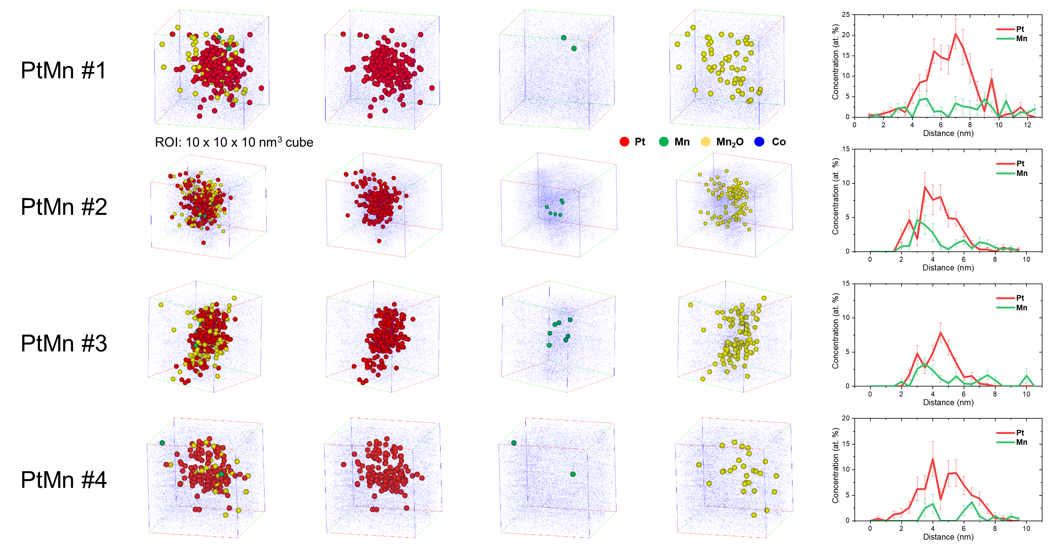
Figure S5. 3d ion maps of detected PtMn nanoparticles and 1d concentration profiles across the nanoparticles.

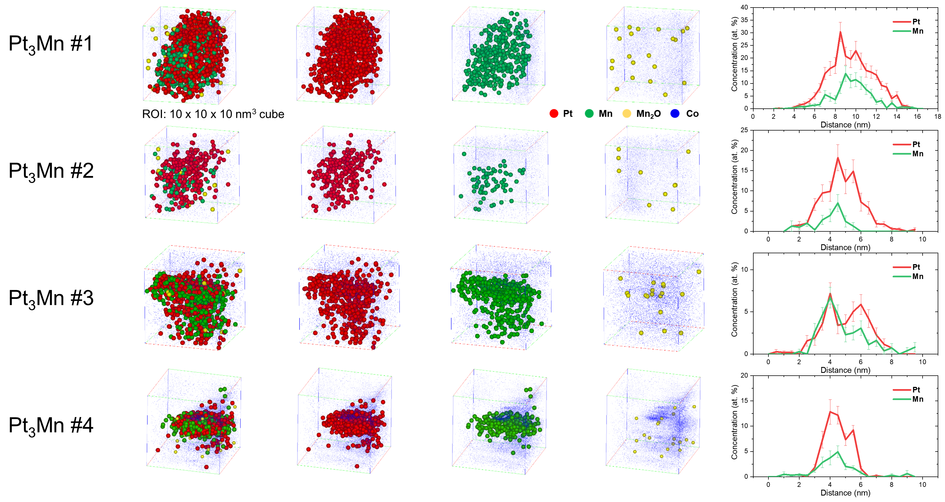
Figure S6. 3d ion maps of detected Pt₃Mn nanoparticles and 1d concentration profiles across the nanoparticles.

Reference
[1] P. Scherrer, Göttinger nachrichten math, Phys. 2 (1918) 98–100.
[2] U. Holzwarth, N. Gibson, The Scherrer equation versus the’Debye-Scherrer equation’, Nat. Nanotechnol. 6 (2011) 534.

