Advanced hybrid positioning system of SEM and AFM for 2D material surface metrology
Taeryong Kim^{a‡}, Dongwan Kim^{b‡}, TaeWan Kim^{c}, Hyunwoo Kim^{d*}, and ChaeHo Shin^{b**}

ª Department of Materials Science & Engineering, Seoul National University, Seoul 08826, South Korea
^{b} Interdisciplinary Materials Measurement Institute, Korea Research Institute of Standards and Science, Daejeon 34113, South Korea
^{c} Department of Electrical Engineering and Smart Grid Research Center, Jeonbuk National University, Jeonju, South Korea
^{d} Laboratory for Advanced Molecular Probing (LAMP), Korea Research Institute of Chemical Technology, Daejeon 34114, South Korea

Corresponding Authors
*hwkim@krict.re.kr, **chaeho.shin@kriss.re.kr
‡These authors contributed equally to this work
1. SEM and AFM adaptors for measuring the same location using the external hybrid positioning system

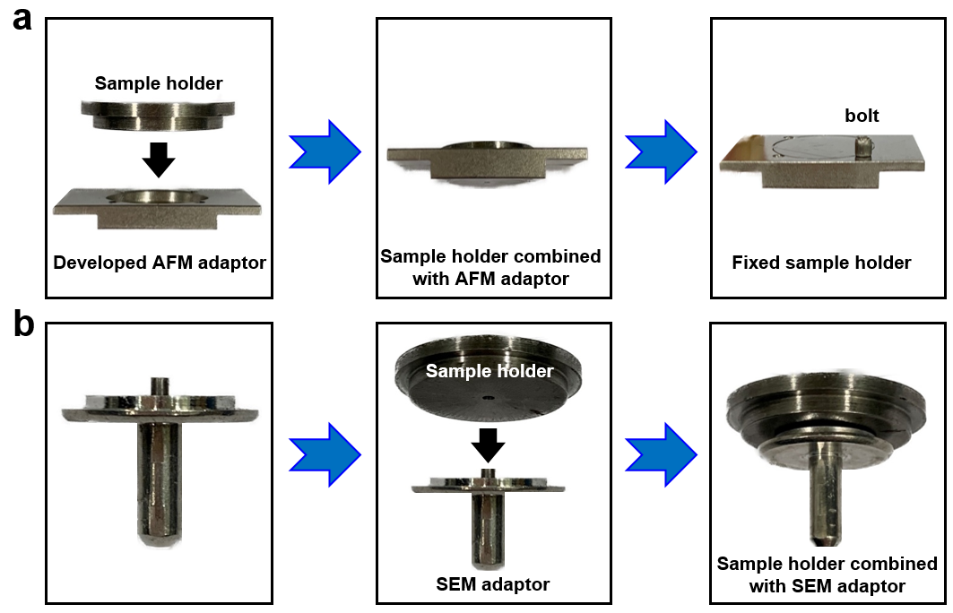

Fig S1. (a) Sample holder attached to a developed AFM adaptor, which has the marginal space at the sides for the lift-bar gripper. (b) Sample holder attached to a commercial SEM adaptor.

2. Alignment mark on the sample holder for measuring the same location between SEM and AFM

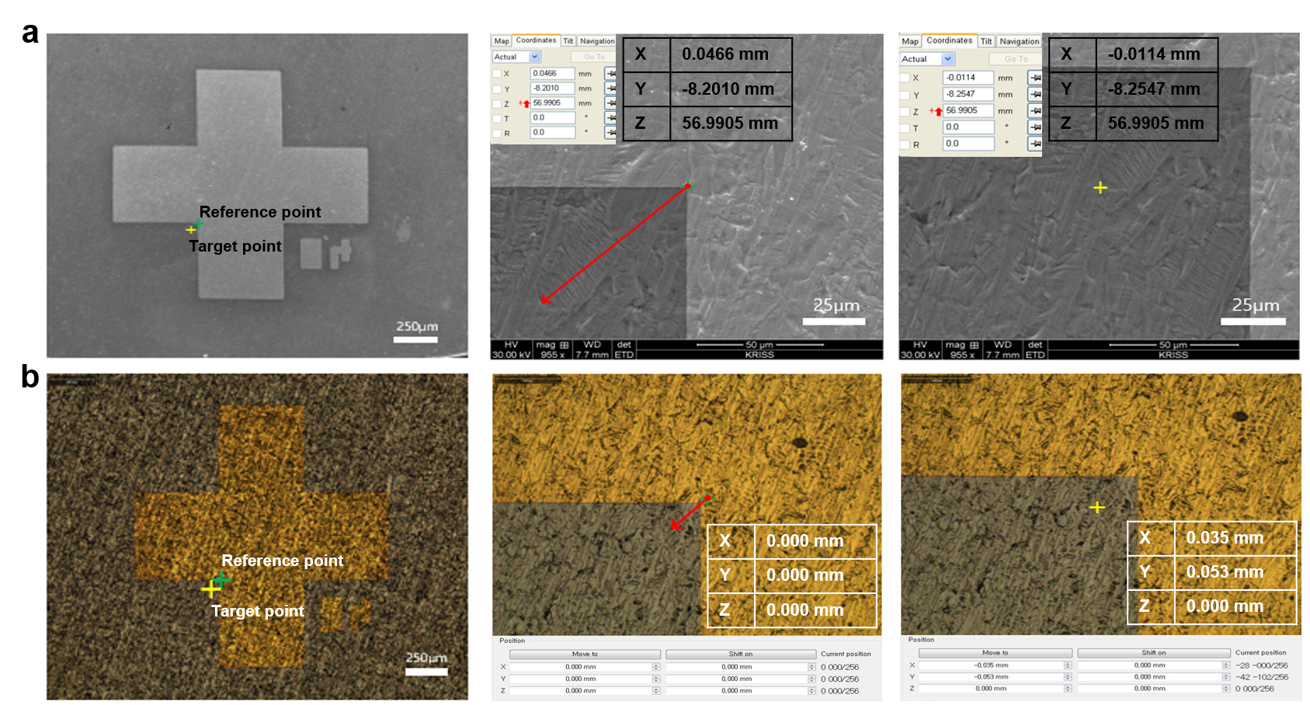

Fig S2. Reference point (green cross-shaped mark) on the sample holder for the same measurement coordinate. (a) SEM image of the target point from the reference point (X : 0.047(Reference) - 0.012(Target) = 0.035 mm, Y : -8.201 + 8.255 = 0.054 mm) (b) Optical image of the target point from the reference point using a 5 axis positioning stage for the AFM measurement (X : 0.000(Reference) + 0.035(Target) = 0.035 mm, Y : 0.000 + 0.053 = 0.053 mm)

3. Schematic of a 5-axis positioning stage with a lift-bar gripper

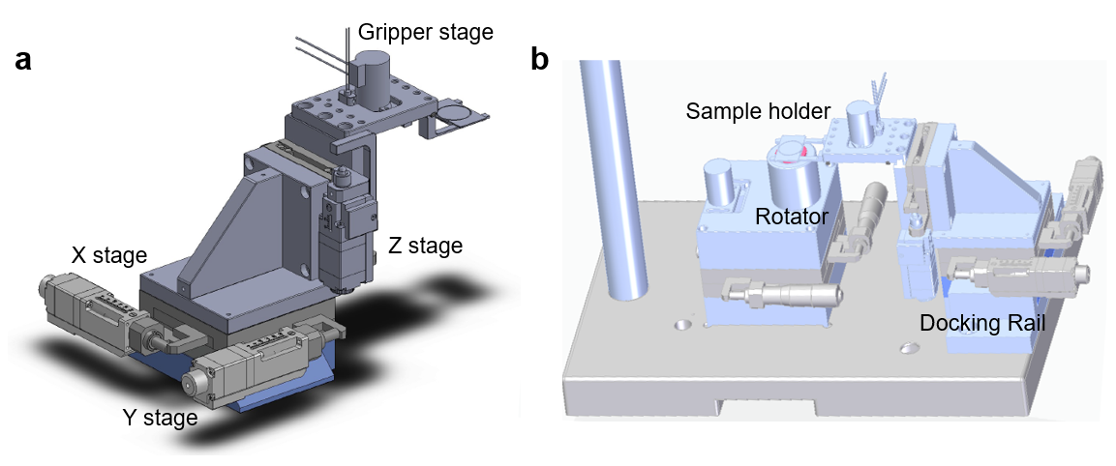

Fig S3. Schematic of (a) 4- axis positioning stage (X, Y, Z and Lift-bar gripper stage) and (b) 5–axis positioning stage (Rotator, 4-axis stage mounted on a docking rail).
4. Spatial offset of the denting points from the coordinate origin

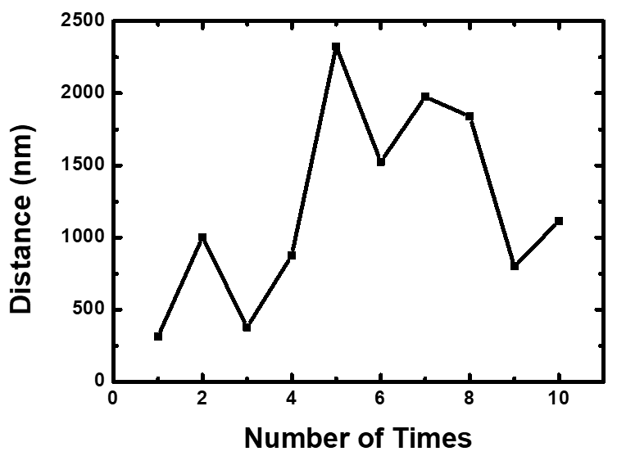

Fig S4. The distance from the origin coordinate to the denting points during the repeated mounting and unmounting process of the tip cartridge.
5. Analysis of sources of positioning errors between SEM and AFM measurement

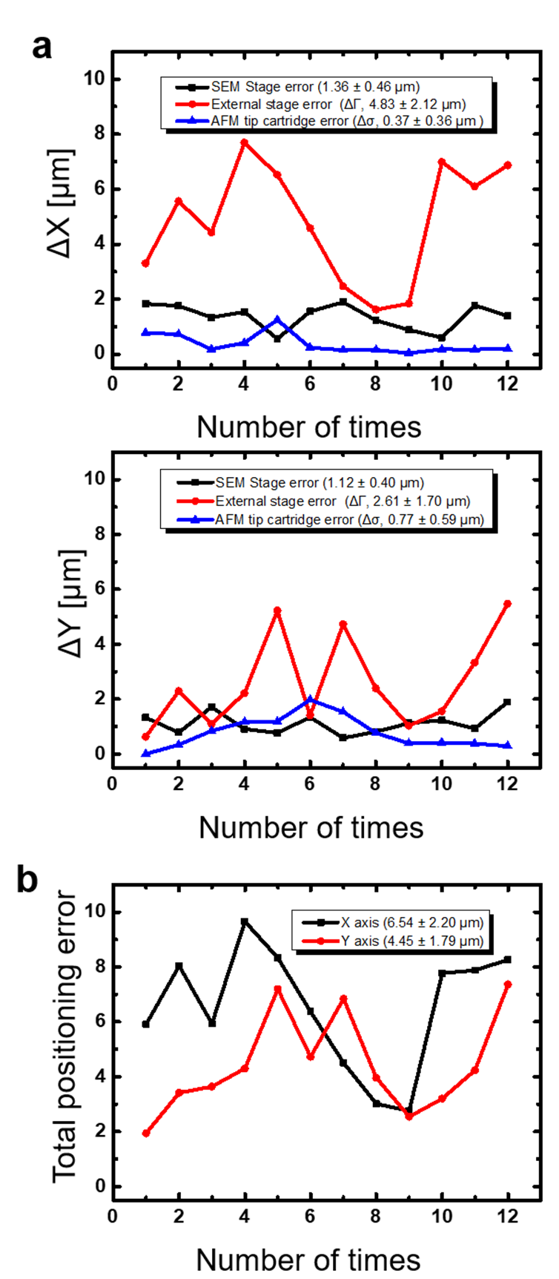

Fig S5. (a) The positioning errors (X and Y axis) between SEM and AFM measurement at the same location (b) Total error (SEM stage error, External stage error, and Tip cartridge error) from the target position in the measurement of X and Y axis.
6. SEM imaging before AFM measurement

Fig S6. (a) SEM image of Te crystallites rods grown on MoTe₂ with a 32 µm FOV. AFM images were contained in an overall SEM image at the same location with a 10-µm FOV.
(The upper part of an overall SEM image was analyzed by AFM and the reliability value is indicated in yellow.) (b) Three-dimensional image of the MoTe₂ nanorod by AFM measurement (c) Three-dimensional overlay of the SEM and AFM images of MoTe₂ nanorod acquire at the same location.

7. The rotation error between the SEM and AFM image

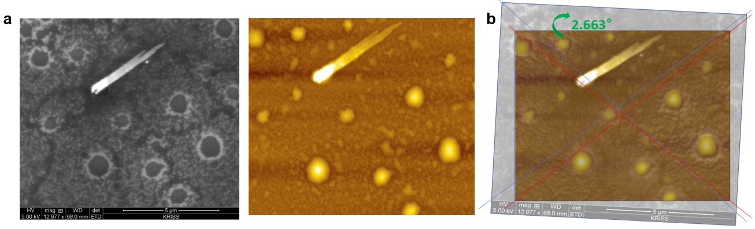

Fig S7. (a) SEM(left) and AFM(right) images at the same location using a developed rotator. (b) Overlay of SEM and AFM images, the error of rotational accuracy is estimated to be 2.663°.
8. Beam damage on a 1layer MoS₂ film occurred during the SEM measurement

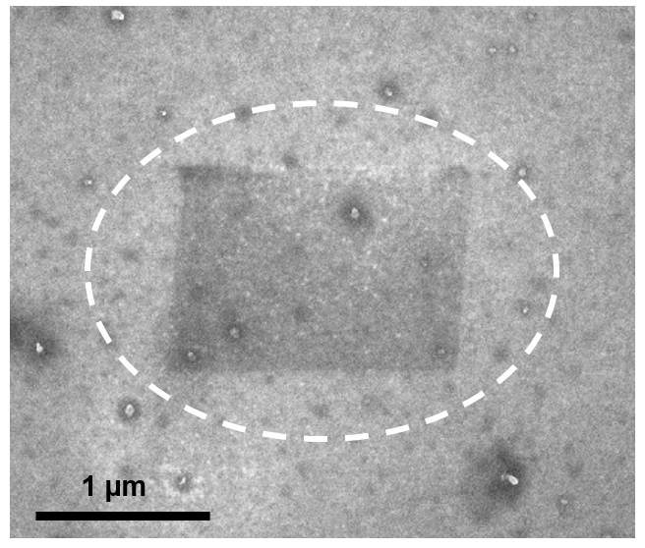

Fig S8. SEM image of a monolayer MoS₂ film. A burn mark appeared during an electron beam.

9. AFM measurement before SEM imaging

Fig S9. (a) AFM and (b) SEM image of MoS₂ film at the same location, respectively. (The roughness was 1.36 nm and the reliability value is indicated in yellow.) (c) Three-dimensional image of MoS₂ grains measured by AFM (c) Three-dimensional overlay of SEM and AFM images of MoS₂ grains at the same location.

