Precise Drift Tracking for in situ Transmission Electron Microscopy via Thon-ring based Sample Position Measurement

Fan Zhang^{1,2}, Xiaoben Zhang^{1,2}, Zhenghao Jia¹, Wei Liu^{1,2*}

1 Dalian National Laboratory for Clean Energy, Dalian Institute of Chemical Physics (DICP), Chinese Academy of Sciences, Dalian, Liaoning 116023, China.
2 University of Chinese Academy of Sciences, Beijing 101408, China.

Corresponding author: weiliu@dicp.ac.cn

- Workflow of bulgy height calculation using Thon-ring based sample position measurement.
First, we obtained the image of the Si₃N₄ film (Fig.S1(a)) that carries the sample and performed Fast Fourier Transform (FFT) on it to obtain the amorphous ring (Fig.S1(b)) in the frequency domain. Next, the intensity distribution curve corresponding to different frequencies can be obtained by performing aforesaid radial integration of diffraction intensity profile (the red circle in Fig.S1(b)). The resulted curve now comes to be the contrast transfer function at this time, and its formula can be written as
$χ(u)$= $π∆fλu^{2}+\frac{1}{2}πC_{s}{λ^{3}u}^{4}$ (5)
Where Cs is spherical aberration. λ is the electrons wavelength. u is a reciprocal-lattice vector, corresponding to the spatial frequency along that radical direction, and Δf is defocus. The value of defocus at this time can be obtained by fitting the contrast transfer function.
It is fit well with an error of less than 0.4%. The fitting process and the fitted curves (red curve) and parameters are shown in the Fig.S1(c). Therefore, we can quantify the relationship between heating temperature and sample height bias by calculating the defocus change varying with temperatures (Fig.S1(d)).
- Exclusion of electron beam effect
In order to make sure that the expansion of the nanochips is independent of the thermal effects of the electron beam, we continued to irradiate the chip at room temperature for 20 s, found that the drift of the heater chip induced by the electron beam was less than 0.5 nm, which was much lower than the change of the chip height caused by heating, indicating that the thermal effect caused by the electron beam is not the main reason for the observed imaging drift. The height change of the Si₃N₄ film under electron beam irradiation is shown in the figure below (Fig.S2a). And we used the camera frame rate of 300 frames/s at this time, trying to capture the possible vibration of the MEMS heating when the temperature remained constant (Fig.S2b), and found that there were no obvious periodic vibrations within the temporal accuracy range (3 ms) we could achieve.

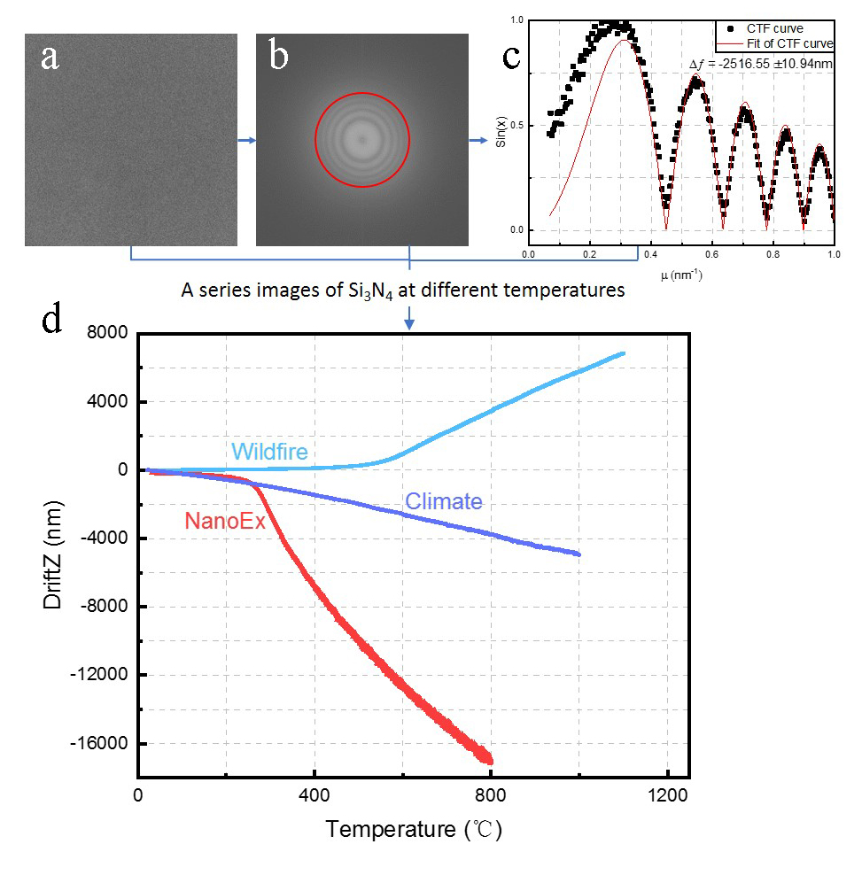
Figure S1. Workflow of bulgy height calculation using Thon-ring based precise sample position measurement. a) the HRTEM image of amorphous Si₃N₄ film acquired from the interested area of the nanochip; b) the Fourier transform pattern of image a; c) the integrated radial intensity profile (black dotted line) extracted from image b, and corresponding CTF fitting (red line) to calculate the defocus value; d) the overall evaluation about the height drift characteristics of three commercially available nanochips during practical heating process.

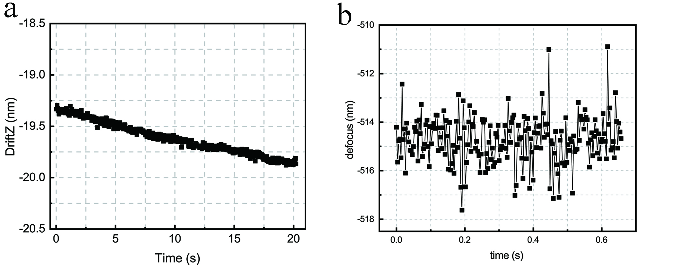
Figure S2. a. The height of the Si₃N₄ film in the Z direction changes under the affection of the electron beam at room temperature. b. The height of the Si₃N₄ film in the Z direction changes when the chip is heated at 150°C.

