Al₂O₃ grain boundary segregation in a thermal barrier coating on a Ni-based Superalloy

Supplementary Material
The compositional fluctuations of the main constituent elements, Al and O, across grain boundaries are plotted in Figure S1. All four grain boundaries exhibited a slight depletion of Al balanced by the higher concentrations of REs. This can be attributed to the substitution of Al by REs, as was experimentally observed in Hf-doped alumina samples using the high-resolution scanning transmission electron microscope (HR-STEM) (Yu et al., 2013).
At the grain boundaries, the slight increase in oxygen concentrations (~0.5 at.%) is relative to the local atomic densities and should not be interpreted as oxygen segregating to the grain boundaries. The concentration of Al₂O₃ grains shows some extent of oxygen deficits that are commonly observed for APT. The cause of oxygen deficit remains an active area of research, but commonly accepted explanations include DC evaporation, dissociation, and multihit events (Devaraj et al., 2013; Bachhav et al., 2011). A stronger oxygen deficit is observed in Figure S1(c) compared to the rest, because the analysis of GB3 was carried out using a higher effective laser pulse energy.
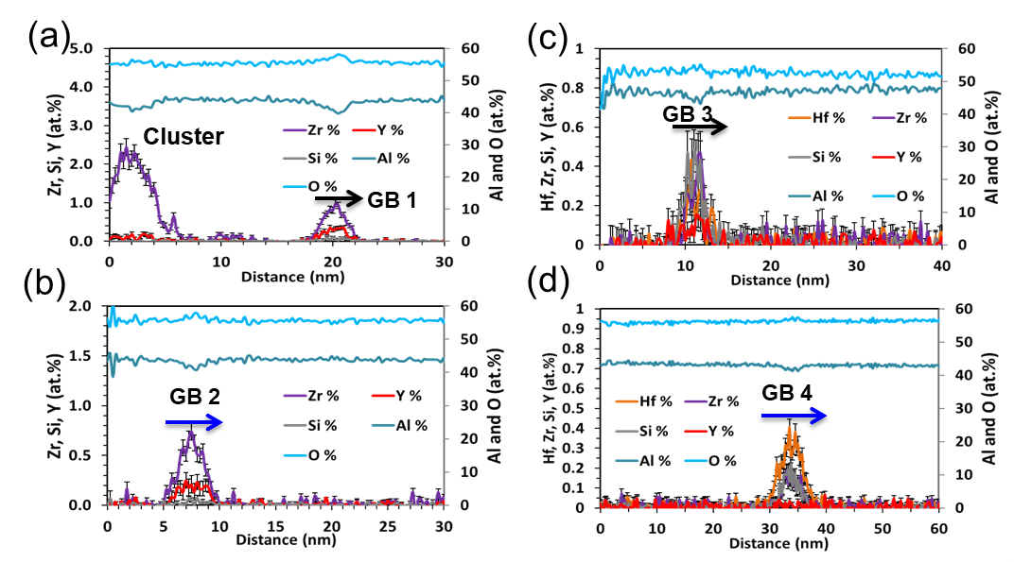
Figure S1. 1D concentration profiles taken across grain boundaries where (a) for GB1, (b) for GB2, (c) for GB3, and (d) for GB4. In each plot, the Al and O concentrations are shown on the secondary axis to the right.
References:
Bachhav, M., Danoix, R., Danoix, F., Hannoyer, B., Ogale, S. & Vurpillot, F. (2011). Investigation of wustite (Fe1-xO) by femtosecond laser assisted atom probe tomography. Ultramicroscopy 111, 584–588.
Devaraj, A., Colby, R., Hess, W., Perea, D. E. & Thevuthasan, S. (2013). Role of photoexcitation and field ionization in the measurement of accurate oxide stoichiometry by laser-assisted atom probe tomography. Journal of Physical Chemistry Letters 4, 998–1003.
Yu, Z., Wu, Q., Rickman, J. M., Chan, H. M. & Harmer, M. P. (2013). Atomic-resolution observation of Hf-doped alumina grain boundaries. Scripta Materialia 68, 703–706.

