Supplementary Material
Sub-pixel tomographic methods for characterising the solid architecture of foams
Paula Cimavilla-Románª*, Saúl Pérez-Tamaritª, Suset Barroso-Solares^{a,b}, Javier Pinto^{a,b}, Miguel Ángel Rodríguez-Pérez^{a,b}
ª Cellular Materials Laboratory (CellMat), Condensed Matter Physics Department, University of Valladolid, Paseo Belen 7, Valladolid 47011, Spain
^{b}BioEcoUva. Research Institute on Bioeconomy, University of Valladolid
* Correspondence: Paula Cimavilla Román (E-mail: paulacimavilla@fmc.uva.es)

S1 Attenuation Density Function of the Polymer Matrix
Figure 2 (b) in the manuscript was obtained after applying the workflow detailed in Figure S1. To obtain the gas phase histogram (Figure S1(f)) the original tomography volumes had to be binarised. A satisfactory binarisation of the gas phase was achieved after applying the 2D Anisotropic Diffusion filter implemented in Fiji (parameters: 20 iterations, smooth 1, diffusion limiter along minimal variation 0.5, diffusion limiter along maximal variation 0.9, time step 20, and edge threshold 10). The diffusion filter permitted to homogenise the attenuation values of gas inside the cells. To ensure correct subtraction of the attenuation density functions the volume fraction of gas binarised had to be equivalent to the macroscopic porosity of the sample. Finally, to obtain Figure 2 (b) in the manuscript the subtraction of the probability density plots in Figure S1 (b) and (f) was performed numerically.
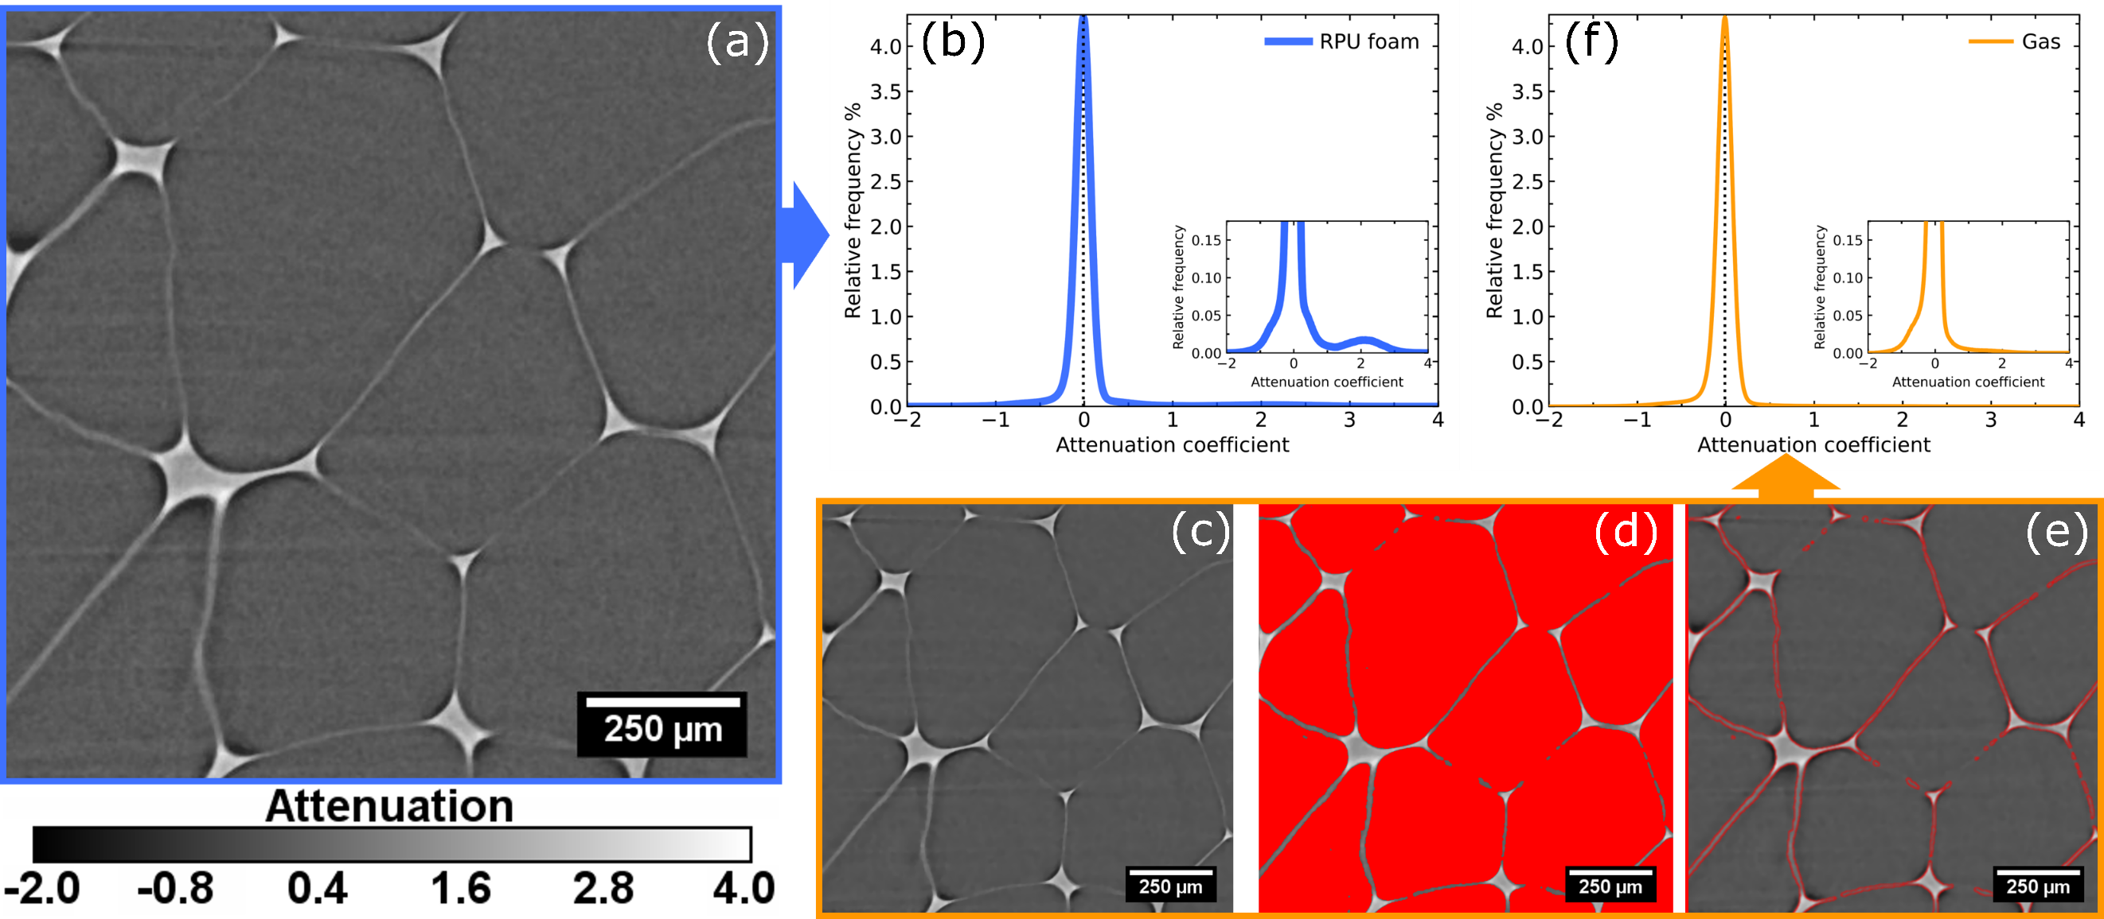
Figure S1: Workflow for obtaining the solid phase attenuation density function (Figure 2 (b)). From the lab-scale tomography volumes (a), the attenuation density function for the foam (gas + polymer) is then calculated performing a spline interpolation to the attenuation values histogram (bin size: 0.01) (b). Next, an anisotropic diffusion filter was applied to the lab-scale tomography volumes (c), and the filtered volume was binarised to obtain the gas phase inside the cells (d). ROIs were created from the binarised volume (e) and after applying them on the original lab-scale reconstructed volumes (a) the attenuation density function of the gas could be computed (f).
S2 Normalisation factor: Watershed segmentation method
Eq (7) in the manuscript is obtained following the derivation detailed in Figure S2.
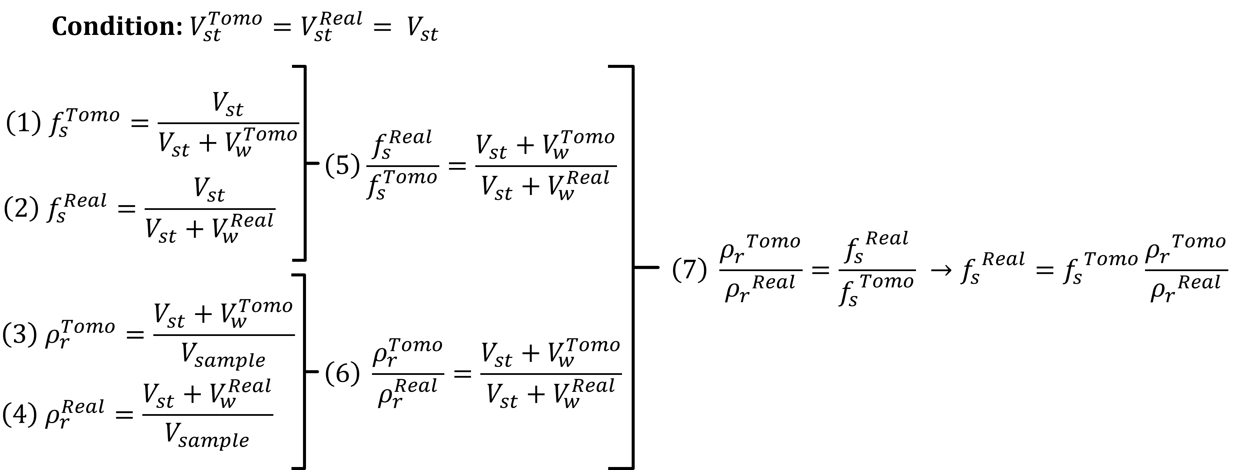
Figure S2: Steps to obtain the normalisation factor for the fraction of mass in the struts obtained from laboratory tomographies using the Watershed segmentation method.
S3 Volume fraction of polymer in sub-pixel cell walls
Using eq. 3 in the manuscript and the right attenuation coefficients of the gas and polymer phase it is possible to obtain the fraction of polymer in the under-resolved cell walls. However, the choice of an attenuation coefficient for each phase is not obvious since gas or high thickness polymer regions (struts) show a spectrum of attenuation values (Figure S1 (f) and Figure 9). To obtain reasonable results ${\overline{μ}}_{s}$ must be the minimum attenuation value of solid with thickness above the pixel size (for RPU foams that is the minimum value of the struts attenuation density function Figure 9 (a)). Using larger attenuation values for ${\overline{μ}}_{s}$ would imply that solid elements thicker than the pixel size are, according to eq. 3, a mix of gas and solid phase. Therefore, any value below ${\overline{μ}}_{s}$ will correspond to regions with sizes below the pixel size. For the gas phase the representative attenuation coefficient (${\overline{μ}}_{g}$) can be obtained from the probability density function in Figure S1(f). The average value of the density function is approximately 0 (exact value -0.007) excluding shading areas. In Figure S3 (a) the change in attenuation with the volume fraction of polymer can be seen. In addition, the cell walls attenuation probability density function in Figure 9 (a) was transformed into volume fraction of solid using eq. 3. Then, assuming that the solid thickness in partial pixels is equal to the volume fraction times the pixel size the probability density function of the cell walls can be expressed in terms of its thickness (Figure S3 (b)).
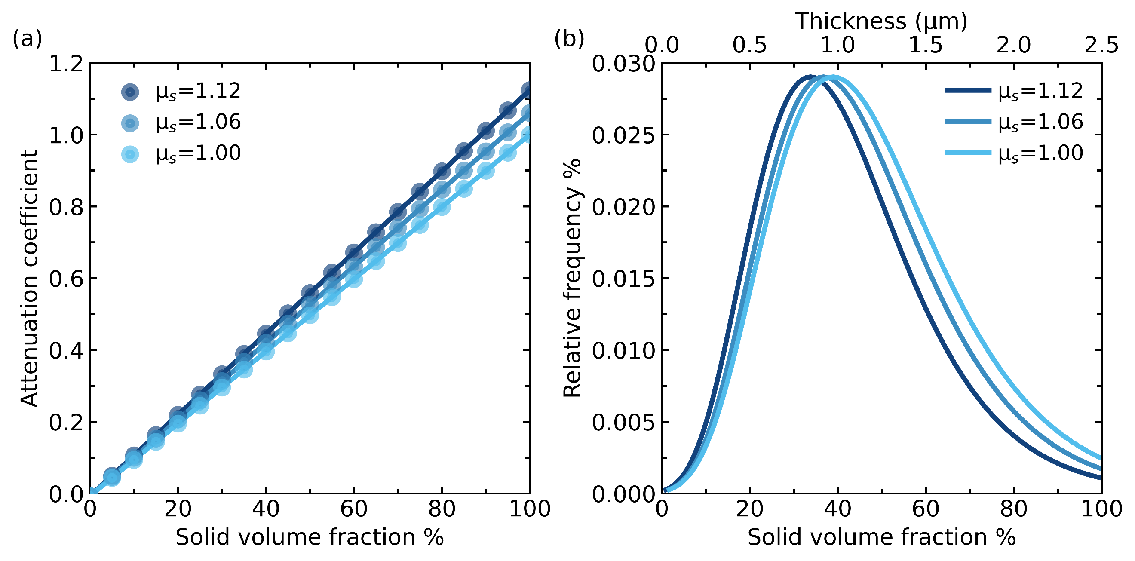
Figure S3: (a) The increase in attenuation coefficient of partial pixels (solid+gas) with the fraction of solid is calculated for three different values of ${\overline{μ}}_{s}$ (pure solid attenuation). (b) The cell walls probability density function is presented in terms of the fraction of solid and solid thickness for three different values of ${\overline{μ}}_{s}$.

