Supporting Materials
Accurate and Robust Calibration of the Uniform Affine Transformation Between Scan-Camera coordinates for Atom-Resolved In-Focus 4D-STEM Datasets

Shoucong Ning^{1, 2}, Wenhui Xu^{3, 4}, Yinhang Ma⁵, Leyi Loh¹, Timothy J. Pennycook⁶, Wu Zhou⁵, Fucai Zhang³, Michel Bosman¹, Stephen J. Pennycook⁵, Qian He¹*, N. Duane Loh^{2,7,8}*

- Department of Materials Science and Engineering, National University of Singapore, 117575, Singapore
- Center for Bio-Imaging Sciences, National University of Singapore, 117557, Singapore.
- Department of Electrical and Electronic Engineering, Southern University of Science and Technology, Shenzhen 518055, China
- Harbin Institute of Technology, Harbin, 150001, China
- School of Physical Sciences and CAS Key Laboratory of Vacuum Physics, University of Chinese Academy of Sciences, Beijing, 100049, China
- EMAT, Universiteit Antwerpen, Campus Groenenborger, 2020 Antwerpen, Belgium
- Department of Physics, National University of Singapore, 117551, Singapore.
- Department of Biological Sciences, National University of Singapore, 117557, Singapore.

Table of Contents

S1 Coordinate system transformation between the $Jscan$ and the $Jdet$ matrices 3
S2 STEM image simulation parameters. 4
S3 The selection of target functions in the J-matrix method. 6
S5 About the Weighted J-Matrix. 10
S6 Other factors influencing the accuracy of the J-matrix method. 11
S7. First-order disk shift vector Q. 13
S8. The Algorithm of fitting first-order disks. 14
S9 The reconstructed object using different aberration correction results. 18
S10 ePIE reconstruction of an experimental dataset. 19
S11 Experimental 4D-STEM dataset of MoS₂. 20
S12 Simulated 4D-STEM datasets of thick specimens. 22
S13 Performance of the hybrid method at the cases of low electron doses. 23
S14 Testing the hybrid method on simulated amorphous carbon. 25
S15 Estimation of computation time/requirement for a typical 4D-STEM dataset between the case of using the hybrid method and the case of using the J-matrix method alone. 26
Reference 26

S1 Coordinate system transformation between the $J_{scan}$ and the $J_{det}$ matrices

Using the camera coordinates that is Cartesian as a reference, if the scanning coordination system has been uniformly rotated for an angle $θ$, then
$$h=\left(\cos{θ},\sin{θ}\right)*∆$$
$$v=(-\sin{θ}, \cos{θ})*∆$$
where $h$ is the fast-scanning direction, and $v$ is the slow scanning direction, $Δ$ is the scan interval in the sample plane and the scan interval along the fast and slow scanning direction is assumed to be the same for a conventional raster scanning. In the reciprocal space, we have:
$$k_{h}=(\cos{θ}, \sin{θ})/∆$$
$$k_{v}=(-\sin{θ}, \cos{θ})/∆$$
where $k_{h}$ and $k_{v}$ is the corresponding reciprocal vectors of $h$ and $v$, respectively. Using the chain rule, the gradient of a $E_{x}$ components of the electric field along the horizontal direction of the camera coordinates is formulated as:
$$\frac{∂E_{x}}{∂x}=\frac{∂E_{x}}{∂h}*\frac{∂h}{∂x}+\frac{∂E_{x}}{∂v}*\frac{∂v}{∂x}=∆\frac{∂E_{x}}{∂h}*\cos{θ}-∆\frac{∂E_{x}}{∂v}*\sin{θ}$$
$$\frac{∂E_{x}}{∂y}=\frac{∂E_{x}}{∂h}*\frac{∂h}{∂y}+\frac{∂E_{x}}{∂v}*\frac{∂v}{∂y}=∆\frac{∂E_{x}}{∂h}*\sin{θ}+∆\frac{∂E_{x}}{∂v}*\cos{θ}$$
The $E_{y}$ component of the electric field E along the vertical direction of the camera coordinate can be formulated in the same way.
$$\frac{∂E_{y}}{∂x}=\frac{∂E_{y}}{∂h}*\frac{∂h}{∂x}+\frac{∂E_{y}}{∂v}*\frac{∂v}{∂x}=∆\frac{∂E_{y}}{∂h}*\cos{θ}-∆\frac{∂E_{y}}{∂v}*\sin{θ}$$
$$\frac{∂E_{y}}{∂y}=\frac{∂E_{y}}{∂h}*\frac{∂h}{∂y}+\frac{∂E_{y}}{∂v}*\frac{∂v}{∂y}=∆\frac{∂E_{y}}{∂h}*\sin{θ}+∆\frac{∂E_{y}}{∂v}*\cos{θ}$$
Rewrite above equations for both $E_{x}$ and $E_{y}$ as a matrix multiplication:
$$\left[\begin{matrix}\frac{∂E_{x}}{∂x} & \frac{∂E_{y}}{∂x} \\ \frac{∂E_{x}}{∂y} & \frac{∂E_{y}}{∂y}\end{matrix}\right]=∆\left[\begin{matrix}\cos{θ} & -\sin{θ} \\ \sin{θ} & \cos{θ}\end{matrix}\right]\left[\begin{matrix}\frac{∂E_{x}}{∂h} & \frac{∂E_{y}}{∂h} \\ \frac{∂E_{x}}{∂v} & \frac{∂E_{y}}{∂v}\end{matrix}\right]$$
where $E_{x}$ and $E_{y}$ are the electric field components determined from the diffraction patterns in the camera coordinates. $\left[\begin{matrix}\frac{∂E_{x}}{∂h} & \frac{∂E_{y}}{∂h} \\ \frac{∂E_{x}}{∂v} & \frac{∂E_{y}}{∂v}\end{matrix}\right]$ can be numerically computed for each scanning position.

S2 STEM image simulation parameters.

The simulated datasets shown in Figures 1, 2, 3, S3, 5, and 8 are generated using the same sample and same machine parameters. The defocus is set to 0. The accelerating voltage is set to 80 kV, the probe forming lens aperture is set to 30mrad, and the size of the electron probe is set to 256*256 pixels. The maximum angle of the diffraction patterns is set to 120 mrad, indicating a 44.6Å sptial extend and a 0.17 Å sampling interval of the probe. In the simulated data used in Figure 8, the aperture is reduced to 24 mrad, and the pixel number and spatial extend of the probe is the same as Figure1 (b-e). The CUDAEM code developed by Dr. Ning is used for the simulations, the slice thickness is set to 0.5 Å, and the phonon configuration number is set to 80 to consider the thermal diffuse scattering. Figure2 III and Figure3 share the same simulation parameters except for probe-forming lens settings to consider residual lens aberrations.
In the simulation of the 4D-STEM dataset of thick MoS₂ sample shown in Figure 7 and Figure S9, the accelerating voltage, the probe forming lens aperture and the size of the electron probe are kept the same as monolayer MoS₂. The slice thickness is set to 0.5 angstroms, and the number of phonon configurations is set to 40. As shown in Figure S1, compared to the position averaged CBED (PACBED) of the monolayer MoS₂, the boundary of the bright field aperture of thick MoS₂ with 30nm thickness is interrupted due to the multiple scattering.
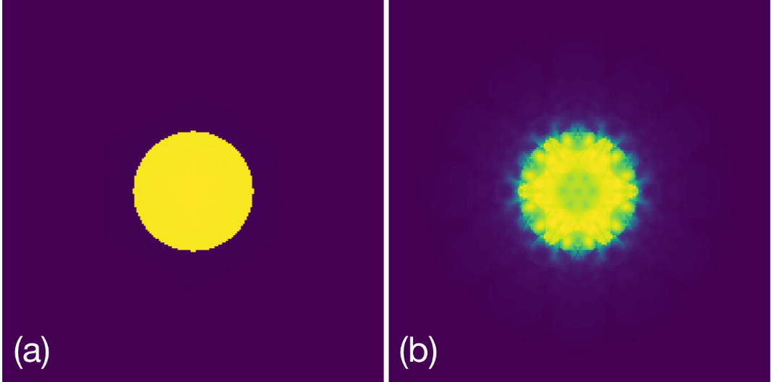
Figure S1. The averaged CBED patterns of (a) monolayer MoS₂ and (b) 30nm thick MoS₂.

S3 The selection of target functions in the J-matrix method.

The published method (Hachtel et al., 2018) identifies the uniform rotation angle by either maximizes the charge density or minimizes the curls of the electric field, which are mathematically equivalent. In the J-matrix method, the sum of the difference between the squared diagonal terms (charge density) and non-diagonal terms (curls) are combined as one target function in the determination of the uniform rotation angle $θ$ in order to improve the signal to noise ratio in practice. The Jacobian matrix $J_{det}$ computed in the camera coordinates is given in EQ2 in the main text as:
$J_{det}=∆\left[\begin{matrix}\cos{θ} & -\sin{θ} \\ \sin{θ} & \cos{θ}\end{matrix}\right]J_{scan}=\left[\begin{matrix}J_{1}^{'} & J_{2}^{'} \\ J_{3}^{'} & J_{4}^{'}\end{matrix}\right]$
where $J_{scan}=[J_{1}, { J}_{2}; J_{3}, J_{4}]$ is numerically computed in the coordinate system of the scanning coordinate system for each scanning position. Assuming $∆ =1$ ($∆$ does not influence the determination of rotation angle), the sums of each squared diagonal at all scanning position is:
$$\sum{{J_{1}^{'}}^{2}}=\sum{{(J_{1}\cos{θ}-J_{3}\sin{θ})}^{2}}=\sum{J_{1}^{2}\cos^{2}{θ}+J_{3}^{2}\sin^{2}{θ}-2J_{1}J_{3}\cos{θ}\sin{θ}}$$

$$\sum{{J_{4}^{'}}^{2}}=\sum{{(J_{2}\sin{θ}+J_{4}\cos{θ})}^{2}}=\sum{J_{4}^{2}\cos^{2}{θ}+J_{2}^{2}\sin^{2}{θ}+2J_{2}J_{4}\cos{θ}\sin{θ}}$$
Then the sums of the squared diagonal at all scanning position is:
$$\sum{({J_{1}^{'}}^{2}+{J_{4}^{'}}^{2})}=\sum{\left(J_{1}^{2}+J_{4}^{2}\right)\cos^{2}{θ}+\left(J_{2}^{2}+J_{3}^{2}\right)\sin^{2}{θ}+2(J_{2}J_{4}-J_{1}J_{3})\cos{θ}\sin{θ}}$$
Since $2\cos{θ}\sin{θ}=\sin{2θ}$, $\cos^{2}{θ}=(\cos{2θ}+1)/2$, $\sin^{2}{θ}=(1-\cos{2θ})/2$, the above equation will be updated as:
$$\sum{({J_{1}^{'}}^{2}+{J_{4}^{'}}^{2})}=\sum{\left(J_{1}^{2}+J_{4}^{2}\right)(\cos{2θ}+1)/2+\left(J_{2}^{2}+J_{3}^{2}\right)(1-\cos{2θ})/2+(J_{2}J_{4}-J_{1}J_{3})\sin{2θ}}$$
A simple form will be derived by separating the constant and variates:
$$\sum{({J_{1}^{'}}^{2}+{J_{4}^{'}}^{2})}= cos2θ\frac{\sum{\left(J_{1}^{2}+J_{4}^{2}-J_{2}^{2}-J_{3}^{2}\right)}}{2}+sin 2θ\sum{ \left(J_{2}J_{4}-J_{1}J_{3}\right)}+\sum{(J_{1}^{2}+J_{2}^{2}+J_{3}^{2}+J_{4}^{2})}/2$$
Similarly, the integrated squared non-diagonal terms of $J_{det}$ at rotation angle θ at all scanning positions is:
$$\sum{({J_{2}^{'}}^{2}+{J_{3}^{'}}^{2})}= cos2θ\sum{\frac{\left(J_{2}^{2}+J_{3}^{2}-J_{1}^{2}-J_{4}^{2}\right)}{2}}+sin 2θ \sum{\left(J_{1}J_{3}-J_{2}J_{4}\right)}+\sum{(J_{1}^{2}+J_{2}^{2}+J_{3}^{2}+J_{4}^{2})}/2$$
Consequently, maximizing the squared diagonal terms or minimizing the squared non-diagonal terms are equivalent. Practically, in order to improve the signal to noise ratio, both the charge density and the curl are used in the J-matrix method as the target function $T(θ)$ to determine the uniform rotation angle $θ$:
$$T\left(θ\right)= \sum{({J_{1}^{'}}^{2}+{J_{4}^{'}}^{2})}- \sum{\left({J_{2}^{'}}^{2}+{J_{3}^{'}}^{2}\right)}=- cos 2θ\sum{(J_{2}^{2}+J_{3}^{2}-J_{1}^{2}-J_{4}^{2})}+2sin 2θ \sum{(J_{2}J_{4}-J_{1}J_{3})}$$
When $∂T(θ)/∂θ$ equals zero, the uniform rotation angle $θ$ is analytically given as EQ3 in the main text:
$$tan2θ=2\sum{(J_{2}J_{4}-J_{1}J_{3})}/\sum{(J_{1}^{2}+J_{4}^{2}-J_{2}^{2}-J_{3}^{2})}$$

S4 Influence of chirality change on ptychography reconstruction.

To show the influence of incorrect initialization of scanning positions, the simulated 4D STEM dataset of single-layered graphene is used. The whole dataset consists of 64*64*256*256 pixels, the defocus and aperture of the probe are set to 40nm and 30 mrad, respectively. The accelerating voltage is 60 kV, and the maximum angle in the diffraction pattern is set to 120 mrad, indicating a 0.2 Å sampling interval. There is no rotation between the CBED frames and scanning positions of the probe. The scanning interval along both directions is 0.65 angstroms, and this interval ensures the uniqueness of reconstructed results. The ePIE approach (Maiden & Rodenburg, 2009) is adopted in the reconstruction of the object and electron probe, and only the bright field signal of CBED patterns is used. The reconstructed object has almost no changes after 100 iterations; the phase angle of the reconstructed result is plotted in Figure S2 (a). As shown, the phase distribution of carbon atoms inside the scanned area matches the atomic structures of graphene. The outline of the atomic model is successfully retrieved, and an extension of this model is also observed due to the periodic boundary condition adopted in the multislice simulation. When a π-rotation is applied to the scanning positions, the reconstructed object phase distribution (Figure S2 (b)) shows inverted contrast compared to Figure S2 (a). The negative phase values at carbon atoms consist of the electric field in Figure 1 (e). In Figure S2(c), further ptychography reconstruction is conducted with flipped fast scanning direction and the determined object phase is shown. Different from the π-rotation case, there are almost no similarities between Figure S2(a) and Figure S2(c), the structure of graphene cannot be correlated with the reconstructed phase when the chirality of the scanning directions is changed.

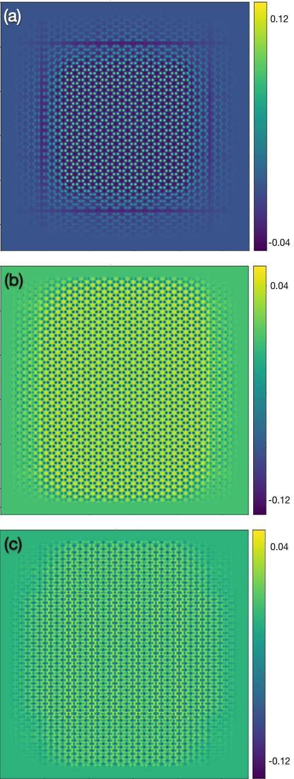
Figure S2. Ptychography reconstruction phase results using different scanning directions based on a simulated graphene 4D STEM dataset. (a). Reconstructed phase angle when the diffraction patterns are flipped and the scanning vectors are determined directly on modified diffraction patterns. (b). Reconstructed phase angle when the scanning vectors along the row and column direction are rotated by 180° referring to their correct values. (c). Reconstructed phase angle when the flip is applied to diffraction patterns but the corresponding probe positions of these diffraction patterns are the same as the values used in the simulation. Color bars represent the phase shift in the unit of radian. The accelerating voltage used in the simulation was 60kV.

S5 About the Weighted J-Matrix.

The weighted Jacobian matrix $J_{w}$ of the electric field is used to ensure the solution uniqueness of the J-matrix method and check the existence of the flip, and the weight used in the generation of $J_{w}$ is the signal having higher values at nuclei. Taking the simulated 4D-STEM dataset of monolayer MoS2 given in Figure 2(i) as an example. The ADF-STEM image of it is chosen as the weight matrix, and $J_{w}$ is computed by multiplying the ADF intensity at each scanning position with the terms of J-matrix. The integrated $J_{w}$ at all scanning positions at rotation angles 0° and 180° are listed in Table S1. At angle 0°, both two diagonal terms are positive, and they are right opposite to the 180° case. In comparison, the corresponding integrated squared J-matrix listed in Table S2 does not show any difference when the 180° rotation is applied.
$J_{w}$ terms | J1 | J2 | J3 | J4
0° | 2469.93 | 1.25 | 1.14 | 2504.16
180° | -2469.93 | -1.25 | -1.14 | -2504.16
Horizontal flip | -2469.93 | 1.25 | -1.14 | 2504.16
Table S1. The integrated terms of weighted Jacobian matrix at different geometrical configurations.
$J$ terms | J1 | J2 | J3 | J4
0° | 11547.11 | 4296.81 | 4296.81 | 11547.11
180° | 11547.11 | 4296.81 | 4296.81 | 11547.11
Horizontal flip | 11547.11 | 4296.81 | 4296.81 | 11547.11
Table S2. The integrated terms of the squared Jacobian matrix at different geometrical configurations.
Moreover, when the fast scanning direction h is flipped, the gradient of the electric field along this direction will become their negative values. As listed in Table S1, the two diagonal terms show different signs at rotation angles 0 and 180°, while the flip does not have any influences on the integrated terms of the squared J-matrix as shown in Table S2. Consequently, the weighted J-matrix $J_{w}$ must be computed to detect the flip and find the unique solution.

The flip of the scanning directions does not influence the determination of uniform rotation angle computed using EQ3 since the square of gradient terms listed in Table S2 is used. Consequently, we use EQ3 to determine the possible uniform rotation angles in practice. Then the integrated squared Jacobian matrix will be computed at these angles to exclude the two solutions. After that, the only solution and possible flip can be confirmed when integrated $J_{w}$ is known.

S6 Other factors influencing the accuracy of the J-matrix method.

In addition to the sampling interval, lens aberrations, and scanning distortions, other factors such as camera tilt, camera gain distribution, point spread function (PSF), incoherency, and the sample thickness are also evaluated in this part. In Figure S3 (a) and (b), a 10° rotation is applied to the electron camera and the vertical direction is taken as the rotational axis. Compared to the result computed in Figure 3 (a) and (b), the tilt of the cameras do not influence the accuracy of the J-matrix method. Moreover, the other properties of cameras such as PSF (Figure S3(g)) and gain distribution (Figure S3 (c) and (d)) also have negligible influence on the determined rotation angle. The incoherency of the electron microscope reduces the error by enhancing the spatial continuity of the electric field since the spatial resolution of the electron probe decreases. In addition, the temporal incoherence (Figure S3 (f)) has smaller influences on the accuracy compared to the spatial incoherent case (Figure S3 (e)) although the contrast of its CBED patterns has been more dramatically reduced. The surprising result appears when the sample thickness is considered as shown in Figure S3 (h) and (i). The increasing sample thickness reduces the error caused by the J-matrix method when a 25° rotation was applied to the CBED patterns. The dynamical scattering of the electrons in the thick specimen possibly eliminates the difference of properties of the computed electric field in both scanning directions.

To further explore the factors causing the error at the case with a 25° rotation, we rotate the CBED patterns in the dataset shown in Figure 2. I and IV from 0° to 45° with a 5° interval. As shown in Table S3, for both datasets, the computed angle obviously increases as the rotation angle increases, and symmetrically drops off at 45°. For the dataset with a 0.34Å scan interval, the angular error is more dramatic compared to the 0.17Å case. Consequently, the angular error is caused by the interruption of continuity of the electric field, and this error is a function of both rotation angle and the scan interval. The error disappears at 45° since the errors along the horizontal and the vertical direction cancel each other.
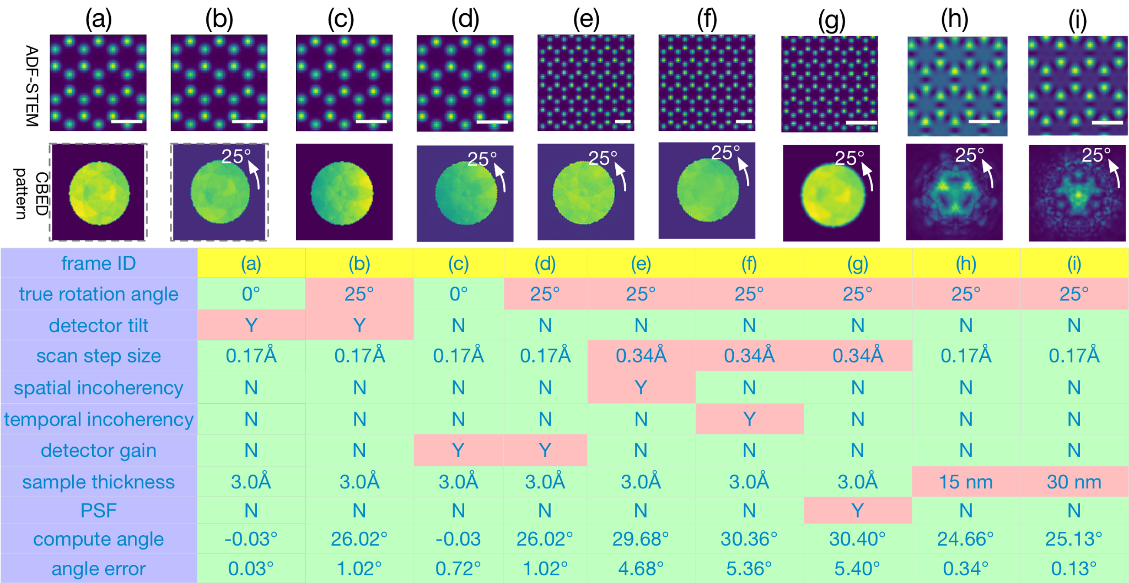
Figure S3. The influence of extra factors on the accuracy of the J-matrix method. (a-b) The camera is rotated by 10° along the vertical direction to consider the camera tilt. In (b), CBED patterns are rotated by 25° to introduce the sampling artifacts and differences of the electric field along with the horizontal and vertical directions. (c-d). The gain distribution of the camera is considered by applying a gain distribution function linearly increasing along the horizontal direction. As shown by the CBED patterns, the intensity is lower on the left part since the gain on the left is 0.4 and grows to 0.6 on the right border of the aperture. In (d), A 25° rotation is also applied. (e-f) The spatial and temporal incoherence is considered in the 4D-STEM simulation, the defocus spread is set to 4.88nm and the source size is set to 0.37 angstroms. In addition, the scanning step size is set to 0.34 angstroms for both cases. (g) The point spread function of the camera is considered by the convolution of CBED patterns with a Gaussian kernel, and the sigma value of the Gaussian kernel is set to 1.0 pixel. The scanning step size is the same as (e) and (f). In (h) and (i), the thickness of the sample increases to 15 nm and 30 nm, respectively, and the scanning step size is set to 0.17 angstroms. In addition, the CBED patterns are rotated by 25° to evaluate if the sample thickness can suppress the sampling artifacts and differences of the electric field in each scanning direction. The scale bars represent 3.0 Å. The accelerating voltage used in the simulation was 80kV and more details can be found in Supporting Materials S2.

Step size | 0° | 5° | 10° | 15° | 20° | 25° | 30° | 35° | 40° | 45°
0.34Å | 0.02° | 2.42° | 4.32° | 5.47° | 5.78° | 5.41° | 4.49° | 3.20° | 1.66° | 0.01°
0.17Å | 0.01 | 0.41° | 0.71° | 0.94° | 1.04° | 1.02° | 0.88° | 0.65° | 0.34° | 0.01°
Table S3. The influence of CBED rotation angles on the difference between the true rotation angle and computed rotation angle using the J-matrix method at 0.17 Å and 0.34Å scanning step size. As the rotation angle increases, the error increases and starts to drop off around 22.5°, and finally reduces to near zero at 45°. This phenomenon is due to the different properties of the electric field in different scanning directions and sampling artifacts.

S7. First-order disk shift vector Q.

Following the discussion in the section S1, the shift vector Q of the first order disks relative to the center disk in the G-slices with index (i, j) according to $k_{h}$ and $k_{v}$ is given as:
$$Q=ik_{h}+j k_{v}= (i*\cos{θ}-j*\sin{θ},i*\sin{θ}+j*\cos{θ})/∆$$
When the rotation angle and scanning interval are not uniform, we assume that there is an affine transformation between the scanning positions and the camera. Then the real space and reciprocal space vector of scanning directions are given as:
$$h=\left(\cos{θ_{x}},\sin{θ_{x}}\right)*∆$$
$$v=(-\sin{θ_{y}}, \cos{θ_{y}})*γ∆$$
In reciprocal space, the corresponding reciprocal space scanning frequency is:
$$k_{h}=(\cos{θ_{y}}, \sin{θ_{y}})/(∆^{'})$$
$$k_{v}=(-\sin{θ_{x}}, \cos{θ_{x}})γ/(∆^{'})$$
$$∆^{'}=∆(\cos{θ_{y}}\cos{θ_{x}}+\sin{θ_{x}}\sin{θ_{y}})$$
where $θ_{x}$, $θ_{y}$ are the rotation angle of the fast and slow scanning direction, respectively. $∆^{'}$ equals $∆$ only when $θ_{x}=θ_{y}$ due to the reciprocal relationship. The relationship between the Jacobian Matrix computed in scanning coordinate systems and camera coordinate systems is modified as:
$$\left[\begin{matrix}\frac{∂E_{x}}{∂x} & \frac{∂E_{y}}{∂x} \\ \frac{∂E_{x}}{∂y} & \frac{∂E_{y}}{∂y}\end{matrix}\right]=∆\left[\begin{matrix}\cos{θ_{x}} & -γ\sin{θ_{y}} \\ \sin{θ_{x}} & γ\cos{θ_{y}}\end{matrix}\right]\left[\begin{matrix}\frac{∂E_{x}}{∂h} & \frac{∂E_{y}}{∂h} \\ \frac{∂E_{x}}{∂v} & \frac{∂E_{y}}{∂v}\end{matrix}\right]$$
The shift vector Q of the first order disks relative to the center disk in the G-slices with index (i, j) is given as:
$$Q=(i*cos θ_{y} -j*γsin θ_{x} , i*sin θ_{y} +j*γcos θ_{x} )/∆^{'}$$

S8. The Algorithm of fitting first-order disks.

S7.1 Disk fitting algorithm
In the G-set slices of Fourier transformed 4D-STEM datasets, three disks including the direct disk and two first-order appear. The direct disk shares the same position with the aperture, and the other two first-order disks are relatively shifted referring to the direct disk with the opposite shift vectors Q and -Q. Here we proposed an algorithm to accurately determine the first order disk, or the shift vector Q by maximizing the similarity between the slice and the predicted slice using Q. For weak-phase objects, the non-overlapped area of these disks shows zero intensities. When there are almost no aberrations in the probe forming lens, the triple overlapped areas show zero intensities. When the residual aberrations appear, the intensity distribution inside the triple overlapped area cannot be easily predicted.

To estimate the intensity distribution after computing the shift vector of first-order disks using known geometric parameters, the bright field disk (Figure S4. (a)) is shifted with this vector and its inversion. The shifted frames (Figure S4. (b-c)) are summed and multiplied with the bright field disk to generate the intensity distribution of G-set slices as shown in Figure S4. (d). If there is no residual aberration, the triple overlapped region (the brightest part in Figure S4. (d)) can be set to zero. Now we can generate the ideal intensity distribution of G-set slices when Q is known as shown in Figure S4.
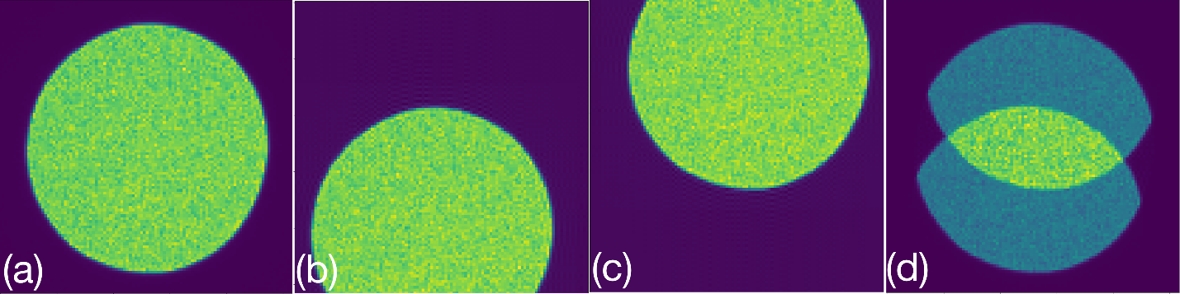
Figure S4. The generation of the intensity distribution in a G-set slice. (a) The zero-order disk, or the bright field disk. (b-c) The first-order disks determined using the provided disk shift vector, or the probe frequency vector computed using the geometric parameters and slice index. (d) Estimated intensity distribution in the G-set slice by summing (b) and (c), and masking with (a).
Using the cross-correlation between the intensity distribution of actual and estimated G-set slices (Figure S5. (a-b)) as the objective function, the Q, or the geometric parameters can be estimated iteratively using various optimization methods. The initialization of Q can be done manually or using the geometric parameters determined using the J-matrix method. Practically, we can select the slices with high spatial frequencies to get rid of the triple overlapped region. For the cases when the triple overlapped region appears in the G-set slices and the intensity distribution in this region varies, the gradient error between the actual and estimated G-set slices (Figure S5. (c-d)) can be used as the to be minimized target when optimizing Q.

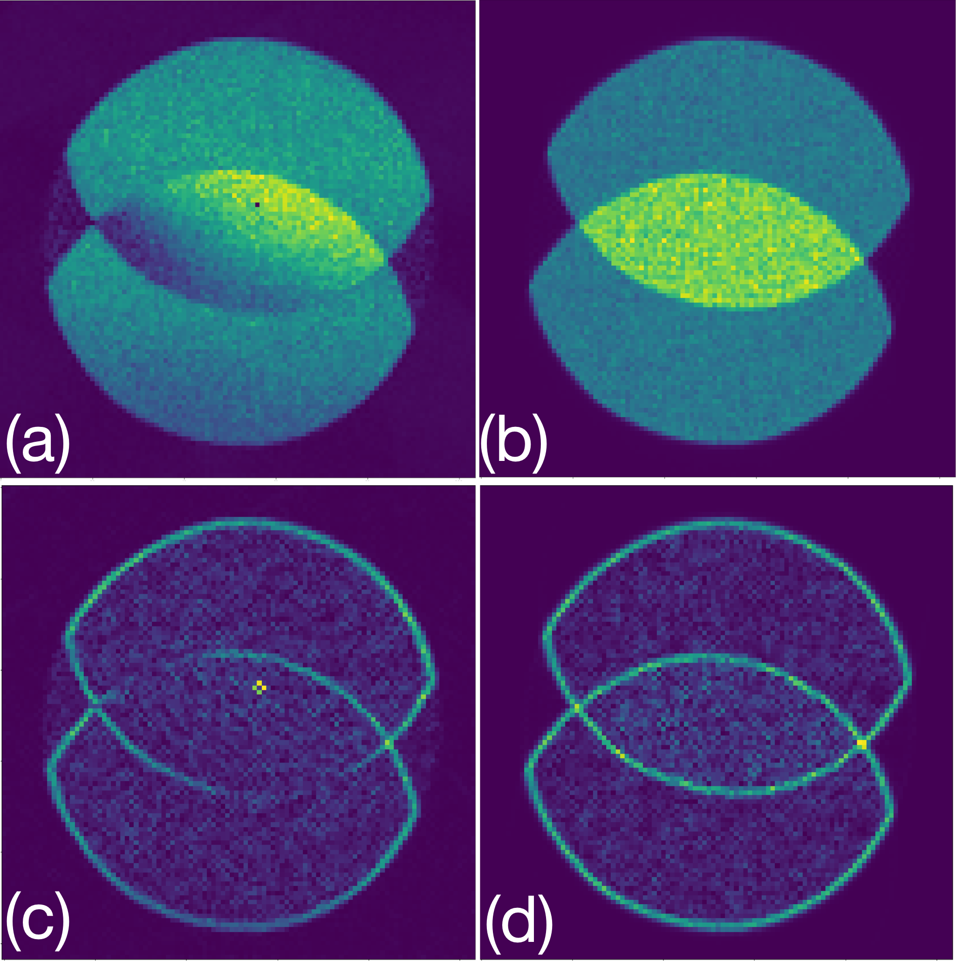
Figure S5. (a) Experimental G-set slice with index (i = 6, j=20). (b) Generated G-set slice using the refined geometric parameters. (c) Gradient of (a). (d) Gradient of (b).
S7.2 Procedures of the Fourier method
To get a better understanding of our Fourier method and its source code, the procedures of the Fourier method are given as follows.
      - Generate the position averaged CBED patterns on the 4D-STEM dataset and locate the center of the position averaged CBED pattern.
      - Trim the diffraction patterns of 4D-STEM dataset. The aperture must be included in the trimmed dataset, and the center of the position averaged CBED corresponds to the center of each trimmed diffraction pattern.
      - Apply Fourier transformation on the trimmed 4D-STEM dataset with respect to scan coordinates.
      - Plot the total intensity distribution on different probe frequencies, and select three slices in the G-sets with large total intensity values.
      - Determine the Q vectors in the selected slices using the disk fitting algorithm.
      - Compute the geometric parameters such as $θ_{x}$, $θ_{y}$, $∆'$ and $γ$ with the Q vectors of slices of the G-sets and their corresponding frequency index (i, j) by solving these equation groups:
$$\left\{\begin{aligned}i_{1}*∆^{'}cos θ_{y} -j_{1}*γ∆^{'}sin θ_{x}=Q_{x1} \\ i_{2}*∆^{'}cos θ_{y} -j_{2}*γ∆^{'}sin θ_{x}=Q_{x2} \\ i_{3}*∆^{'}cos θ_{y} -j_{3}*γ∆^{'}sin θ_{x}=Q_{x3}\end{aligned}\right.$$
$$\left\{\begin{aligned}i_{1}*∆^{'}sin θ_{y} +j_{1}*γ∆^{'}cos θ_{x} =Q_{y1} \\ i_{2}*∆^{'}sin θ_{y} +j_{2}*γ∆^{'}cos θ_{x} =Q_{y2} \\ i_{3}*∆^{'}sin θ_{y} +j_{3}*γ∆^{'}cos θ_{x} =Q_{y3}\end{aligned}\right.$$
Where $Q_{x}$ and $Q_{y}$ are the horizontal and the vertical components of Q, respectively. The $i_{1}$, $i_{2}$, $i_{3}$ are the horizontal index of three slices, and $j_{1}$, $j_{2}$, $j_{3}$ are their vertical indexes. From these two equation groups, the $∆^{'}cos θ_{y}$, $∆^{'}sin θ_{y}$ and $γ∆^{'}sin θ_{x}$, $γ∆^{'}cos θ_{x}$ can be solved firstly. Then $θ_{x}$, $θ_{y}$ are known. Then the $∆^{'}$ and $γ$ can be determined by solving these six linear equations with the least square method. When $θ_{x}$, $θ_{y}$ and $∆^{'}$ are known, $∆$ can be solved using the following relationship:
$$∆^{'}=∆(\cos{θ_{y}}\cos{θ_{x}}+\sin{θ_{x}}\sin{θ_{y}})$$

S9 The reconstructed object using different aberration correction results.

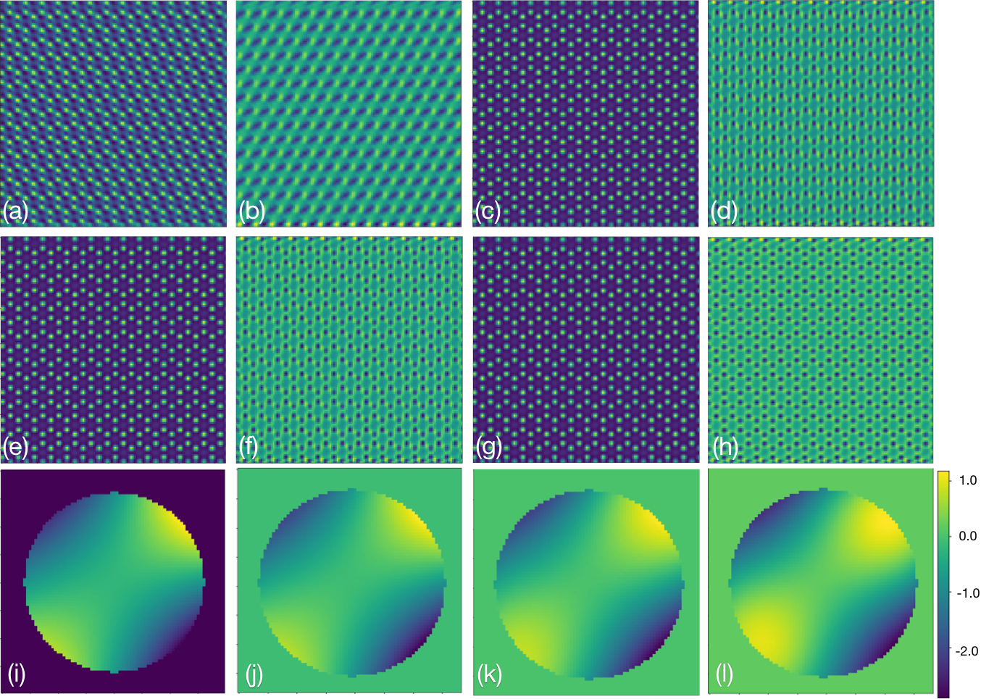
Figure S6. Reconstructed object functions using SSB methods on the simulated dataset VI shown in Figure 2 and Table 1. (a-b) Phase and amplitude distribution of the reconstructed object function without aberration correction. (c-d) Reconstructed object function with the aberration coefficient determined with a 5° error. (e-f) Reconstructed object function with the aberration coefficient determined with a 2.5° error. (g-h) Reconstructed object function with the aberration coefficient determined without angular error. (i) The phase shift in the aperture of the probe forming lens according to the aberration coefficient listed in Table 2. (j-l) The determined phase shift using SSB method in the aperture of the probe forming lens when the rotation angle error is 0°, 2.5°, and 5°, respectively. A good match between the (i) and (j) is observed, and the discrepancy becomes dramatic as the increase of the rotation angle error. Color bars of (i-l) represent phase shift in the unit of radian.

S10 ePIE reconstruction of an experimental dataset.

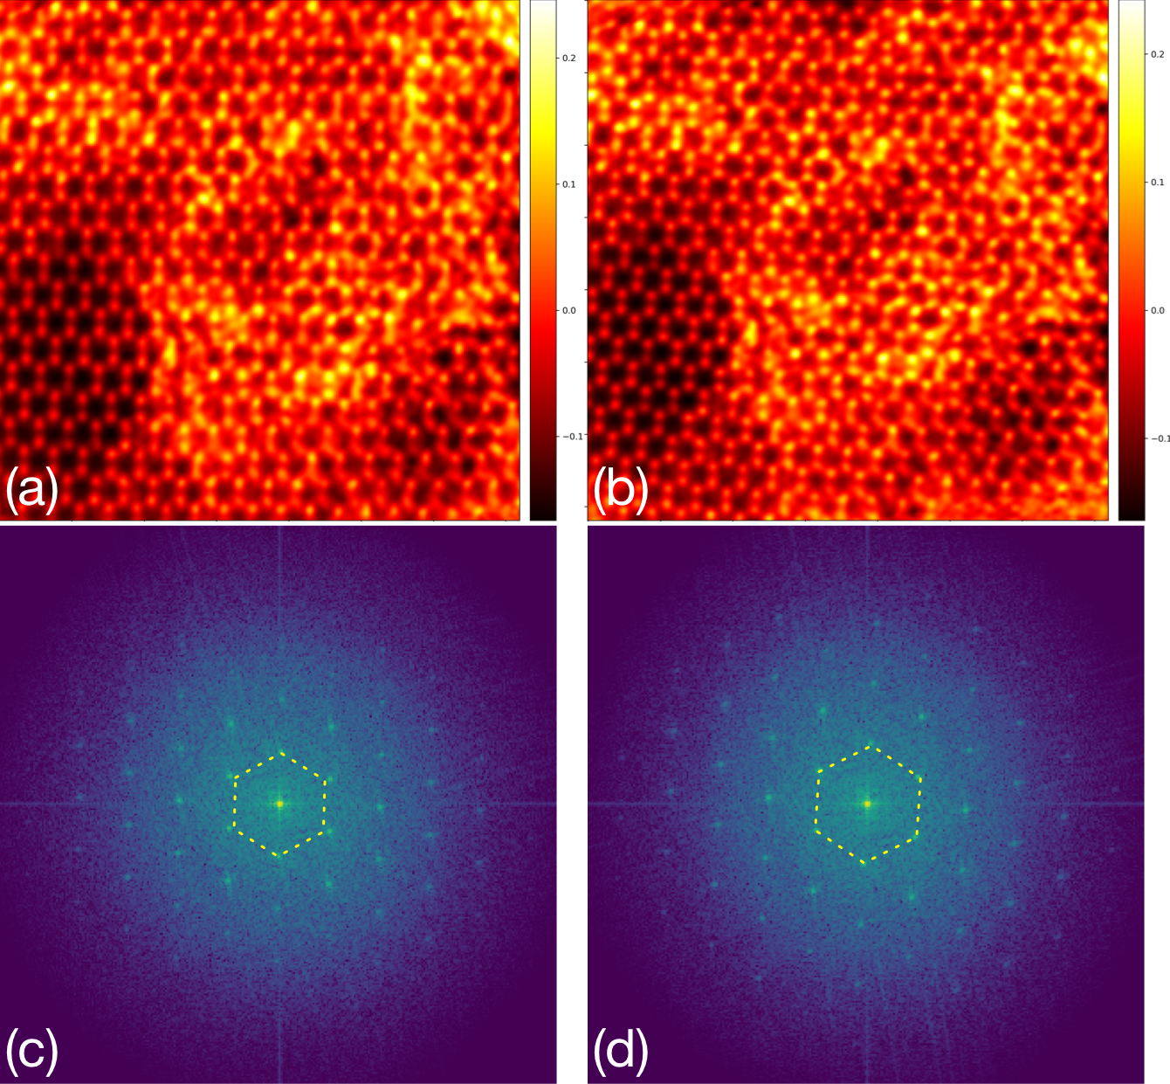
Figure S7. The phase-angle distribution and power spectrum of retrieved object using iterative ePIE reconstruction, the experimental 4D-STEM dataset shown in Figure 6 is used. (a-b) The reconstructed object phase with the scanning positions initialized with the J-matrix method and hybrid method, respectively. (c-d) The corresponding power spectrums of computed objects with the J-matrix and hybrid calibration method, respectively. A more obvious lattice distortion in (a) compared to (b) due to uncorrected uniform scan distortions can be visualized with the help of a dash hexagon reference overlaid on the power spectra. Color bars represent the phase shift in the unit of radian.
In the ePIE reconstruction of the experimental dataset in Figure 6, the position correction is enabled for both cases after the 30th iteration. An obvious elongation of the lattice is still observed in Figure S7(a) and the uniform deformation of the scanning positions is not eliminated during position correction after 500 iterations. This experimental result well matches our simulations in Figure 8. In comparison, the honeycomb-structured lattice of MoS₂ is recovered in Figure S7 (b) when our hybrid method is adopted. More evidences are provided by the Bragg peaks corrected using a ortho-hexagon in the power spectrum of the reconstructed object (Figure S7 (d)). In comparison, the power spectrum of the object with J-matrix method does not only show a degradation of resolution, especially along the vertical directions, but the {1100} Bragg peaks deviate from the hexagonal rings plotted using dotted yellow lines in Figure S7 (c).

S11 Experimental 4D-STEM dataset of MoS₂.

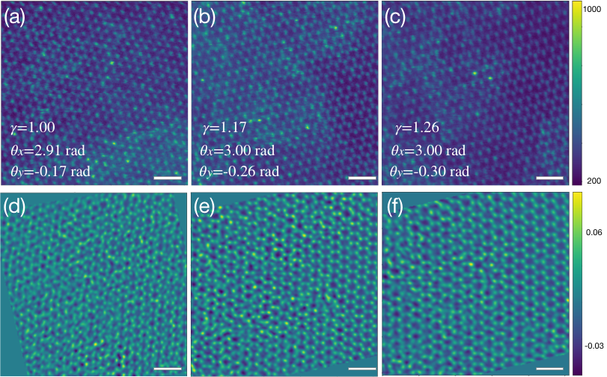
Figure S8. (a-c) Corresponding ADF-STEM images of three 4D-STEM datasets captured within the same time slot without change of samples. The sample is monolayer MoS2, and the model of the electron microscope is JEOL ARM200CF operating at 80 kV. The (b) and (c) suffer from more obvious scanning distortions compared to the (a) as indicated by the elongation of MoS2 hexagons along the vertical direction. (d-f). Reconstructed phase angles of (a-c). In (d-f), the scanning distortion is considered during the determination of shifted disk positions, and further compensated by applying an affine transformation to the 2D phase distribution as shown by the obvious outlines. The affine transformation successfully compensates for the uniform scanning distortion as indicated by the regular hexagons. Both local scan distortions and local strains due to defects remain in the image. Color bars in (a-c) represent the number of electrons. Color bars in (d-f) represent the phase shift in the unit of radian.

S12 Simulated 4D-STEM datasets of thick specimens.
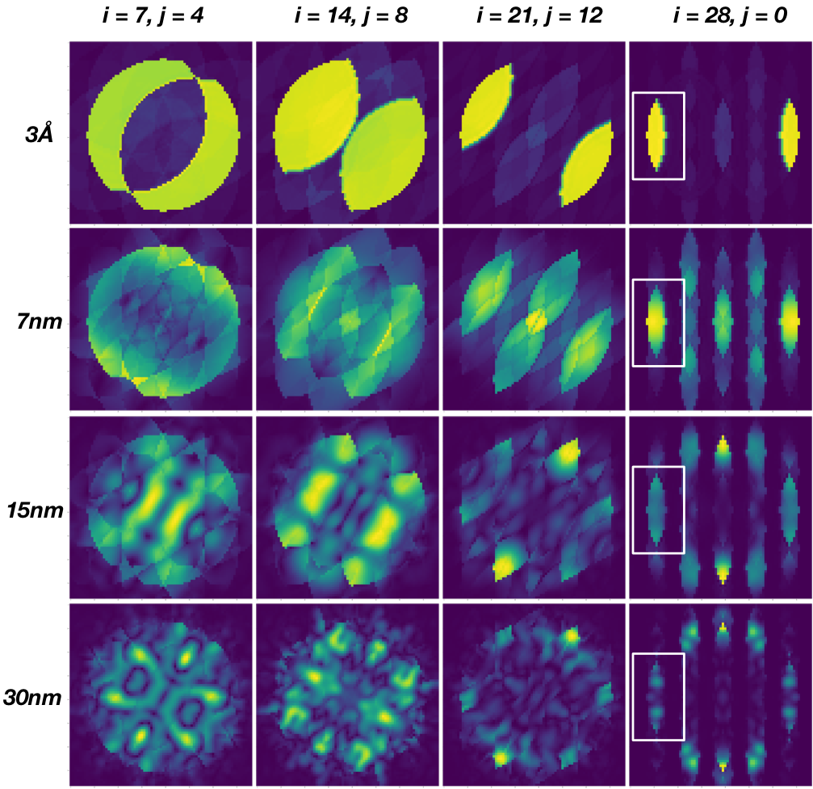
Figure S9. Simulated slices at different probe frequencies of 4D-STEM datasets of AA stacked MoS2 samples with sample thickness ranges from 3Å to 30 nm. The indexes of the probe frequencies, increasing from left to right, are (7, 4), (14, 8), (21, 12), (28, 0) respectively. The outline of the double-overlapped regions is the most obvious in the G-set slices of MoS₂ monolayer. As the sample thickness increase, the outlines of these regions are interrupted by the multiple scattering. The aperture in the averaged CBED patterns of the 30 nm MoS₂ specimen shown in Figure S1 also has an interrupted outline. Compared to the G-set slices indexed (7, 4), (14, 8), (21, 12), the double-overlapped regions marked by the white rectangles in (28, 0) G-set slice have clear outlines.

S13 Performance of the hybrid method at the cases of low electron doses.
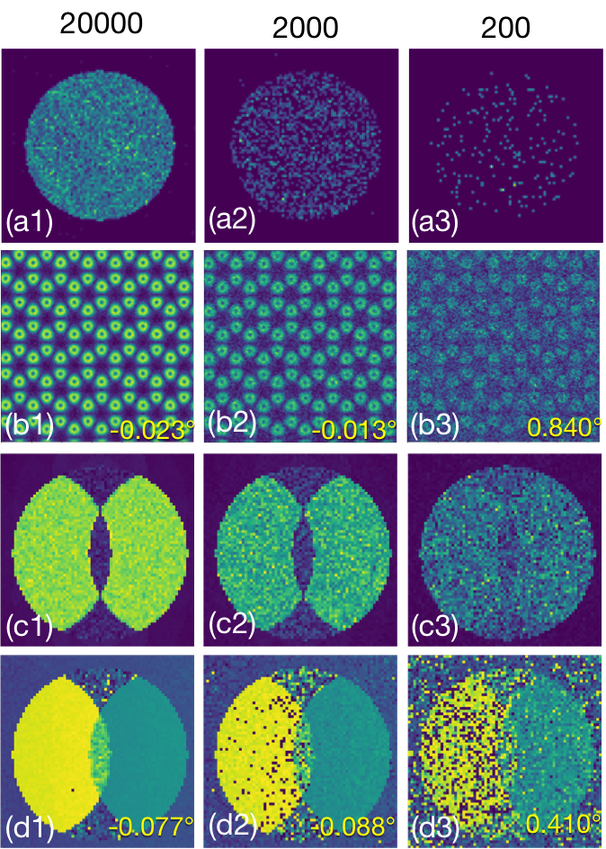
Figure S10. The low-dose performance of the J-matrix and the Fourier method involved in the hybrid method was evaluated using a similar on three simulated 4D-STEM datasets with electron doses of $6.6×{10}^{5}$, $6.6×{10}^{4}$, $6.6×{10}^{3}$ e/Å². These datasets are generated based on the simulated dataset shown in Figure 2 (I) with$128×128$ scanning positions, assuming 0° rotation angles between the scan-camera coordinates. Only random Poisson noise has been considered in the generation of low-dose datasets. (a1-a3) Representative diffraction patterns are taken from these three 4D-STEM datasets, the number of electrons for these diffraction patterns are roughly 20000, 2000, and 200, respectively. (b1- b3) The computed amplitude of the electric fields using these datasets, the contrast of the electric field degrades as the dose decreases. The determined uniform rotation angle using the J-matrix method are -0.023°, -0.013°, and 0.840°, respectively. (c1-c3). The amplitude distribution of the G-set slice is indexed (0, 14) in different cases. (d1-d3). The phase distribution of the G-set slice indexed (0, 14) at different doses. It becomes increasingly difficult to distinguish the outlines of the double-overlapped regions in G-set slices in both amplitude and phase pictures as the dose decreases. Using the phase images of the G-set slices, the rotation angle by fitting the diffracted disks are -0.077, 0.088, and 0.410, respectively. The accelerating voltage used in the simulation was 80kV and more details can be found in Supporting Materials S2.
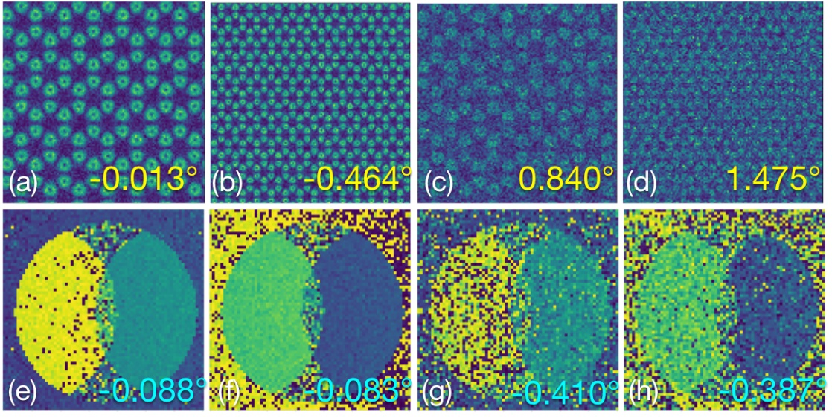
Figure S11. Additional discussion about the dose effect on the J-matrix method and the Fourier method. (a-d) The computed amplitude of the electric fields and the corresponding calibrated uniform rotation angles using the J-matrix method, which are -0.013°, -0.464°, 0.840° and 1.475°, respectively (e-h) The phase distribution of the G-set slice indexed (0, 28) and the corresponding calibrated uniform rotation angles using the Fourier method, which are -0.088°, -0.083°, -0.410° and -0.387°. (a) (e), (b) (f), (c) (g) and (d) (h) are obtained from the same simulated datasets. (b) and (d) are related to (a) and (c) in the way that the field of view was englarged by 4 times, but the total number of electrons in the dataset remain unchanged: (a,e) - $6.6×{10}^{4}$ e/Å²;(b,f) - $1.65×{10}^{4}$ e/Å² ; (c,g) - $6.6×{10}^{3}$ e/Å²; (d,h) - $1.65×{10}^{3}$ e/Å² . (a) and (c) are the same data as in Figure S10 (b2) and (b3), respectively. The accuracy of the Fourier method remains largely unchanged as long as the total number of electrons in the dataset were kept the same. This is not the case for the J-matrix method. The accelerating voltage used in the simulation was 80kV, with 128 by 128 probe positions and 0° angle between the scan-camera coordinates. More details can be found in Supporting Materials S2.

S14 Testing the hybrid method on simulated amorphous carbon.
The hybrid method was tested using a simulated 4D-STEM dataset of the amorphous carbon, which not only is more complicated than crystalline MoS₂, but also has small projected interatomic spacings within. As shown in Figure S12 below, we found that both the J-matrix method and the Fourier methods (two sub-routines for the hybrid method) behaves exactly the same as in the case of MoS₂ sample: (i) the J-matrix method is still able to find the correct rotation angle using the target function discussed in Figure 1; (ii) the disks are clearly visible in the G-slices and the shift vector Q and the angle α defined in Figure 3 can be easily determined. Hence the hybrid method will be able to function properly in the case of the amorphous carbon specimen, which is structurally much more complicated than single layer MoS₂ specimen. We can safely say that material is not the limiting factor as long as the weak phase object approximation holds.

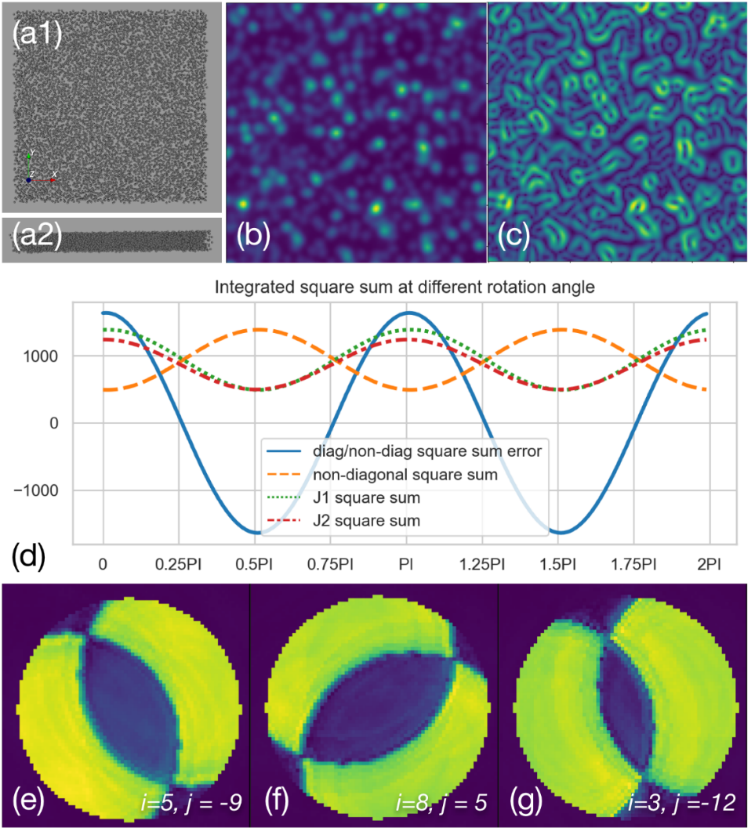
Figure S12. Testing the hybrid method using a simulated 4D-STEM data from the amorphous carbon. (a1 –a2). The top-view and the cross-section view of a thin amorphous carbon model. The thickness of this amorphous carbon sample is set to 2nm, and the minimum distances between the carbon atom is set to 1.4 Å. In the 4D-STEM simulation, the aperture of the probe-forming lens is set to 30 mrad, and the accelerating voltage is set to 80 kV. The scanning interval and defocus are 0.35 Å and 0 nm, respectively. The 4D-STEM dataset consists of 128*128 diffraction patterns, and each diffraction pattern have 256*256 pixels. The angular ranges of the diffraction pattern along horizontal and vertical directions are both 240 mrad. (b). The computed ADF-STEM image from the 4D-STEM dataset of the thin amorphous carbon model. (c). The computed modulus of the electric filed from the 4D-STEM dataset of the thin amorphous carbon model. (d). The integrated squared Jmatrix terms at different rotations angles. The computed relationship between the Jmatrix and the rotation angle is the same as the one give in Figure 1(f). (e–f). The intensity distribution of the G-set slice of different (i,j) coordinates. The disks are clearly visible so that the vector Q and the angle α defined in Figure 3 can be determined.

S15 Estimation of computation time/requirement for a typical 4D-STEM dataset between the case of using the hybrid method and the case of using the J-matrix method alone.
For a typical 4D-STEM dataset like the experimental dataset given in Figure 6 consisting of 256*256 diffraction patterns with 256*256 pixels as an example, the time cost using the J-matrix code is around 44.5 seconds including the time cost of generating the STEM and electric field images for data visualization, the cost of the computer RAM is around 4.0GB since the experimental dataset is stored in 8 bit. When applying the Fourier method, the time and RAM cost dramatically increase to 122.3 seconds and 32GB since the Fourier transform of the 4D-STEM dataset is needed.

Reference

Hachtel, J. A., Idrobo, J. C. & Chi, M. (2018). Sub-Ångstrom electric field measurements on a universal detector in a scanning transmission electron microscope. Advanced structural and chemical imaging 4, 10.
Maiden, A. M. & Rodenburg, J. M. (2009). An improved ptychographical phase retrieval algorithm for diffractive imaging. Ultramicroscopy 109, 1256–1262.

