Supplemental Information for Cost and Capability Compromises in STEM Instrumentation for Low-Voltage Imaging.

Frances Quigley^{1,2}, Patrick McBean^{1,2}, Peter O’Donovan¹, Jonathan J. P. Peters^{1,2}, Lewys Jones^{1,2}
1. School of Physics, Trinity College Dublin, Dublin 2, Ireland
2. Advanced Microscopy Laboratory, Centre for Research on Adaptive Nanostructures & Nanodevices (CRANN), Dublin 2, Ireland

Calculating the electron dose after the monochromation of the electron beam
The beam current reduction of a Schottky and cold FEG from various levels of monochromation was determined from the EELS ZLP of the Schottky and cold FEGs (Figure 3 of (Grogger et al., 2008) and Figure 2a of (Hachtel et al., 2018)) using the method detailed by (Hachtel et al., 2018). These can be seen on the left-hand plots of Figure 1 below. The remaining area was then integrated and compared to the total area to determine the fractional reduction in current, shown in the right-hand plot of Figure 1. These have been extended beyond the maximum 500 meV and 250 meV monochromation for the Schottky FEG and cold FEG, respectively, in order to display the full trend. For a given dwell time, the fractional reduction in current is equal to the fractional reduction in dose.

Gaussian Distribution of weights
As detailed in (Aarholt et al., 2020) a series of defocus images were weighted according to a normalised Gaussian distribution and then summed. Figure 2 shows an example of this Gaussian distribution for one of the hardware configurations. 13 defocus planes were taken, evenly spanning a range of ±3σ (where σ is defined as $σ=\frac{FWHM}{2\sqrt{2\ln\left(2\right)}}$ ).

Signal-to-Noise Ratio Calculation
In order to calculate the SNR, the final image (with all effects included) and the ground truth image (i.e. the zero defocus plane image, with source size applied) are both mean-subtracted in order to examine only the undulations in the signal which produce the visual contrast. The ground truth was then subtracted from the final image to give just the noise. The SNR could then be calculated using the following equation;
$$SNR=\frac{RMS(signal - mean(signal))}{RMS(noise - mean(noise))}.$$

References
Aarholt, T., Frodason, Y. K. & Prytz, Ø. (2020). Imaging defect complexes in scanning transmission electron microscopy: Impact of depth, structural relaxation, and temperature investigated by simulations. Ultramicroscopy 209, 112884.
Grogger, W., Hofer, F., Kothleitner, G. & Schaffer, B. (2008). An introduction to high-resolution EELS in transmission electron microscopy. Topics in Catalysis 50, 200–207.
Hachtel, J. A., Lupini, A. R. & Idrobo, J. C. (2018). Exploring the capabilities of monochromated electron energy loss spectroscopy in the infrared regime. Scientific Reports 8, 1–10.
Figure 1: (Left) ZLP of an unmonochromated (solid blue), and monochromated at various levels (dashed), of a cold FEG (top) and Schottky (bottom). The data points for the ZLP were taken from Figure 2a in (Hachtel et al., 2018) and Figure 3 in (Grogger et al., 2008) for the cold and Schottky FEG, respectively. (Right) By integrating the area after the different levels of monochromation, the relative current can be calculated and applied in terms of dose for Poisson noise.
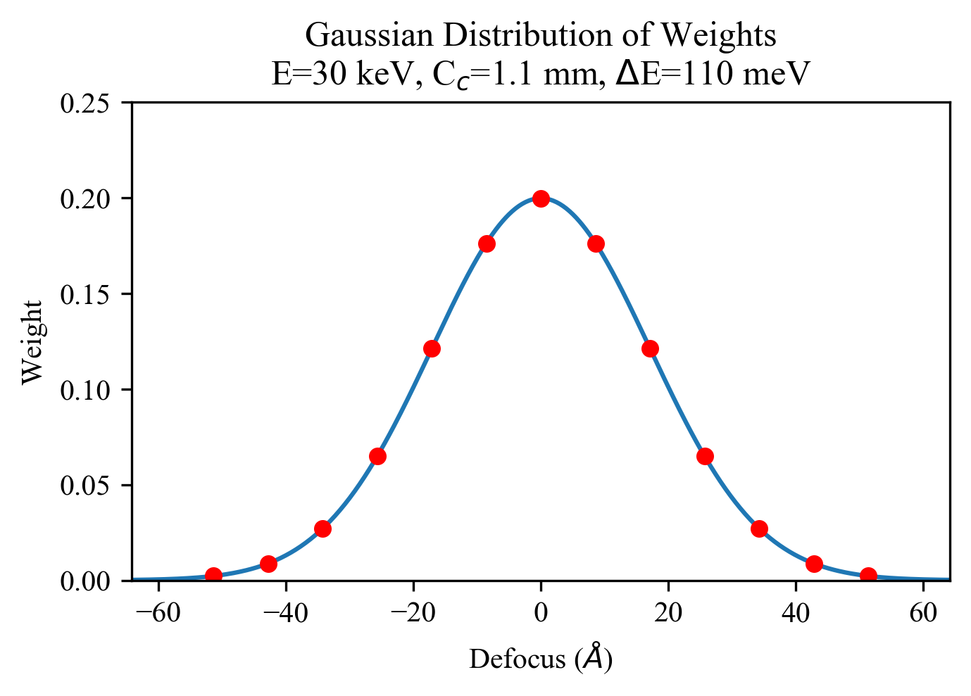
Figure 2: Gaussian Distribution of weights for weighted summation of defocus planes. An equally spaced range of defocus values spanning a range of ±3σ. A normalised Gaussian is then used to assign weights to each of these defoci.

Images of a gold nanoparticle for a Schottky and cold FEG at different electron acceleration voltages

Figure 3: Simulated Au nanoparticle images at E = 60 keV with a Schottky FEG at various levels of monochromation. For each column ΔE = 25 meV, 50 meV, 75 meV, 110 meV, 150 meV, 200 meV, 250 meV, 287 meV, 400 meV, 500 meV, and 650 meV. The C_{c} coefficient for each row is C_{c} = 0 mm, 1.1 mm, 1.8 mm, and 3.0 mm from top to bottom respectively. Scale bar is 15 angstroms.
Figure 4: Simulated Au nanoparticle images at E = 30 keV with a Schottky FEG at various levels of monochromation. For each column ΔE = 25 meV, 50 meV, 75 meV, 110 meV, 150 meV, 200 meV, 250 meV, 287 meV, 400 meV, 500 meV, and 650 meV. The C_{c} coefficient for each row is C_{c} = 0 mm, 1.1 mm, 1.8 mm, and 3.0 mm from top to bottom respectively. Scale bar is 15 angstroms.
Figure 5: Simulated Au nanoparticle images at E = 15 keV with a Schottky FEG at various levels of monochromation. For each column ΔE = 25 meV, 50 meV, 75 meV, 110 meV, 150 meV, 200 meV, 250 meV, 287 meV, 400 meV, 500 meV, and 650 meV. The C_{c} coefficient for each row is C_{c} = 0 mm, 1.1 mm, 1.8 mm, and 3.0 mm from top to bottom respectively. Scale bar is 15 angstroms.
Figure 6: Simulated Au nanoparticle images at E = 60 keV with a cold FEG at various levels of monochromation. For each column ΔE = 25 meV, 50 meV, 75 meV, 110 meV, 150 meV, 200 meV, 250 meV, 287 meV. The C_{c} coefficient for each row is C_{c} = 0 mm, 1.1 mm, 1.8 mm, and 3.0 mm from top to bottom respectively. Scale bar is 15 angstroms.
Figure 7: Simulated Au nanoparticle images at E = 30 keV with a cold FEG at various levels of monochromation. For each column ΔE = 25 meV, 50 meV, 75 meV, 110 meV, 150 meV, 200 meV, 250 meV, 287 meV. The C_{c} coefficient for each row is C_{c} = 0 mm, 1.1 mm, 1.8 mm, and 3.0 mm from top to bottom respectively. Scale bar is 15 angstroms.
Figure 8: Simulated Au nanoparticle images at E = 15 keV with a cold FEG at various levels of monochromation. For each column ΔE = 25 meV, 50 meV, 75 meV, 110 meV, 150 meV, 200 meV, 250 meV, 287 meV. The C_{c} coefficient for each row is C_{c} = 0 mm, 1.1 mm, 1.8 mm, and 3.0 mm from top to bottom respectively. Scale bar is 15 angstroms.

