Title: Three-dimensional analysis of interstitial cells in the smooth muscle layer of murine vas deferens using confocal laser scanning microscopy and FIB/SEM tomography

Tasuku Hiroshige¹*, Kei-Ichiro Uemura², Shingo Hirashima¹, Kiyosato Hino¹, Akinobu Togo³, Keisuke Ohta^{1, 3}, Tsukasa Igawa² and Kei-Ichiro Nakamura¹
¹Division of Microscopic and Development Anatomy, Department of Anatomy, Kurume University School of Medicine, Kurume, 830-0011, Japan; ² Department of Urology, Kurume University School of Medicine, Kurume, 830-0011, Japan; ³ Advanced Imaging Research Center, Kurume University School of Medicine, Kurume, 830-0011, Japan

Corresponding author: Dr. Tasuku Hiroshige, Division of Microscopic and Development Anatomy, Department of Anatomy, Kurume University School of Medicine, Kurume, 830-0011, Japan
E-mail: hiroshige_tasuku@med.kurume-u.ac.jp

Keywords: three-dimensional analysis, interstitial cells, FIB/SEM, murine vas deferens

Supplementary Table S1
Primary antibody | Host | Working dilution | Source
PDGFR-α | Goat | 1:400 | Catalog no. AF1062; R&D systems
β3-tubulin | Rabbit | 1:500 | Catalog no. ab18207; abcam
Iba-1 | Rabbit | 1:250 | Catalog no. 019-19741; wako
αSMA | Rabbit | 1:700 | Catalog no. ab5694; abcam
connexin43 | Rabbit | 1:1000 | Catalog no. ab34710; abcam
Details of the primary antibodies

Supplementary Figure S1
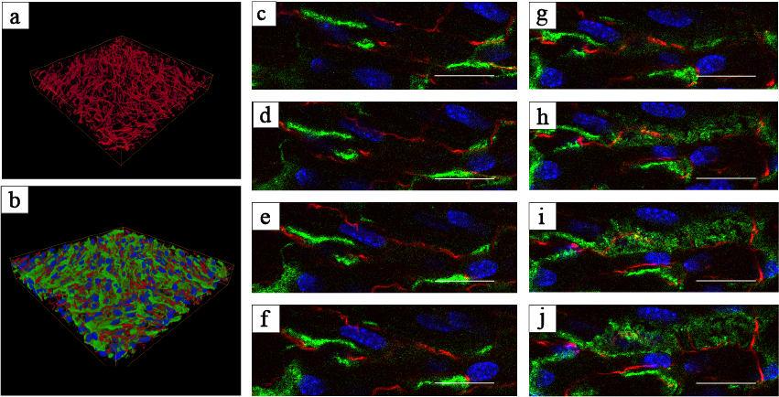
Reconstructed sequential 3D immunofluorescence images for β3-tubulin (red). (a) Reconstructed sequential 3D immunofluorescence images for PDGFRα (green) and β3-tubulin (red). (b) Sequential high-magnification immunofluorescence images of frozen sections for PDGFRα (green) and β3-tubulin (red). (d-k) The same images following deconvolution and 3D reconstruction using the Avizo software (version 9.1.1) available at https://www.fei.com/software/avizo3d/. Scale bar: 20 µm (c-j).

Supplementary Figure S2
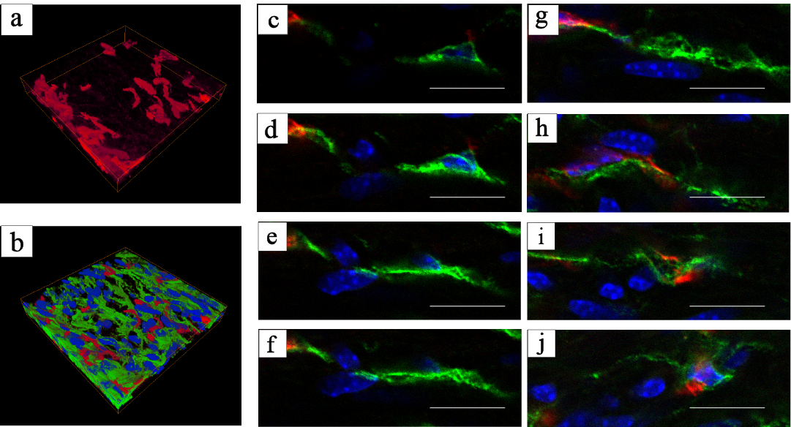
Reconstructed sequential 3D immunofluorescence images for Iba-1 (red). (a) Reconstructed sequential 3D immunofluorescence images for PDGFRα (green) and Iba-1 (red). (b) Sequential high-magnification immunofluorescence images of frozen sections for PDGFRα (green) and Iba-1 (red). (c-j) The same images following deconvolution and 3D reconstruction using the Avizo software (version 9.1.1) available at https://www.fei.com/software/avizo3d/. Scale bar: 20 µm (c-j).

Supplementary Figure S3
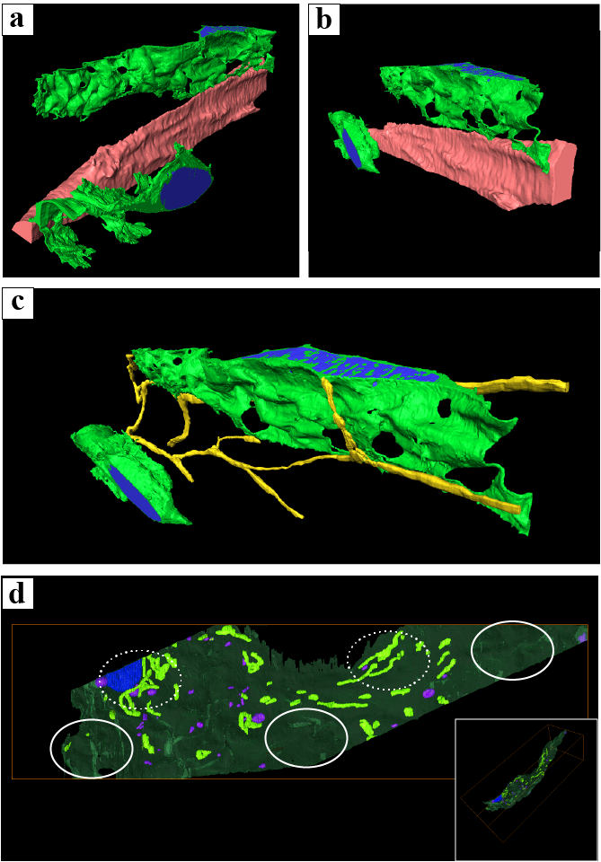
Spatial relationships between two interstitial cells (ICs) and smooth muscle cells (SMCs). (a, b) Spatial relationships between the two ICs and nerves. (c) 3D reconstruction of the mitochondria and lysosomes in ICs. (d) Oblique view of the 3D reconstructed mitochondria and lysosomes in the IC (inset of (d)). For better visualization, object surfaces are color-coded; IC, light green (a-c), transparent green (d); nuclei, blue (a-d); smooth muscle cell, coral (a, b); nerve, yellow (c); mitochondria, light green (d); lysosomes, purple (d). The same images following deconvolution and 3D reconstruction using the Avizo software (version 9.1.1) available at https://www.fei.com/software/avizo3d/.

