Supplemental Document

Aberration correction to optimize the performance of two-photon fluorescence microscopy using the genetic algorithm
Wei Yan*, Yangrui Huang, Luwei Wang*, Yong Guo, Jin Li, Yinru Zhu, Zhigang Yang, AND Junle Qu
Center for Biomedical Photonics & College of Physics and Optoelectronic Engineering, Key Laboratory of Optoelectronic Devices and Systems of Ministry of Education and Guangdong Province , Shenzhen University, Shenzhen 518060, China
*Corresponding author: wanglowell@szu.edu.cn, weiyan@szu.edu.cn

1. Experimental principles and processes
The genetic algorithm, first put forward by John Holland, is a method of seeking an optimal solution by simulating natural evolution. It transforms the solution to issues into crossover and mutation of chromosome genes in biogenetics, and finally obtains the answer with the optimal fitness function value after finite evolution (Fang et al, 2007; Lin et al, 2015). The genetic algorithm is mainly made of the following basic steps, as Fig. S1 shown. First, we transform the problem to be solved into representative individuals with different genetic information by encoding (step 1). Second, an appropriate fitness function is set according to the requirements of solving the problem itself, and then the number of individuals, iteration times, genetic operation, and other relevant parameters in the algorithm are determined (step 2). After generating the initial random population, the fitness value of each individual in the population is calculated (a total number of n) (step 3). Finally, m (m < n) individuals with the highest fitness value from the previous generation are selected to become the next generation. If the individual of the new population meets the stop criterion, the algorithm ends. Instead, step 3 will be repeated and a new cycle is to continue until the number of iterations is met and the optimal solution is selected (step 4). In this experiment, the optimal solution is determined mainly by whether the image gets the best brightness after correction.
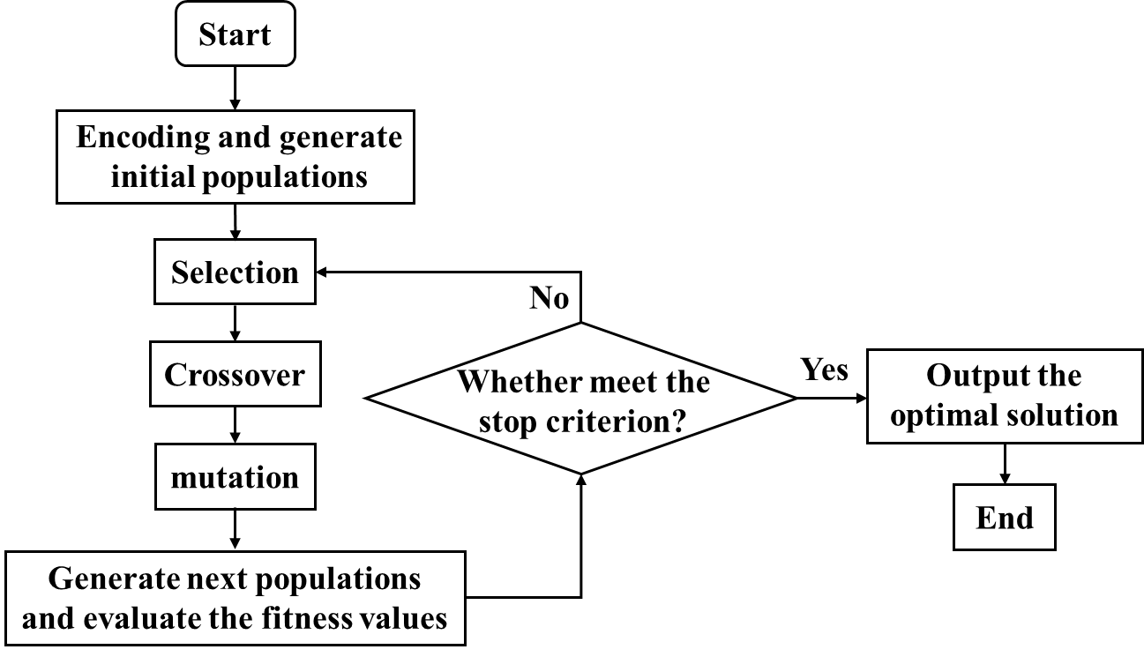
Fig. S1. Schematic diagram of genetic algorithm.
In our experiment, we used the spatial light modulator as the wavefront controller, mainly because of its high pixel (1920 × 1080) and fast pixel update rate. We treated the LCD surface as an individual, where each pixel was treated as a gene. Each pixel has 256 phase values (0-255). However, to improve the running speed of the program, it was reasonable to select only the square area (1080 × 1080) on the liquid crystal surface for processing because the Gaussian spot was symmetrically distributed. The optical signal from the sample was collected by the PMT and converted into an electrical signal in the course of imaging, so each individual may correspond to a voltage value. We stipulated that when the voltage value reached the maximum of absolute value (because the voltage signal of PMT was negative), and the corrected phase was what we need (that is, the optimal solution of the genetic algorithm).
Encoding is necessary to be highlighted in genetic algorithms. In practice, we have to consider the size of the population because it is unrealistic to carry out an infinite number of genetic manipulations. Therefore, the diversity of the individual population is likely to be lost when implementing the genetic algorithm. Genes in individuals are prone to be the same, resulting in obtaining the local optimal solution. This is known as the precocity problem. Appropriate coding methods can effectively solve this dilemma. Two different encoding methods like block coding method and Zernike polynomial coding method are used in the experiment.
Block coding is a random aberration correction method. The initial phase of the pixel is zero, and the phase gradually changes as the program progresses. Considering a large number of genes in each individual (1080 × 1080), the entire control region is divided into n² × 9 small blocks. At the same time, the number of pixels in each region is equal, and the phase value of the pixels in the same region keeps the same. When the number of blocks is insufficient, premature convergence is easy to occur and the correction effect is poor. On the contrary, although the final result is relatively accurate by adding the number of blocks, it will make the fitness function converge more slowly, and greatly increase the processing time of the genetic algorithm program. Therefore, the appropriate number of blocks is an important parameter in the experiment.
The aberration of an optical system is usually described in terms of power series expansion. The Zernike polynomials are often used to describe the wavefront characteristics because their form and the aberration polynomials are identical (Noll & Robert, 1976). These polynomials with appropriate regularization factors are shown in the following formula:
$φ\left(ρ,θ\right)=A_{00}+\frac{1}{\sqrt{2}}\sum_{n=2}^{∞}{A_{n0}R_{n}^{0}}\left(\frac{ρ}{R^{'}}\right)+\sum_{n=1}^{∞}{\sum_{m=1}^{n}{\left[A_{nm}\cos\left(mθ\right)+B_{nm}\sin\left(mθ\right)\right]R_{n}^{m}\left(\frac{ρ}{R^{'}}\right)}}$ (1)
where $n≥m$ is a non-negative integer, $θ$is an azimuth,$ρ$ is the radial distance, and $R^{'}$is the radius of the circle defined by the polynomial.
When n-m is odd,
$R_{n}^{m}\left(ρ\right)=0$ (2)
Otherwise, when $n-m$ is even,
$R_{n}^{±m}\left(\frac{ρ}{R^{'}}\right)=\sum_{s=0}^{\frac{n-m}{2}}{{(-1)}^{s}\frac{(n-s)!}{s!(\frac{n+m}{2}-s)!(\frac{n-m}{2}-s)!}}{\left(\frac{ρ}{R^{'}}\right)}^{n-2s}$ (3)
Since various optical aberrations can be described by Zernike polynomials, the wavefront of the incident light is controllable. The block coding method can improve the running speed of the program, and the Zernike polynomial coding method can correct the high-order aberration. Therefore, the combination of these two methods can correct the complex aberration in biological samples. In the experiment, the block coding method was used to correct the system aberration, and the hybrid coding method combining block coding and Zernike polynomial coding was used to correct the sample aberration.

2. The experimental setup
In our home-built microscope system, excitation beam is provided by a pulsed Ti: sapphire laser (Chameleon Ultra II, Coherent, Santa Clara, CA, USA) that ran at 770 nm with a 140 fs pulse width and 80 MHz repetition frequency. Then the excitation light was coupled in a 1 m long single-mode fiber (DH-FP780-FC-1, DHC, China) to have a fundamental mode. After expanding, a SLM (PLUTO-NIR-011, HOLOEYE Photonics AG, Berlin, Germany) as an essential optical device worked in two ways. On the one hand, it loaded a fixed period of blazed grating to obtain first-order diffraction light by using a pinhole to enhance the imaging quality. On the other hand, it loaded various phases to alter the wavefront of the laser in the focal plane so as to compensate for the wavefront distortion caused by aberration. The modulated laser was sent to the dichroic mirror, and laser scanning was accomplished by a pair of galvanometer scanning mirrors (6210H, Cambridge Technology Inc., Cambridge, MA, USA) before entering the objective. The emission signal from samples was through a pinhole and a band-pass filter to make a better signal-to-noise ratio and was detected by a PMT (H7422-40, Hamamatsu Photonics, Japan). The PMT was coupled to a time-correlated single-photon counting (TCSPC) module and FLIM imaging was completed using the commercial software SPC150 (Becker & Hickl GmbH, Berlin, Germany). First, we fixed an acquisition time (such as 10 s in this paper), and the TCSPC card counted the photon number before and after aberration correction within the fixed acquisition time. After signal acquisition, the image was imported into the SPCImage software (Becker & Hickl GmbH, Berlin, Germany) for fitting the lifetime attenuation curve. Reference signal was provided from the pulsed laser. ScanImage (HHMI/Janelia Farm, Ashburn, VA, USA) was used to control the scanning and to acquire images. Different objective lenses and filters were used in different experiments. Specifically, all the other experiments used a 100X oil-immersed objective (HCX PL APO, 100X/1.4 OIL, Leica, Germany) except for the mouse kidney sample, which used a 63X objective (HCX PL APO, 63X/1.32 OIL, Leica, Germany). Choices of different filters will be explained according to various samples in the Results and discussion.
A feedback system was built in the TPM system for a real-time evaluation of the effect on the aberration correction. The scattering light originating from samples was enhanced by a preamplifier and the output signal was divided into two parts then transferred to the computer through two data acquisition cards (PCI-6110/USB-6351) for imaging and aberration correction, respectively. The genetic algorithm program was applied for analyzing the data and gives instructions to SLM, which can transform the phase value of the liquid crystal display plane to change the phase of the laser’s wavefront.

3. Sample preparation
3.1 Gold nanoparticles sample
3.5 μL gold nanoparticles (GPs) solution was taken with a pipette and dripped onto the cover glass. After drying, it was dripped into a fixed solution (TDE) with a concentration of 8.5 μL (97%) and affixed to a glass slide. Finally, the sample was sealed with nail polish.
3.2 Simulation sample
The simulated sample was prepared in the following steps. First, 40 mg of agar powder was added to 2 mL to prepare a 2% agarose solution. A mixture of 150 nm gold nanoparticles was applied to the coverslip. After naturally air-dried, agarose solution was added to the isolation zone (held up by a 170 μm coverslip). Finally, the sample was sealed with nail polish.
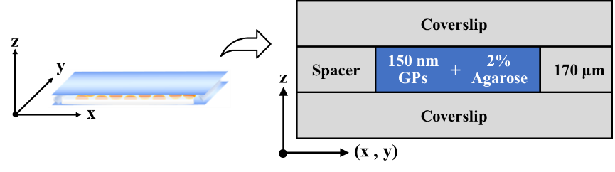
Fig. S2. Simulation sample.
3.3 Cell sample
HeLa cells were cultured at Roswell Park Memorial Institute (RPMI-1640) (Sigma-Aldrich) and maintained at 37°C and 5% CO2. The well-cultivated HeLa cells were transferred to the dish, and an appropriate amount of gold nanoparticle solution was added. In the fixed cell samples, the microtubules of HeLa cells were immunolabeled with primary (anti-alpha-tubulin antibody, ab7291, Abcam) and secondary antibodies (goat anti-mouse Alexa flour 488, ab150113 Abcam). The fixation and immunolabeling of cells are performed according to published protocols (Sebastian et al, 2011; Lampe & Fouquet, 2014).
3.4 Mouse kidneys slices sample
Mouse kidneys were carefully cut lengthwise into 500 μm thick slices, and one of which was soaked in rhodamine B (1 mmol/L) to stain for 2 hours and rinsed with PBS again for 3 times. The stained slice was then fixed on the coverslip for observation.

4. System resolution of two-photon fluorescence microscopy
To measure the resolution of two-photon fluorescence microscopy, a sample was prepared by attaching the fluorescent microspheres of 170 nm in diameter to a coverslip. Fig. S3 shows the intensity profile of a single fluorescent microsphere in a TPM image. The FWHM is calculated to be 340 nm, which represents the system resolution. In terms of the imaging field of view (FOV), we have added the scale bar to the lower left of each 2D-TPM image to indicate the field of view of the different samples
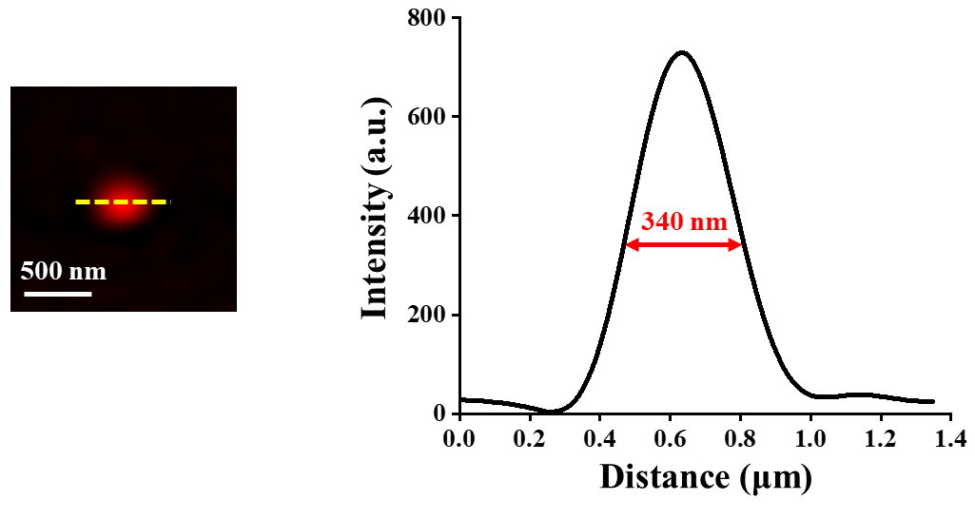
Fig. S3. Measurement of system resolution of two-photon fluorescence microscopy. FOV: 1.8 × 1.8 μm². Scale bar: 500 nm.

5. Correction of system aberration by genetic algorithm
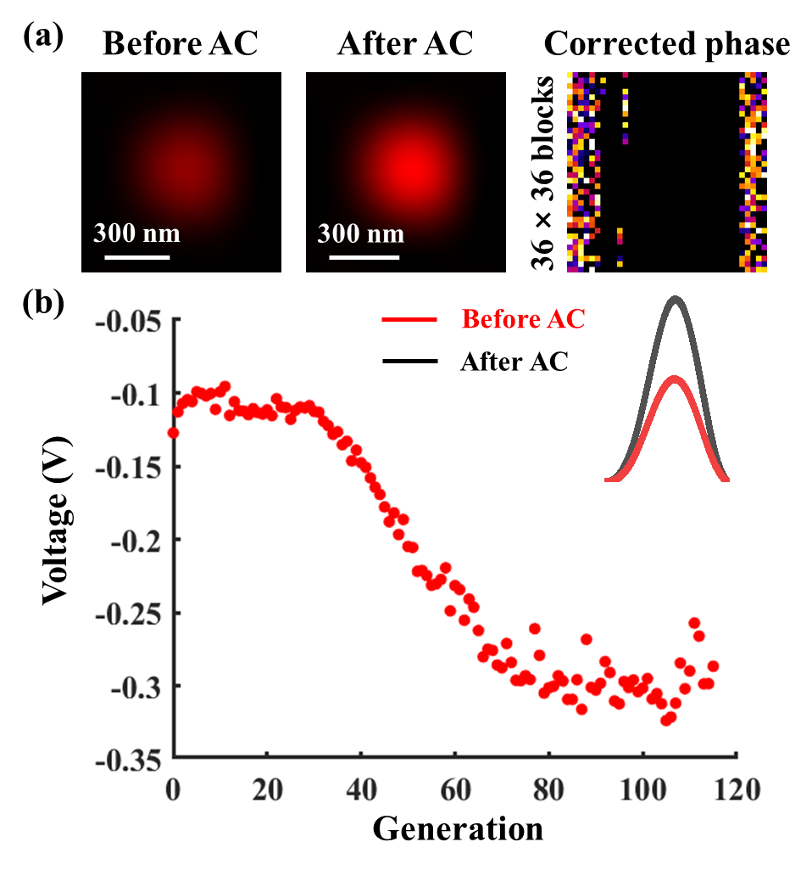
Fig. S4. Correction of system aberration by genetic algorithm at 36 × 36 blocks. (a) Comparisons of the point spread function of the microscope system before and after aberration correction and the corrected phase. FOV: 850 × 850 nm². Scale bar: 300 nm. (b) The voltage curve and the FWHM of the point spread function before and after aberration correction.

6. Comparison of aberration correction effects

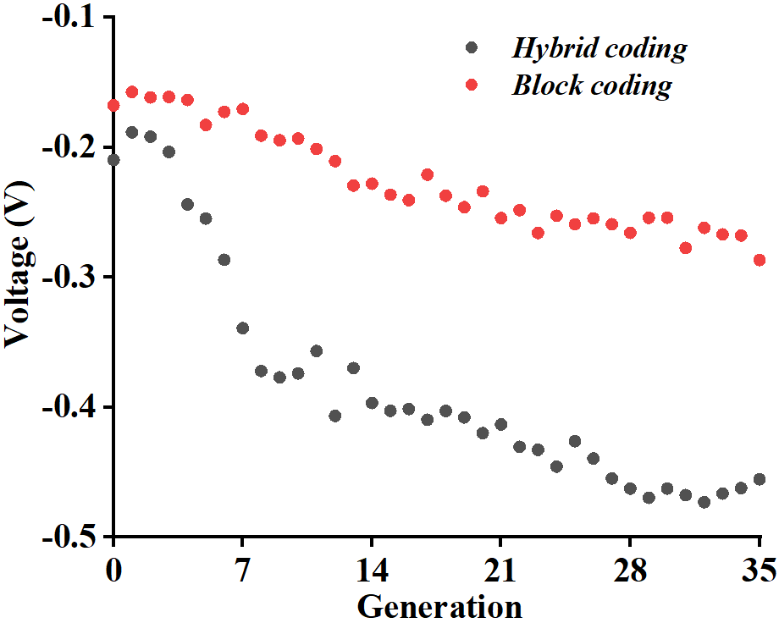
Fig. S5. Comparison of aberration correction effects of different coding methods in the same generation.

Reference
Y. C. Fang, C. M. Tsai, J. Macdonald & Y. C. Pai (2007). Eliminating chromatic aberration in Gauss-type lens design using a novel genetic algorithm. Appl. Opt. 46(13), 2401-2410.
C. D. Lin, C. M. Anderson-Cook, M. S. Hamada, L. M. Moore & R. R. Sitter (2015). Using Genetic Algorithms to Design Experiments: A Review. Qual. Reliab. Eng. Int. 31(2), 155-167.
Noll & J. Robert (1976). Zernike polynomials and atmospheric turbulence. J. Opt. Soc. Am. A. 66(3), 207-211.
M. Lampe & W. Fouquet (2014). Requirements for Samples in Super-Resolution Fluorescence Microscopy. Neuromethods 86, 343-367.
V. Sebastian, A. L. Schberger, T. Klein, M. Heidbreder, S. Wolter, M. Heilemann & M. Sauer (2011). Direct stochastic optical reconstruction microscopy with standard fluorescent probes. Nat. Protoc. 6(7), 991-1009.

