Na⁺ and K⁺ Ions Differently Affect Nucleosome Structure, Stability and Interactions with Proteins
Tatyana V. Andreeva¹, Natalya V. Maluchenko¹, Anastasiia L. Sivkina¹, Oleg V. Chertkov¹, Maria E. Valieva¹, Elena Y. Kotova ², Mikhail P. Kirpichnikov ^{1,3}, Vasily M. Studitsky ^{1, 2}* and Alexey V. Feofanov^{1,3}*
¹ Biology Faculty, Lomonosov Moscow State University, Moscow, 119234, Russia
² Fox Chase Cancer Center, Philadelphia, PA, 19111-2497, USA
³ Shemyakin-Ovchinnikov Institute of Bioorganic Chemistry of Russian Academy of Sciences, 117997 Moscow, Russia
* Corresponding authors: avfeofanov@yandex.ru; vasily.studitsky@fccc.edu

Supplementary Materials

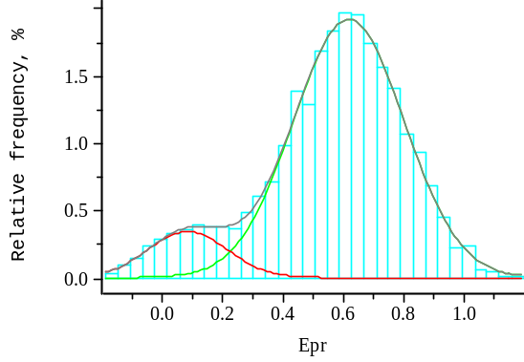a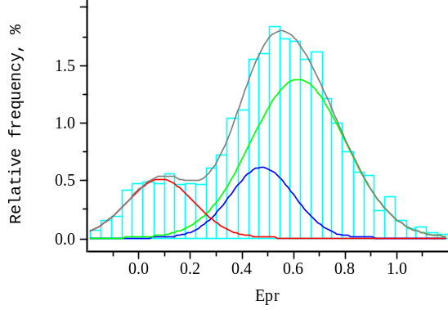b
Figure S1. Typical examples of E_{PR} profiles of nucleosomes N(13,91) at 150 mM KCl (a) and 500 mM KCl (b) fitted with two (a) or three (b) Gaussian curves (normal distributions). Peak maxima: 0.08 (LF subpopulation), 0.47 (MF subpopulation), 0.62 (HF subpopulation).

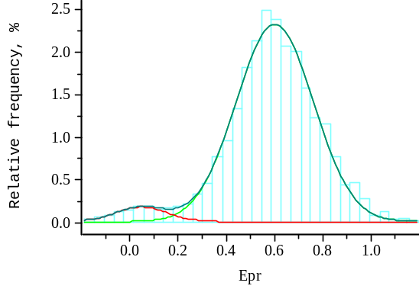a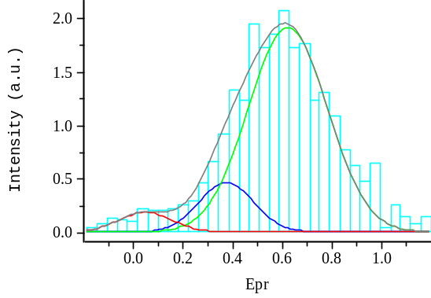b
Figure S2. Typical examples of E_{PR} profiles of nucleosomes N(35,112) at 150 mM KCl (a) and 1000 mM KCl (b) fitted with two (a) or three (b) Gaussian curves (normal distributions). Peak maxima: 0.03 (LF subpopulation), 0.37 (MF subpopulation), 0.60 (HF subpopulation).

Electrophoretic Mobility Shift Assay
Nucleosomes N(13,91) (2 nM) were incubated (10 min, 25 °C) in a buffer containing 0.001% NP40, 0.5 mM EDTA, 10 mM Tris-HCl (pH 7.5) and 12 mM β-ME as well as a particular concentration of NaCl or KCl (150, 500, 1000 or 1300 mM). After incubation the probes were analyzed by electrophoresis in non-denaturing 4% polyacrylamide gel (PAGE, acrylamide:bisacrylamide 39:1; 0.5× Tris-borate-EDTA buffer). The gels were scanned with a Typhoon PhosphoImager (GE Healthcare, USA): fluorescence was excited at the 532 nm wavelength and recorded in the 570–610 nm (for Cy3, assigned green color) and 650–700 nm (for Cy5, assigned red color) spectral regions. The obtained images were merged, and the resulting color indicated FRET efficiency, which reduced in the following order: red > yellow > green.
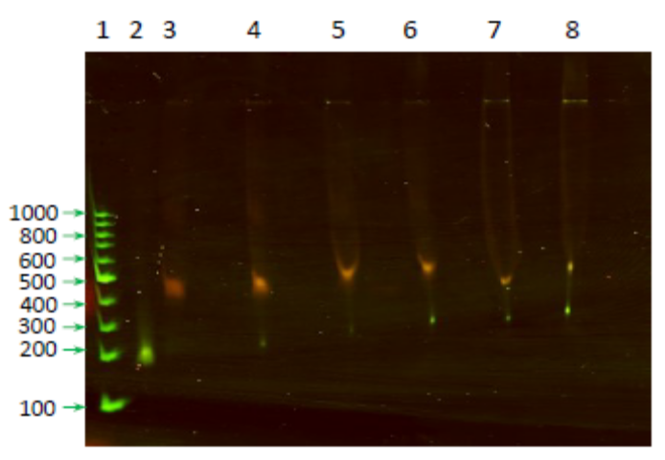
Figure S3. Electrophoretic mobility shift assay for the N(13,91) nucleosomes preincubated at different concentrations of NaCl or KCl.
(1) - GeneRuler 100 bp DNA ladder (Thermo Scientific, USA), (2) - DNA template (167 bp) in a buffer with 150 mM KCl, (3-8) - N(13,91) in a buffer with 150 mM KCl (3),150 mM NaCl (4), 500 mM KCl (5), 500 mM NaCl (6), 1 M KCl (7) or 1,3 M KCl (98).
(2-8) - Green and red colors correspond to Cy3 and Cy5 fluorescence, respectively, excited at 532 nm. FRET efficiency is encoded by color and decreases in the following order: red > yellow > green.

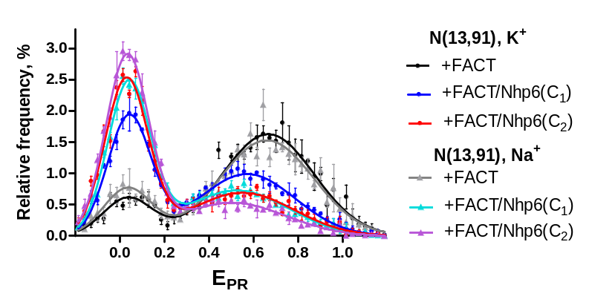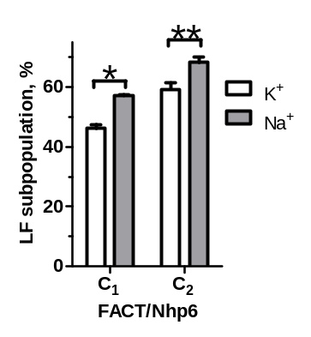
a
b
Figure S4. Interaction of FACT with nucleosomes in the presence of Na⁺ or K⁺ ions (no Mg²⁺ ions in solution). (a). Uncoiling of nucleosomal DNA by FACT/Nhp6 occurs more efficiently in the presence of Na⁺ ions that in the presence of K⁺ ions. Nucleosomes N(13,91) were incubated with FACT or FACT/Nhp6 at two different concentrations C₁ or C₂ in Na⁺ or K⁺ environment (without addition of MgCl₂) as described in Materials and Methods. (b). Content of uncoiled nucleosomes in Na⁺ or K⁺ environment at FACT/Nhp6 concentrations C₁ or C₂ (mean±SEM, n=3) was calculated from the data presented in panel (a). Statistical significance of differences: *p=0.0013, **p=0.04.

