**Supplementary**

**for**

**A combinatorial approach to reliable quantitative analysis of small nano-sized precipitates: A case study with α/ precipitates in Fe-20 at.% Cr alloy**

Sudip Kumar Sarkar1*,3, Deodatta Shinde1, Debasis Sen2,3,Aniruddha Biswas1,3

*1Materials Science Division, 2Solid State Physics Division*

*Bhabha Atomic Research Centre, Mumbai-400085*

*3Homi Bhabha National Institute, Mumbai-400094*

*E-mail: [s.sudip.iitg@gmail.com](mailto:s.sudip.iitg@gmail.com), [sudips@barc.gov.in](mailto:sudips@barc.gov.in)

**Ranging of mass spectrum:**

The detail of mass spectrum ranging has been depicted in Figure S1 below.

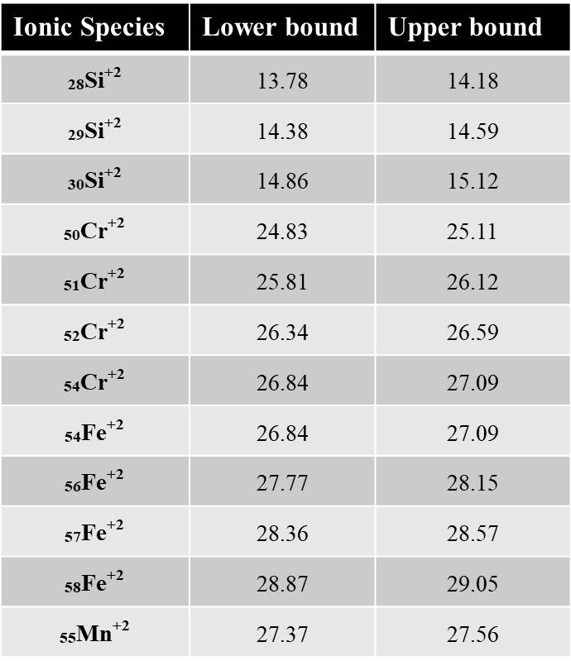

**Figure S1.** Mass spectrum ranging for Fe-20 at.% Cr alloys aged at 773 K for 1000 h

**Determination of TEM sample thichness:**

Thickness of TEM Sample of the analysis has been calculated using CBED method under two beam conditions; the detailed methodology is described elsewhere (Williams & Carter, 2009).



(110)

(000)

**Figure S2.** Parallel Kossel-Mollenstedt fringes recorded in CBED pattern from Fe-20 at.% Cr alloy under two-beam conditions with (110) strongly excited.

The deviation Si (magnitude) for the i-th fringe (where i is an integer) can be calculated from the equation described below:

$S_{i}=λ\frac{Δθ_{i}}{2θ_{B}d^{2}}$ (S1)

Where $λ$ is the wavelength of electron beam (0.0025 nm for 200 KV electron beam), $Δθ_{i}$ is the fringe spacing, ${2θ}_{B}$ is the separation of the (000) and (110) disks ($θ_{B},$ Bragg angle for the diffracting (110) plane), d is the (110) inter-planar spacing (0.206 nm).

The foil thickness (t) can be calculated from the intercept of the plot of Si2/nk2 vs 1/nk2(values are displayed in supplementary Table S1). Where nk is the fringe number.

|  |  |  |  |  |  |  |  |
| --- | --- | --- | --- | --- | --- | --- | --- |
| Table S1. Details of thickness measurement parameters. | | | | | | | |
| λ (nm) | d (nm) | 2 (nm-1) | (nm-1) | Si (nm-1) | nk | 1/nk2 | Si2/ nk2 (nm-2) |
| 0.0025 | 0.206 | 4.93 | 0.45 | 0.539 x 10-2 | 1 | 1 | 2.90 X 10-5 |
| 1.09 | 1.30 x 10-2 | 2 | 0.25 | 4.26 X 10-5 |
| 1.68 | 2.01 x 10-2 | 3 | 0.11 | 4.50 X 10-5 |

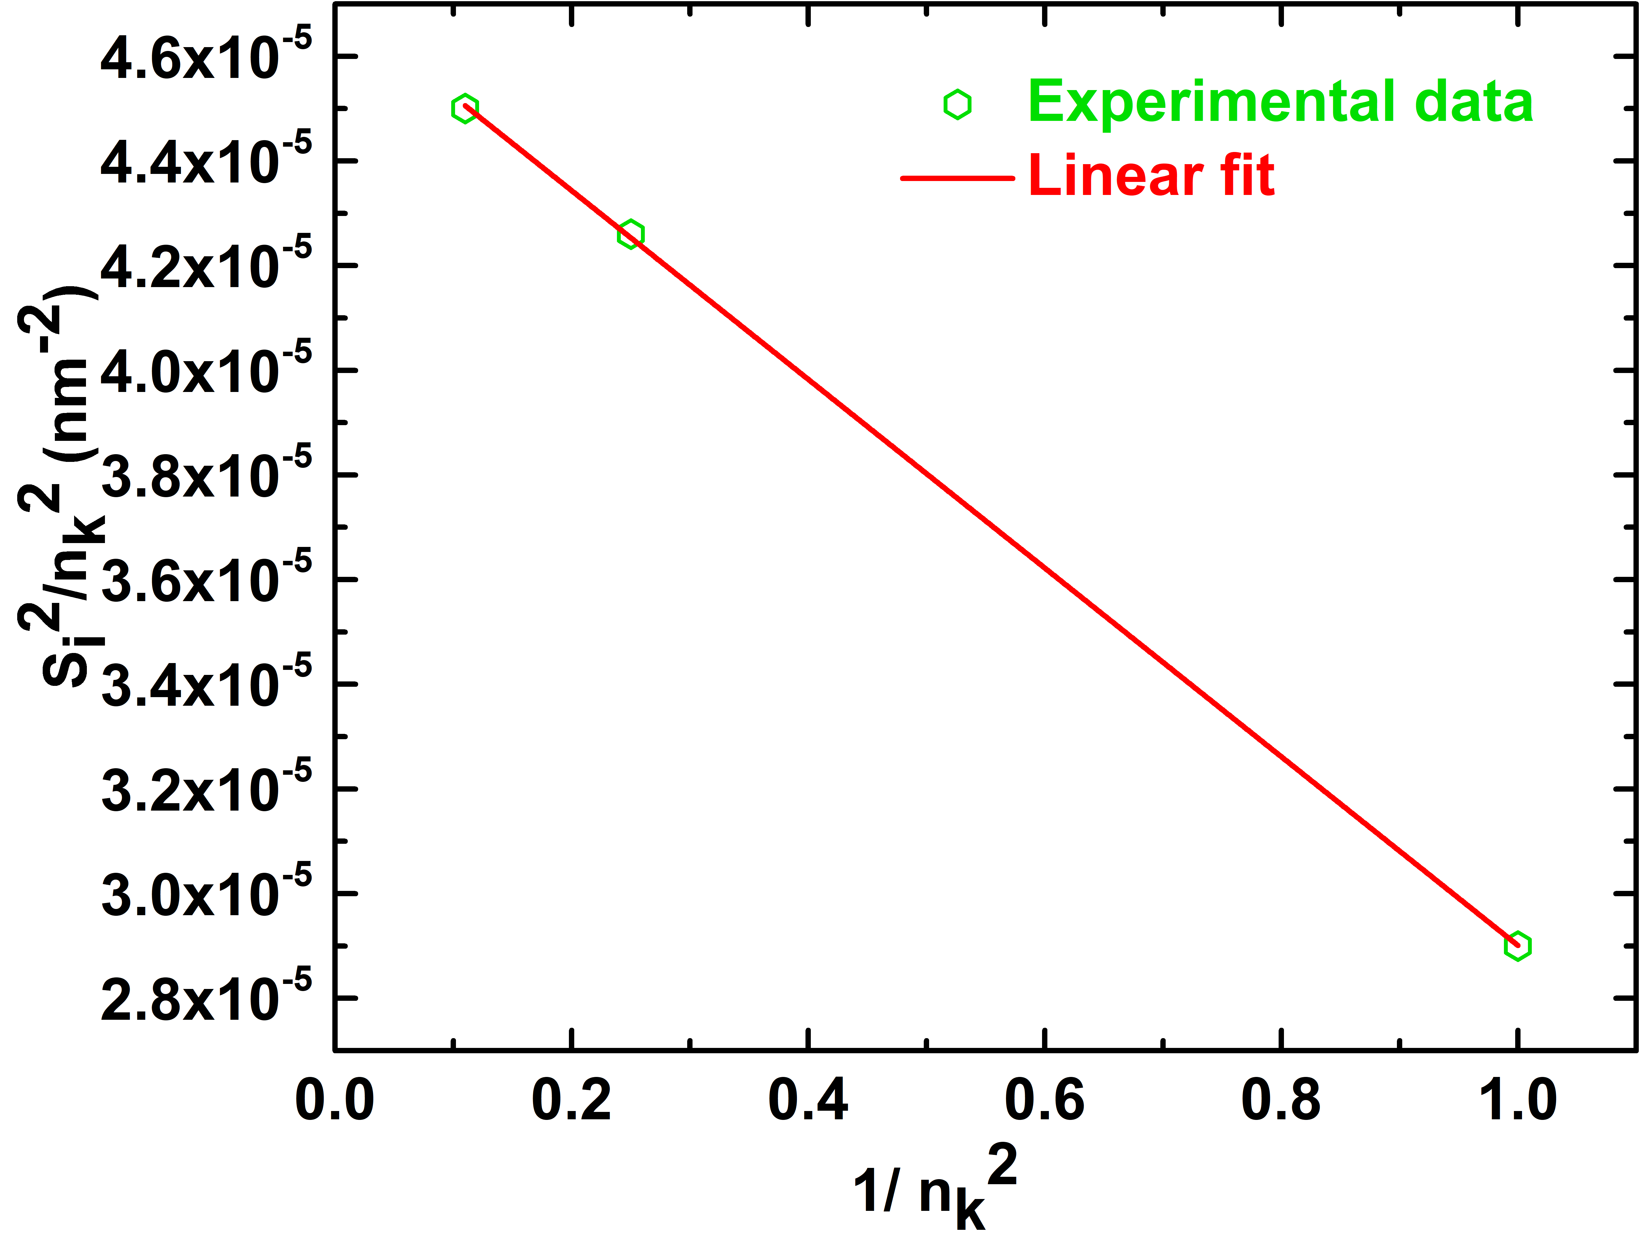

**Figure S3.** Plot of Si2/nk2 vs 1/nk2

The intercept value (to y-axis) is found from the linear fitting of the data as 4.704 x 10-5 nm-2 which is nothing but equals to 1/t2.

Therefore, the sample thickness is estimated as 145.8 nm

**Quantification of α/ precipitates using maximum separation based cluster search analysis:**

Quantitative analysis of Cr-rich clusters has been carried out utilizing the solute analysis tool available in IVAS. The tool works on the maximum separation based cluster identification algorithm (Larson et al., 2013). The success of cluster count distribution analysis depends totally on the merit of two parameters *Dmax* and *Nmin* (Marquis et al., 2016; Dong et al., 2019). For example, if *Dmax* is low then single big cluster might dissociate into a large number of small ones while a high value of *Dmax* suggests coalescence of small clusters into a large cluster. Similarly, if *Nmin* is too low then random solute fluctuations may be incorrectly identified as clusters. On the other hand, when *Nmin* is too high then small clusters may be ignored. Therefore, wrong choice of *Dmax* and *Nmin* might lead totally incorrect statistics (size, number density and volume fraction) of clusters. Therefore, we followed systematic analysis in a careful way.

First, cluster count distribution along with random data has been generated and result is displayed in Figure S4a, respectively and a *Dmax* value of 0.2 nm (dashed black line) is chosen so that the small clusters coming from the random fluctuation of 20 at.% Cr in the alloy is being removed. In the next step, *Nmin* has been chosen from the cluster size distribution utilizing the *Dmax* value as obtained from cluster count distribution. Figure S4b show the cluster size distribution along with random data. The dashed black line shows a reasonable estimate for *Nmin* of 70 atoms when compared to randomized data so that random solute fluctuations are not identified as clusters as well as small clusters are not ignored at the same time.

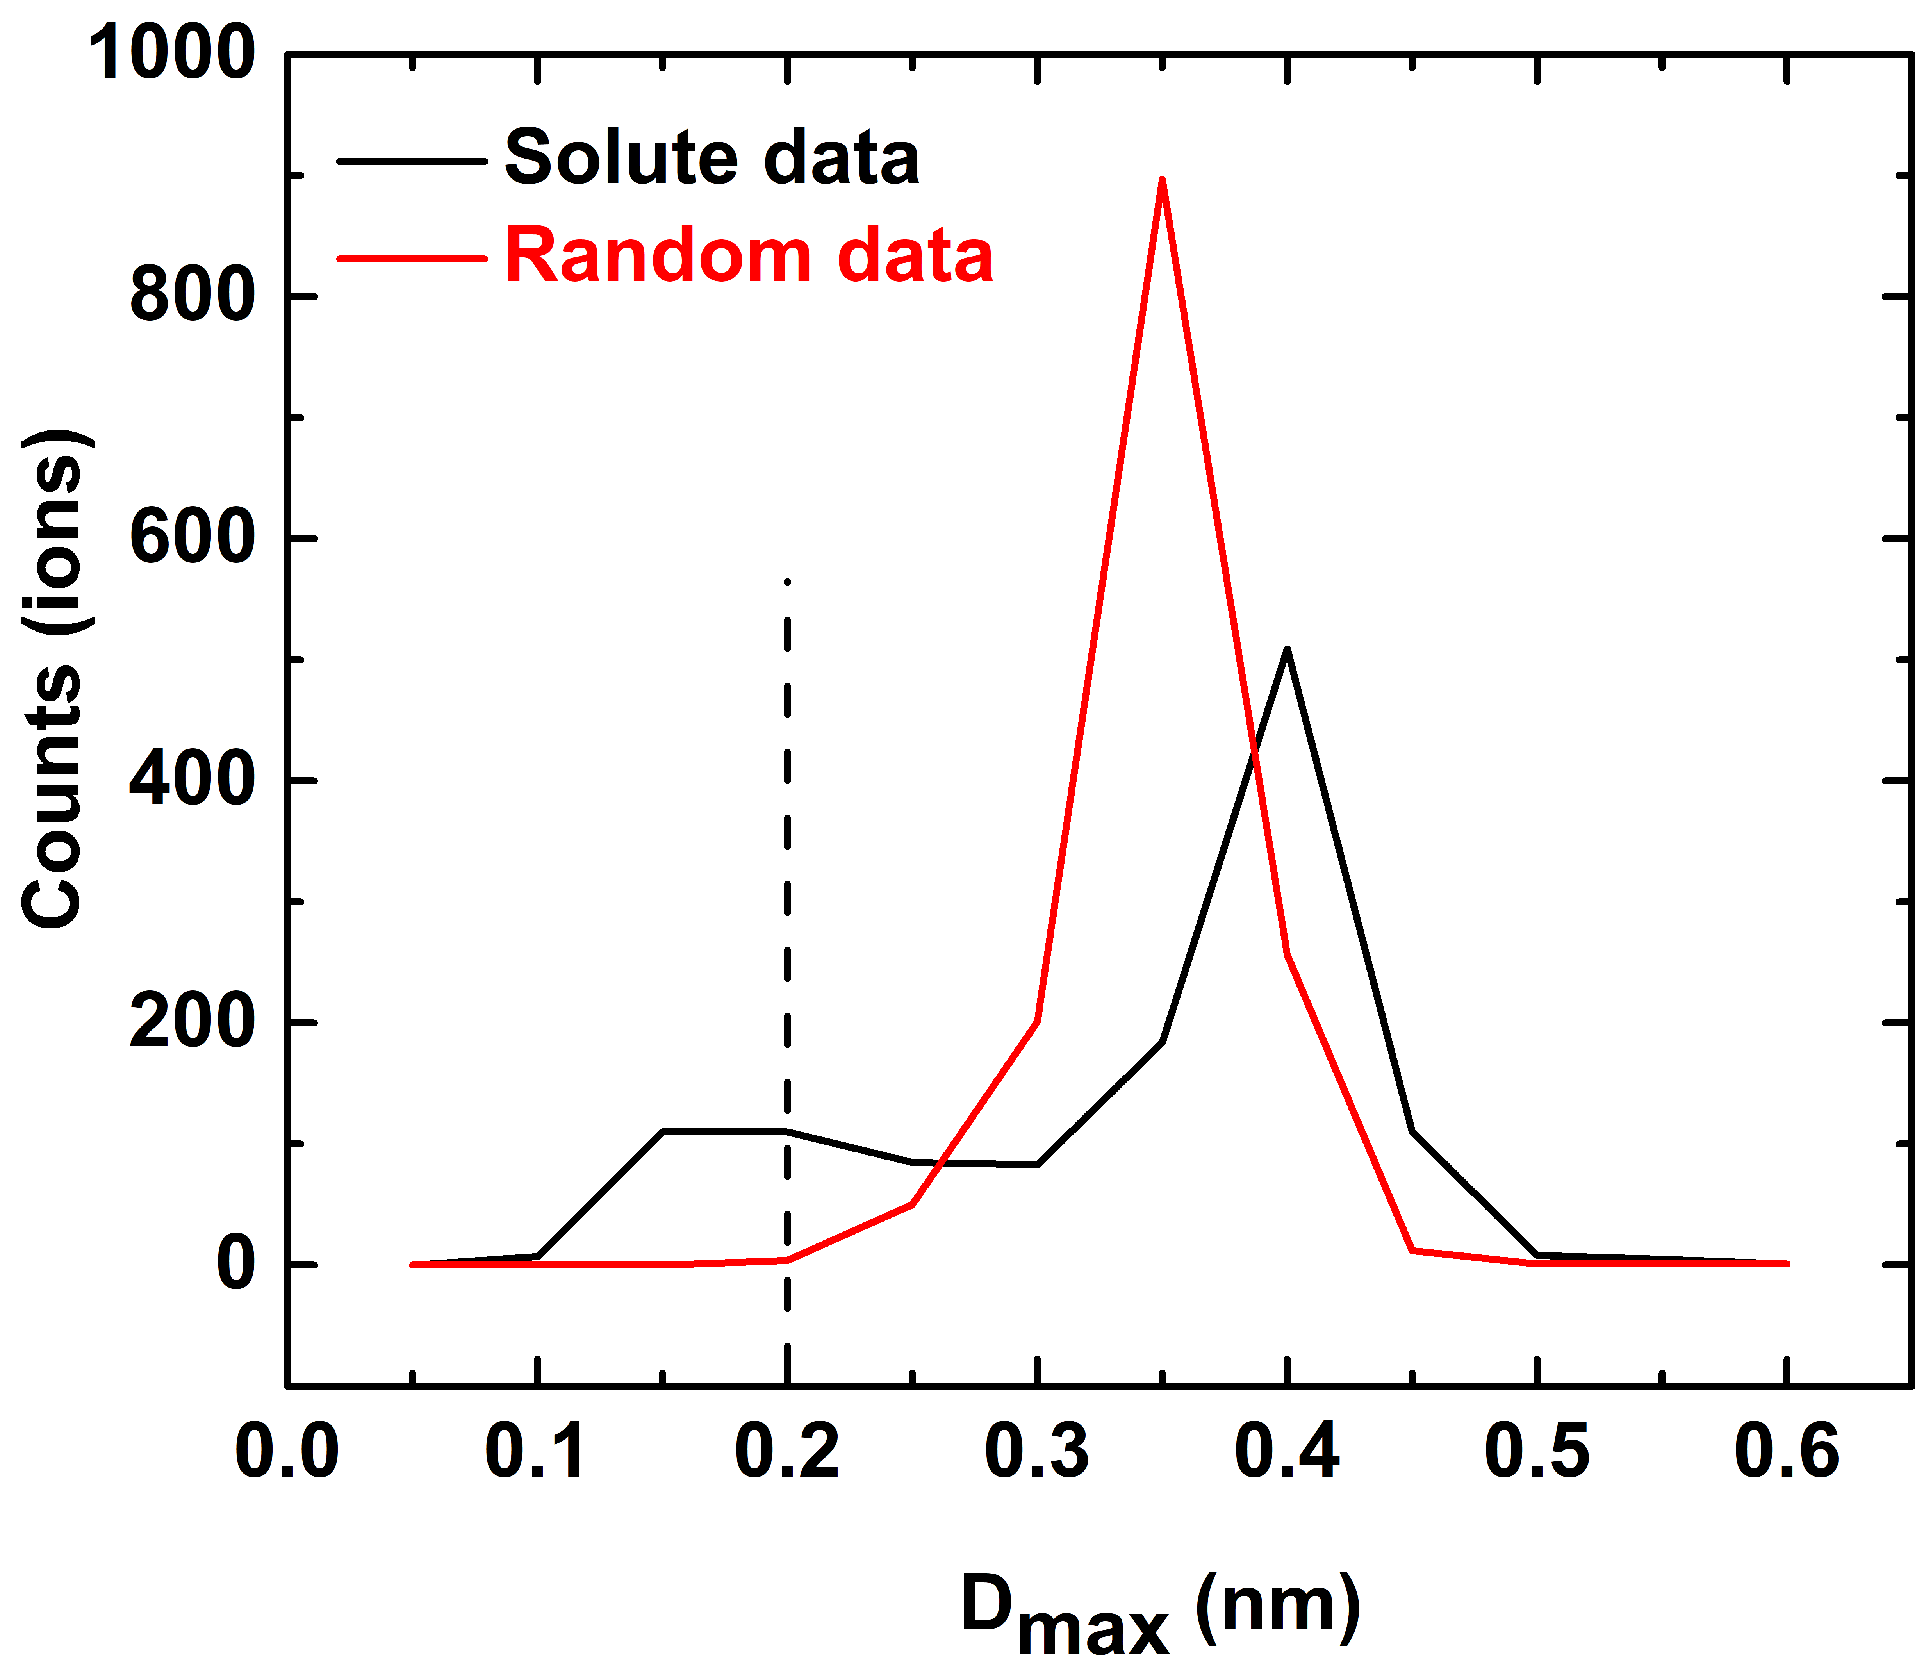

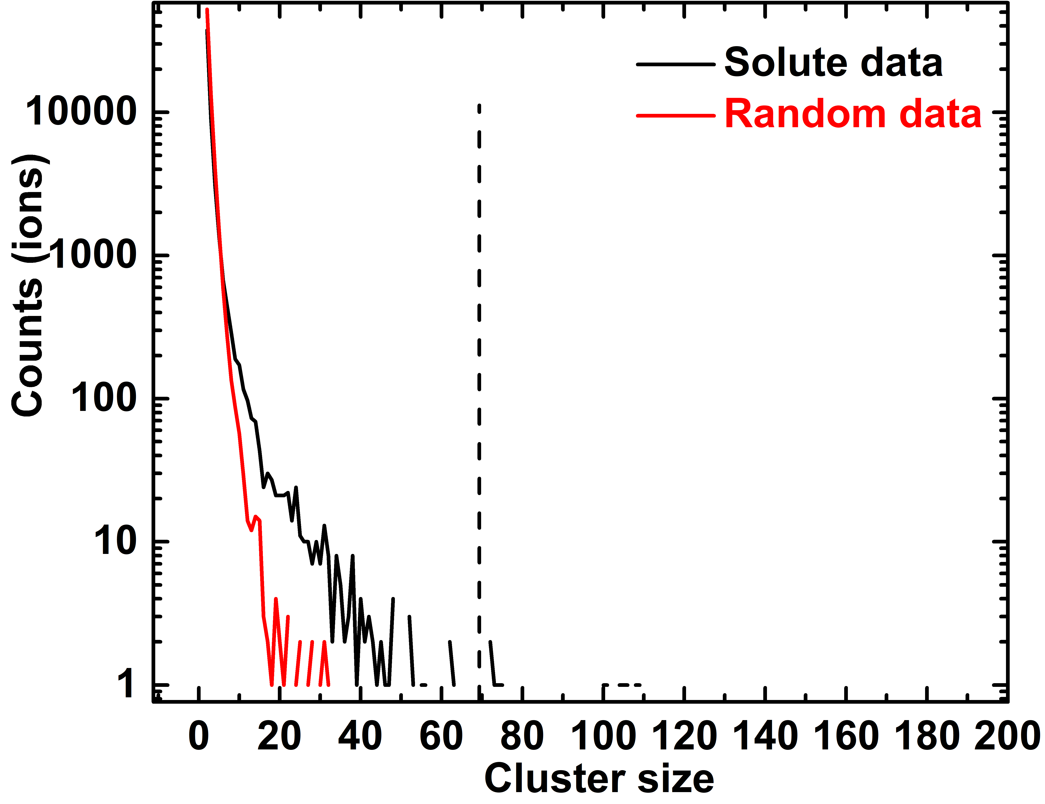

(a)

(b)

**Figure S4. a:** Cluster count distribution, and **b:** cluster size distribution.

After satisfactory determination of *Dmax* and *Nmin* values, the cluster detection algorithm has been run. However, not all the atoms contained in the clusters are solute and the matrix atoms are identified in the cluster by defining a parameter *L*, called the envelope parameter (Larson et al., 2013). Those matrix atoms are removed from the cluster by another parameter *E*, erosion parameter (Larson et al., 2013). In this work, *L* and *E* values are taken as same as *Dmax* value, i.e. 0.2 nm. The program yields 48 clusters (for this displayed representative analysis volume) along with other relevant statistics. The as obtained clusters are displayed in Figure S5. The spherical equivalent radius (*r*) of each cluster can be written as follows:

$r=\sqrt[3]{\frac{3nV}{4πη}}$ (S2)

where *V* is the atomic volume (*V*= $\frac{a^{3}}{2}$), *a* is the lattice parameter of Fe i.e. 0.2866 nm, *n* is the number of atoms in the cluster and $η$ is the detector efficiency (0.62 for FlexTap) (Tissot et al., 2019).

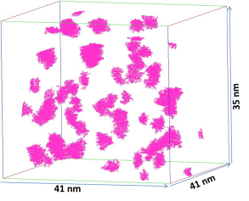

**Figure S5.** Distribution of Cr-rich clusters within the reconstructed volume.

The as obtained cluster size (radius) distribution has been presented in Figure S6 in histogram.

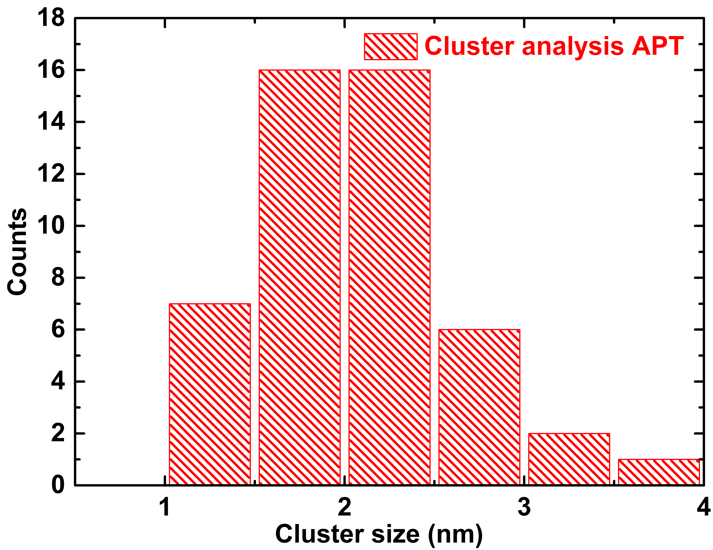

**Figure S6.** Cluster size distribution.

The average radius of the cluster is found to be 2.08 $±$ 0.57 nm.The number density of the clusters is determined by dividing the number of clusters by the analysis volume. The calculated number density is found to be 1.34 x 1024 0.3 x 1024/m3. The volume fraction of the cluster has been determined as the ratio between the numbers of Cr atoms present in the cluster to the overall solute atoms present in the analysis volume. The as determined volume fraction is found to be 6.99 $±$ 0.3%. The error (standard deviation) in number density and volume fraction has been calculated by performing the same task in three different selective analysis volumes. Figure S7 shows the Cr-concentration of the clusters as a function of their radius (as obtained from equation (S2)).

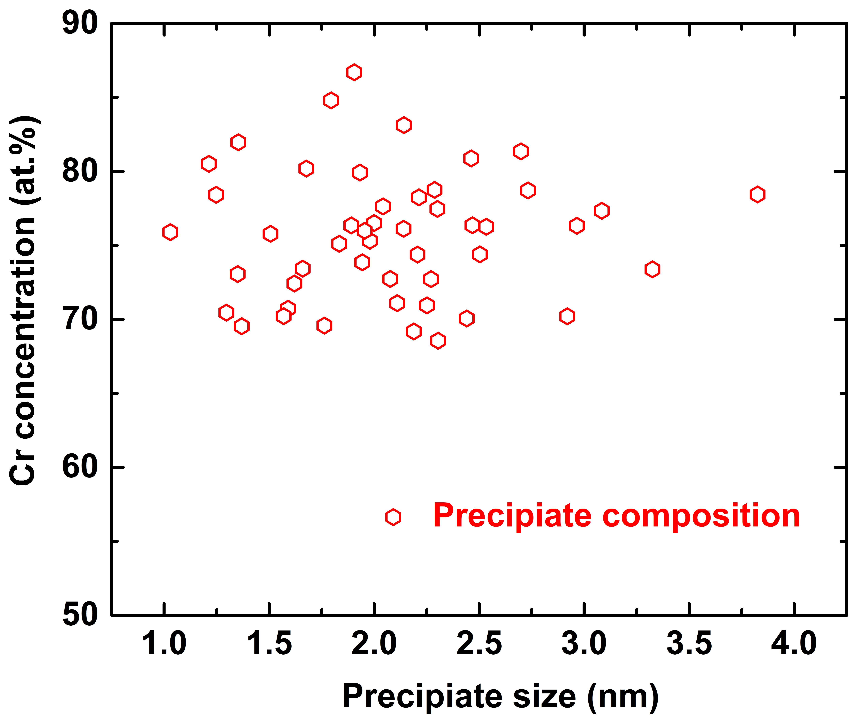

**Figure S7.** Cr-concentration of the clusters as a function of their radius value

The average Cr concentration in the cluster is estimated to be 75.65 $±$ 4.33 at.%.

**SANS analysis without constraint:**

SANS data has been fitted without considering neutron contrast using spherical particle model interacting via hard sphere potential (as per equation (2-4) of main text). Figure S8 below represents the experimental data along with fit (dotted line).

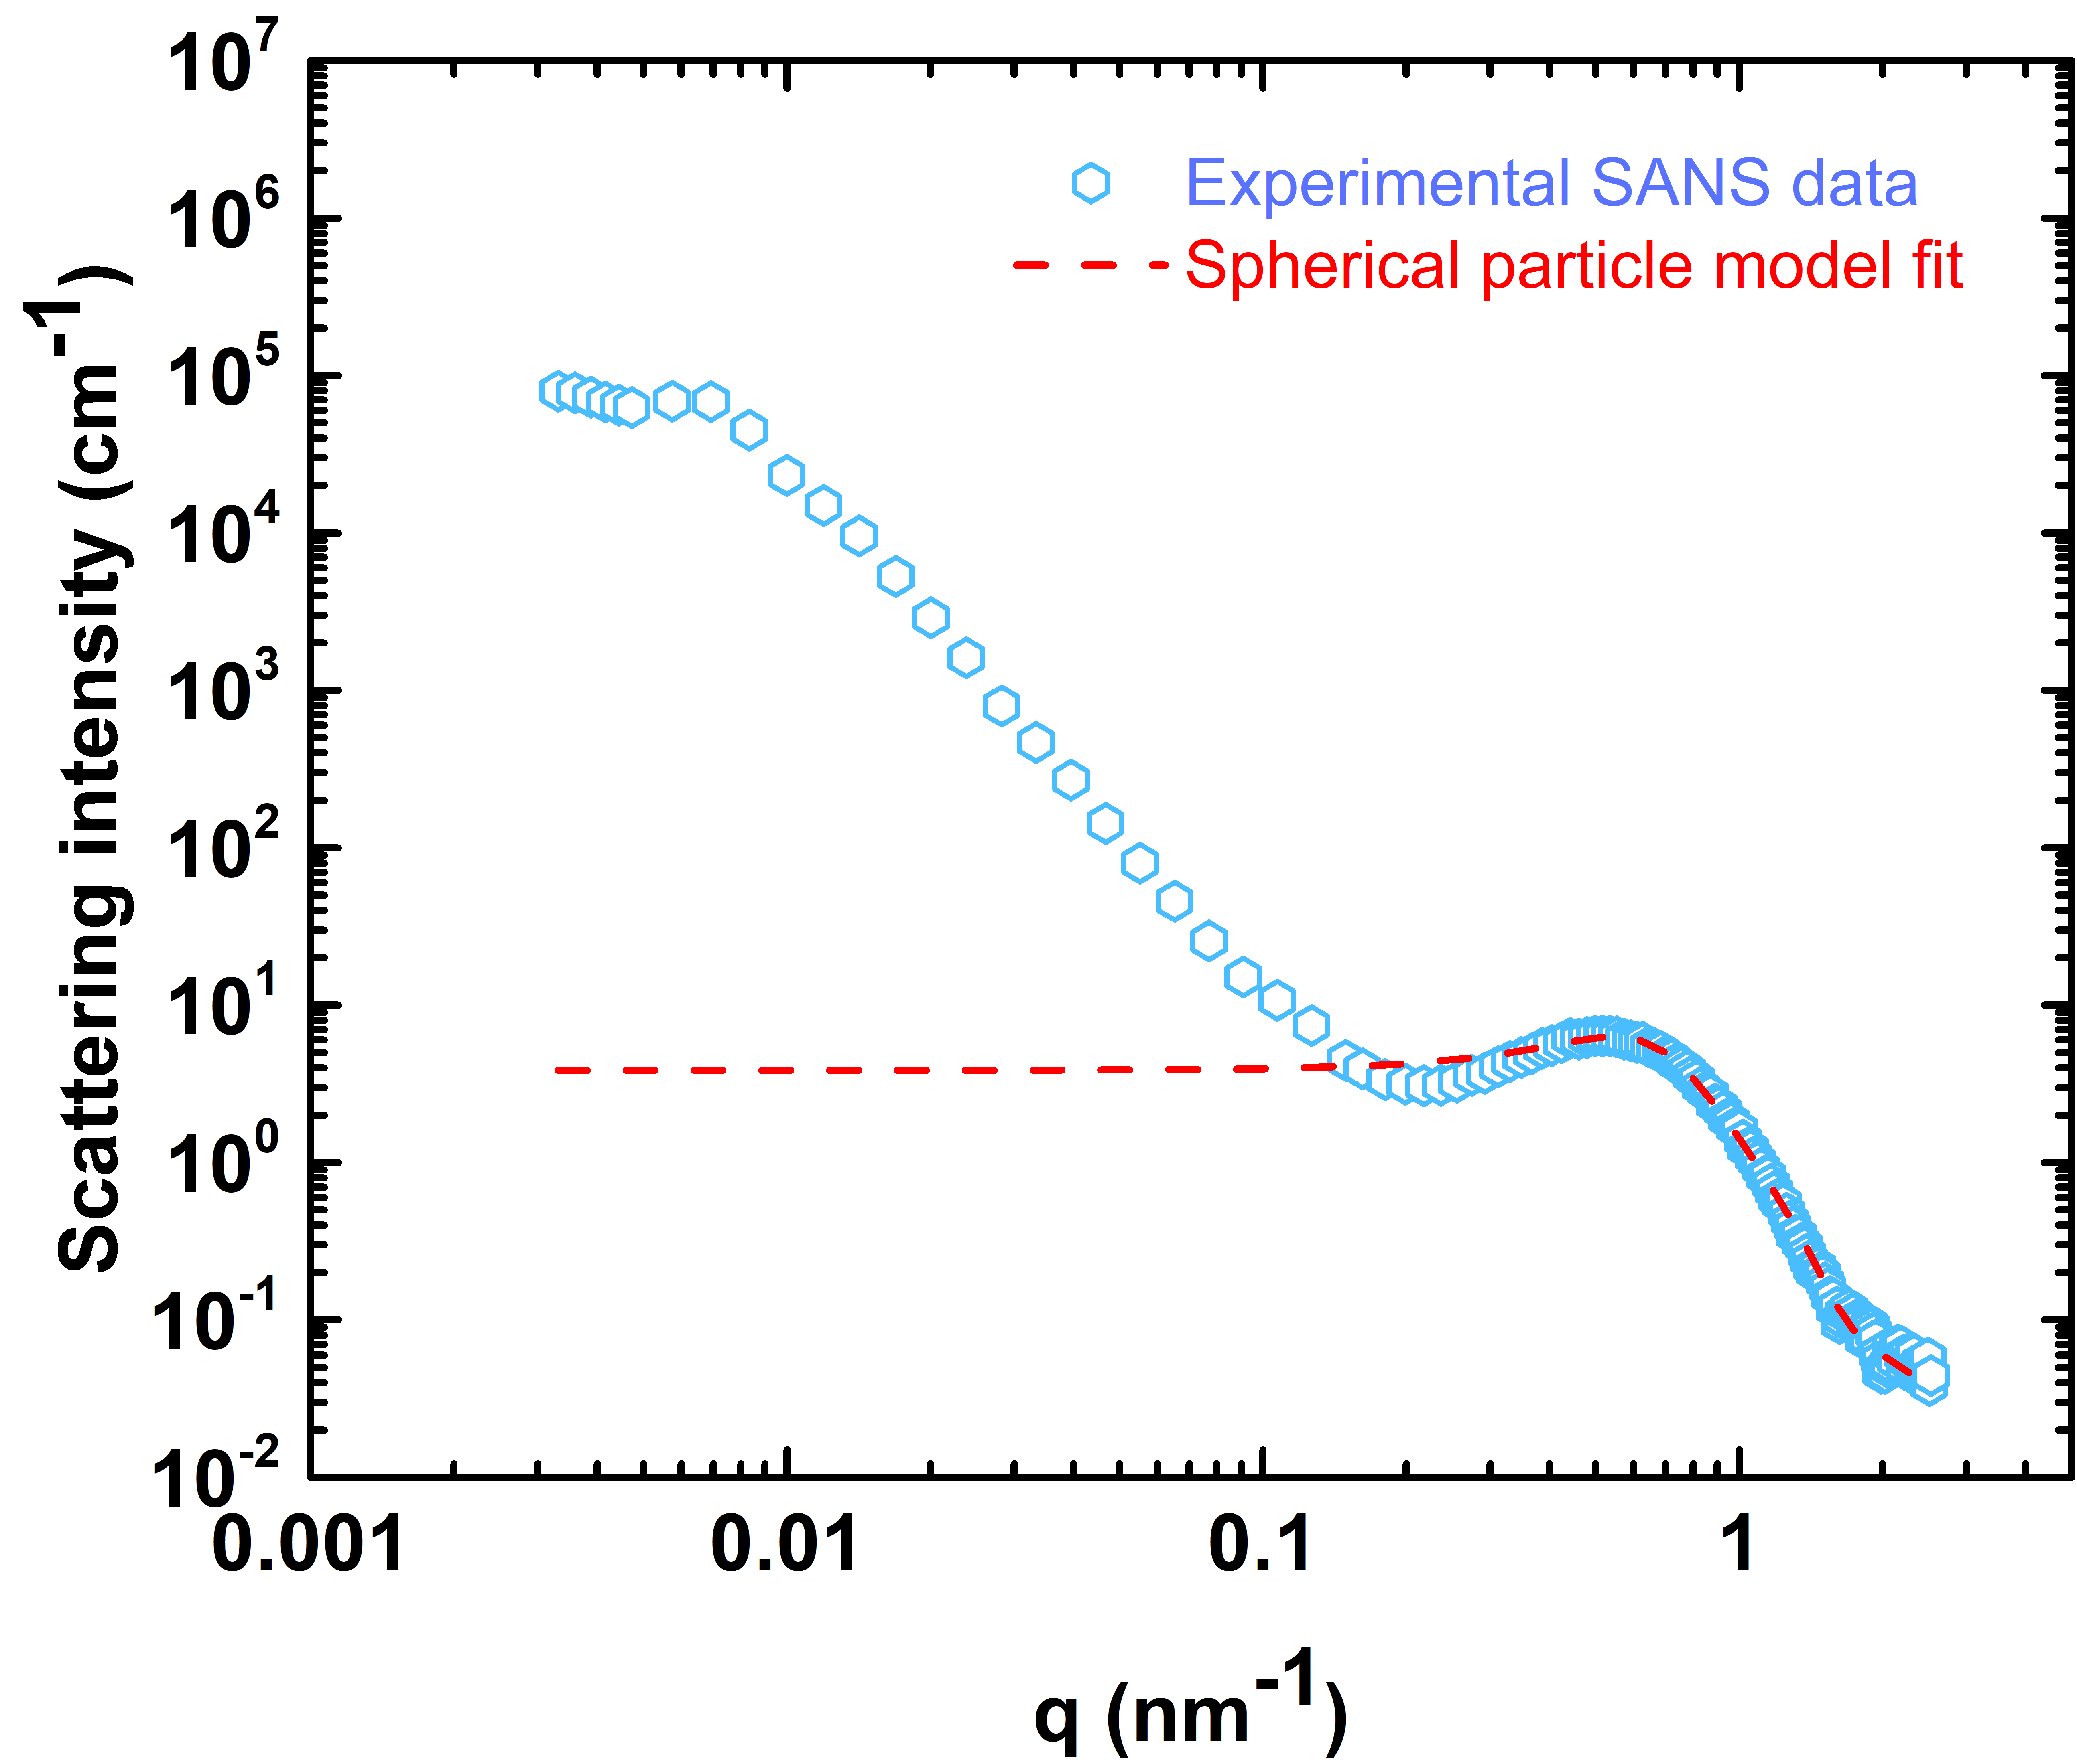

**Figure S8.** Spherical particle model fit of SANS data without considering any inputs from APT or TEM

Only the scattering data in the range q > 0.2 nm-1 are fitted as α/ signal appears in that q range and it is discussed in the original manuscript. The best fit yields the following quantitative information about the precipitates:

Average radius=2.44 $±$ 0.01 nm

Polydispersity = 0.22 $±$ 0.001

**References:**

Dong, Y., Etienne, A., Frolov, A., Fedotova, S., Fujii, K., Fukuya, K., Hatzoglou, C., Kuleshova, E., Lindgren, K., London, A., Lopez, A., Lozano-Perez, S., Miyahara, Y., Nagai, Y., Nishida, K., Radiguet, B., Schreiber, D. K., Soneda, N., Thuvander, M., Toyama, T., Wang, J., Sefta, F., Chou, P. & Marquis, E. A. (2019). Atom Probe Tomography Interlaboratory Study on Clustering Analysis in Experimental Data Using the Maximum Separation Distance Approach. *Microscopy and Microanalysis***25**, 356–366.

Larson, D. J., Prosa, T. J., Ulfig, R. M., Geiser, B. P. & Kelly, T. F. (2013). *Local Electrode Atom Probe Tomography: A User’s Guide*. New York: Springer-Verlag https://www.springer.com/gp/book/9781461487203 (Accessed August 16, 2020).

Marquis, E. A., Araullo-Peters, V., Etienne, A., Fedotova, S., Fujii, K., Fukuya, K., Kuleshova, E., Legrand, A., London, A., Lozano-Perez, S., Nagai, Y., Nishida, K., Radiguet, B., Schreiber, D., Soneda, N., Thuvander, M., Toyama, T., Sefta, F. & Chou, P. (2016). A Round Robin Experiment: Analysis of Solute Clustering from Atom Probe Tomography Data. *Microscopy and Microanalysis***22**, 666–667.

Tissot, O., Pareige, C., Mathon, M.-H., Roussel, M., Meslin, E., Décamps, B. & Henry, J. (2019). Comparison between SANS and APT measurements in a thermally aged Fe-19 at.%Cr alloy. *Materials Characterization***151**, 332–341.

Williams, D. B.&Carter, C. B. (2009). *Transmission Electron Microscopy: A Textbook for Materials Science*. 2nd ed. 2009 edition. New York: Springer.