Electronic Supplementary Information

In situ observation of the early stages of solid-liquid reaction in closed liquid cell transmission electron microscopy using graphene encapsulation

Hyun Woo Cha, ª Byeong-Seon An ª and Cheol-Woong Yang *ª

a. School of Advanced Materials Science & Engineering, Sungkyunkwan University, Suwon, Gyeonggi-do 16419, Korea
* E-mail: cwyang@skku.edu; Tel: +82-31-290-7362

Supporting figures

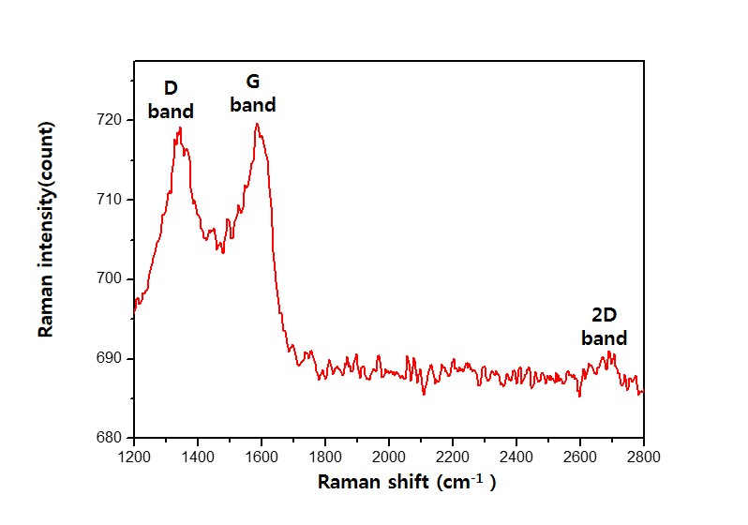
Support figure 1

Fig. S1. Raman spectrum of multi-walled carbon nanotube (MWCNT). The intensity ratio of D to G band (D/G ratio) of MWCNT is 0.99, which is comparable to the D/G ratio of MGCN (0.97).
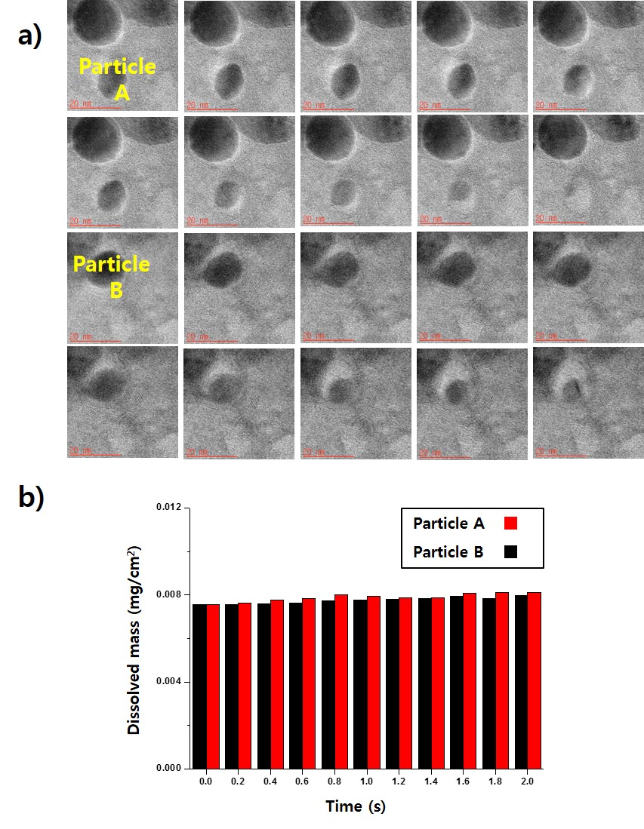
Support figure 2.
Fig. S2. a) TEM images sequentially captured from in-situ experiment video 2, showing rapid dissolution of copper nanoparticles A and B. The images were captured at 0.2 s intervals. The mass of the copper nanoparticles was calculated based on this observation. In order to calculate the mass of the copper nanoparticles, two assumptions were made. First, the copper nanoparticles are spherical. Second, the area reacted with the aqueous iron chloride solution is planar. Based on these assumptions, a dissolved mass of copper nanoparticle from each image was calculated. The radius of the particle and the area of the interface were measured from the captured images. The dissolved mass of copper was then calculated from the volume change. In the captured TEM images, the interface between solid and liquid is not flat. This may be caused by projecting a three-dimensional object into two dimensions. b) Mass of copper dissolved every 0.2 s per unit area (mg/nm²)

