**Figures and Supplementary Materials for**

Atom probe tomography for isotopic analysis: development of the 34S/32S system in sulfides

Phillip Gopon, James O. Douglas, Frederick Meisenkothen, Jaspreet Singh, Andrew London, Michael P. Moody

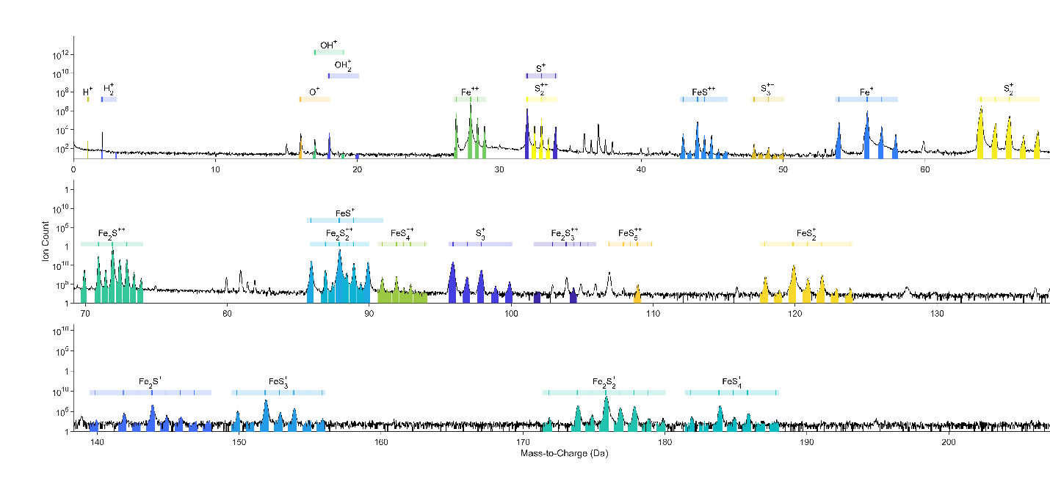

Figure 1: Mass spectrum of dataset R5083_08493, showing the complexity of the mass spectrum as well as the overlaps present on the main S peak family (34 Da, 33 Da, 34 Da, and 36 Da). Note only the main peaks are labeled for sake of clarity.

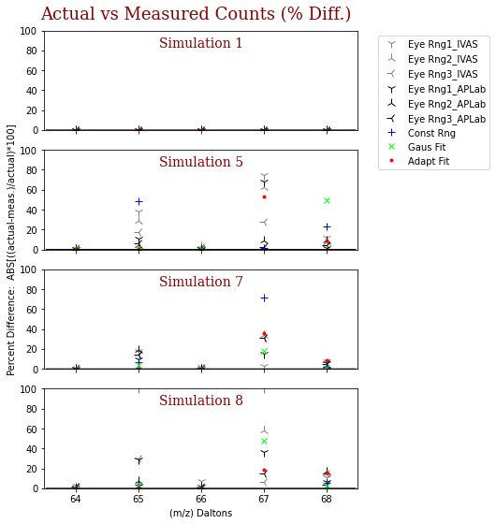Figure 2: Plot of the deviation of the various methods of peak count determination from the ‘actual.’ Note values shown are absolute values of percent differences calculated from the values in Table 1.

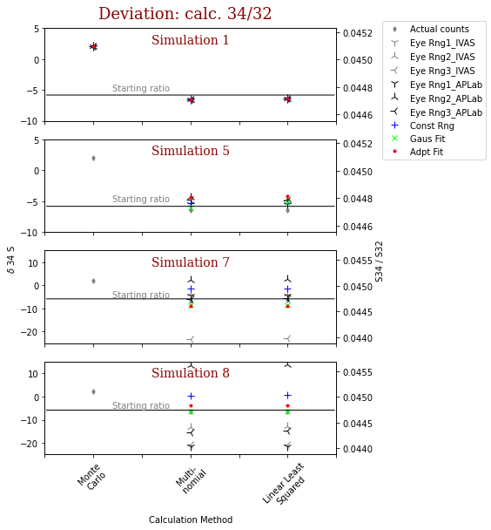

Figure 3: Comparison of three different methods to determine the 34S/32S ratios (from Table 1). Plotted as both δ34S (left axis) and absolute 34S/32S ratio (right axis). Note that only ± 20 ‰ δ34S is shown. Values outside of this range can be found in Table 1. With the exception of Simulation 1, all calculations using the Monte Carlo Approach are outside of this range.

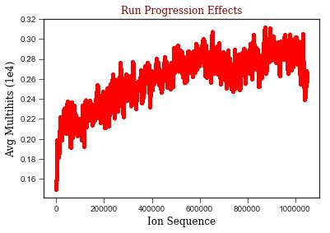

Figure 4: The ion hit sequence plotted versus multi-hits (averaged over 1e4 ion hits) for dataset R5083_08493. Note the increase in multi-hits as the run progresses.

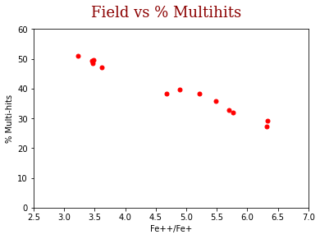

Figure 5: Plot of % multi-hits versus the charge state ratio of Fe++/Fe+ (from Table 2). The CSR is used here as a direct proxy for the local electric field.

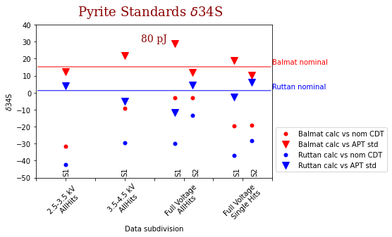

Figure 6: Comparison of calculated δ34S of datasets of pyrite standards run at 80 pJ. Data is subdivided by specific voltage ranges, as well as if only single hits or all hits are used. S1 means dataset pair 08492/08493 and S2 dataset pair 11434/11435. Data is shown both calculated against the nominal CDT value (Equation 8) and against a known standard (Equation 9).

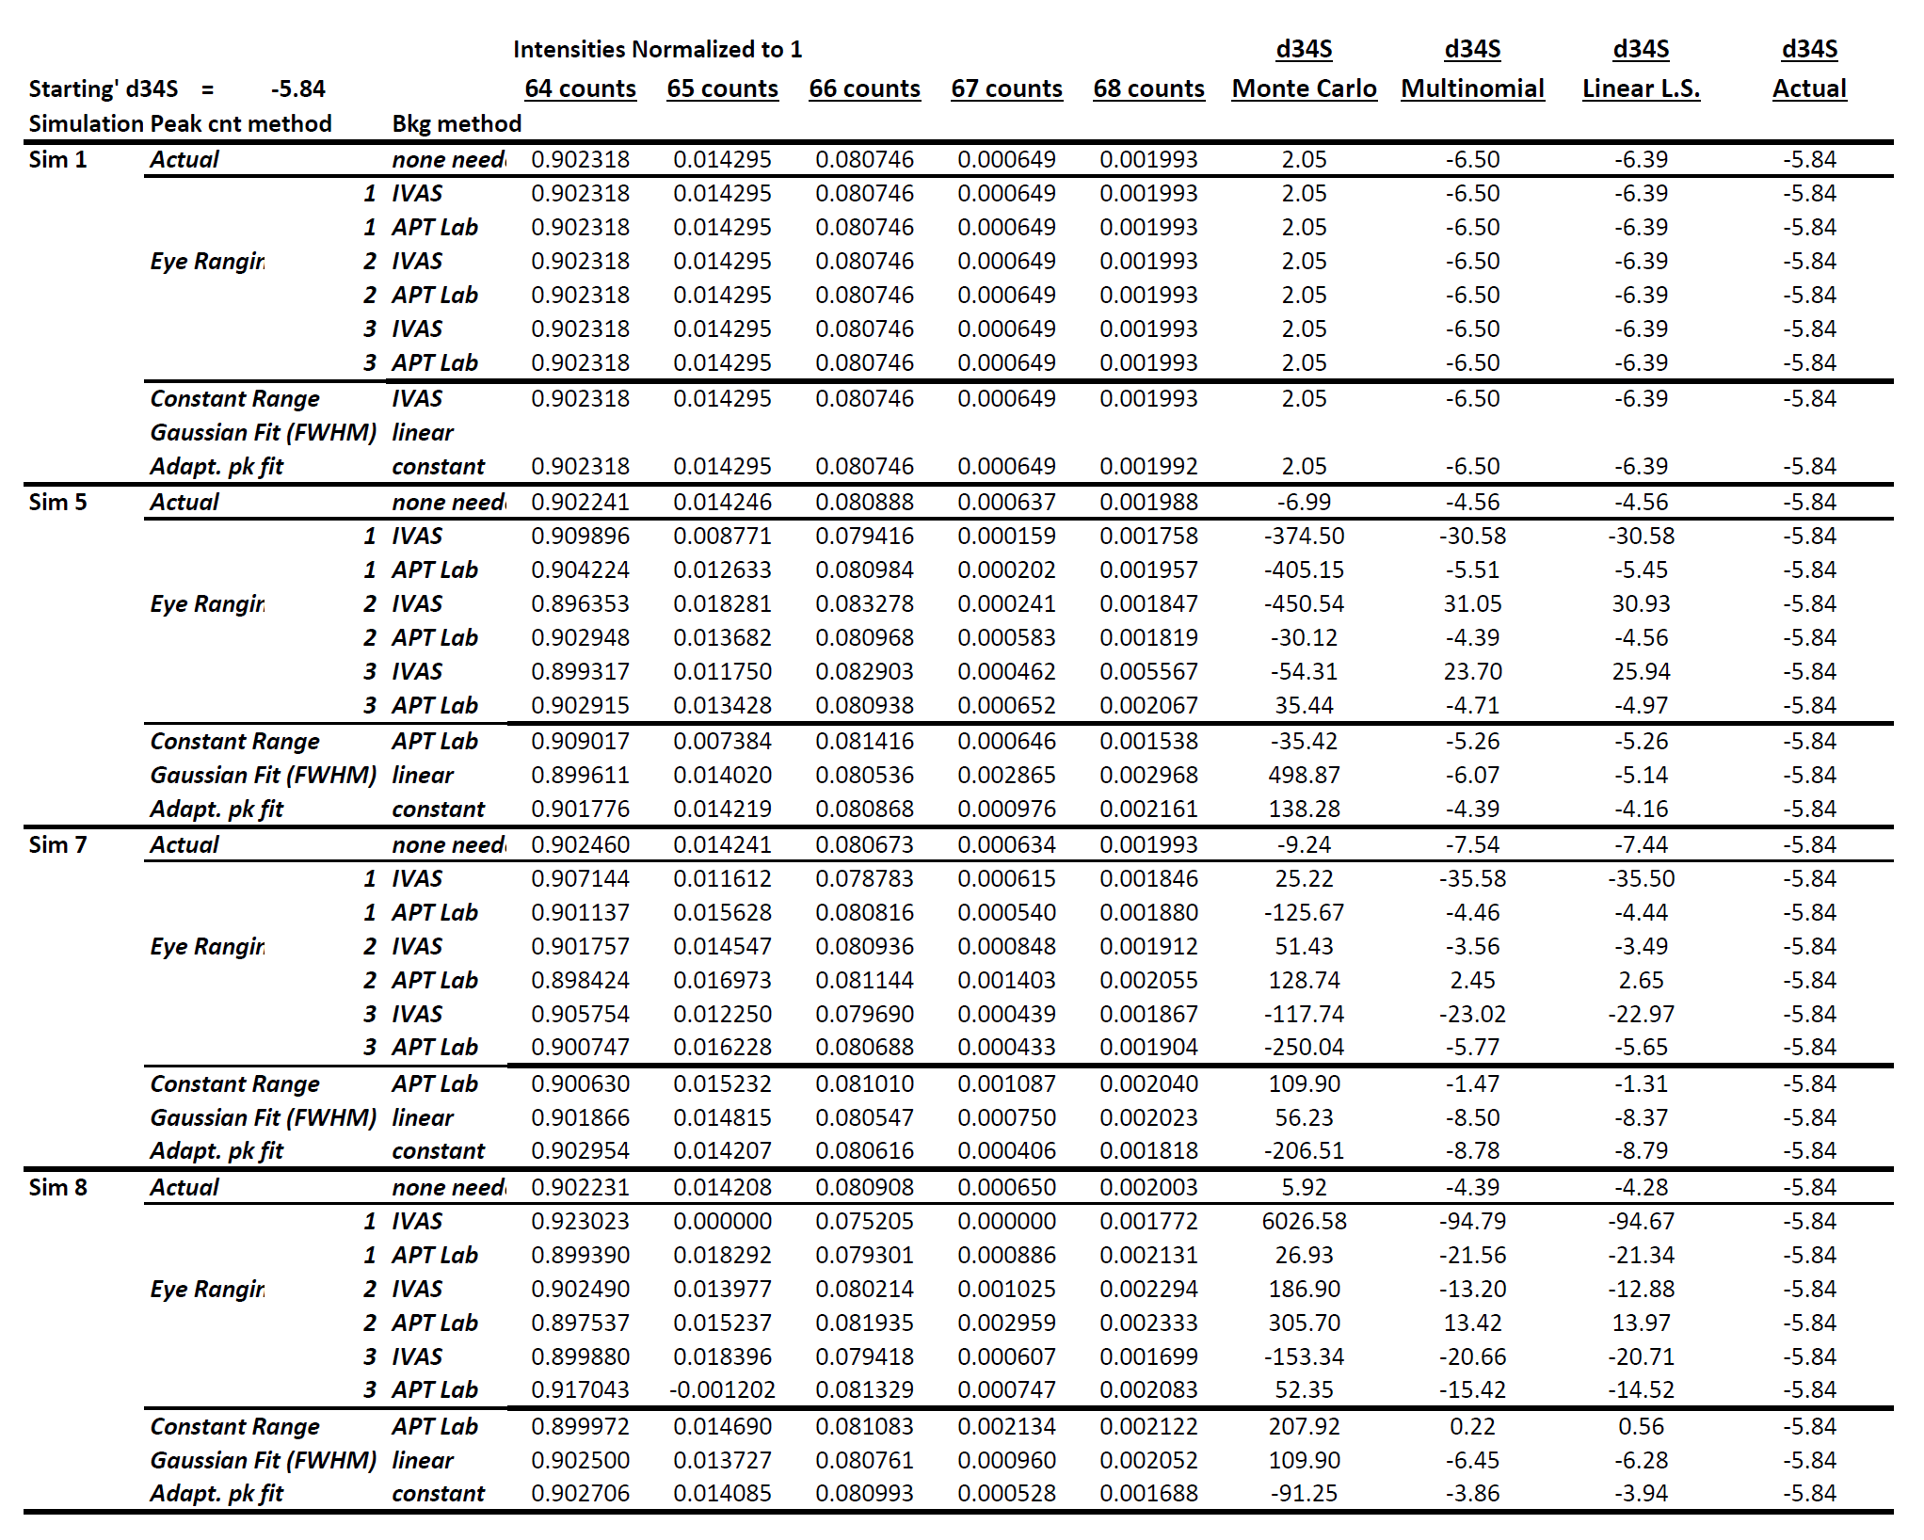

Table 1: Collation of various methods used to measure peak counts and to calculate the 34S/32S ratio. To save space, only Simulations 1,5,7,8 are shown. Results for all simulations are reported in Appendix C.



Table 2: Run conditions, calculated 34S/32S, and δ34S for each dataset and subdivision of each dataset. Multi-hit fractions as well as the corresponding Fe++/Fe+ ratio (as a proxy for the local field), were calculated for the data containing all hits. δ34S is calculated both against the nominal CDT value (equation (8)) and calculated against the corresponding standard that was acquired closest in time (equation (9)). Note - other than applied voltage, all other acquisition conditions kept constant (see section 2).

**Appendix A: Detailed table of all ranges used for the ranging exercise.**

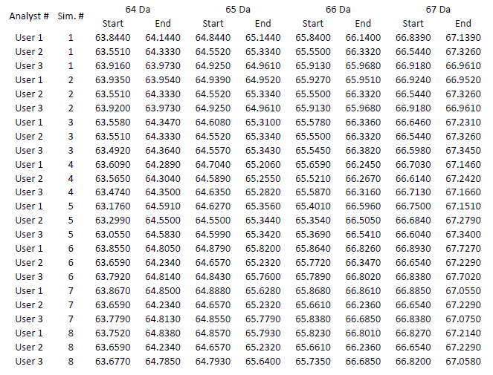

**Appendix B: Simulated spectra (Simulations 1-8)**

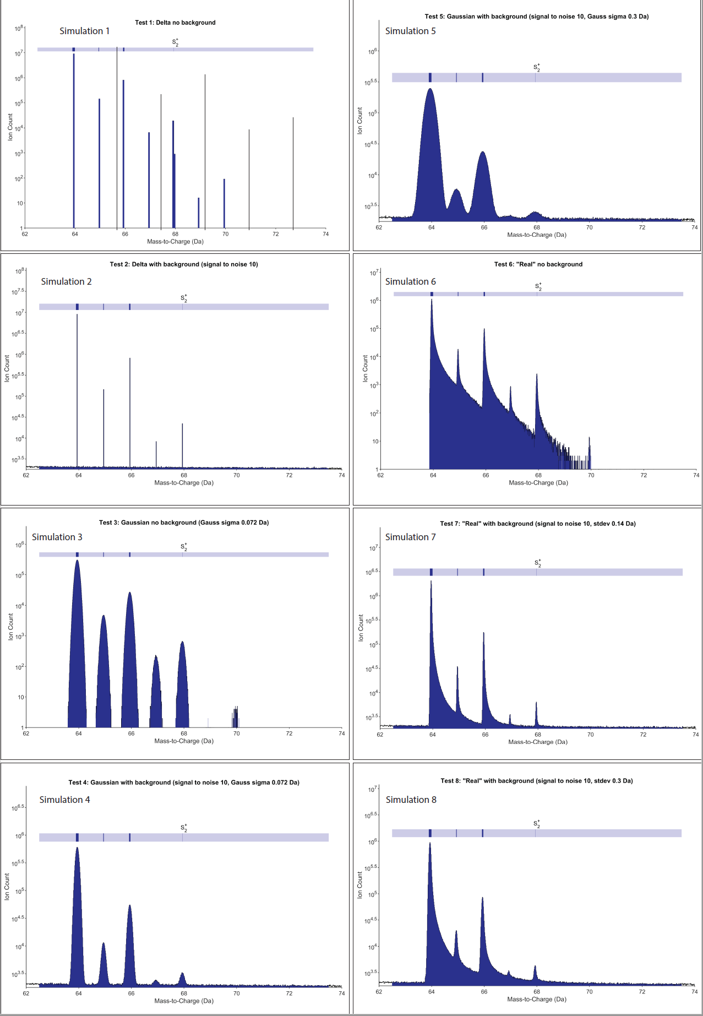

**Appendix C: Full simulated data results (Simulations 1-8)**

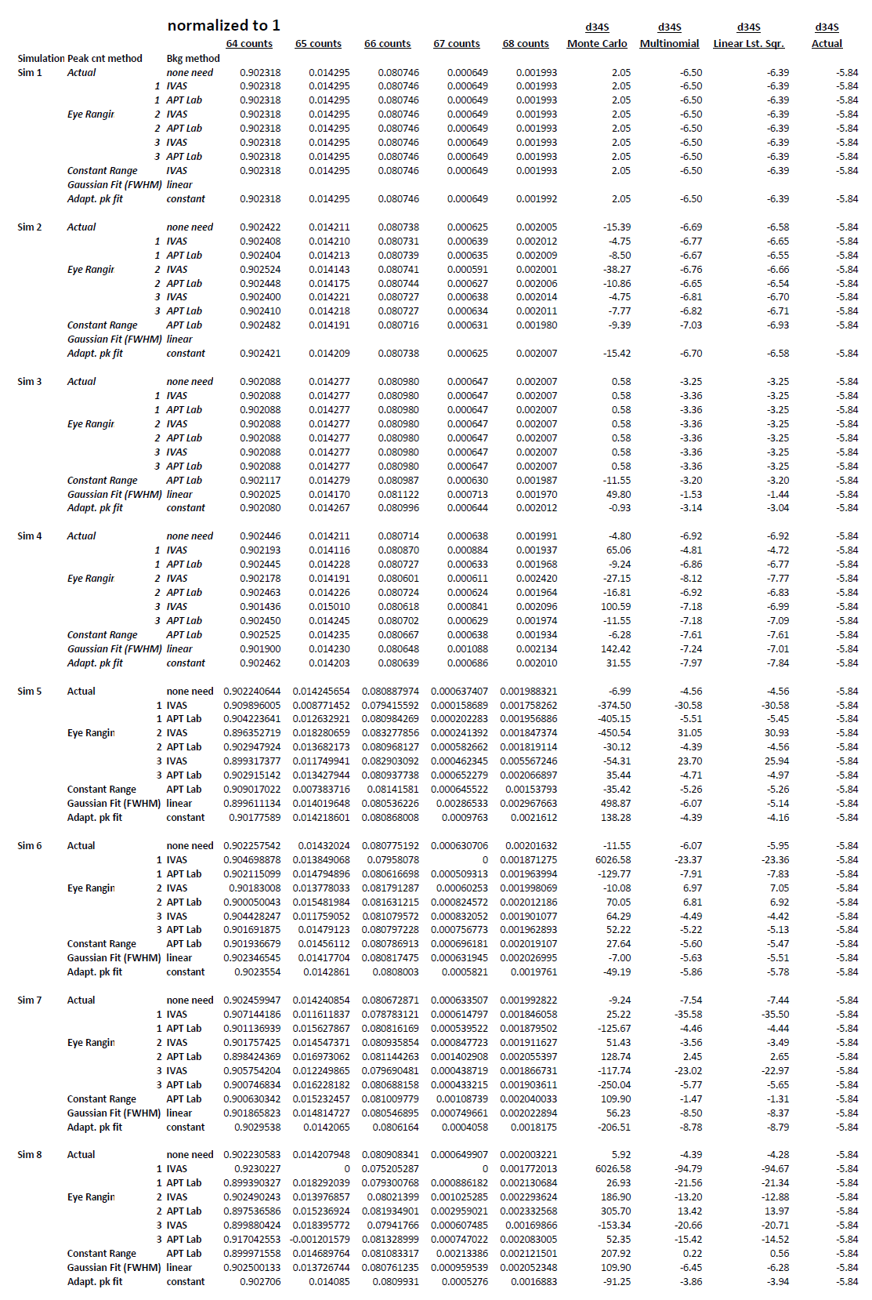

**Appendix D: Full empirical data results (Adaptive fit, IVAS, and Gaussian)**

**Adaptive Peak Fitting**



**IVAS**



**Gaussian Fitting**

