Supplementary materials
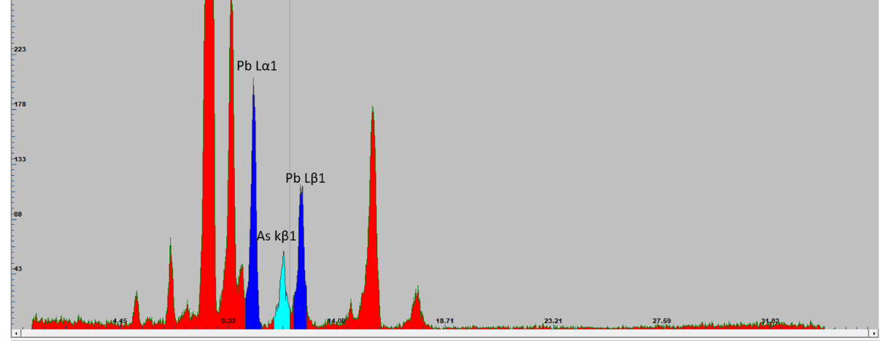
Figure I. The EDXRF spectrum, relative to the n.29 point, where lead Lα1 and Lβ1 (in blue), and the arsenic kβ1 (in pale blue) lines are highlighted.

Figure II. FTIR spectrum of the varnish layer.

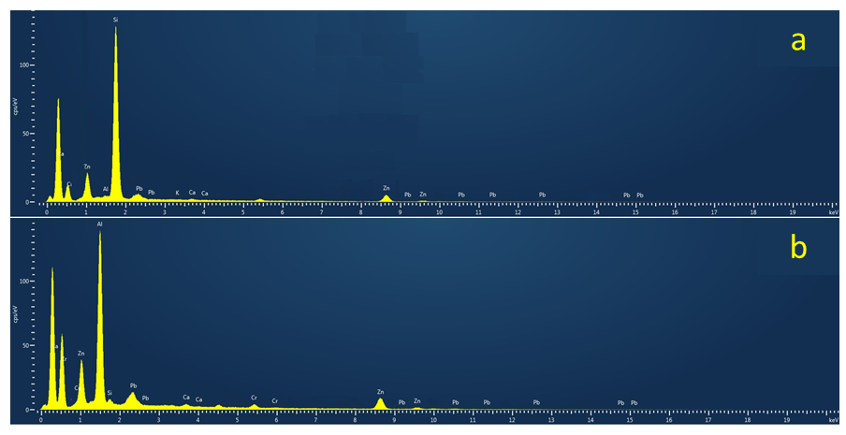
Figure III a) EDS spectrum n. 18; b) EDS spectrum n. 6.

