# SUPPLEMENTARY INFORMATION

**Atom probe tomography analysis of mica**

Chiara Cappelli1,*, Alberto Pérez-Huerta 1,2, Sardar B. Alam 3 and Tanya Prozorov3

*1Department of Geological Sciences, The University of Alabama, Tuscaloosa, AL 35487, USA*

*2Alabama Museum of Natural History, The University of Alabama, Tuscaloosa, AL 35487, USA*

*2 Division of Materials Sciences and Engineering, Ames Lab, Ames IA, 50011, USA*

*Corresponding author – E-mail: ccappelli@ua.edu

## **Preparation of biotite lamella sample for STEM imaging**

The biotite lamella for STEM imaging was prepared using focus ion beam (FIB) milling with Thermo Scientific Helios NanoLab G3 UC DualBeam (hosted in the Sensitive Instrument Facility of the Ames Laboratory). We started with half a millimeter-thin biotite flake that was a few millimeters in width and length. The biotite flake was affixed to a carbon tab with an adhesive that was itself supported on a metal stub compatible with FIB sample holder.

The biotite lamella was created using standard FIB *in situ* lift-off process (Schaffer et al., 2012), where a thin piece of sample was transferred to a TEM half-grid by an internal nanomanipulator. Briefly, a ca. 500 nm thin protective pad of carbon approximately 12 µm long and 1.5 µm wide was deposited over the region selected for the lamella. The carbon was deposited by e-beam induced deposition with a beam current of 0.23 nA at 30 kV. For SEM imaging, the accelerating voltage for electrons was later set to 5 kV. Trenches were milled by Ga ions on both sides of the protective pad with an ion beam current of 21 nA at 30 kV. Once the trenches are formed, the sample is tilted at 52o and a “J-cut” was milled using beam current of 2.5 nA at 30 kV, after which point the lamella was released from the biotite flake except for a small neck. A micro-manipulator needle was welded to the free edge of the lamella by carbon deposition followed by removing the neck. The released biotite lamella was extracted from the biotite flake and attached to one of the copper posts of a TEM half grid by carbon deposition. The micro-manipulator needle was detached from the lamella by milling, and the lamella was further thinned to electron transparency with 2.5 nA beam at 30 kV. Finally, the surface of lamella was cleaned by thinning with reduced Ga ion beam current of 40 pA at 5 kV.

The HR-STEM images were recorded from the thinnest darker section of the lamella.

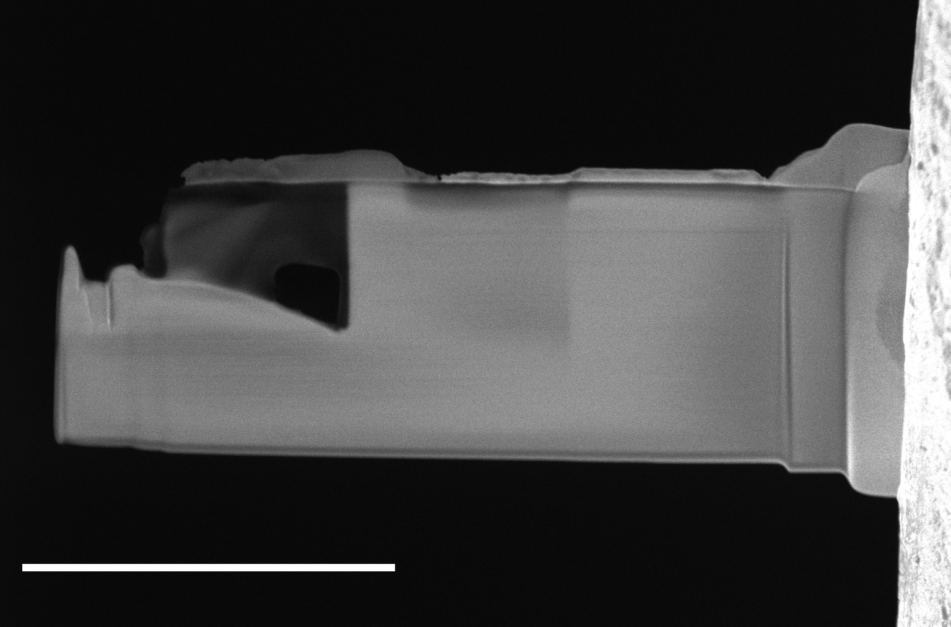

Image of the biotite lamella created by FIB and attached to Cu post of TEM half grid. The HR-STEM images were recorded from the thinnest darker section of the lamella. **Scale bar**: 5 mm

# SEM images of mica surface

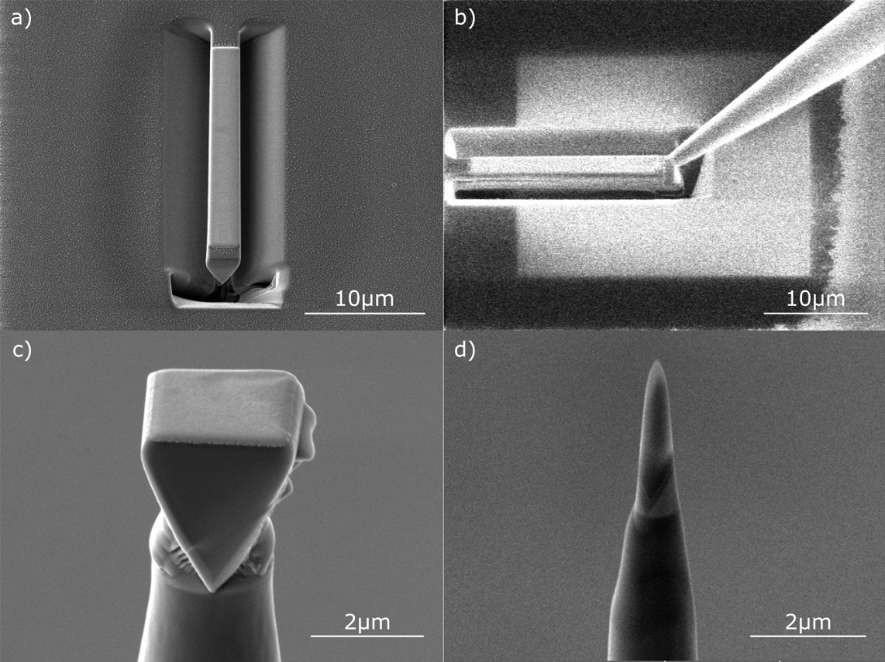

**Figure SI1**. Representative steps of the lift-out FIB protocol for atom probe mica specimen preparation. a) Cut wedge previously preserved by Pt deposition; b) nanomanipulator attachment to the loose end of the wedge; c) pyramidal sample segment secured by Pt on Si post; d) final tip-shaped specimen after low kV sharpening.

# Mineral sample analysis

**Table SI1**. EPMA analysis of the studied mica.



**Table SI2**. EDS analysis of the studied mica. Wt% Sigma=error in the weight percent concentration at the 1 sigma level.



# APT spectrum of 001 specimen

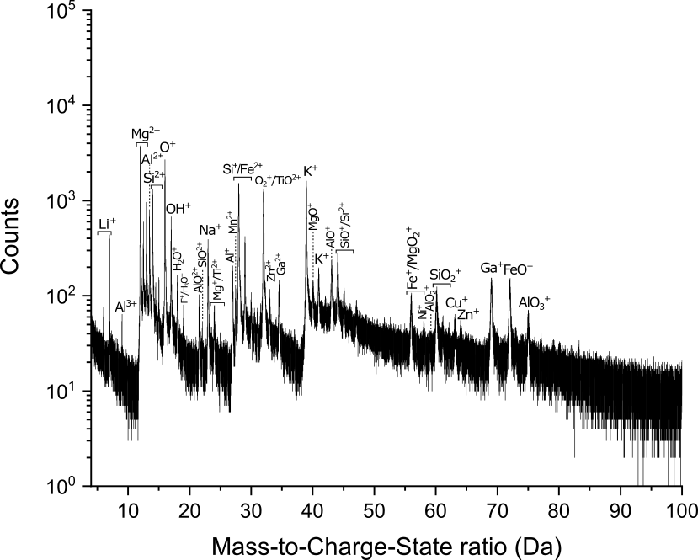

**Figure SI2**. Representative APT spectrum of a 001 specimen of the studied Mg-biotite.

# Voltage history of APT runs



**Figure SI3**. Voltage history of a representative specimen extracted from the (001) surface of the studied mica.



**Figure SI4**. Voltage history of a representative specimen extracted from the (hk0) surface of the studied mica.

**Reference**

**Schaffer M, Schaffer B & Ramasse Q** (2012). Sample preparation for atomic-resolution STEM at low voltages by FIB. *Ultramicroscopy* **114**, 62–71.