Supplementary Material

In Situ Measurement of Elastic and Frictional Properties using Atomic Force Microscopy
Ngoc-Phat Huynh, Tuan-Em Le, and Koo-Hyun Chung*
School of Mechanical Engineering, University of Ulsan, Ulsan 44610, Republic of Korea
*Corresponding author: Prof. Koo-Hyun Chung, School of Mechanical Engineering, University of Ulsan; 93 Daehak-ro, Nam-gu, Ulsan 44610, South Korea; Tel: +82-52-259-2744; Fax: +82-52-259-1680; Email: khchung@ulsan.ac.kr

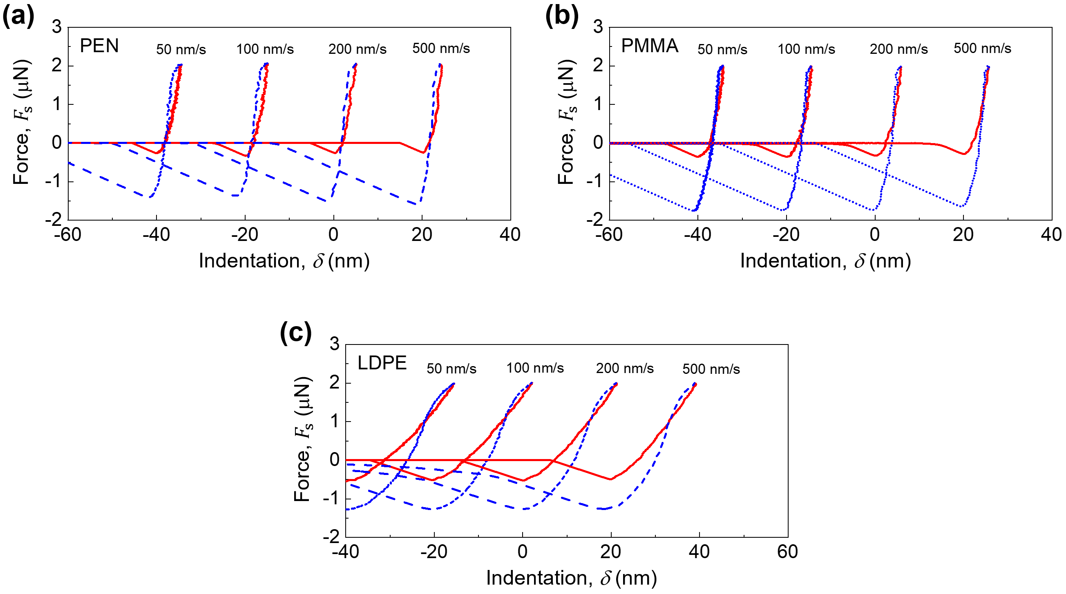
Fig. S1 Force-indentation curves of the (a) PEN, (b) PMMA and (c) LDPE specimens obtained with various speeds, ranging from 50 nm/s to 500 nm/s.

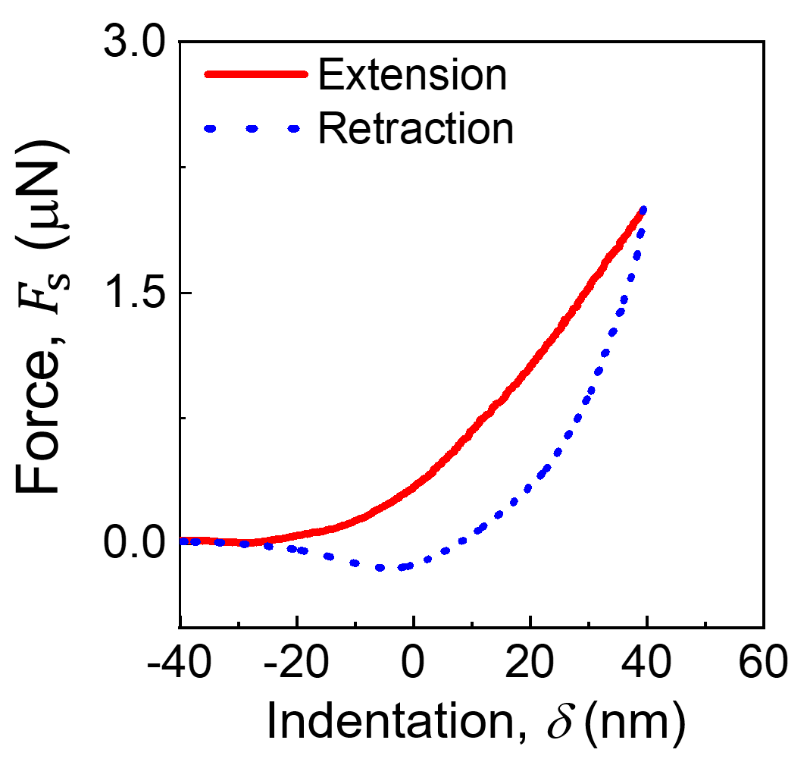
Fig. S2 Force-indentation curve of the LDPE specimen obtained with probe A.

