Supplementary Information
Experimental Methods
Table 1 and Table 2 contain the ionic inputs used to produce the simulated data. Table 1 contains the data for the whole mass spectrum, whereas Table 2 is Zr²⁺ charge state peaks only.
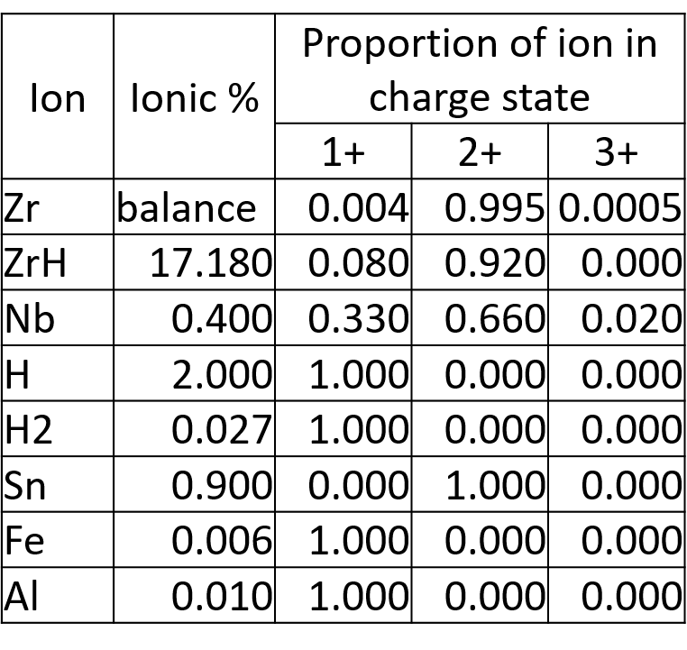
Table 1: Ionic input to generate the simulated Zirlo data set for the whole mass spectrum.

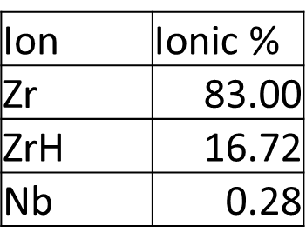
Table 2 Ionic input to generate the simulated Zirlo mass spectrum for the Zr ²⁺ charge state only.

The full list of APT experiments used in this analysis, including run conditions can be found in ‘Deuterium Quantification Experimental Data.xslx’. All available data used in this work can be found on Oxford Research Archive.
Results
Figure 1 and Figure 2 are the overlap diagrams for Nb overlap problems referenced in Section 3.1, these have been altered to include deuterium containing ions that could be present in the mass spectrum.

Figure 1: Overlap map for the Zr²⁺ charge state peak. Each circle contains the identity of a single ion, the lines connecting each ion represent an overlap at the mass-to-charge-state ratio values (in Da) on the right-hand side of the line. The thickness of each line represents the difficulty in solving the overlap.

Figure 2: Overlap map for the peaks in the Zr ¹⁺ charge state. Each circle contains the identity of a single ion, the lines connecting each ion represent an overlap at the mass-to-charge-state ratio values (in Da) on the right-hand side of the line. The thickness of each line represents the difficulty in solving the overlap. The black line shows the problems which are rank deficient and cannot be solved using conventional methods alone, as further information is needed to constrain the problem.

