Supplementary Information
Detection and Localization of Eu on Biosilica by Analytical Scanning Electron Microscopy
Ellen Hieckmannª*‡, Kaitlin K. K. Kammerlander^{b‡}, Lydia Köhler^{b‡}, Laura Neumann^{a‡}, Stefan Saager^{c}, Nico Albanis^{aⱵ}, Thomas Hutsch^{d}, Frank Seifert^{eⱵ}, Eike Brunner^{b}
ª TU Dresden, Faculty of Physics, Institute of Applied Physics, Helmholtzstraße 10, Dresden, Saxony, 01069, Germany.
^{b} TU Dresden, Faculty of Chemistry and Food Chemistry, Chair of Bioanalytical Chemistry, Dresden, Saxony, 01069, Germany.
^{c} Fraunhofer Institute for Organic Electronics, Electron Beam and Plasma Technology FEP, Dresden, Saxony, 01277, Germany.
^{d} Fraunhofer Institute for Manufacturing Technology and Advanced Materials IFAM, Branch Lab Dresden, Dresden, Saxony, 01277, Germany.
^{e} TU Dresden, Faculty of Physics, Institute of Nuclear and Particle Physics, Dresden, Saxony, 01069, Germany.

* Corresponding Author. Email: ellen.hieckmann@tu-dresden.de, Telephone: +49-351-463 36051, Fax: +49-351-463 37060
^{Ⱶ} Affiliation is former affiliation, now employed in the private/state sector.
‡ These authors contributed equally.

SI 1: On the Spatial Resolution of EDX and CL Measurements
As stated by Eggert (Eggert, 2005), the local resolution in EDX (energy dispersive X-ray) elemental analysis can be expressed by the depth Z at which the characteristic X-ray line is generated in the sample with the highest probability. This depth is given by $Z\left(µm\right)=0.033\left(E_{B}^{2}-E_{C}^{2}\right)/ρ$. Here, $ρ$ is the mass density of the material in g/cm³,$E_{B}=e∙‍V$ is the kinetic energy of the electrons in the electron beam (with the unit charge e and the acceleration voltage V), and $E_{C}$ is the critical energy for the generation of a characteristic X-ray photon, with both energies in keV.
According to Everhart and Hoff (Everhart & Hoff, 1971), the penetration depth R of the electrons in SiO₂ can be roughly estimated by the equation $R\left(µm\right) = 0.0181∙E_{B}^{1.75}$ with E_{B} in keV. The equation is applicable for an electron energy range between 5 keV and 25 keV and for atomic numbers between 5 and 15. The resulting value of R is in agreement with the Monte Carlo simulations described in SI 2. For a stationary electron beam, the quantity R is likewise a measure of the size of the sample region in which the CL (cathodoluminescence) radiation is generated (Yacobi & Holt, 1990).

Figure S1. Temperature dependency of the thermal conductivity of spectrosil (Heraeus, 2019) with supporting points for the temperature simulation.

SI 2: Modeling of the Local Temperature Distribution
The local temperature increase within the diatom biosilica under electron beam irradiation (as shown in Figure 4) was modeled by solving a nonlinear inhomogeneous heat conduction equation (Equation S1). These calculations were performed with the Comsol Multiphysics ® Software Version 5.6 using the Heat Transfer Module (Comsol AB, 2020). In order to take into account the scattering processes of the primary electrons in the diatom material, Monte Carlo simulations were performed by the Casino Software Version 2.4.8.1 (cf. Figure S2b), providing the absorbed heat power density function $p_{A}\left(\vec{r}\right)$ (see Figures S2a and S2c) (Drouin et al., 2007; Demers et al., 2011).

Equation S1.

$$c_{p}\left(T\right)ϱ\frac{∂T\left(\vec{r},t\right)}{∂t}-∇\left[λ(T)∙∇T(\vec{r},t)\right]=p_{A}(\vec{r})$$

with

$$p_{A}=\frac{(1-η)⋅U_{B}I_{B}}{2πσ^{2}}⋅e^{\frac{-(x^{2}+y^{2})}{{2σ}^{2}}}⋅f_{A}(z)$$ | inside the frustule structure, p_{A} = 0 otherwise.

Meaning of the symbols:
$c_{p}\left(T\right)$ specific heat capacity
$T$ temperature
$ϱ$ mass density of the material
$\vec{r}$ position vector from the spot center of the stationary electron beam (incident parallel to the z-direction) on the diatom frustule structure in an xyz coordinate system as shown in Figure 4
$t$ time
$∇$ Nabla operator
$λ\left(T\right)$ coefficient of thermal conductivity
$p_{A}\left(\vec{r}\right)$ absorbed heat power density function
$η$ backscatter coefficient (η = 0.167 according to Monte Carlo simulations)
$U_{B}$ acceleration voltage
$I_{B}$ electron beam current
$σ$ standard deviation of Gaussian approximation for the extent of the interaction volume of primary electrons in the xy-plane in bulk diatom material, estimated from Monte Carlo simulations (σ = 236 nm, cf. Figure S2a)
f_{A}(z) normalized function (in units 1/m) for the z-dependence of the absorbed heat power density, determined from Monte Carlo simulations by integration of $p_{A}(\vec{r})$ in the corresponding xy-planes (see Figure S2c)

(b)
(c)
(a)
Figure S2. Results of the Monte Carlo simulation for the absorbed heat power density p_{A} resulting from inelastic scattering processes of an idle focused electron beam, which is incident perpendicularly to the xy-surface plane on bulk diatom material; (a) Gaussian approximation of the radial latitude of p_{A} in the xy-planes, (b) absorbed heat power density in the xz-plane for y = 0 with color coding, (c) normalized function f_{A}(z) for the z-dependence of the absorbed heat power density, determined by integration of $p_{A}(\vec{r})$ in the corresponding xy-planes.

SI 3: Imaging, EDX, and CL in the SEM

Figure S3. SEM image of a diatom valve after Eu loading, indicating object 1 (area scan), object 2, and object 3 as well as the position of an EDX line scan (top) and the result of the elemental line scan for Eu over the whole diatom valve through object 3 (bottom).

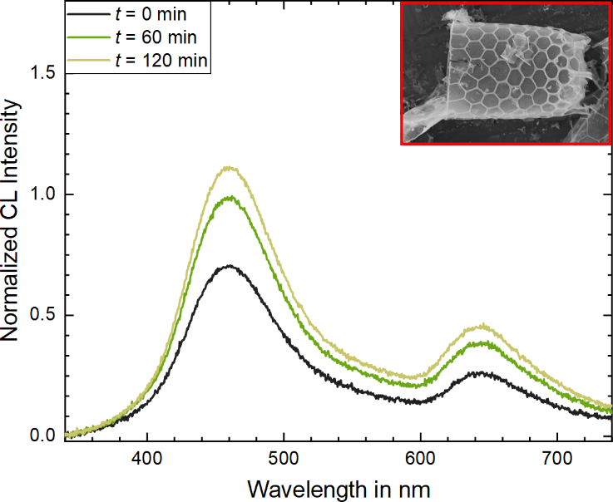
Figure S4. Exposure time dependency of the CL spectra from a scan on the entire diatom valve without Eu loading for comparison with Figure 8. The intensity was normalized by the same value as in Figure 8.

(b)
(a)
(c)
Figure S5. Irradiation time dependent CL spectra of a diatom valve after Eu sorption (cf. Figure S3), excited by different modes; (a) beam scan on the entire area of the diatom valve (object 1), (b) point excitation on the valve (object 2), (c) point excitation on an Eu-containing precipitate (object 3). In contrast to the other spectra, the CL intensity is not normalized in order to visualize the differences in signal intensity over time.

References
Comsol AB (2020). Comsol Multiphysics ®. www.comsol.com.
Demers, H., Poirier-Demers, N., Couture, A. R., Joly, D., Guilmain, M., de Jonge, N. & Drouin, D. (2011). Three-dimensional electron microscopy simulation with the CASINO Monte Carlo software. Scanning 33, 135–146.
Drouin, D., Couture, A. R., Joly, D., Tastet, X., Aimez, V. & Gauvin, R. (2007). CASINO V2.42—A Fast and Easy-to-use Modeling Tool for Scanning Electron Microscopy and Microanalysis Users. Scanning 29, 92–101.
Eggert, F. (2005). Standardfreie Elektronenstrahl-Mikroanalyse. Norderstedt: Books on Demand.
Everhart, T. E. & Hoff, P. H. (1971). Determination of Kilovolt Electron Energy Dissipation vs Penetration Distance in Solid Materials. Journal of Applied Physics 42, 5837–5846.
Heraeus (2019). Quartz Glass for Optics Data and Properties. Hanau.
Yacobi, B. G. & Holt, D. B. (1990). Cathodoluminescence Microscopy of Inorganic Solids. New York: Springer.

