Supplementary material to
Measuring system calibration factors by unmixing the excitation-emission spectra of one dish of cells
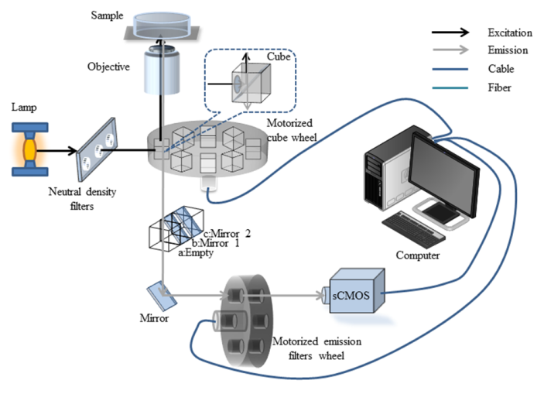
Figure S1. Hardware of the automated ExEm-spFRET microscope: include a wide-field microscope with a motorized cube wheel, a motorized emission filter wheel, and a sCMOS camera. Two exaction cubes are inserted into cube wheel which equipped with a 436/20 nm excitation filter, 455nm dichroic mirror and a 470/20nm excitation filter, 490nm dichroic mirror, respectively. The emission wheel equipped with 470/20 nm, 490/20 nm, 510/20 nm, /530/20 nm, and 550/20 nm emission filters.
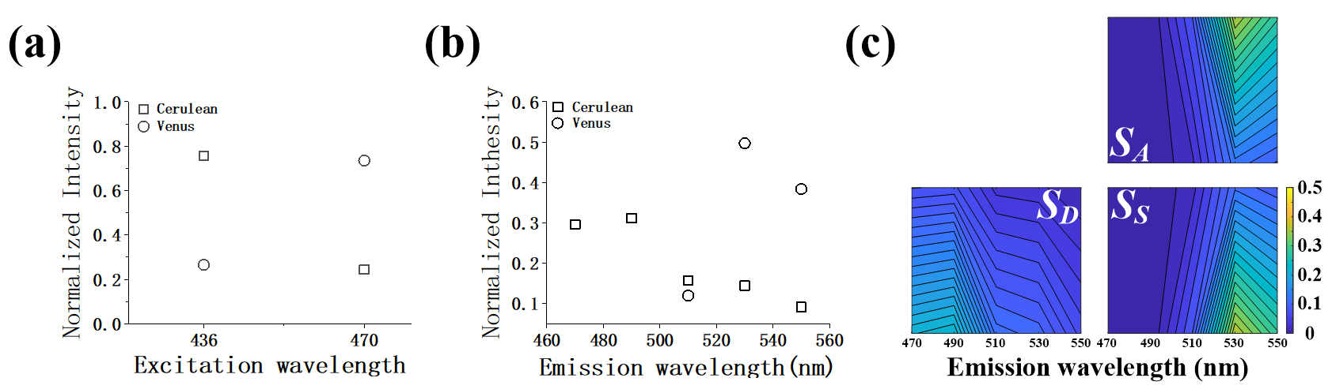
Figure S2. Excitation-emission spectral fingerprints of Cerulean (S_{D}), Venus (S_{A}), and Cerulean-Venus sensitisation (S_{S}). (a) Normalized emission spectrum of Cerulean and Venus. (b) Normalized excitation spectrum of Cerulean and Venus. (c) Spectral fingerprints for S_{D}, S_{A}, and S_{S}.
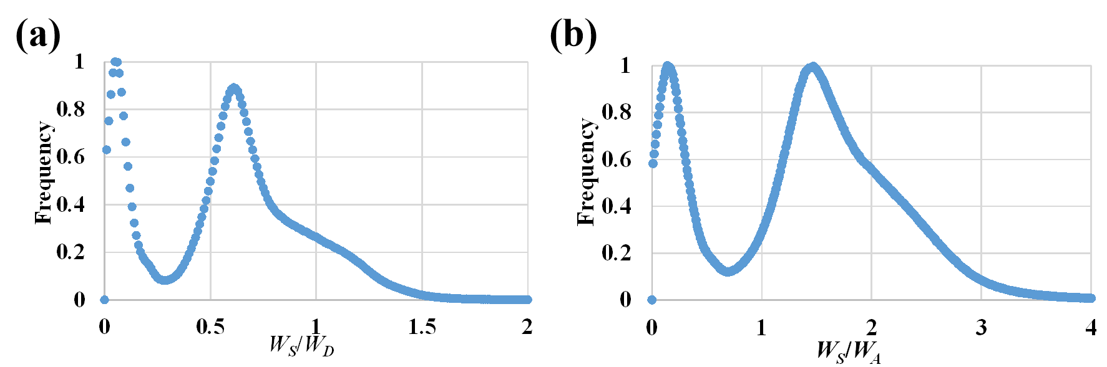
Figure S3. Plots of frequency-W_{S}/W_{D} (a) and frequency-W_{S}/W_{A} (b) directly from the 589 cells used in Figure 2d. Contrast to Figure 2d, only two obvious peaks can be determined in this case, and accurate peak values cannot be obtained through four-Gaussian function fitting.
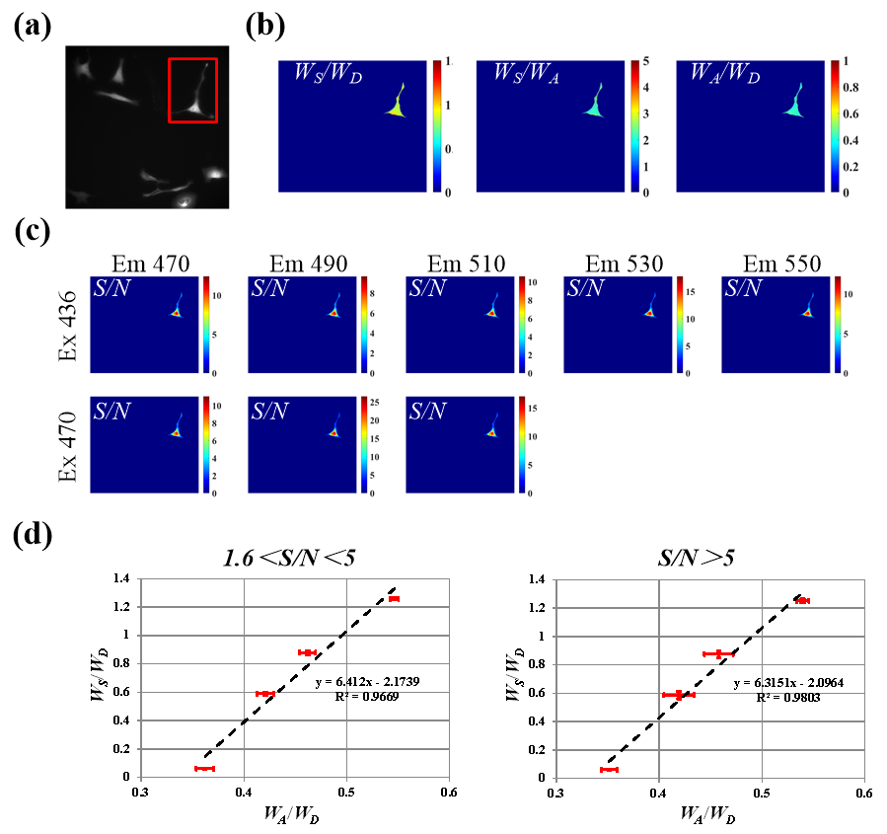
Figure S4. Influence of S/N ratio on the measured K_{A}/K_{D} and Q_{A}/Q_{D} values. (a) ExEm-Spectra images of one dish of cells expressing the four kinds of FRET tandem constructs. (b) Pseudo-color images of W_{S}/W_{D}, W_{S}/W_{A} and W_{A}/W_{D} of the cell indicated by red box in (a). (c) The signal-to-noise ratio images of the spectral images of the cell indicated by red box in (a). (d) Plots of W_{S}/W_{D}-W_{A}/W_{D} in the case of 1.6＜S/N＜5 (Left) and S/N＞5 (Right) respectively, and obtaining the results: K_{A}/K_{D} _{(1.6＜S/N＜5)} = 1/6.412 and Q_{A}/Q_{D} _{(1.6＜S/N＜5)} = 2.174, consistent with the K_{A}/K_{D} _{(S/N＞5)} = 1/6.315 and Q_{A}/Q_{D} _{(S/N＞5)} = 2.069, indicating that S/N ratio greater than 1.6 has no effect on the measured K_{A}/K_{D} and Q_{A}/Q_{D} values.

