Supplemental information for

Automated crystal orientation mapping by precession electron diffraction assisted 4D STEM using a scintillator based CMOS detector
Jiwon Jeong, Niels Cautaerts, Gerhard Dehm and Christian H. Liebscher
Department of Structure and Nano-/Micromechanics of Materials, Max-Planck Institut für Eisenforschung GmbH, Düsseldorf, 40237, Germany
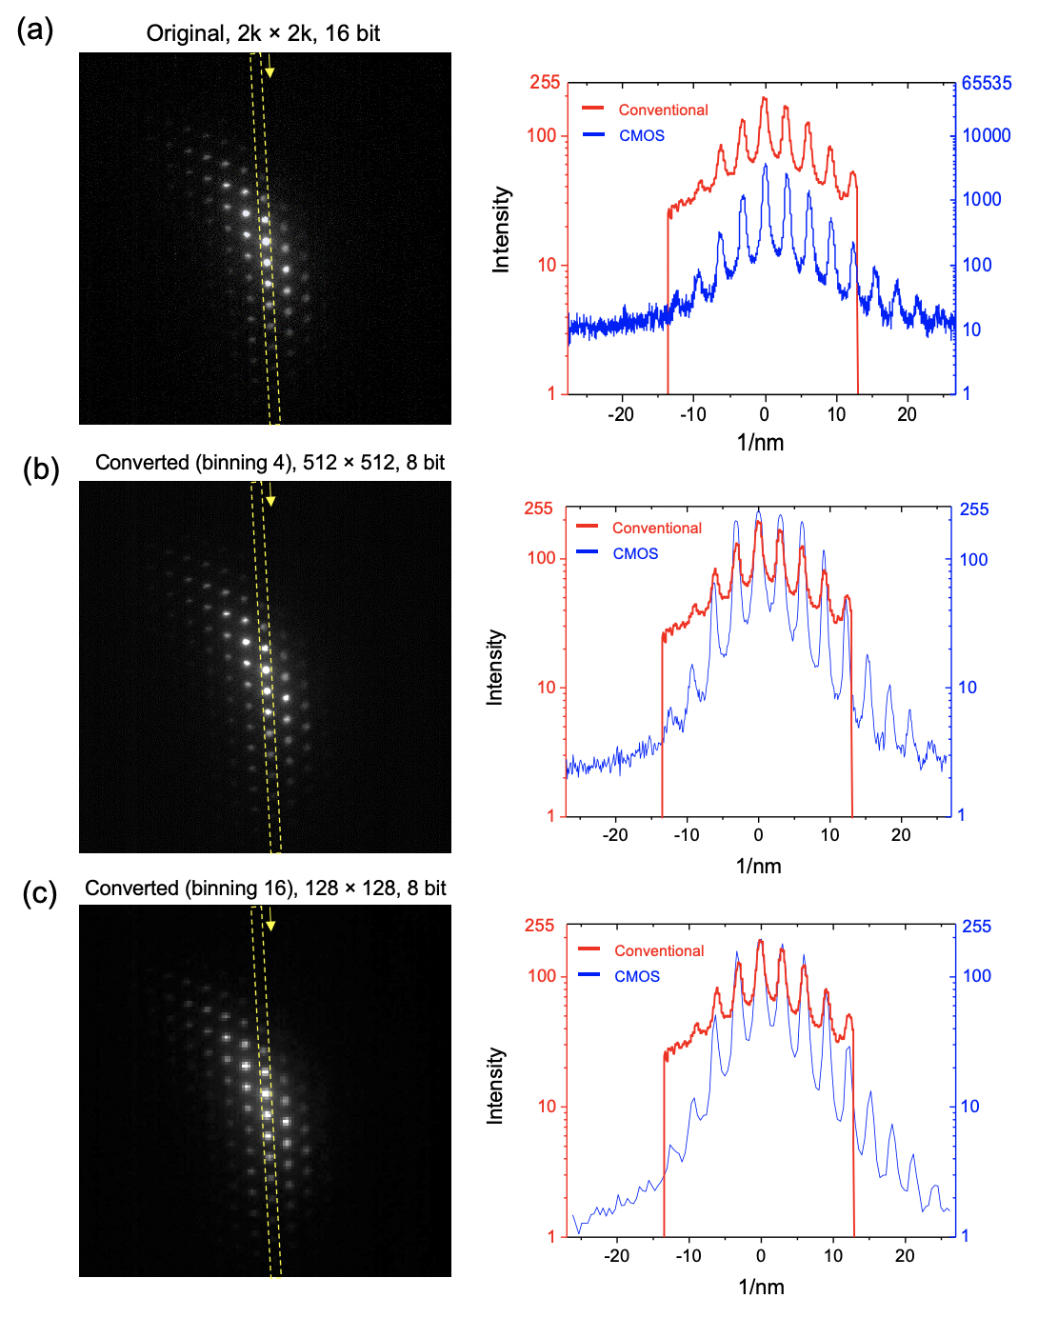
Figure S1. The effect of binning factor and bit depth on the diffraction pattern during the data conversion of CMOS dataset. Intensity profiles are measured along the direction in the pattern image (marked as yellow square) using (a) original raw image of diffraction pattern acquired with 2k × 2k resolution and 16-bit depth shown in Fig. 2b, (b) Converted image with 512 × 512 resolution (binning 4) and 8-bit depth and (c) Converted image with 128 × 128 resolution (binning 16) and 8-bit depth. Intensity profile measured by conventional system (Red line in Fig. 2c) is overlaid for the comparison.
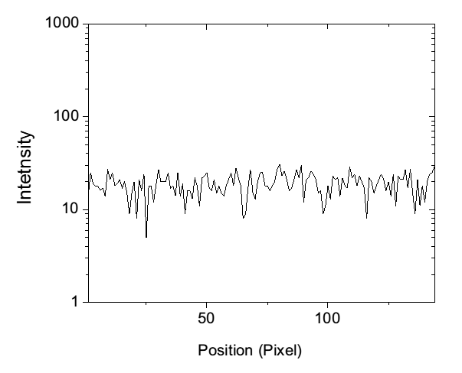
Figure S2. Measurement of the dark noise of external CCD camera in conventional system. Intensity profiles measured along the horizontal direction in the image acquired with gamma correction function and an exposure time of 50 ms. The average intensity of dark noise was measured as 18.96 for the external CCD.

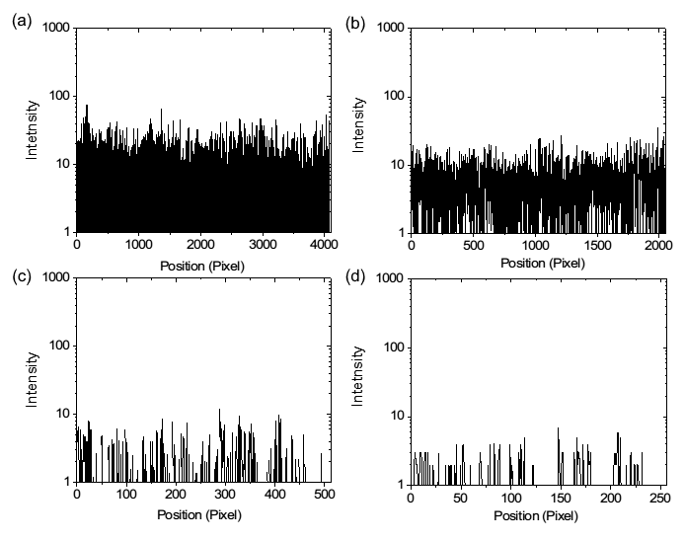
Figure S3. Measurement of the dark noise of XF416 CMOS detector. Intensity profiles measured along the horizontal direction in the image acquired with an exposure time of 50 ms and 16 bit-depth (a) 4k × 4k, full resolution (b) 2k × 2k, binning 2 (c) 512 × 512, binning 8 (d) 256 × 256, binning 16. The average intensity of dark noise was measured as 6.07 for the CMOS detector with binning 2.

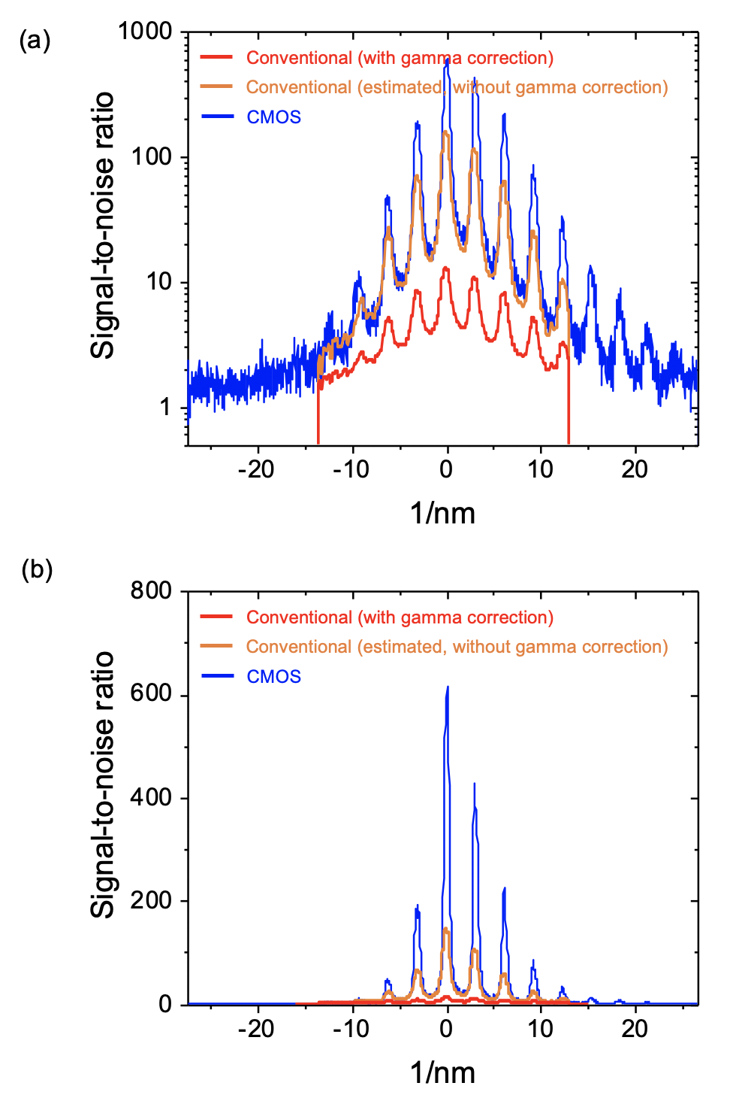

Figure S4. Measurement of the signal to noise ratio of conventional system and CMOS detector. (a) Log-scale plot and (b) linear plot. The signal-to-noise ratio was calculated as the ratio between the measured intensity of pattern image and the average intensity of dark noise measured by using the image without any signal. To estimate the signal-to-noise ratio of conventional system without gamma correction, we calculated the signal-to-noise ratio by assuming the value 0.5 for the gamma exponent (0.5) with reverse mathematical approach.

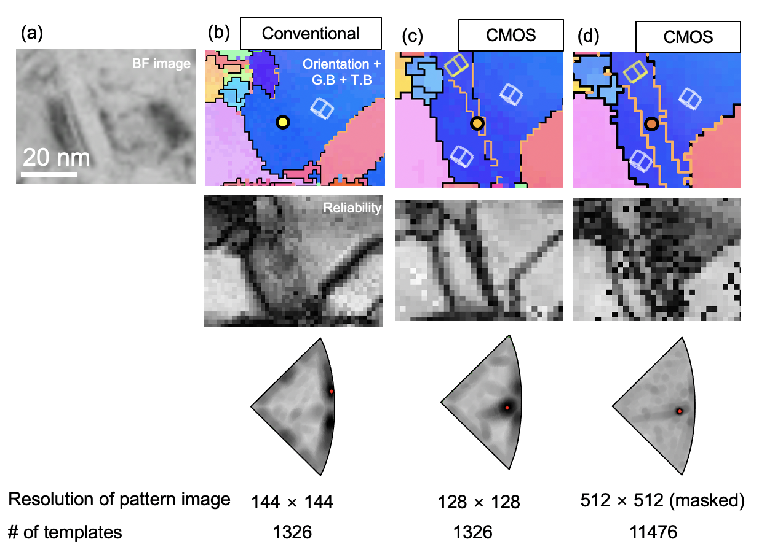

Figure S5. Comparison of magnified orientation maps showing the grain containing a nanotwin acquired by the conventional system and the CMOS detector with different pattern resolution and number of templates. (a) BF image. (b) conventional; image resolution of diffraction pattern: 144 × 144 pixels; the number of templates: 1326. (c) CMOS; image resolution of diffraction pattern: 128 × 128 pixels; the number of templates: 1326. (d) CMOS; image resolution of diffraction pattern: 512 × 512 pixels; the number of templates: 11476. Fuzzy mask is applied to all experimental patterns.

Table S1. Euler angles representing orientation of matrix and twin measured along Σ3 twin boundary (Fig. 7d). Ideal misorientation angle between matrix and twin is 60° for Σ3 twin.
 | Matrix |  |  | Twin |  |  | Misorientation angle
 | ϕ1 | Φ | ϕ2 | ϕ1 | Φ | ϕ2 | Degree (°)
1 | 315.8 | 135.3 | 257.5 | 31.6 | 142.9 | 265.4 | 59.73
2 | 316.6 | 135.1 | 258.1 | 31.8 | 142.8 | 265.5 | 59.68
3 | 316.4 | 135.1 | 258.3 | 31.6 | 142.9 | 265.1 | 59.28
4 | 316.5 | 135.1 | 258.1 | 32.9 | 143.1 | 266.4 | 59.93
5 | 317.1 | 135.2 | 258.4 | 33 | 143 | 266.1 | 59.68
6 | 315.1 | 135.7 | 258 | 33.3 | 144 | 267.5 | 59.56
7 | 316.4 | 135.5 | 257.8 | 32.7 | 143.5 | 267.2 | 59.96
8 | 315.7 | 135.5 | 257.6 | 31.9 | 143.9 | 265.9 | 59.28
9 | 315.7 | 135.6 | 257.2 | 32.9 | 143.6 | 266.9 | 59.98
10 | 316.1 | 135.1 | 257.8 | 31.9 | 142.7 | 265.5 | 59.85
11 | 316.3 | 135.1 | 258 | 31.8 | 142.9 | 265.7 | 59.76
12 | 316.5 | 134.9 | 258.3 | 32.3 | 142.9 | 266.1 | 59.88
13 | 316.1 | 135.1 | 257.7 | 32.1 | 142.8 | 265.5 | 59.88
14 | 316.6 | 134.7 | 258.4 | 31.9 | 142.8 | 265.8 | 59.91
15 | 316.7 | 134.7 | 258.3 | 32 | 142.8 | 265.5 | 59.83
16 | 316.6 | 134.7 | 258.2 | 31.5 | 143 | 265.1 | 59.60
17 | 317.2 | 134.7 | 258.4 | 31.8 | 143 | 265.1 | 59.45
18 | 317 | 134.9 | 258.3 | 32.3 | 142.8 | 265.2 | 59.49
19 | 317.2 | 134.7 | 258.2 | 32.4 | 142.8 | 265.6 | 59.94
20 | 317.3 | 134.7 | 258.4 | 32.5 | 143 | 265.5 | 59.66
21 | 316.9 | 134.7 | 258 | 32.3 | 142.8 | 265.6 | 59.98
22 | 316.1 | 135.1 | 257.8 | 31.9 | 142.7 | 265.5 | 59.85
23 | 317.3 | 134.7 | 258.4 | 32.9 | 143.3 | 266 | 59.76
24 | 316.5 | 134.7 | 257.9 | 32.6 | 143 | 265.5 | 59.86
25 | 317.2 | 134.5 | 258.3 | 32.1 | 143 | 265.1 | 59.70
 |  |  |  |  |  | AVR | 59.74
 |  |  |  |  |  | STDV | 0.20

