Supplementary materials
Understanding the effects of graphene coating on the electrostatic field at the tip of an atom probe tomography specimen
Graphene coating for APT samples

Florant Exertier¹, Jiangting Wang¹, Jing Fu² and Ross K.W. Marceau¹

^{1.} Deakin University, Institute for Frontier Materials, Geelong, VIC 3216, Australia
^{2.} Department of Mechanical and Aerospace Engineering, Monash University, Clayton, VIC 3800, Australia

Corresponding author: Florant Exertier; Ross K. W. Marceau.
Emails: fexertier@deakin.edu.au; ross.marceau@deakin.edu.au
Phone: +61 3 52271283
Mailing address: Deakin University, Institute for Frontier Materials, 75 Pigdons Road,
Waurn Ponds, VIC 3216, Australia
- Graphene coating visualisation
Figure S1 shows an example of failure during the graphene-coating process, similarly reported by Adineh, et al. (2018). The filament resulting from this failure makes it impossible to run the specimen in the atom probe.
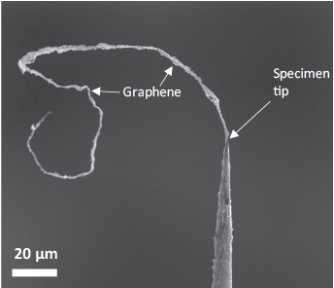
Figure S1. Example of graphene-coating failure
Figure S2 is a screen capture from Video S1, which shows an accelerated recording of the APT acquisition of the multi-coated specimen studied in this work. Some of the features visible in Figure 4(c, e) can also be seen in this footage. This video sequence reveals the underlying sharp specimen needle once the visible graphene coating features seem to be removed.
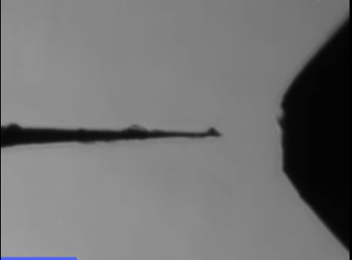
Figure S2. Video capture of the multi-coated specimen APT acquisition (accelerated)
- 3D reconstructions
Accurately reconstructing the APT data from the graphene-coated specimen is challenging because the region of interest is within the first 50,000 detected ions, which are usually discarded for most APT analyses because of the increased amount of uncertainty regarding the tip shape and compositional artefacts (Gault, et al., 2012) due to the dynamic nature of the field evaporation conditions towards stable running conditions and consistent data collection. In this study, the SEM images of the graphene-coated tips show a larger radius than the post-acquisition images, thus affecting the accuracy of the “Tip Profile” reconstruction method in IVAS. On the other hand, the “Voltage” method using the calibrated ICF and k_{f} parameters accurately reconstructs the W substrate at the cost of a distorted shape for the region of interest located at the very tip of the specimen needle. This was also reflected in the attempt to estimate the intensity of the electrostatic field at the tip of the specimens, comparing the graphical method using the Kingham curves to the theoretical model based on Equation (3). For the two samples highlighted in this work, we consider that the theoretical model is more valid for the single-coated specimen than for the multi-coated specimen because the tip radius was less affected by the graphene-coating layer as shown in Figure 2.
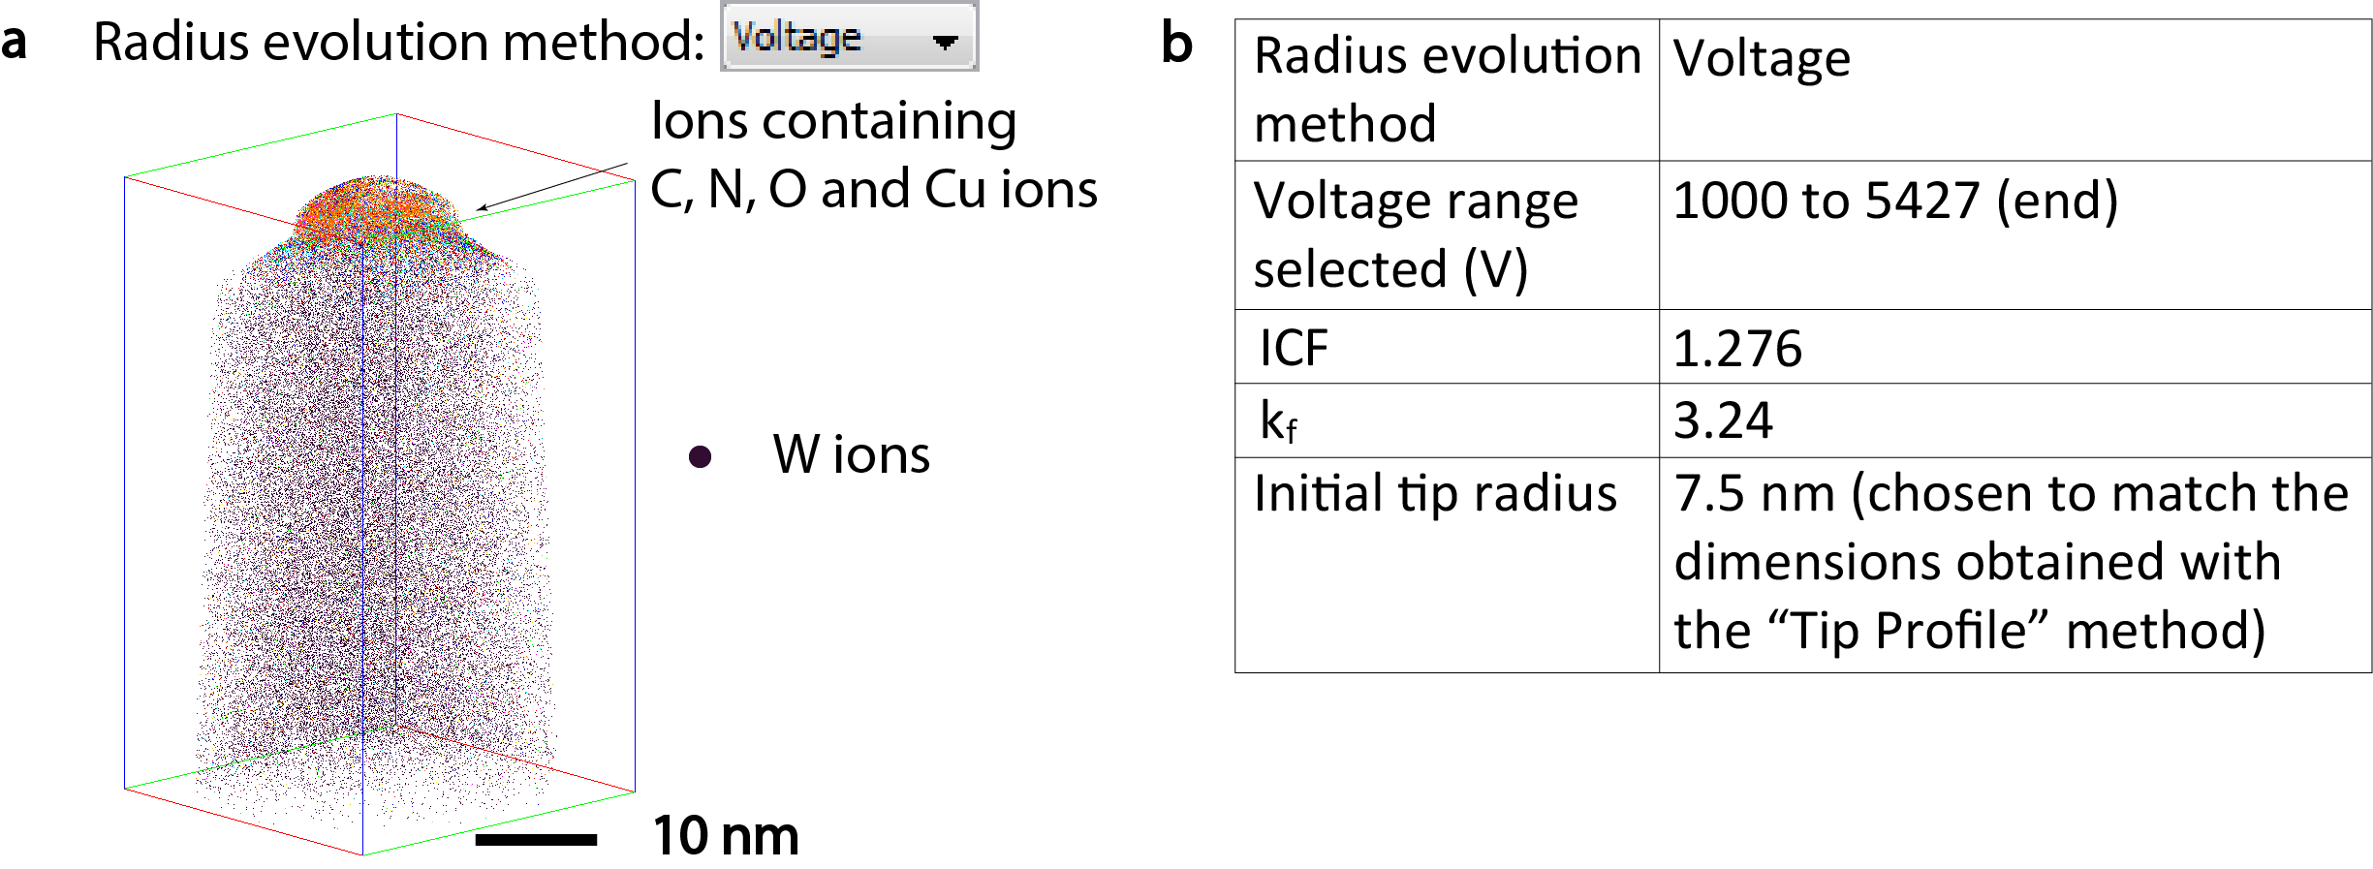
Figure S3. (a) Alternative reconstruction of the multi-coated specimen using the “Voltage” radius evolution method. (b) Parameters used to generate the reconstruction.

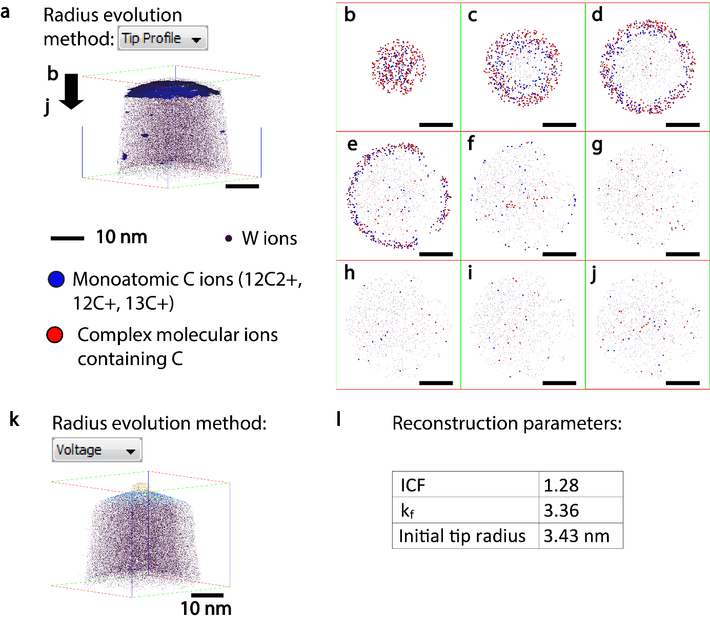
Figure S4. (a) “Tip Profile” 3D reconstruction of the single-coated specimen including a 1.0 at% C concentration isosurface (in blue). (b) to (j) (x,y) projections of successive 1 nm thick layers measured from the tip of the “Tip Profile” reconstruction – as indicated by the black arrow – with 1 nm depth increments. (k) “Voltage” 3D reconstruction of the single-coated specimen. (l) Reconstruction parameters used for the “Voltage” reconstruction.

- Stability of the graphene-coated experiments
Assessing the stability of an APT experiment, especially at the early stage of its evaporation can be challenging. Here we chose to compare the evolution of detection rate and the evaporation of W ions at the beginning of the evaporation sequence (Figure S5). For each sample (graphene-coated run) the stabilisation of the detection rate to its target value can be associated with the W ionic proportion reaching its final plateau concentration value. However, sub-figures g, j, k and l show the detection rates reaching an intermediary equilibrium at a slightly lower value (∼ 0.2%) corresponding to the earliest stage of the evaporation, where the material related to the graphene-coating process (deposited at the surface of the W needle) is evaporated. For the first multi-coated specimen (sub-figure g), the zones as defined per Figure 7 have been reproduced and show the evaporation in zone 1 to be quite unstable. However, as soon as Cu is no longer detected and C and O are the major non-W elements, with atomic proportions around 37% and 15%, respectively, the detection rate reaches the intermediary equilibrium mentioned earlier, showing a relatively stable evaporation – although for a short sequence of evaporation – until zone 3 is reached.
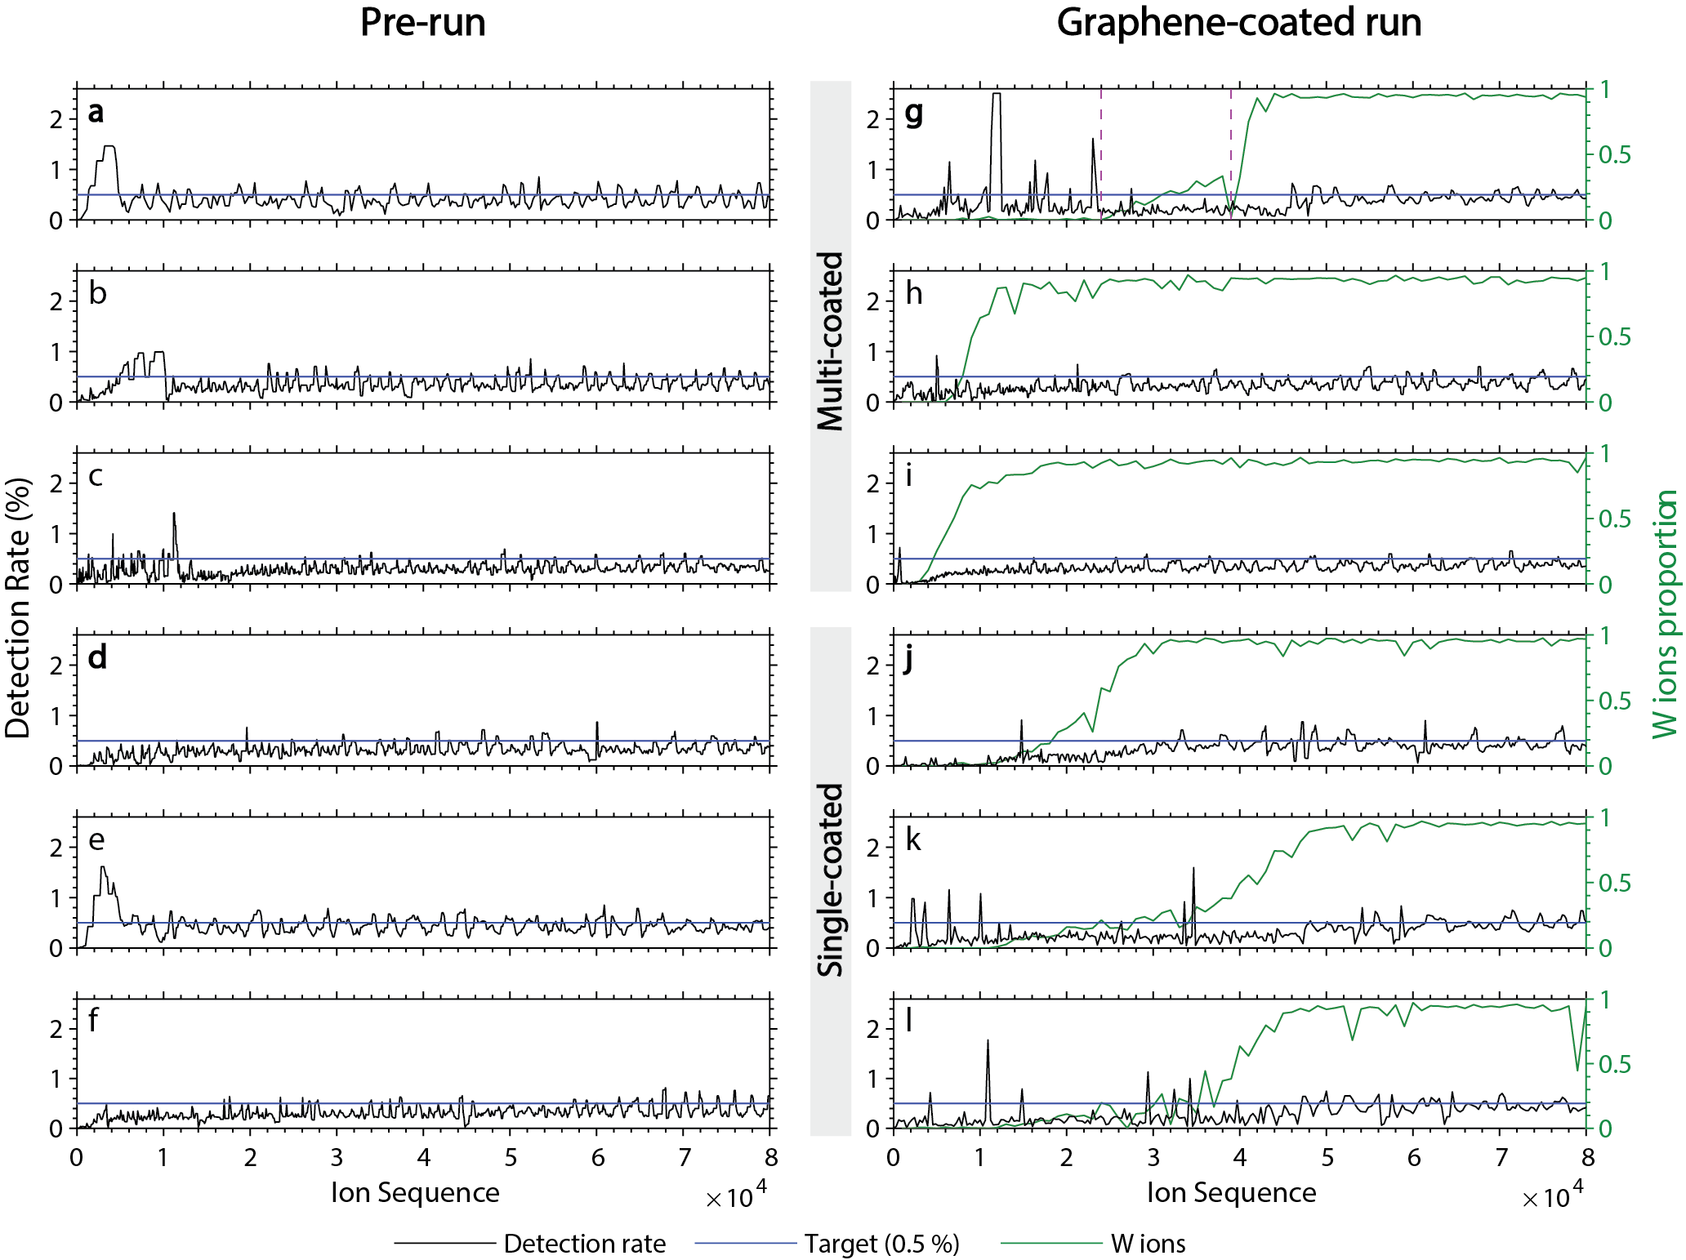
Figure S5. Evolution of the detection rate and W ions proportion as a function of the evaporated ion sequence for six samples. Left column (a to f) represents the pre-run data. Right column (g to l) represents the data for the graphene-coated run. Each row corresponds to one sample, before and after graphene-coating. The first three rows correspond to specimens that were coated multiple times, last three rows correspond to specimens coated one single time. The (a,g) and (d,j) pairs correspond to the multi-coated specimen and single-coated specimen, respectively. The dashed purple lines in (g) represent the limits of Zone 1, 2 and 3 as defined in Figure 7.

- Evaluation of the electrostatic field metrics
Here we compare the uncoated pre-run with the multi-coated dataset (same specimen), then we will compare the two coating strategies (single vs multi-coated). The mass history in Figure S6(j) shows that all ions evaporated after the 4 × 10⁴ mark (end of the blue highlighted area) and which do not contribute to the background noise are either W⁴⁺, W³⁺, as indicated by the two purple arrows. This means that all the peaks seen in the mass spectrum, other than W⁴⁺ and W³⁺, come from within the area highlighted in blue (0 to 50,000 detected ions), which is shown in greater detail in Figure 7, and constitute the major difference between coated and uncoated runs. A notable point is that for both specimens, all four metrics (multiple rate, CSR, MRP and STB) have similar values at the beginning of the coated run as at the end of the pre-run. The W⁴⁺/W³⁺ CSR increases slightly for both scenarios, which is related to the slight increase in radius due to the evaporation of the atoms at the tip of the specimen, inducing an increase in the electrostatic field. An increasing electrostatic field increases the chance of DC evaporations (Gault, et al., 2012), which is consistent with the constantly decreasing STB ratio for both scenarios. On the contrary, the MRP, which is slightly decreasing for the uncoated specimen, displays a slightly increasing pattern for the coated specimen (6 % increase between the beginning and the end of the run, based on the trend line calculated in Matlab). The third column of Figure S6 shows the same metrics calculated for the single-coated specimen. The data is very similar to that from the multi-coated specimen. Except for the data within the first 50,000 detected ions – highlighted in orange, and analysed further in Figure 8 – there are no significant differences for any of the chosen field metrics in the stable regime, in spite of a higher starting voltage (due to a higher end voltage from the pre-run)
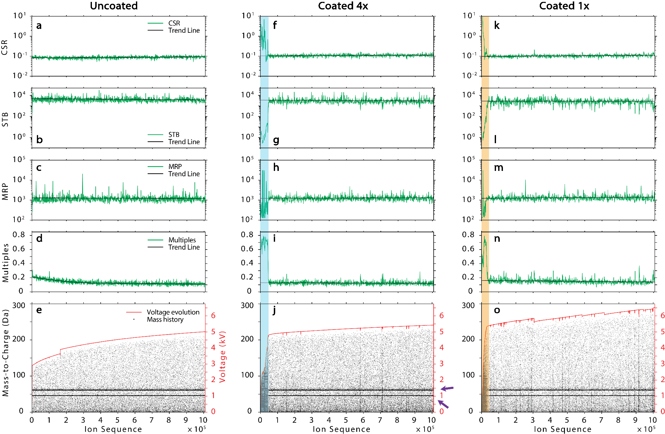
Figure S6. Evolution of electrostatic field metrics determined for the sample before coating (a) to (e) and after multi-coating 4 times (f) to (j), and for a different sample after a single coating (k) to (o) plotted against the ion evaporation sequence. (a), (f) and (k) represent the CSR W^{4+/}W³⁺. (b), (g) and (l) represent the STB ratio calculated for the ¹⁸⁴W³⁺ peak. (c), (h) and (m) represent the MRP at FWHM calculated for the ¹⁸⁴W³⁺ peak. (d), (i) and (n) represent the proportion of multiple hits. (e), (j) and (o) represent the mass history (black dots) and the voltage evolution (red curve) for each run. The green lines represent data fittings. The blue and orange highlighted areas show regions of interest to be studied further.

- Compositional analysis
The mass spectrum in Figure S7 is a close-up of the mass spectrum shown in Figure 5, showing the 21 Da to 31 Da range. For each peak, the detection limit was determined with a confidence level of 95%, using the criteria defined by Currie (1968). For each peak, the caption colour indicates whether its net count is above the detection limit L_{D}, but under the determination limit L_{Q} (in grey), or above L_{Q} (in black). The critical limit, detection limit and determination limit calculated for each peak (as defined by Currie) are shown in Table S1 along with the total signal N_{i}, the corrected count C_{i} and the background count B_{i} as defined in Equation (2). For these calculations, the background was determined, by counting the ions within a range centred on a value 0.5 Da below (to the left of) the peak, with the same width as the peak range. The caption colour for the peaks shown in Figure S7 has been reflected in the first column of Table S1 for easier identification.

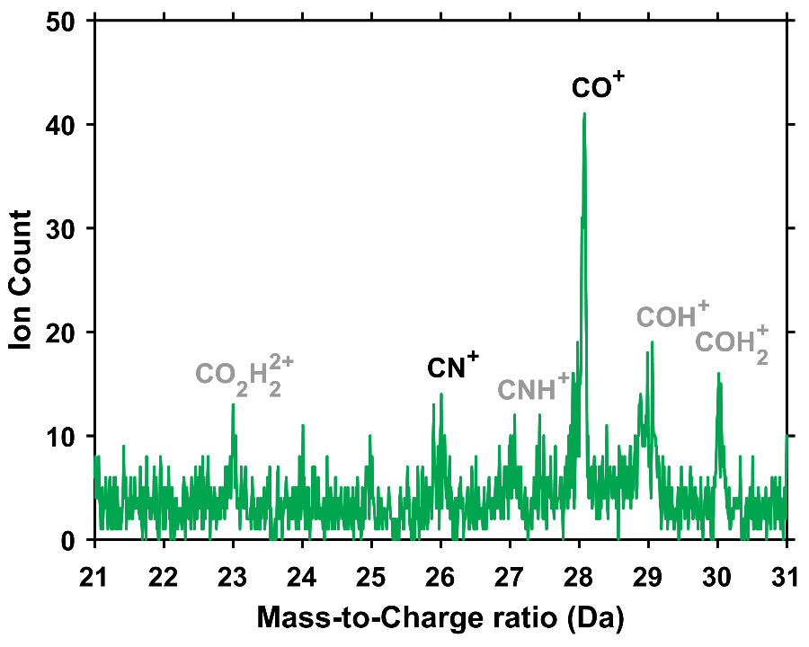
Figure S7. Mass spectrum of the multi-coated specimen

Table S1. Summary of the measured signal, background level and detection thresholds for the peaks visible in Figure S7. The underlined values highlight the detection threshold met for each peak.
Peak (Da) | Total count | Corrected count | Background count | Critical limit (L_{c}) | Detection limit (L_{D}) | Determination limit (L_{Q})
23 | 172 | 51 | 121 | 26 | 51 | 155
24 | 104 | 32 | 72 | 20 | 39 | 120
25 | 98 | 23 | 75 | 20 | 40 | 122
26 | 209 | 130 | 79 | 21 | 41 | 125
27 | 221 | 89 | 132 | 27 | 53 | 162
28 | 478 | 329 | 149 | 28 | 57 | 172
29 | 397 | 172 | 225 | 35 | 70 | 212
30 | 143 | 84 | 59 | 18 | 36 | 108

Table S2. Elemental composition of the single-coated specimen and the multi-coated specimen for several peak assignment scenarios.
 | Total decomposed atomic count | W | O  (at.%) | Cu  (at.%) | H  (at.%) | C  (at.%) | N  (at.%)
Single-coated | 804602 | Bal. | 0.83 | n.a. | 0.28 | 0.18 | n.a.
Multi-coated (CH scenario) | 882254 | Bal. | 0.75 | 0.66 | 1.33 | 0.52 | 0.08
Multi-coated (CO scenario) | 876842 | Bal. | 1.09 | 0.67 | 0.47 | 0.42 | 0.10
Multi-coated (N scenario) | 875148 | Bal. | 0.70 | 0.67 | 0.53 | 0.07 | 0.58

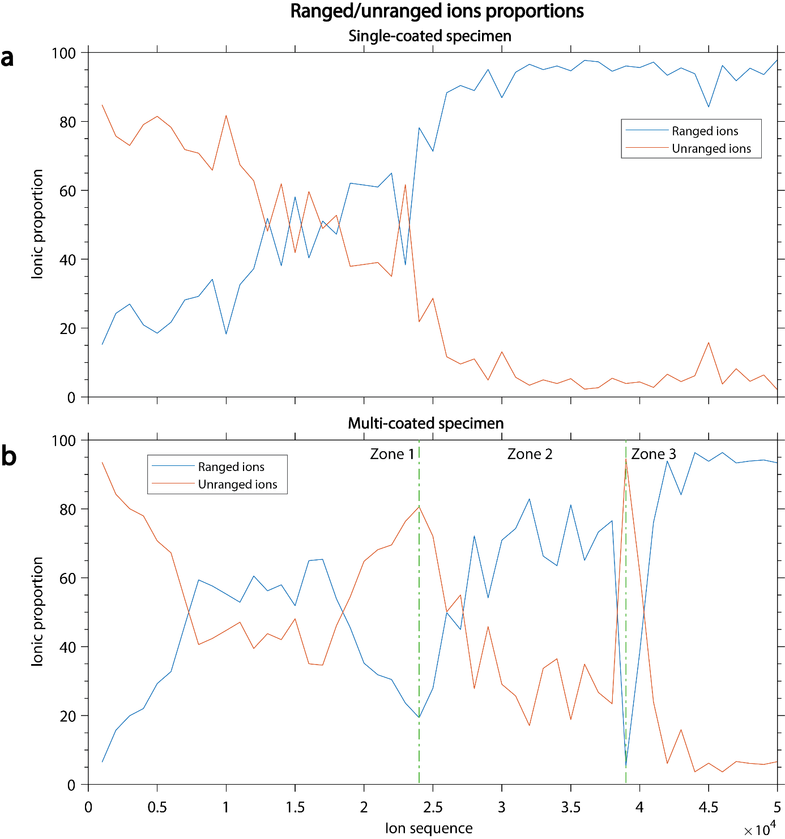
Figure S8. Ionic proportions of ranged and un-ranged ions as a function of the ion sequence for (a) the single-coated specimen and (b) the multi-coated specimen. The vertical, dotted green lines represent the transitions between the zones as per defined in Figure 6.
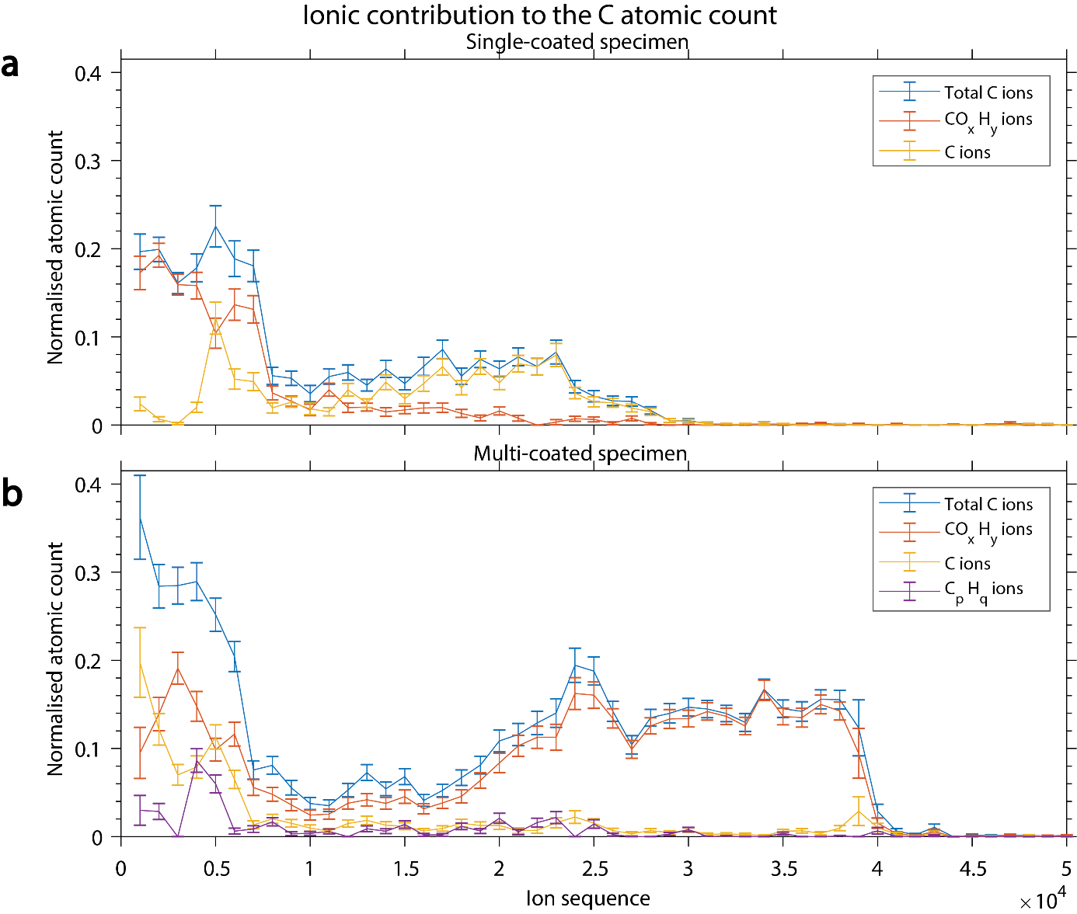
Figure S9. Contribution of selected ion groups to the total decomposed C atomic count as a function of the ion sequence for (a) the single-coated specimen and (b) the multi-coated specimen. The displayed values were normalised over the total number of ranged ions for each bin.

Table S3. Peak assignment for the single-coated specimen, and for the multi-coated specimen according to three different scenarios. For the multi-coated specimen, only the peak assignments differing from one scenario to another are shown in the two last columns.
 | Single-coated specimen |  |  | Multi-coated specimen
Mass-to-charge ratio (Da) |  |  | Mass-to-charge ratio (Da) | CO scenario | CH scenario | N scenario
1.0 | H⁺ |  | 1.0 | H⁺
2.0 | H₂⁺ |  | 2.0 | H₂⁺
3.0 | H₃⁺ |  | 3.0 | H₃⁺
6.0 | C²⁺ |  | 6.0 | C²⁺
 |  |  | 7.0 | CO³⁺ | CH₂²⁺ | N²⁺
12.0 | ¹²C⁺ |  | 12.0 | ¹²C⁺
13.0 | ¹³C⁺ |  | 13.0 | ¹³C⁺
14.0 | CO²⁺ |  | 14.0 | CO²⁺ | CH₂⁺ | N⁺
 |  |  | 15.0 | COH₂²⁺ | CH₃⁺ | NH⁺
16.0 | O⁺ |  | 16.0 | O⁺
17.0 | OH⁺ |  | 17.0 | OH⁺
18.0 | OH₂⁺ |  | 18.0 | OH₂⁺
19.0 | OH₃⁺ |  | 19.0 | OH₃⁺
20.0 | OH₄⁺ |  | 20.0 | OH₄⁺
 |  |  | 21.0 | Cu³⁺
 |  |  | 21.6 | Cu³⁺
23.0 | CO₂H₂²⁺ |  | 23.0 | CO₂H₂²⁺
 |  |  | 26.0 | CN⁺ | C₂H₂⁺ | CN⁺
 |  |  | 27.0 | CNH⁺ | C₂H₃⁺ | CNH⁺
28.0 | CO⁺ |  | 28.0 | CO⁺ | C₂H₄⁺ | N₂⁺
29.0 | COH⁺ |  | 29.0 | COH⁺ | C₂H₅⁺ | N₂H⁺
 |  |  | 30.0 | COH₂⁺ | C₂H₆⁺ | N₂H₂⁺
 |  |  | 31.4 | ⁶³Cu²⁺
32.0 | O₂⁺ |  | 32.0 | O₂⁺ | O₂⁺ | N₂H₄⁺
 |  |  | 32.4 | ⁶⁵Cu²⁺
 |  |  | 39.4 | ⁶³CuO²⁺
 |  |  | 40.4 | ⁶⁵CuO²⁺
 |  |  | 44.0 | CO₂⁺ | CO₂⁺ | N₃H₂⁺
45.0 | ¹⁸⁰W⁴⁺ |  | 45.0 | ¹⁸⁰W⁴⁺
45.5 | ¹⁸²W⁴⁺ |  | 45.5 | ¹⁸²W⁴⁺
45.8 | ¹⁸³W⁴⁺ |  | 45.8 | ¹⁸³W⁴⁺
46.0 | ¹⁸⁴W⁴⁺ |  | 46.0 | ¹⁸⁴W⁴⁺
46.5 | ¹⁸⁶W⁴⁺ |  | 46.5 | ¹⁸⁶W⁴⁺
60.0 | ¹⁸⁰W³⁺ |  | 60.0 | ¹⁸⁰W³⁺
60.7 | ¹⁸²W³⁺ |  | 60.7 | ¹⁸²W³⁺
61.0 | ¹⁸³W³⁺ |  | 61.0 | ¹⁸³W³⁺
61.3 | ¹⁸⁴W³⁺ |  | 61.3 | ¹⁸⁴W³⁺
62.0 | ¹⁸⁶W³⁺ |  | 62.0 | ¹⁸⁶W³⁺
 |  |  | 63.0 | ⁶³Cu⁺
 |  |  | 65.0 | ⁶⁵Cu⁺
 |  |  | 65.3 | ¹⁸²WN³⁺
 |  |  | 65.6 | ¹⁸³WN³⁺
65.9 | ¹⁸²WO³⁺ |  | 65.9 | ¹⁸²WO³⁺
66.3 | ¹⁸³WO³⁺ |  | 66.3 | ¹⁸³WO³⁺
66.6 | ¹⁸⁴WO³⁺ |  | 66.6 | ¹⁸⁴WO³⁺
67.3 | ¹⁸⁶WO³⁺ |  | 67.3 | ¹⁸⁶WO³⁺
 |  |  | 78.7 | ⁶³CuO⁺
 |  |  | 79.7 | ⁶³CuOH
 |  |  | 80.7 | ⁶⁵CuO⁺
 |  |  | 81.8 | ⁶⁵CuOH
91.0 | ¹⁸²W²⁺ |  | 91.0 | ¹⁸²W²⁺
91.5 | ¹⁸³W²⁺ |  | 91.5 | ¹⁸³W²⁺
92.0 | ¹⁸⁴W²⁺ |  | 92.0 | ¹⁸⁴W²⁺
93.0 | ¹⁸⁶W²⁺ |  | 93.0 | ¹⁸⁶W²⁺
 |  |  | 98.0 | ¹⁸²WN²⁺
 |  |  | 98.4 | ¹⁸³WN²⁺
99.0 | ¹⁸²WO²⁺ |  | 99.0 | ¹⁸²WO²⁺
99.5 | ¹⁸³WO²⁺ |  | 99.5 | ¹⁸³WO²⁺
100.0 | ¹⁸⁴WO²⁺ |  | 100.0 | ¹⁸⁴WO²⁺
101.0 | ¹⁸⁶WO²⁺ |  | 101.0 | ¹⁸⁶WO²⁺
106.8 | ¹⁸²WO₂²⁺ |  | 106.8 | ¹⁸²WO₂²⁺
107.4 | ¹⁸³WO₂²⁺ |  | 107.4 | ¹⁸³WO₂²⁺
107.8 | ¹⁸⁴WO₂²⁺ |  | 107.8 | ¹⁸⁴WO₂²⁺
108.8 | ¹⁸⁶WO₂²⁺ |  | 108.8 | ¹⁸⁶WO₂²⁺

