Supplementary Table S1. The complexation coefficient of Pb and macromolecular organic matter
Organic ligands | Complexing constant | References
2-[(5-bromo-2-pyridinyl)-azo]-5-(diethylamino)-Phenol | 11.17 | (Yang et al., 2016)
Bovine Albumin | 10.63 | (Bhattacharya et al., 2007)
Humic Acid | 5.79 | (Quan & Yan, 2010)
Ciprofloxacin | 8.79 | (Turel & Bukovec, 1996)
Sulfamerazine free Acid | 6.77 | (Lin et al., 1997)
Ethylene Glycol | 0.70 | (Sun et al., 2008)
5,10,15,20-tetrakis(4-trimethyl-ammonio-phenyl)-porphine tetratosylate | 7.65 | (Jaberi et al., 2013)
Extracellular Polymeric Substances | 4.52-7.58 | (Lombardi & Vieira, 1998; Song et al., 2012)
AceticAcid | 3.13 | (Pounds et al., 2017)
Dicyclohexanoneoxaly Dihydrazone | 5.93 | (Sung et al., 2011)
Tetracycline | 6.15 | (Ghosh & Banerjee, 1997)
Nitrilotri-3-propanonic Acid | 16.23 | (Zhang et al., 2004)
Ethylene Diamine Tetraacetic Acid | 17.88 | (Smith & Martell, 1989)
8-hydroxy-Quinoline | 5.26 | (Suchitra, 2019)
cross-linked poly (acrylic acid) | 7.40 | (Catherine et al., 2011)

Supplementary Table S2. The method of preparation of experimental media
Name of medium | The preparation methods
BE medium | After 50 mL of distilled water was added to the beaker, 3.0 g of BE, 10.0 g of tryptone and 5.0 g of NaCl were added. The pH should be adjusted to 7.2-7.6. The solution was then added to 1000 mL. 20.0 g of agar was added and heated to melt.
PDB medium | 200.0 g of potatoes and 20.0 g of glucose were weighed by electronic balance. After peeling and dicing potatoes, they were added into 1000 mL water and boiled for 1 min until completely dissolved.
PDA media | After calculating the actual dosage of drugs, 200.0 g of potatoes, 20.0 g of glucose and 10.0 g of agar were weighed with an electronic balance, and 3.0 g of KH₂PO₄ and 1.5 g of MgSO₄·7H₂O were weighed with an analytical balance. After that, it was placed in a beaker according to recipe. The potatoes were washed, peeled, and weighed. Then it was cut into small pieces, adding 1200 mL of water, and heated it until boiling (100.0 ºC, 15 min). 4 layers of gauze were used to filter the mixture while it was hot. The filtrate was poured into a beaker and heated at above 95.0 ºC. The filtrate was constantly stirred with a glass rod until the agar was completely dissolved and water was added to 1000 mL.
TAP medium | 0.50 g/L of ethylene diamine tetraacetic acid (EDTA), 0.22 g/L of ZnSO₄·7H₂O, 0.22 g/L of H₃BO₃, 5.06 mg/L of MnCl₂·4H₂O, 1.61 mg/L of CoCl₂·6H₂O, 1.10 mg/L of (NH₄)₆Mo₇O₂₄·4H₂O, 1.57 mg/L of CuSO₄·5H₂O, and 4.99 mg/L of FeSO₄·7H₂O), phosphate buffer solution (0.0108 g/L of K₂HPO₄ and 0.0054 g/L of KH₂PO₄), TAP salts (0.10 g/L of MgSO₄·7H₂O, 0.38 g/L of NH₄Cl and 0.05 g/L of CaCl₂·H₂O), and 2.42 g/L of H₂NC(CH₂OH)₃ were added to sterile water. Then the pH was adjusted to 7.0 by glacial acetic acid.

Supplementary Table S3. List of the experiment equipment
Name of instrument | Manufacturer | Model
Ultra-thin slicer | Leica | Leica UC7
Diamond slicer | Daitome | Ultra 45°
Transmission electron microscope | FEI | Tecnai G2 F20 S-Twin + Aztec X-Max 80T
Energy dispersive X-ray spectrometry | Oxford | AZtec X-Max 50

Supplementary Table S4. List of the experiment reagents
Reagent | Manufacturer | Article number
2.5% (v/v) triple distilled glutaraldehyde | Wuhan Guge biology | G1102
Anhydrous ethanol | Sinopharm Chemical Reagents Co. Ltd.
Acetone | Sinopharm Chemical Reagents Co. Ltd. | 67-64-1
Phosphoric acid buffer
Resin | SPI | 90529-77-4
Osmic acid
Uranium dioxide acetate
Pb(NO₃)₂ | Xilong Scientific Ltd.
Pb(C₆H₅O₂)₂ | Wuhan Servicebio technology Co. Ltd | G1201-1L
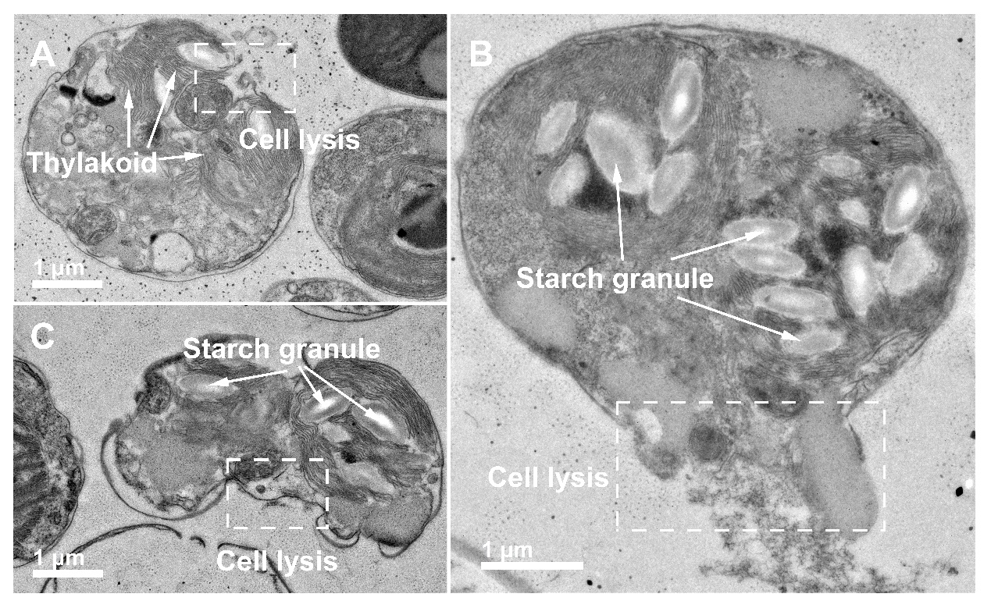
Fig. S1. TEM images of the lysis of Chlamydomonas reinhardtii in different stages of aging by ULLM technique.

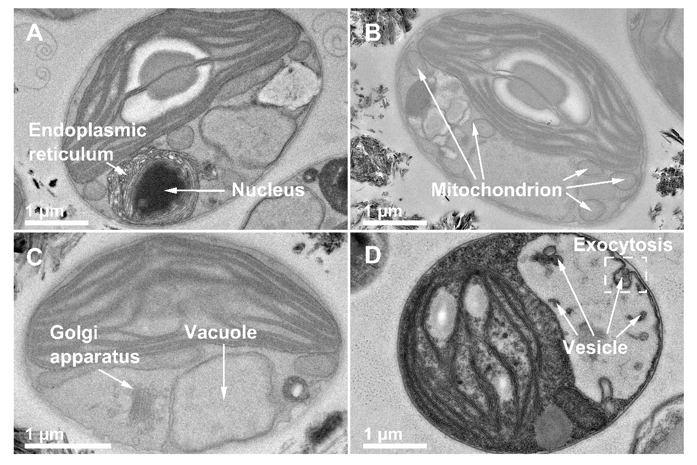
Fig. S2. TEM images of the morphological structure of Chlamydomonas reinhardtii by ULLM technique.

Supplemental References
Bhattacharya, A., Shukla, R., Auyang, E.D., Dietrich, K.N. & Bornschein, R. (2007). Effect of succimer chelation therapy on postural balance and gait outcomes in children with early exposure to environmental lead. Neurotoxicology 28, 686-695.
Catherine, M., Yolande, M., Monique, C., Michelle, C. & OLIVIER,V. (2011). Potentiometric study of cadmium(II) and lead(II) complexation by a cross-linked poly(acrylic acid). Comparison with the linear analogue. J Northeast Univ 78, 348-351.
Ghosh, R. & Banerjee, D.K. (1997). Complexation of trace metals with humic acids from soil, sediment and sewage. Chem Speciation Bioavailability 9, 15-19.
Jaberi, F., Gharib, F. & Farajtabar, A. (2013). Solute–Solvent Interaction Effects on Protonation and Aggregation Constants of TTMAPP in Different Aqueous Solutions of Methanol. J Solution Chem 42, 1559-1571.
Lin, C.E., Chang, C.C. & Lin, W.C. (1997). Migration behavior and separation of sulfonamides in capillary zone electrophoresis III. Citrate buffer as a background electrolyte. J Chromatogr A 768, 105-112.
Lombardi, A.T. & Vieira, A.A.H. (1998). Copper and lead complexation by high molecular weight compounds produced by Synura sp. (Chrysophyceae). Phycologia 37, 34-39.
Pounds, T., Sieradzki, K., Erlebacher, J. & Cammarata, R.C. (2017). Effects of Acetic Acid, Tartaric Acid and Pb UPD on Cu Electrodeposition in Sub-Micron Trenches. J Electrochem Soc 164, 307-314.
Quan, G. & Yan, J. (2010). Binding Constants of Lead by Humic and Fulvic Acids Studied by Anodic Stripping Square Wave Voltammetry. Russ J Electrochem 46, 90-94.
SMITH, R.M. & MARTELL, A.E. (1989). Iminodiacetic Acid Derivatives. In Critical stability constants, SMITH, R.M. & MARTELL, A.E. (Eds.), pp. 67-127. New York: Springer.
SONG, W.J., PAN, X. & ZHANG, D. (2012). Lead Complexation of Soluble and Bound Extracellular Polymeric Substances from Activated Sludge: Characterized with Fluorescence Spectroscopy and Ftir Spectroscopy. Biotechnol Biotechnol Equip 26, 3371-3377.
SUCHITRA, J.P., KALA, A., SAGADEVAN, S., DEVI, V.B. & PODDER, J. (2019). Synthesis and characterisation of bis(2 methyl-8-hydroxyquinoline) zinc nanoparticles for organic light emitting diode applications. Mol Simul 45, 790-796.
Sun, Z.X., Zheng, T.T., Bo, Q.B., Du, M. & Forsling, W. (2008). Effects of calcination temperature on the pore size and wall crystalline structure of mesoporous alumina. J Colloid Interface Sci 319, 247-251.
SUNG, Y.M., LIM, J.M., XUE, Z., SHEN, Z. & KIM, D. (2011). Comparative photophysical properties between bicyclo[2.2.2]octadiene(BCOD)- and benzo-fused free-base triphyrins (2.1.1). Chem Commun (Camb) 47, 12616–12618.
Turel, I., Bukovec, N. & FARKAS, E. (1996). Complex formation between some metals and a quinolone family member (ciprofloxacin). Polyhedron 15, 269-275.
YANG, R., XING, Z. & ZHOU, H. (2016). Spectrophotometric Determination of the Amount of Zinc on the Imprint Left on Hands by Zinc Coatings with 5-Br-PADAP as the Chromogenic Reagent. Guang Pu Xue Yu Guang Pu Fen Xi 36, 4017-4020.
Zhang, J.M., Shi, Q.Z. & Ying, L.U. (2004). The Application of Polarographic Complex Formation Curve to the Study on Stability Constants for Metal Complex System. J Anal Sci 20, 181-183.

