Endocrine, stemness, proliferative, and proteolytic properties of alarm cells in ruby-red-fin Shark, (rainbow Shark), Epalzeorhynchos frenatum (Teleostei: Cyprinidae)
Hanan H. Abd-Elhafeez¹, Soha A. Soliman², Abdelraheim H. Attaai³, Sara S. Abdel-Hakeem⁴, Abeera Mohamoud El-Sayed⁵, and Alaa Sayed Abou-Elhamd⁶
^{1, 3, 6} Department of Anatomy, Embryology and Histology, Faculty of Veterinary Medicine, Assiut University, Assiut, 71526, Egypt
² Department of Histology, Faculty of Veterinary Medicine, South Valley University, Qena, 83523, Egypt
⁴Parasitology Lab, Zoology Department, Faculty of Science, Assiut University, Assiut 71526, Egypt;
⁵Fellow of Sohag University Hospital, Faculty of Human medicine, Sohag University, Sohag, 82524, Egypt

Supplementary figure1: Negative image of endocrine properties of alarm cells identified by silver staining and Synaptophysin immunostaining.
Paraffin sections of skin subjected to silver staining (A_F) and (G) Synaptophysin immunostaining (D). A: low magnification showing the all stages of alarm cells had staining affinity in silver staining and B: Basal alarm cells (black Square) had low staining affinity in silver staining. Mid-epithelial alarm cells (blue square) had strong staining affinity in silver staining. C: Mid-epithelial alarm cells (black Square) had strong staining affinity for silver stain. D: superficial alarm cells exhibited strong staining affinity in silver staining (black square). E, F: Superficial alarm cells exhibited granular cytoplasm (black square). G: Basal (1), mid-epithelial (2), and superficial (3) alarm cells exhibited staining affinity for Synaptophysin immunostaining. Inset showed the negative control.
Supplementary figure2: Negative image of immunohistochemical staining of alarm cells using CD117.
Immunostained paraffin sections for CD117. A, B: Basal alarm precursor cells (Black Square) were CD117-positive. Mid-epithelial alarm cells (red squares) were CD117-positive and exhibited CD117-positive fine granules. Superficial alarm cells (blue squares) had strong CD117 immunoaffinity and large CD117-positive granules. C: Epidermal cells (ep) were CD117-negative while alarm cells (black squares) were CD117-positive. D: Mid-epithelial alarm cells (black squares) were CD117-positive and exhibited CD117-positive fine granules. Superficial alarm cells (blue squares) had strong CD117 immunoaffinity and large CD117-positive granules. Inserted square in figure B showing the negative control.

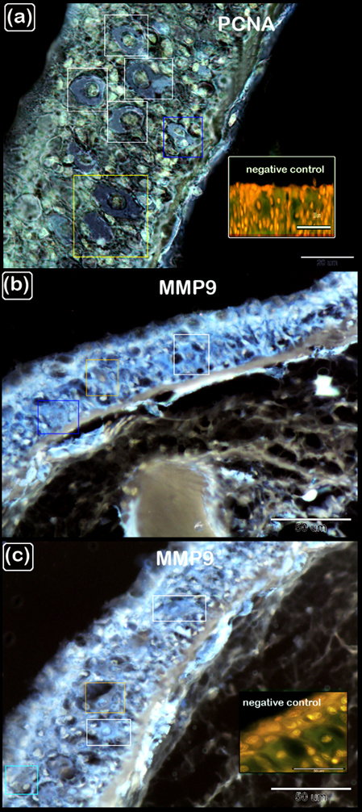

Supplementary figure3: Negative image of immunohistochemical staining of alarm cells using PCNA, and MPP-9.
Paraffin sections subjected to immunostaining for PCNA (A), and MPP-9 (B, C). A: Basal alarm precursor cells (Yellow Square) had extensive immunoaffinity for PCNA. Some alarm cells retained PCNA immunoaffinity (black squares) while others lost it (blue square). Inserted square showing the negative control.
B: Basal alarm precursor cells (yellow Square) and mid-epithelial alarm cells (black squares) strongly expressed MPP-9. C: Mid-epithelial alarm cells (black squares) strongly expressed MPP-9, while others (blue square) located more superficially had less immunoaffinity for it. Superficial alarm cells (red square) had less immunoaffinity for MPP-9. Inset in figure D showed the negative control.

