Supporting information for “Atom probe tomography investigations of Ag nanoparticles embedded in pulse electrodeposited Ni films”

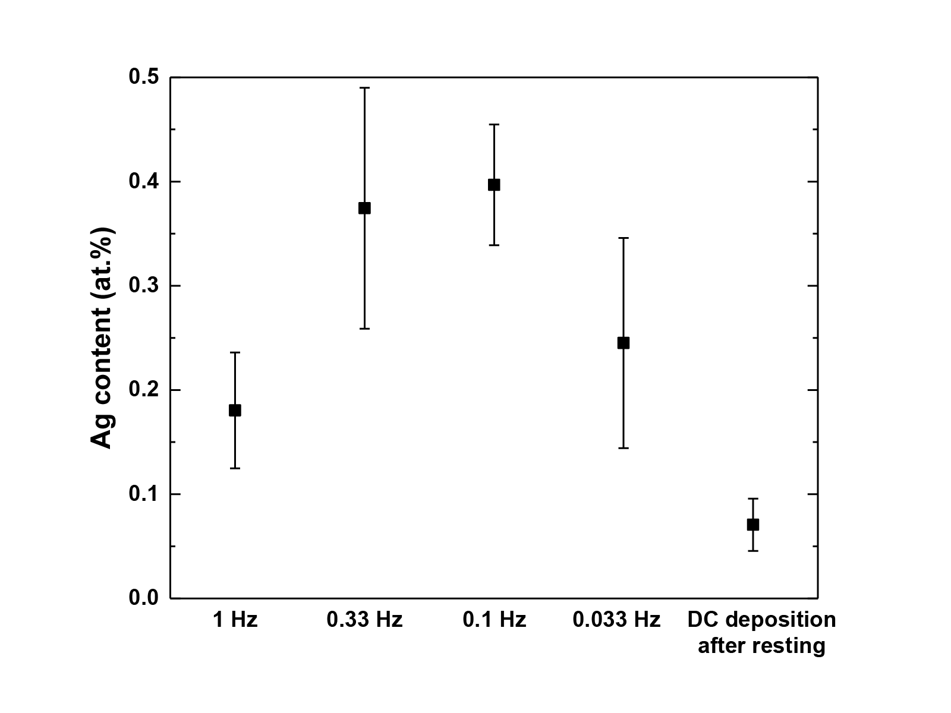
Figure S1. Ag content of Ni films electrodeposited with varied pulse frequency (1, 0.33, 0.1, 0.033 Hz) and fixed duty cycle of 10 %, and DC electrodeposited for 800 s after 7200 s of resting period.

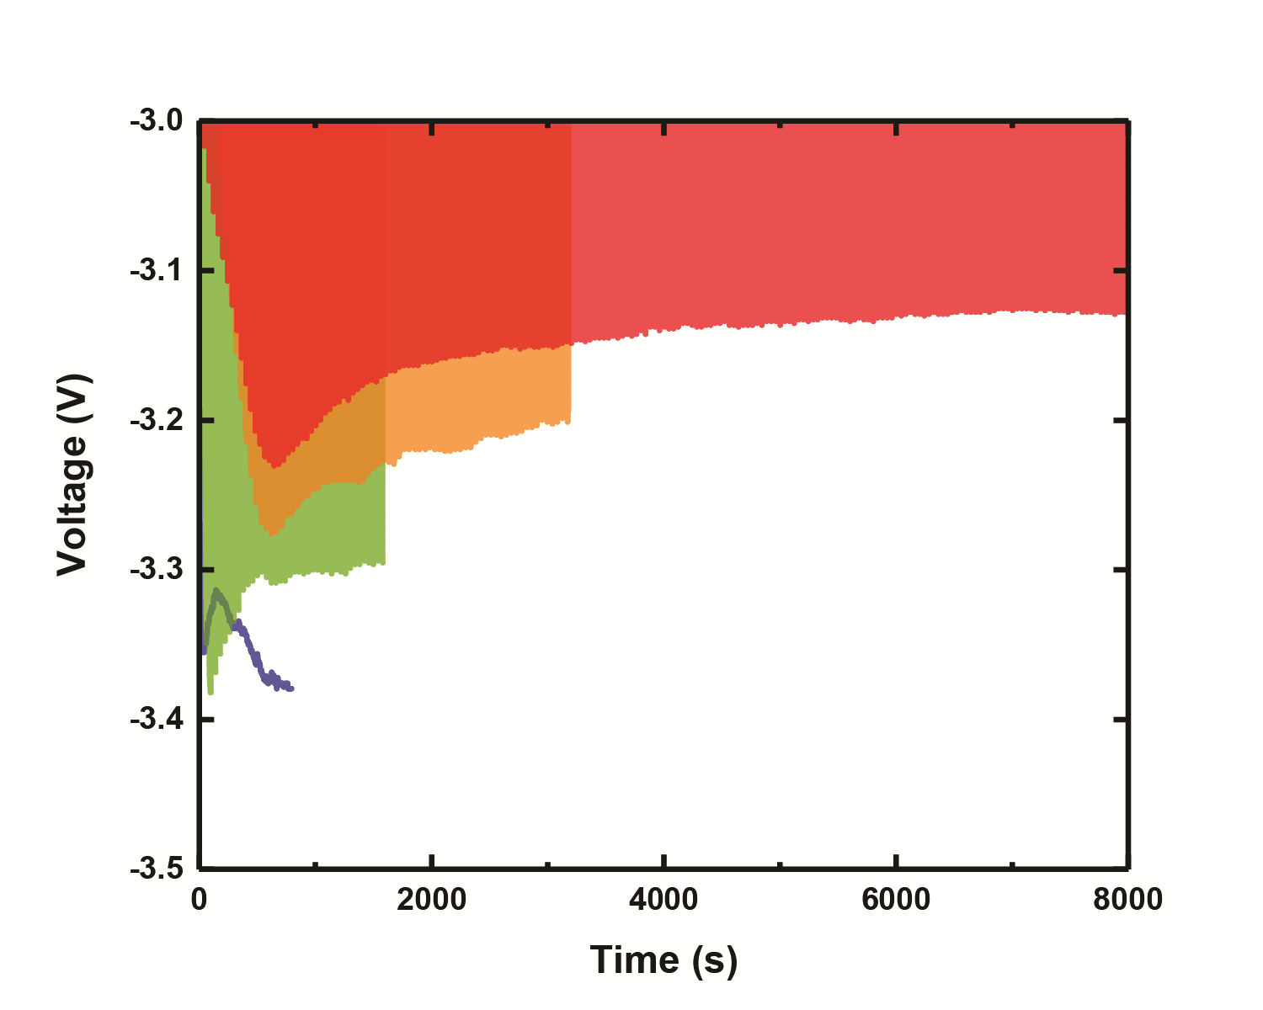
Figure S2. Voltage-Time graph of specimen electrodeposited with duty cycle of 10 % (red), 25 % (orange), 50 % (green), and DC electrodeposited specimen (blue).

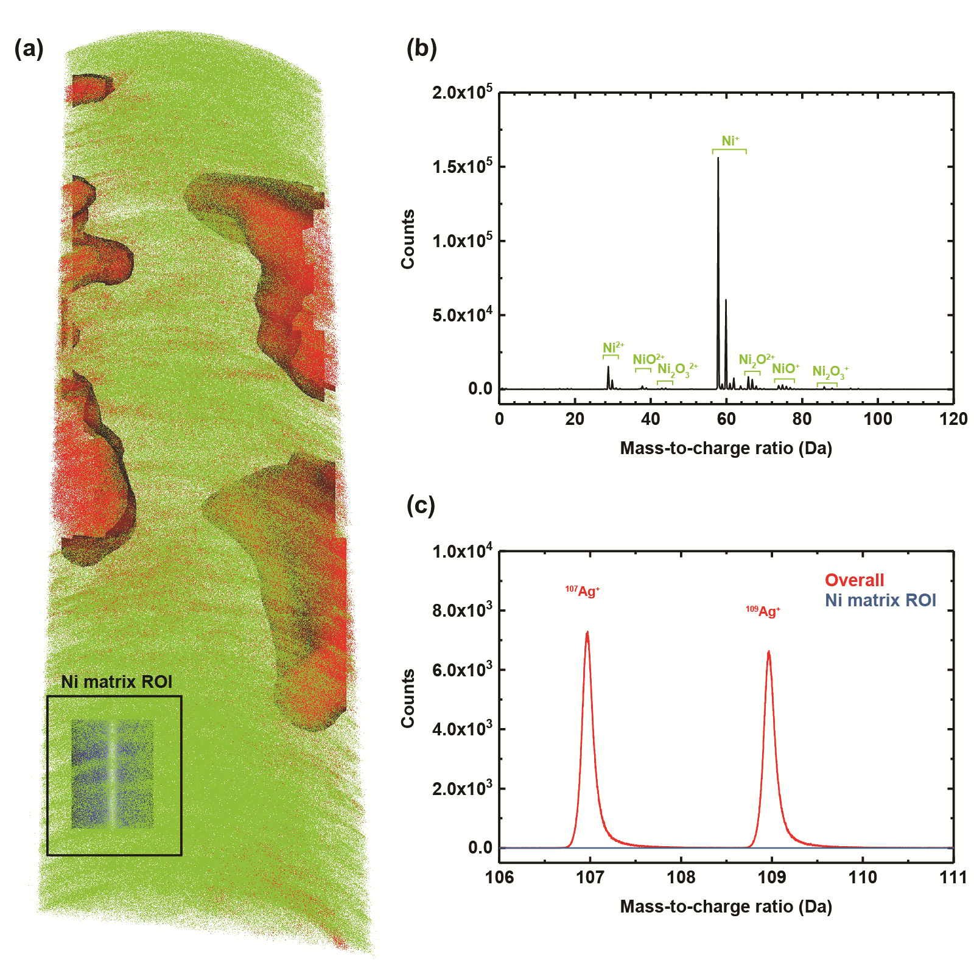
Figure S3. (a) Position of the ROI analyzed for studying the composition of the Ni matrix (blue cylinder). (b) Mass spectrum of the studied ROI. (c) Mass spectrum of overall atom map overlayed with Mass spectrum of the studied ROI.
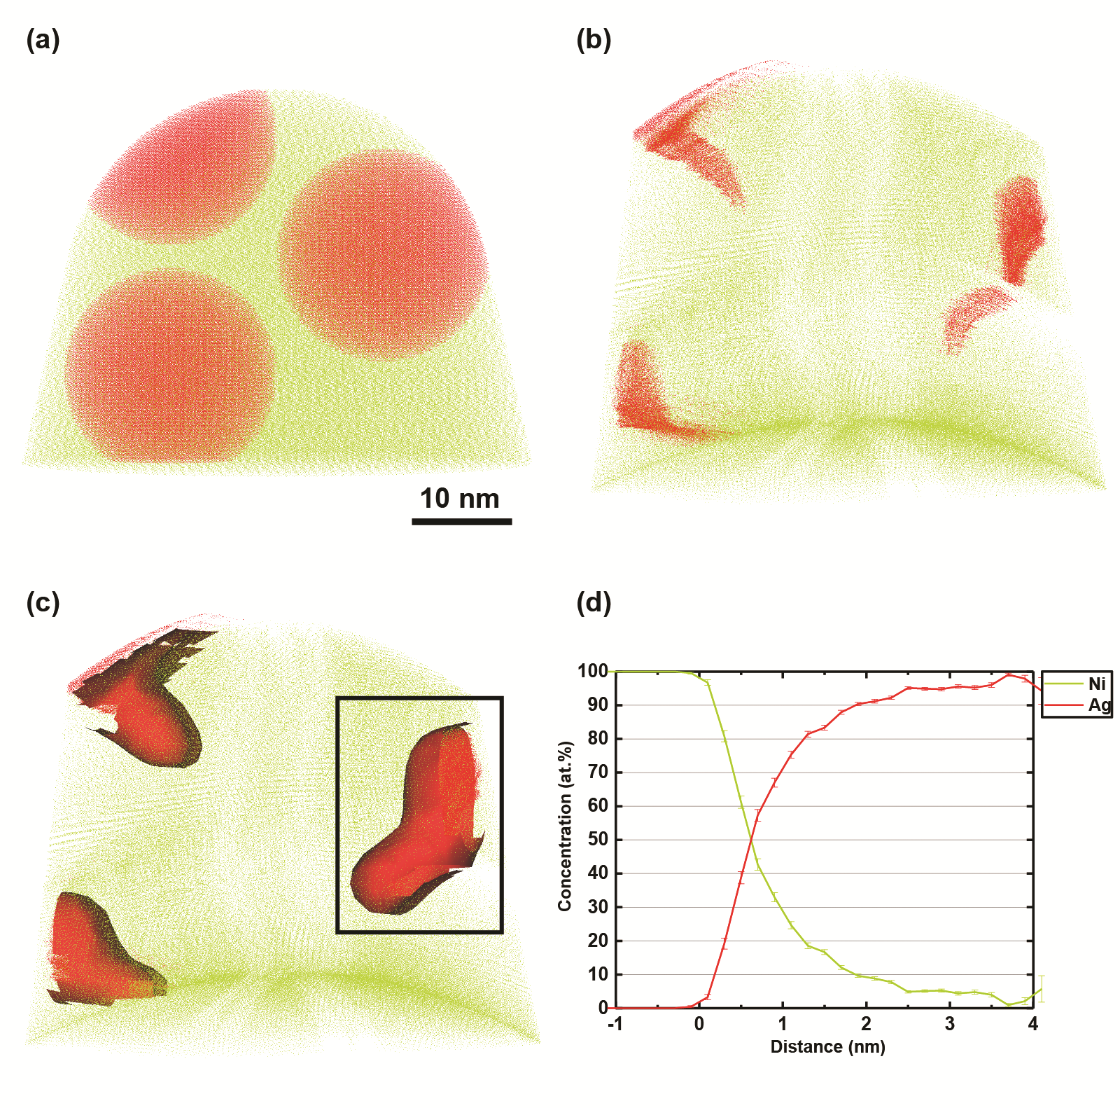
Figure S4 (a) pristine tip containing three Ag nanoparticles used for the field evaporation simulation. (b) reconstructed atom map showing Ag in red, Ni in orange dots. (c) reconstructed atom map showing 50 at. % iso-concentration surface of Ag. (d) Proximity histogram with respect to the iso-concentration surface within the green box.

