Supplementary Information for

Minimizing Crinkling of Soft Specimens Using Holey- Gold Films on Molybdenum Grids for Cryogenic Electron Microscopy

Xi Jiang¹*, Sunting Xuan², Ronald N. Zuckermann², Robert M. Glaeser⁴, Kenneth H. Downing ^{4#}, Nitash P. Balsara^{1,3}

1. Materials Sciences Division, Lawrence Berkeley National Laboratory, Berkeley, CA 94720, USA2. Molecular Foundry, Lawrence Berkeley National Laboratory, Berkeley, CA 94720, USA
3. Department of Chemical and Biomolecular Engineering, University of California, Berkeley, CA 94720, USA
4. Molecular Biophysics and Integrated Bioimaging, Lawrence Berkeley National Laboratory, Berkeley, CA 94720, USA
# Deceased

*Corresponding author: xijiang@lbl.gov

Submission to Microscopy and Microanalysis

Figure S1. Chemical structures of diblock copolypeptoids. Blue and green colors represent the hydrophilic block and hydrophobic block in polypeptoid, respectively.

Polypeptoids | Molecular weight  (Theoretical [M+H]⁺) | Molecular weight ª  (Observed [M+H]⁺) | Purity ^{b}
Nte₄-N4Brpe₆ | 2272 | 2272 | 96.3
Nte₄-N3Brpe₆ | 2272 | 2272 | 98.1
Table S1. Characteristics of polypeptoids

- Mass was obtained from UPLC-MS.
- Purity was determined from UPLC.

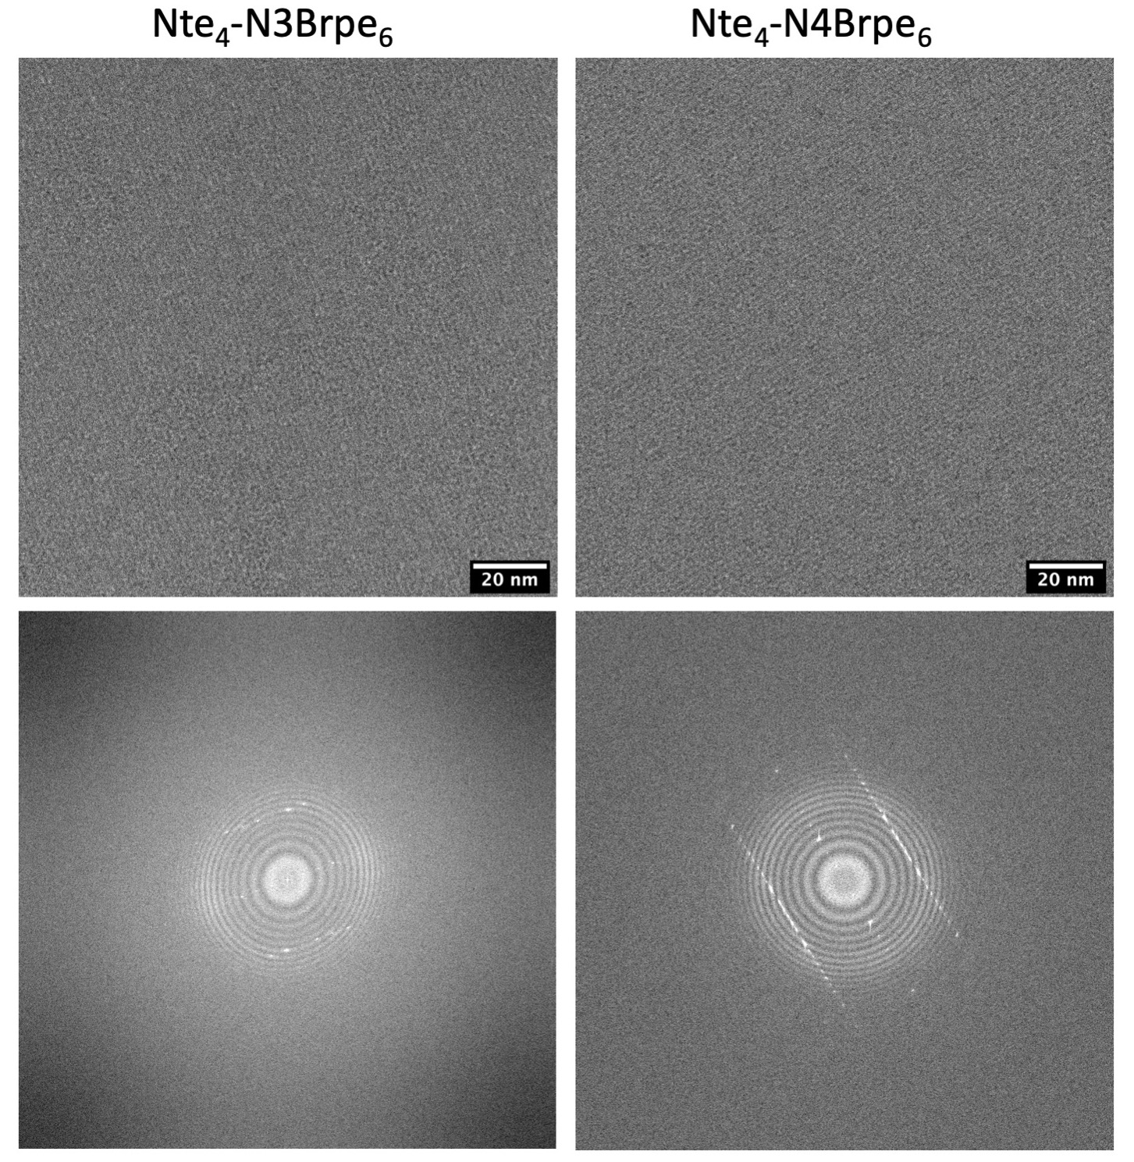

Figure S2. Cryo-EM micrographs (top) and power spectrums (bottom) of two crystalline polypeptoid membranes. The defocus value is

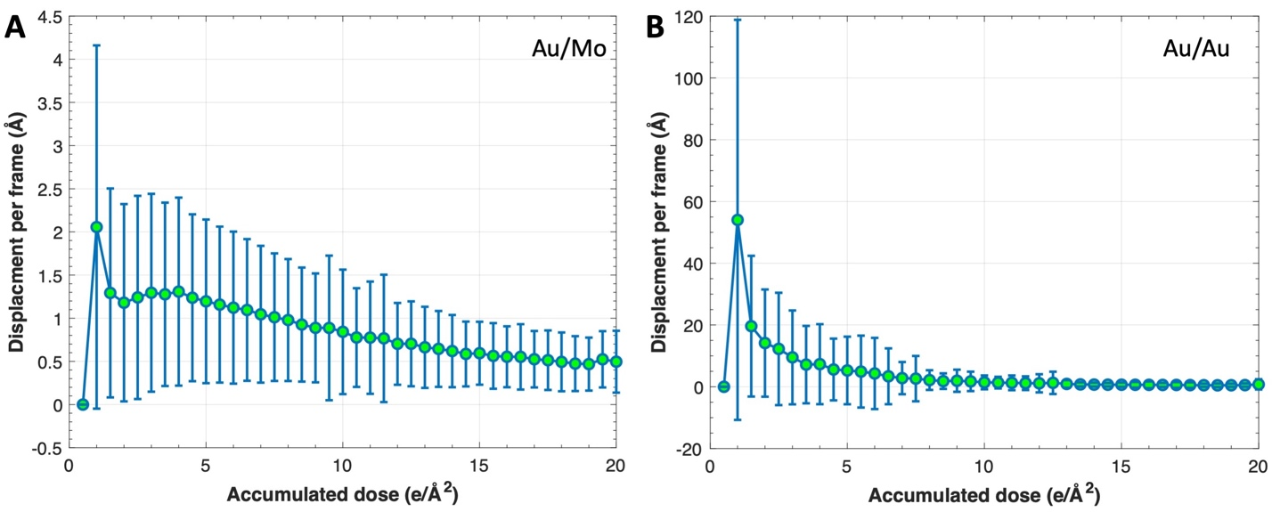
Figure S3. Mean beam-induced displacement and standard deviation of tilted crystalline polypeptoid membranes under cryogenic conditions on the A. Au/Mo grid, and B. Au/Au grid. 291 and 297 micrographs of specimens with a tilt angle of 45º supported on the Au/Mo and Au/Au grids were analyzed, respectively.

