Supporting Information:

Quantification of Nanoparticles in Dispersions using Transmission Electron Microscopy
Ralf Kaegi¹*, Martin Fierz², Bodo Hattendorf³
ralf.kaegi@eawag.ch

8 figures, 7 tables

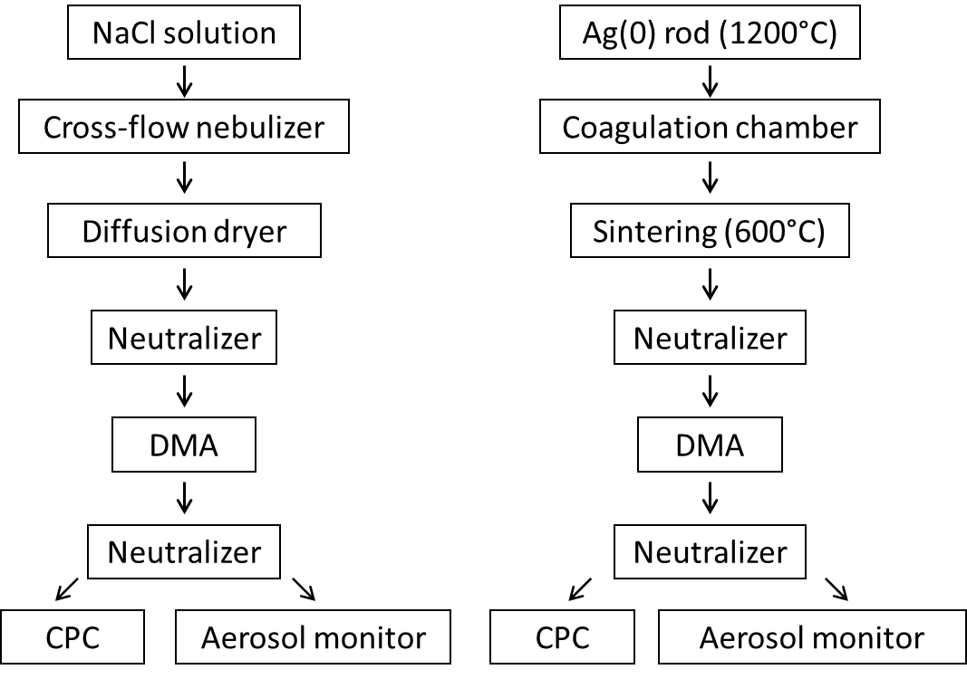
Figure S1: Schematic of the experimental setup for the production and deposition of the Ag NPs (left) and NaCl NPs (right) for assessing the deposition efficiencies of the electrostatic precipitator of the aerosol monitor. The diameters of the NaCl NPs were 70 nm, 80 nm, 120 nm, 160 nm and 200 nm. The diameters of the Ag NPs were 10 nm, 20 nm, 40 nm and 80 nm.

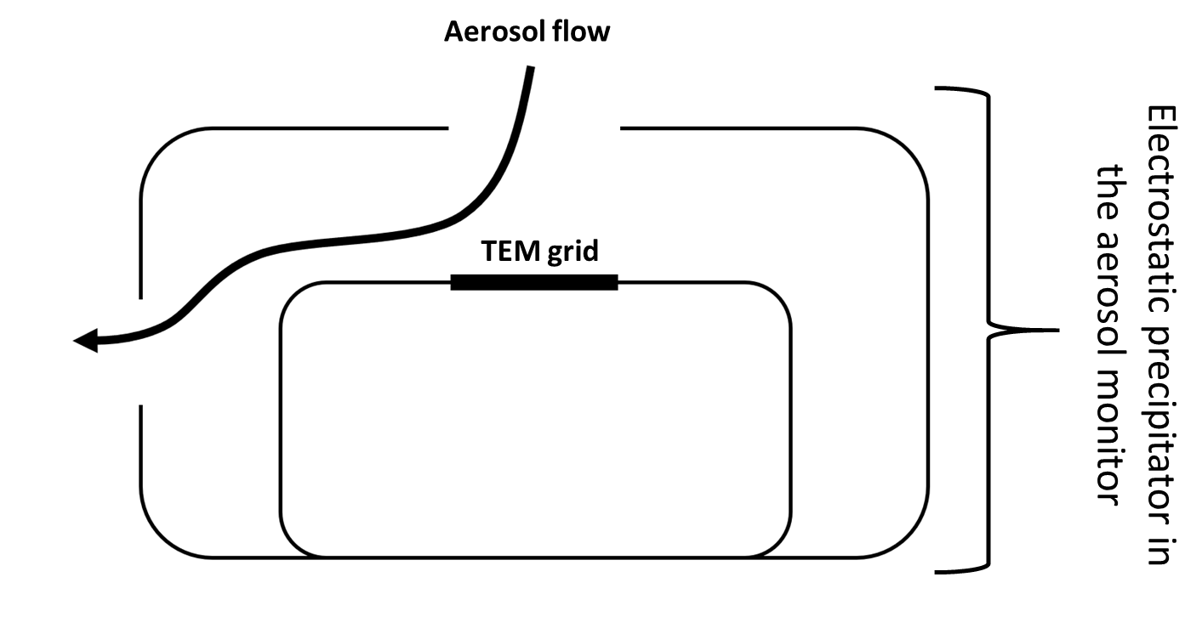
Figure S2: Schematic layout of the aerosol flow around the TEM grid in the electrostatic precipitator of the aerosol monitor.

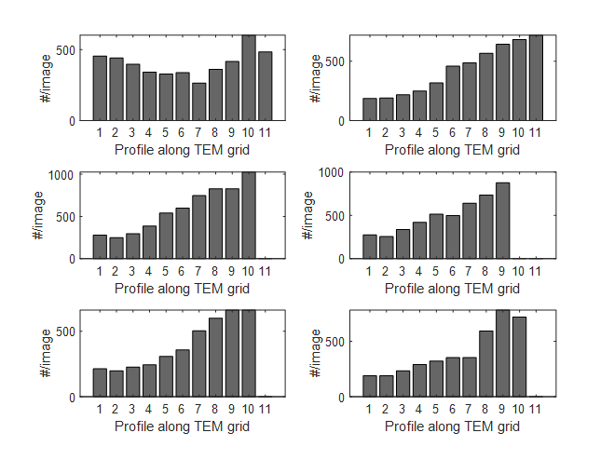
Figure S3: Number of particles detected per TEM image recorded along two perpendicular TEM grid transects. Each image covers an area of 68 x 68 µm². Each individual transect spans a distance of ~ 1.5 mm. The TEM grids correspond to the experiments conducted with 200 nm NaCl particles listed in Table S1.

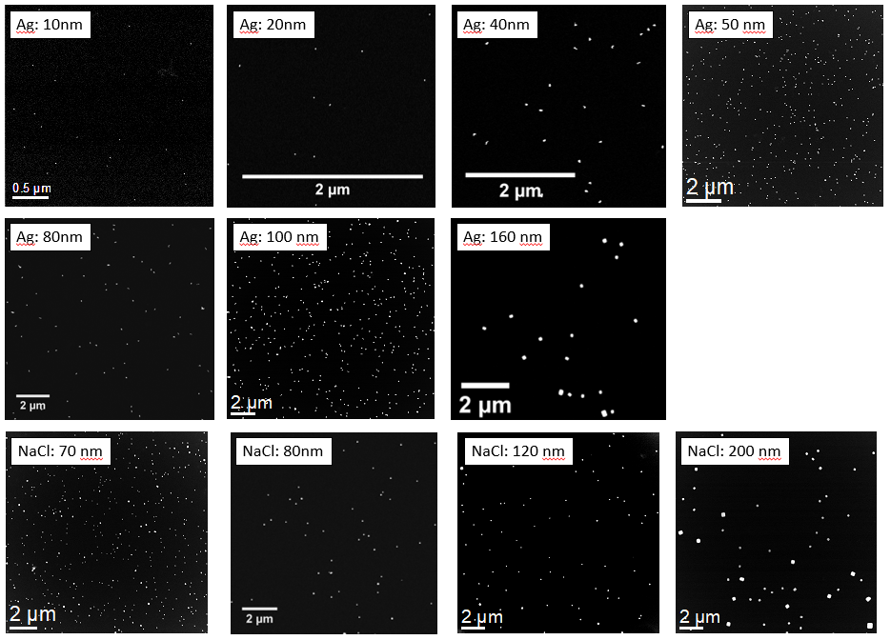
Figure S4: Selected TEM images from the experiments conducted with Ag NP and NaCl particles to determine the deposition efficiency of the electrostatic precipitator of the aerosol monitor. The diameter of the particles in individual experiments ranged from 10 - 200 nm.

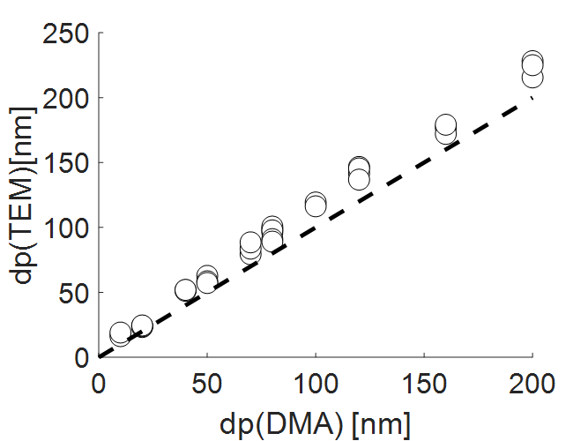
Figure S5: Comparison of the particle diameters determined from TEM images (modal values of a lognormal fit to the ECD) and derived from the DMA-CPC setup of experiments conducted to assess the deposition efficiency of the electrostatic precipitator. The dashed line corresponds to the 1:1 line.

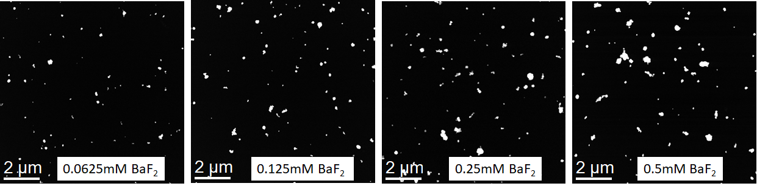
Figure S6: TEM - high angular annular dark field (HAADF) images of BaF₂ residues from solutions nebulized using the USN and collected on TEM grids using the electrostatic precipitator.
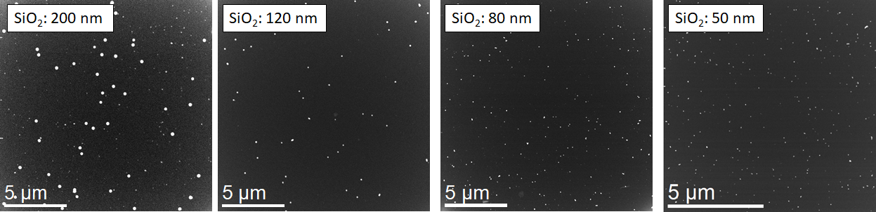
Figure S7: TEM-HAADF images of SiO₂ NP from suspensions (50 – 200 nm) nebulized using the USN and collected on TEM grids using the electrostatic precipitator.
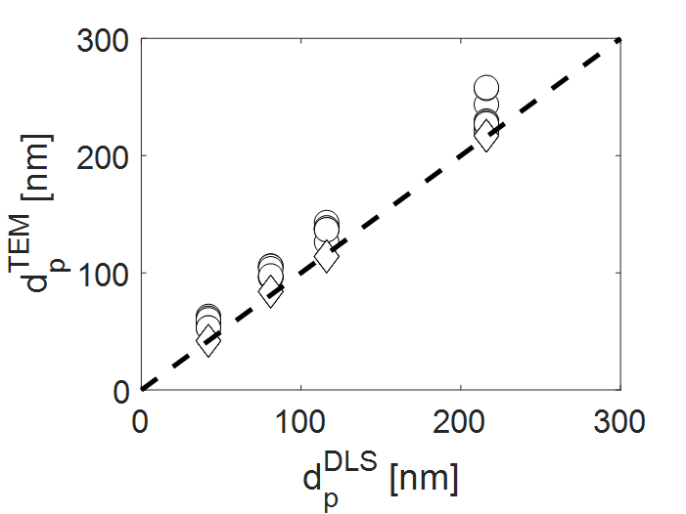
Figure S8: Comparison of the particle diameter determined from DLS (mean number based diameter, concentrated stock suspensions) and from TEM images for SiO₂ particles ranging from 50 – 200 nm. The circles refer to results from nebulization experiments conducted on diluted suspensions and collected using the electrostatic precipitator (mean of a lognormal fit to the ECD determined by TEM). The diamonds refer to results obtained from centrifuging (concentrated) SiO₂ suspensions directly on TEM grids (mean of the ECD determined by TEM analyses). The dashed lines represents a 1:1 correlation.

Tables:
Table S1: Diameters of the SiO₂ and Au NPs. All diameters are given in nanometers. dp(nom) refers to the diameter given by the manufacturer. dp(DLS) refers to the mean number based diameter determined by DLS and std(DLS) refers to the standard deviation from three measurements (1 σ) , dp(TEM) refers to the equivalent area circular diameter (ECD) extracted from TEM images, and std(TEM) refers to the standard deviation of the TEM diameters (1 σ). N represent the number of particles included in the TEM analyses.

 | dp(nom) | dp(DLS) | std (DLS) | dp(TEM) | Std (TEM) | N
SiO₂ | 50 | 42 | 0.15 | 42 | 3.4 | 301
SiO₂ | 80 | 81 | 2.14 | 84 | 5.8 | 437
SiO₂ | 120 | 116 | 4.58 | 114 | 6.6 | 361
SiO₂ | 200 | 216 | 3.41 | 217 | 17.3 | 194
Au | 40 | 32 | 0.84 | 41 | 4.6 | 237

Table S2: Comparison between the expected (based on the information of the manufacturer) and the measured Si concentration of suitable dilutions of the working suspensions. The Si concentrations were measured using an ICP-OES at a wavelength of 251.612 nm. The two measurement campaigns were conducted on two different days and the dilutions were prepared at the same day as the analyses were performed.

Sample | 50nm | 80nm | 120nm | 200nm |  | 50nm | 80nm | 120nm | 200nm
Unit | mgL⁻¹ | mgL⁻¹ | mgL⁻¹ | mgL⁻¹ |  | mgL⁻¹ | mgL⁻¹ | mgL⁻¹ | mgL⁻¹
Average  (Triplicate) | 3.03 | 1.17 | 3.07 | 1.42 |  | 2.23 | 0.56 | 2.93 | 3.03
Expected | 3.08 | 0.95 | 3.17 | 1.44 |  | 2.36 | 0.47 | 3.12 | 3.64
Difference (%) | 2 | -23 | 3 | 1 |  | 5 | -18 | 6 | 17

Table S3: Results of the aerosol deposition experiments used to calculate the deposition efficiency of the electrostatic precipitator. dp(DMA) refers to the size selected by the differential mobility analyzer, dp(TEM) refers to the ECD derived from TEM images using the ParticleSizer, N (CPC) corresponds the total number of particles detected by the condensation particle counter over the course of the experiments. N (TEM det) refers to the number of particles detected on the TEM grid and N (TEM tot) corresponds to the number of particles scaled to the area of one TEM grid. The deposition efficiency (Eff) is calculated as the ratio between the total number of particles on the TEM grid and the total number of particles detected by the CPC.
Name | dp (DMA) | dp (TEM) | N (CPC) | N (TEM det) | N (TEM tot) | Eff
[] | [nm] | [nm] | [#] | [#] | [#] | []
Ag10 | 10 | 14 | 3.71E+09 | 1205 | 1.39E+07 | 3.74E-03
Ag10 | 10 | 17 | 3.88E+09 | 872 | 1.34E+07 | 3.46E-03
Ag20 | 20 | 21 | 8.60E+08 | 3084 | 1.96E+07 | 2.28E-02
Ag20 | 20 | 21 | 8.69E+08 | 3689 | 2.34E+07 | 2.70E-02
Ag20 | 20 | 22 | 8.69E+08 | 3440 | 2.19E+07 | 2.52E-02
Ag20 | 20 | 21 | 1.25E+09 | 2385 | 1.88E+07 | 1.50E-02
Ag40 | 40 | 43 | 4.96E+08 | 3814 | 1.22E+07 | 2.46E-02
Ag40 | 40 | 44 | 4.93E+08 | 2180 | 6.97E+06 | 1.41E-02
Ag40 | 40 | 45 | 4.87E+08 | 2924 | 9.35E+06 | 1.92E-02
Ag50 | 50 | 52 | 1.10E+09 | 5134 | 1.84E+07 | 1.67E-02
Ag50 | 50 | 52 | 1.11E+09 | 3550 | 1.27E+07 | 1.15E-02
Ag50 | 50 | 49 | 1.11E+09 | 7021 | 2.51E+07 | 2.27E-02
NaCl70 | 70 | 77 | 6.82E+08 | 6322 | 1.37E+07 | 2.01E-02
NaCl70 | 70 | 76 | 6.78E+08 | 7637 | 1.66E+07 | 2.45E-02
NaCl70 | 70 | 86 | 6.74E+08 | 5815 | 1.26E+07 | 1.87E-02
Ag80 | 80 | 81 | 1.93E+08 | 4033 | 3.22E+06 | 1.67E-02
Ag80 | 80 | 83 | 1.95E+08 | 3322 | 2.66E+06 | 1.36E-02
Ag80 | 80 | 81 | 1.96E+08 | 4905 | 3.92E+06 | 2.00E-02
NaCl80 | 80 | 95 | 1.95E+08 | 2718 | 2.48E+06 | 1.27E-02
NaCl80 | 80 | 86 | 1.94E+08 | 3563 | 2.85E+06 | 1.47E-02
NaCl80 | 80 | 86 | 1.94E+08 | 2955 | 2.36E+06 | 1.22E-02
Ag100 | 100 | 95 | 5.35E+08 | 2071 | 3.31E+06 | 6.19E-03
Ag100 | 100 | 89 | 5.20E+08 | 6342 | 1.08E+07 | 2.08E-02
NaCl120 | 120 | 130 | 2.81E+08 | 3183 | 5.09E+06 | 1.81E-02
NaCl120 | 120 | 133 | 3.34E+08 | 3592 | 5.74E+06 | 1.72E-02
NaCl120 | 120 | 132 | 2.50E+08 | 1627 | 2.60E+06 | 1.04E-02
NaCl120 | 120 | 120 | 1.55E+08 | 1192 | 1.91E+06 | 1.23E-02
NaCl160 | 160 | 173 | 8.94E+07 | 1252 | 9.80E+05 | 1.10E-02
NaCl160 | 160 | 157 | 8.94E+07 | 1517 | 1.18E+06 | 1.33E-02
NaCl160 | 160 | 176 | 8.95E+07 | 1777 | 1.39E+06 | 1.55E-02
NaCl200 | 200 | 197 | 1.68E+08 | 1725 | 2.76E+06 | 1.65E-02
NaCl200 | 200 | 233 | 1.06E+08 | 991 | 1.58E+06 | 1.50E-02
NaCl200 | 200 | 224 | 1.16E+08 | 1090 | 1.74E+06 | 1.51E-02

Table S4: Operational parameters and experimental results of the BaF₂ aerosol experiments conducted to assess the average size of the droplets produced by the USN. The concentration is given in mM of the BaF₂ solution and the sampling time (t) in s. Dp and σ (log10) refer to the mean and the standard deviation of a log-normal distribution fitted to the particle size distribution of the BaF₂ residues determined by TEM analyses. Particles were detected and size classified using the ParticleSizer. N(det) refers to the amount of particles included in the analyses. Dp(drop) refers to the calculated droplet size and N corresponds to the number of droplets (theoretically) generated per mL of sprayed BaF₂ solution.
Conc. | t | Dp | σ | N(det) | Dp(drop) | N
[mM] | [s] | [nm] | [] | [#] | [μm] | [#]
0.0625 | 53 | 116 | 1.47 | 1588 | 11.1 | 1.41E+09
0.0625 | 53 | 118 | 1.52 | 1754 | 11.8 | 1.17E+09
0.0625 | 54 | 116 | 1.48 | 1636 | 11.2 | 1.34E+09
0.125 | 36 | 129 | 1.52 | 1467 | 10.2 | 1.81E+09
0.125 | 36 | 132 | 1.5 | 1338 | 10.2 | 1.79E+09
0.125 | 36 | 129 | 1.49 | 1390 | 9.9 | 1.97E+09
0.25 | 24 | 146 | 1.54 | 1519 | 9.3 | 2.35E+09
0.25 | 24 | 150 | 1.53 | 1342 | 9.5 | 2.23E+09
0.25 | 25 | 155 | 1.51 | 1250 | 9.6 | 2.16E+09
0.25 | 24 | 146 | 1.51 | 1393 | 9.1 | 2.56E+09
0.25 | 24 | 138 | 1.52 | 1385 | 8.7 | 2.94E+09
0.5 | 18 | 160 | 1.5 | 783 | 7.8 | 3.99E+09
0.5 | 18 | 179 | 1.57 | 1316 | 9.2 | 2.43E+09
0.5 | 18 | 173 | 1.55 | 1436 | 8.8 | 2.76E+09

Table S5: Experimental conditions and key results from the SiO₂ spray experiments conducted by nebulizing SiO₂-NP suspensions and collecting the dried particles on TEM grids using the aerosol monitor. dp(nom) refers to the nominal diameter of the SiO₂-NPs. dp(DLS), dp(TEM,spray) and dp(TEM, cent) refers to the number based mean of the diameter of the SiO₂-NPs determined by DLS, the mean of a log-nomal fit to the ECD determined from TEM analyses of sprayed SiO₂ suspensions and the mean of the ECD derived from TEM analyses of centrifuged SiO₂ NP suspensions. time and c(susp) refer to the sampling times and the concentration of the SiO₂ suspension, respectively. N(sprayed) refers to the number of particles sprayed and is calculated based on the diameter (dp(TEM, cent)) of the particles, the SiO₂ concentration in the suspension and the volume of suspension nebulized during the respective experiments. N(det) and A refer to the number of SiO₂ particles detected on TEM images and to the area covered by all TEM images that were investigated for each experiment. Flow(susp) and Flow(A) correspond to the flow rate of the SiO₂ suspension to the USN and to the aerosol flow rate at which the nebulized aerosol was transported to the aerosol monitor. The flow rate of the suspension was determined gravimetrically and the aerosol flow rate was measured with a bubble meter.
dp(nom) | dp(DLS) | dp(TEM,spray) | dp(TEM, cent)* | time | c(susp) | N(sprayed) | N(det) | A | Flow (susp) | Flow(A)
[nm] | [nm] | [nm] | [nm] | [s] | [mM] | [#] | [#] | [m²] | [mL/min] | [L/min]
50¥ | 42 | 63 | 42 | 1024 | 1.66E-03 | 2.49E+10 | 2542 | 1.63E-09 | 1.25 | 0.48
50¥ | 42 | 59 | 42 | 959 | 1.66E-03 | 2.33E+10 | 2439 | 1.63E-09 | 1.25 | 0.48
50 | 42 | 61 | 42 | 1236 | 1.09E-03 | 2.19E+10 | 2247 | 1.97E-09 | 1.39 | 0.3
50 | 42 | 58 | 42 | 1227 | 1.09E-03 | 2.17E+10 | 2105 | 1.97E-09 | 1.39 | 0.3
50 | 42 | 60 | 42 | 1222 | 1.09E-03 | 2.16E+10 | 3248 | 1.97E-09 | 1.39 | 0.3
50 | 42 | 53 | 42 | 1258 | 7.94E-04 | 1.34E+10 | 2022 | 1.65E-09 | 1.14 | 0.47
50 | 42 | 53 | 42 | 1171 | 7.94E-04 | 1.24E+10 | 1957 | 1.74E-09 | 1.14 | 0.47
80 | 81 | 106 | 84 | 1189 | 4.32E-03 | 1.01E+10 | 3070 | 4.57E-09 | 1.39 | 0.3
80 | 81 | 106 | 84 | 1182 | 4.32E-03 | 1.00E+10 | 2387 | 4.57E-09 | 1.39 | 0.3
80 | 81 | 103 | 84 | 1177 | 4.32E-03 | 1.00E+10 | 3496 | 4.57E-09 | 1.39 | 0.3
80 | 81 | 96 | 84 | 1172 | 3.79E-03 | 7.17E+09 | 1253 | 2.58E-09 | 1.14 | 0.47
80 | 81 | 97 | 84 | 1207 | 3.79E-03 | 7.39E+09 | 2154 | 2.58E-09 | 1.14 | 0.47
80 | 81 | 97 | 84 | 1240 | 3.79E-03 | 7.59E+09 | 1998 | 2.58E-09 | 1.14 | 0.47
120¥ | 116 | 137 | 114 | 700 | 1.39E-02 | 7.12E+09 | 956 | 1.63E-09 | 1.25 | 0.48
120¥ | 116 | 126 | 114 | 908 | 1.39E-02 | 9.24E+09 | 1560 | 1.63E-09 | 1.25 | 0.48
120 | 116 | 138 | 114 | 904 | 1.02E-02 | 7.52E+09 | 1011 | 4.57E-09 | 1.39 | 0.3
120 | 116 | 143 | 114 | 585 | 1.02E-02 | 4.87E+09 | 778 | 4.57E-09 | 1.39 | 0.3
120 | 116 | 138 | 114 | 538 | 1.02E-02 | 3.66E+09 | 727 | 4.57E-09 | 1.14 | 0.47
120 | 116 | 137 | 114 | 519 | 1.02E-02 | 3.53E+09 | 732 | 4.57E-09 | 1.14 | 0.47
120 | 116 | 137 | 114 | 721 | 1.02E-02 | 4.90E+09 | 879 | 4.57E-09 | 1.14 | 0.47
200¥ | 216 | 221 | 217 | 252 | 1.11E-01 | 2.93E+09 | 567 | 1.36E-09 | 1.25 | 0.48
200¥ | 216 | 228 | 217 | 220 | 1.11E-01 | 2.56E+09 | 536 | 1.63E-09 | 1.25 | 0.48
200¥ | 216 | 226 | 217 | 219 | 1.11E-01 | 2.55E+09 | 612 | 1.63E-09 | 1.25 | 0.48
200 | 216 | 244 | 217 | 174 | 5.05E-02 | 1.02E+09 | 432 | 4.57E-09 | 1.39 | 0.3
200 | 216 | 257 | 217 | 263 | 5.05E-02 | 1.55E+09 | 683 | 4.57E-09 | 1.39 | 0.3
200 | 216 | 258 | 217 | 176 | 5.05E-02 | 1.04E+09 | 384 | 4.57E-09 | 1.39 | 0.3
200 | 216 | 230 | 217 | 183 | 4.21E-02 | 7.36E+08 | 143 | 4.57E-09 | 1.14 | 0.47
200 | 216 | 228 | 217 | 184 | 4.21E-02 | 7.40E+08 | 242 | 4.57E-09 | 1.14 | 0.47
200 | 216 | 227 | 217 | 179 | 4.21E-02 | 7.20E+08 | 152 | 4.57E-09 | 1.14 | 0.47
*: due to the very narrow particle size distributions derived from TEM measurements, the calculated number and the volume-based diameters do not differ by more than 1 nm.
¥: Experiments conducted without a neutralizer

Table S6: Operating conditions during the sp-ICPMS measurements. The ICPMS was set up according to the manufacturer’s recommendation with the exception that the original pneumatic nebulizer was replaced by the DSN. The aerosol outlet of the DSN was connected with the ICP torch via 0.5 m Tygon tubing (6 mm inner diameter) and a ball joint connection. All measurements were done in “single-quad” and “no-gas” mode, i.e. with the first mass filter operating in bandpass mode and the collision/reaction cell evacuated. The dwell time was set to 1 ms, whereby a substantial fraction of nanoparticle events may be recorded in successive acquisitions. The single-particle module of the instrument software (Masshunter 4.6) corrects for this by assuming that signals from adjacent data above the baseline were generated by a single nanoparticle.
Operating conditions of the Agilent 8900 ICPMS/MS
RF-Power, W | 1550
Nebulizer gas flow, L/min | 0.60
Make-up Gas flow, L/min | 0.53
Auxiliary gas flow, L/min | 0.9
Cool gas flow, L/min | 15
Sample Flow rate, mL/min | 1.25
Extraction lens 1, V | -26
Omega Bias, V | -140
Omega Lens, V | 16.8
Isotope | ¹⁹⁷Au⁺
Dwell time, ms | 1
Acquisition time, s | 120
Replicates | 3
Threshold, ion counts | 28
Mean signal / 40 nm Au NP, ion counts | 164

Table S7: Operating conditions for the ICP-OES analyses. The Instrument (Arcos, Spectro Analytical Instruments, Kleve, DE) was operated according to the manufacturer’s recommendation. The conventional sample introduction system was replaced by a “quartz-free” version consisting of a MiraMist PTFE nebulizer, PTFE cyclonic spray chamber (both: Burgener Research, Canada) and a demountable torch with sapphire injector tube (Spectro).
Operating conditions of the Arcos ICP-OES
RF-Power, W | 1400
Nebulizer gas flow, L/min | 0.90
Auxiliary gas flow, L/min | 1.0
Cool gas flow, L/min | 12
Sample flow rate, mL/min | 1.1
Measurement time | Standard (28 s total)
Replicates | 3
Lines | Si 288.158  Si 251.612  Si 212.412

