Supplementary material for

The nanostructure of the oxide formed on Fe-10Cr-4Al exposed in liquid Pb

Kristina Lindgren*¹, Peter Dömstedt², Peter Szakalos², and Mattias Thuvander¹

¹ Chalmers University of Technology, Department of Physics, Göteborg SE-412 96, Sweden
² Royal Institute of Technology (KTH), Department of Chemistry, Stockholm SE-100 44, Sweden

*corresponding author: kristina.lindgren@chalmers.se, +46 317723337

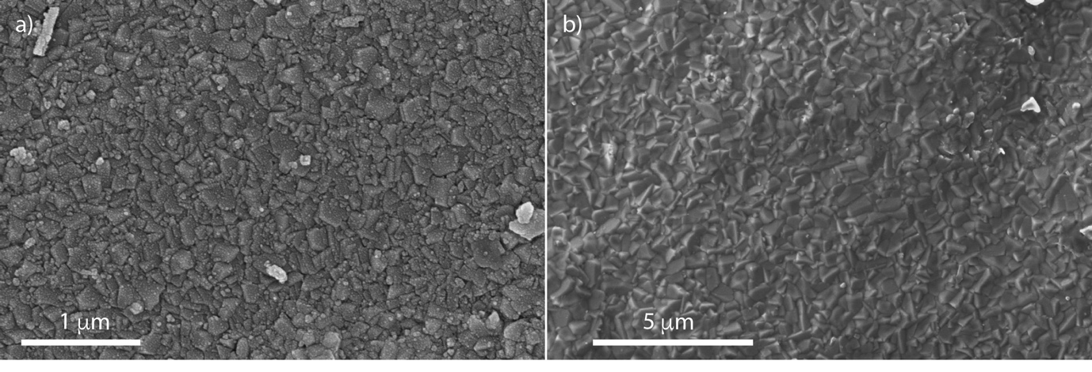
Figure S1. SEM top view of a) the material exposed in 600°C liquid lead and coated with Pd (hence the dotted appearance of the surface), and b) the material exposed in 750°C liquid lead. Please note the different magnification of a) and b).

