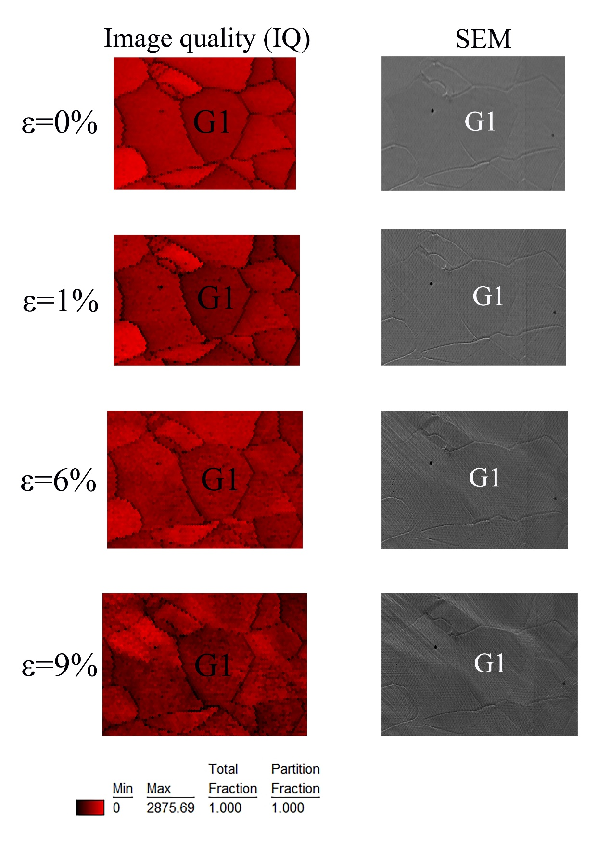
Figure S1. The IQ maps and SEM maps of G1 in RD sample at different strain.
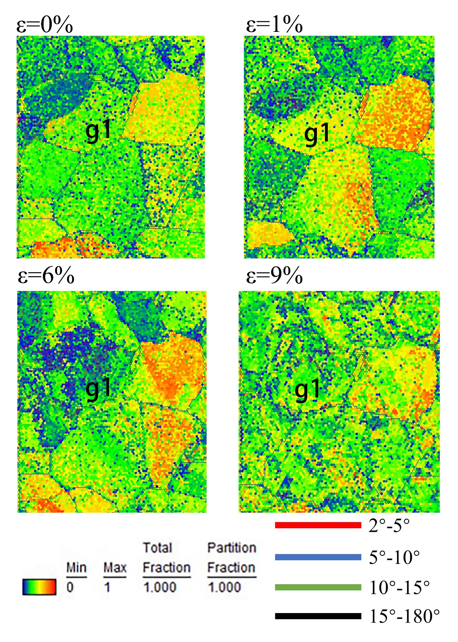
Figure S2. The CI maps of g1 in 45°-RD sample at different strain.

