Supplemental Information: Optimal STEM Convergence Angle Selection using a Convolutional Neural Network and the Strehl Ratio

Noah Schnitzer^{1,2}, Suk Hyun Sung¹, Robert Hovden^{1,3}
^{1.}Department of Materials Science and Engineering, University of Michigan, Ann Arbor, MI 48019, USA
^{2.}Department of Materials Science and Engineering, Cornell University, Ithaca, NY 14853, USA
^{3.}Applied Physics Program, University of Michigan, Ann Arbor, MI 48109, USA

Aberration  C_{n,m} | Scale  s_{n,m} | Aberration  C_{n,m} | Scale  s_{n,m}
C_{1,0} | 50 Å | C_{4,1} | 0.1 mm
C_{1,2} | 50 nm | C_{4,3} | 0.5 mm
C_{2,1} | 157 nm | C_{4,5} | 0.5 mm
C_{2,3} | 95.5 nm | C_{5,0} | 10 mm
C_{3,0} | 10.4 μm | C_{5,2} | 10 mm
C_{3,2} | 10.4 μm | C_{5,4} | 10 mm
C_{3,4} | 5.2 μm | C_{5,6} | 10 mm
Supplemental Table 1: Aberration magnitude scale factors, based on (Kirkland, 2018) and observations on JEOL 3100R5.

 | Training Set (N=98,000) | Test Set (N=1,000)
 | Convergence Angle RMSE vs. 0.8 Strehl | Convergence Angle RMSE vs. 0.8 Strehl | Probe Size MAE (50% probe current)
CNN | 3.02 mrad | 3.64 ± 0.12 mrad | 3.58 ± 0.60 pm
Microscopists | - | - | 25.8 ± 2.96 pm
Supplemental Table 2: Detailed results of network and trained microscopists on test set of 1000 simulated Ronchigrams. Uncertainties are calculated from the standard error of the mean.

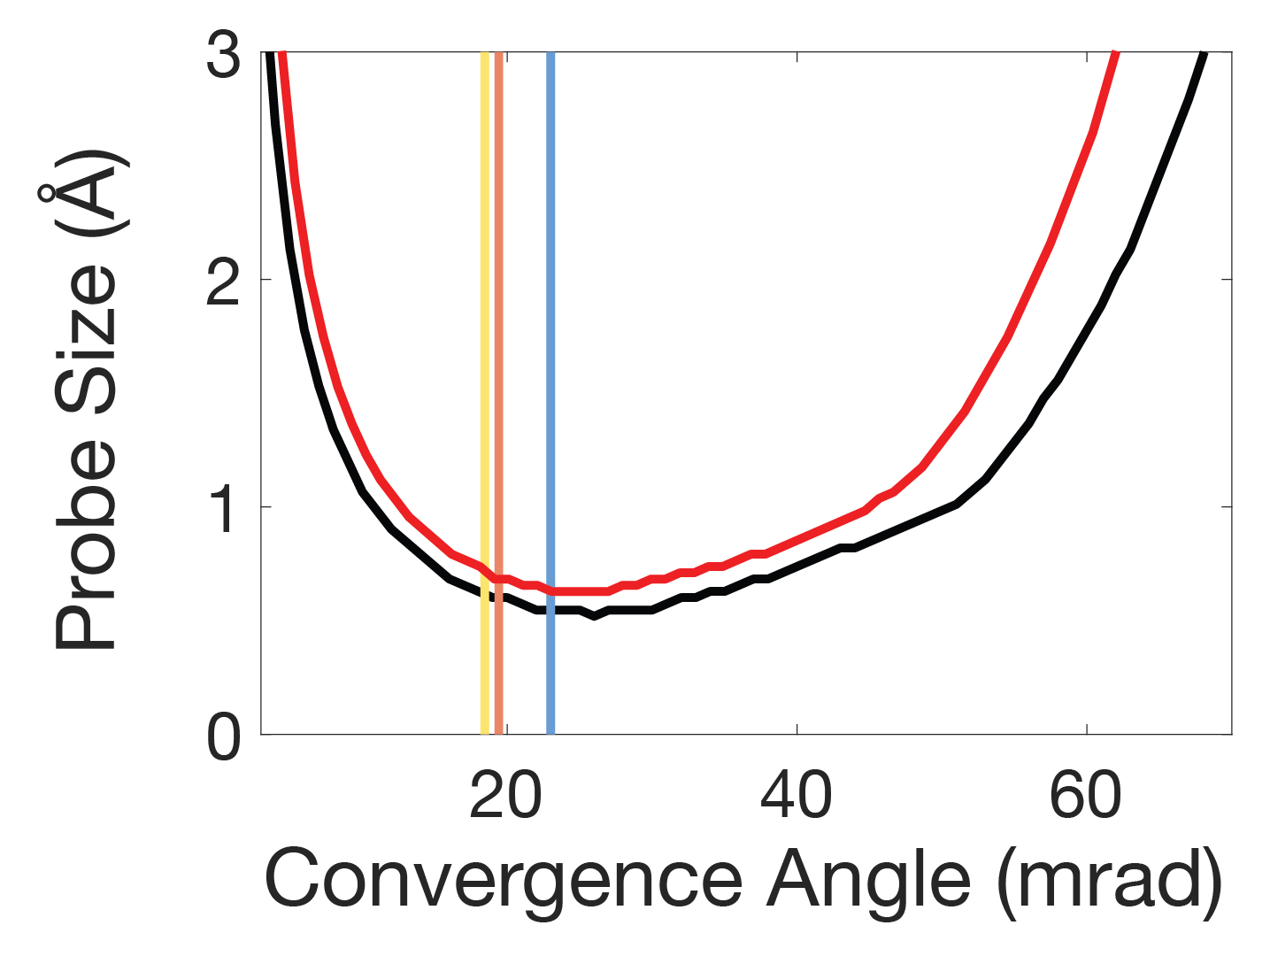
Supplemental Figure 1: For the same aberration function shown in Figure 2a, both the 50% probe current diameter (black line) and 59% probe current diameter (red line) are plotted as a function of convergence angle, and the convergence angles meeting the 0.8 Strehl ratio (blue), total aberration function phase shift (yellow), and individual aberration phase shift (orange) criteria are marked with vertical lines. The convergence angle for the smallest 50% and 59% probe current diameters are the same to within the simulation resolution.

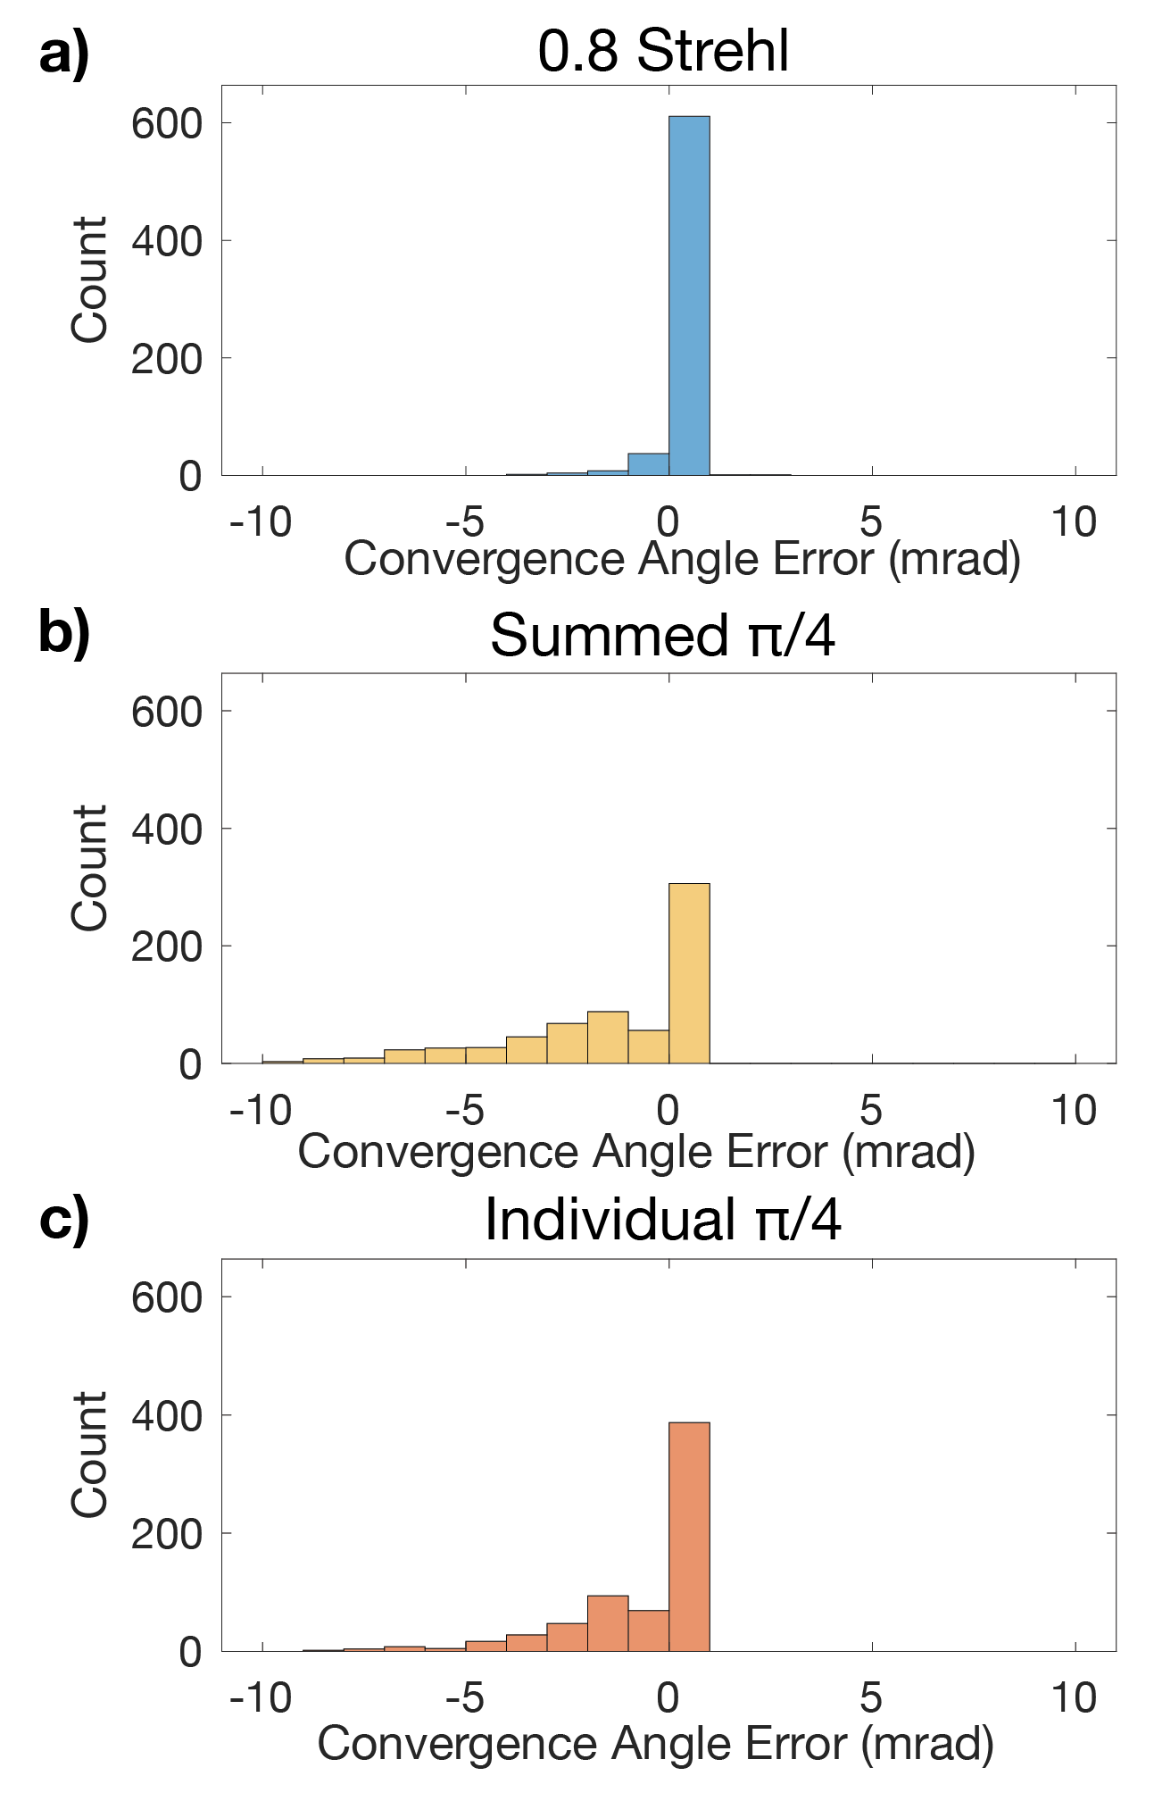
Supplemental Figure 2: Histograms of the error in convergence angle selection for (a) the 0.8 Strehl ratio, (b) the total aberration phase shift, (c) the individual aberration function phase shift with respect to the minimum 50% probe current aperture size, for the same set of 664 aberrations as Figure 2b,c.

