# Supporting Information for:

# Analysis of Electron Transparent Beam Sensitive Samples using Scanning Electron Microscopy coupled with Energy Dispersive X-ray Spectroscopy

Anders Brostrøm1,2, Kirsten Inga Kling3, Karin Sørig Hougaard2, and Kristian Mølhave1*

1Technical University of Denmark, DTU Nanolab – National Centre for Nano Fabrication and Characterization, Fysikvej, Building 307, 2800 Kgs Lyngby, Denmark

2National Research Centre for the Working Environment, Lersø Parkallé 105, 2100 Copenhagen, Denmark

3Technical University of Denmark, DTU Nanolab – National Centre for Nano Fabrication and Characterization, Fysikvej, Building 347, 2800 Kgs Lyngby, Denmark

*Corresponding author: krmo@dtu.dk

## Microscope configuration

A sketch of the detector configurations inside the SEM is shown in SI Figure 1. The FlatQuad detector was retracted when performing EDS measurements with the XFlash detector, as it would otherwise block a large fraction of the generated X-rays.

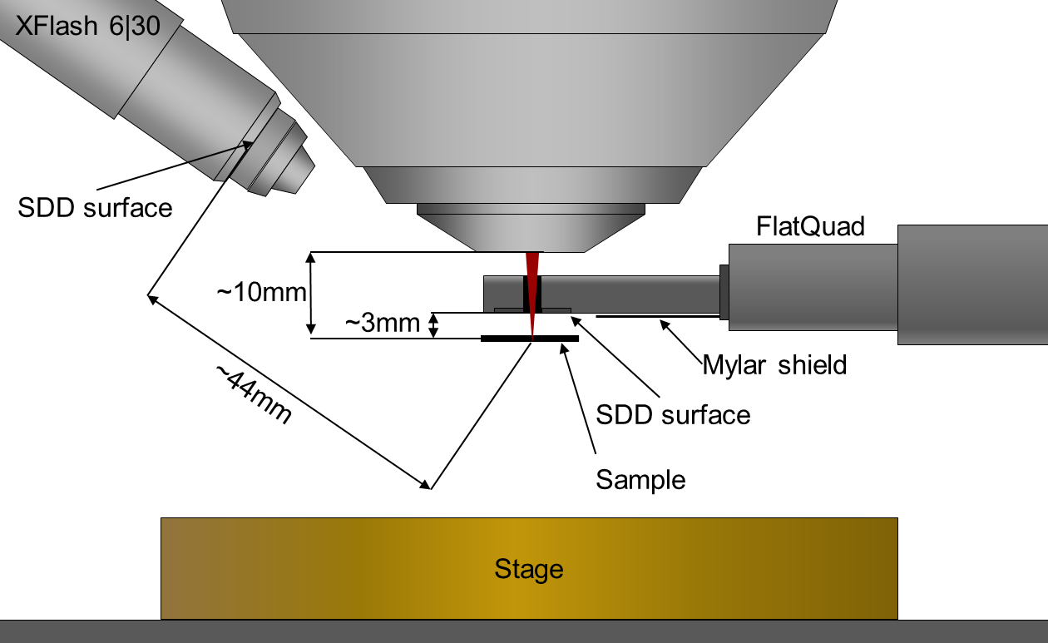

SI Figure 1. Schematic overview of EDS detector setup in the microscope.

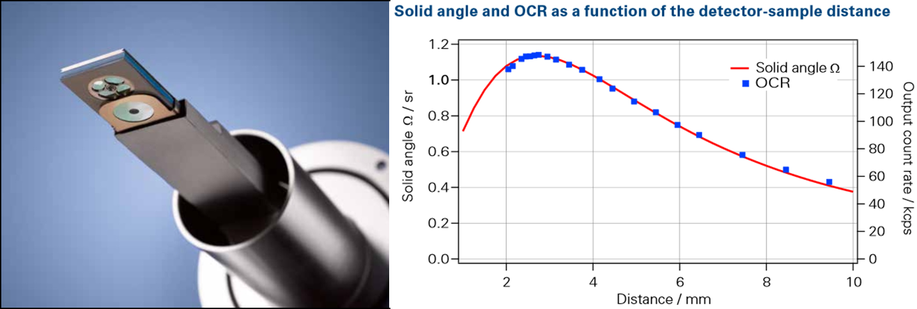

SI Figure 2. Left: Image of the bottom of the FlatQuad detector, showing the four SDD quadrants and the retractable Mylar shield. Right: Plot of the theoretically calculated solid angle of the FlatQuad detector and measured output count rate (OCR) against the sample-detector distance, showing the optimal count rate at a distance of approximately 3 mm. The solid angles were calculated according to Nestor J. Zaluzec, Detector Solid Angle Formulas for Use in EDS, Microsc. Microanal. 15 (2009), 93. Images reprinted with permission, from QUANTAX FlatQUAD Brochure, Bruker Nano GmbH, Berlin, Germany.

## Overview of Analyses

In this section an overview is presented of the different microscope software and hardware settings used when analyzing the NaCl sample. Furthermore the 9 different images used for feature analysis with the XFlash EDS detector are shown.

SI Table 1. Overview of microscope settings for the EDS feature analyses, using either the XFlash or FlatQuad EDS detectors.

|  |  |  |  |
| --- | --- | --- | --- |
| Image Number, # | Livetime, s | Acceleration Voltage, keV | Detector |
| 1 | 1 | 5 | XFlash |
| 2 | 5 | 5 | XFlash |
| 3 | 15 | 5 | XFlash |
| 4 | 1 | 10 | XFlash |
| 5 | 5 | 10 | XFlash |
| 6 | 15 | 10 | XFlash |
| 7 | 1 | 20 | XFlash |
| 8 | 5 | 20 | XFlash |
| 9 | 15 | 20 | XFlash |
| 10 | 1 | 5 | FlatQuad |
| 11 | 5 | 5 | FlatQuad |
| 12 | 15 | 5 | FlatQuad |
| 13 | 1 | 10 | FlatQuad |
| 14 | 5 | 10 | FlatQuad |
| 15 | 15 | 10 | FlatQuad |
| 16 | 1 | 20 | FlatQuad |
| 17 | 5 | 20 | FlatQuad |
| 18 | 15 | 20 | FlatQuad |

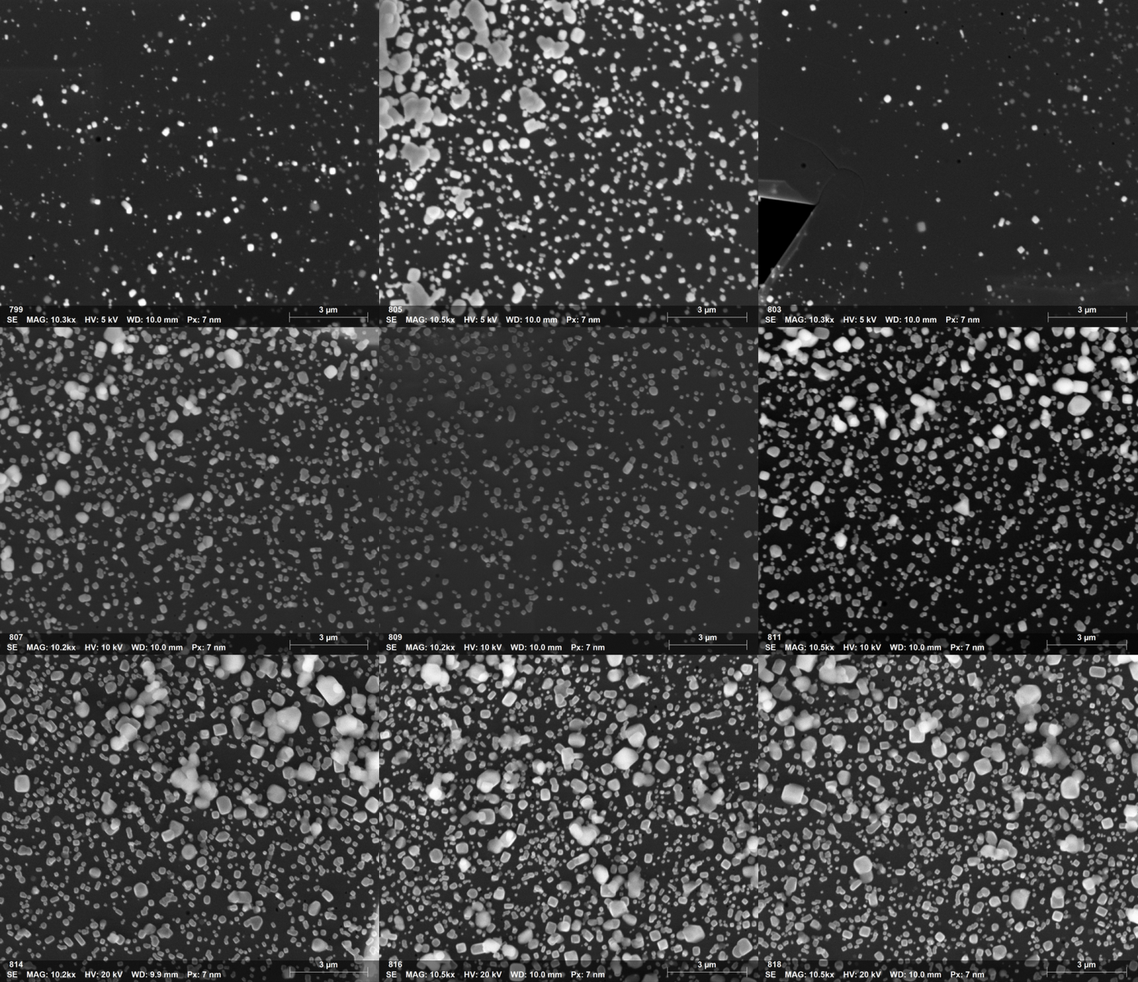

SI Figure 4. The 9 images used for feature analysis with the XFlash detector, with image 1 (from SI Table 1) in the upper left corner and image 9 in the lower right corner. For feature analysis the images were segmented with a global threshold and particles touching the edge of the image were discarded.

SI Table 2. Overview of acceleration voltages, livetimes, and particle sizes for the spectra in Figure 2 in the paper, using the two detectors. In addition, the total X-ray count in each spectrum from 100 eV to the incident beam energy is listed.

|  |  |  |  |  |  |
| --- | --- | --- | --- | --- | --- |
| Detector | Acceleration Voltage, keV | Livetime, s | | Deq, nm | Total X-ray count, # |
| FlatQuad | 5 | | 1 | 126 | 2.6 * 104 |
|  | 5 | | 1 | 563 | 13.8 * 104 |
|  | 10 | | 1 | 93 | 3.9 * 104 |
|  | 10 | | 1 | 502 | 16.4 * 104 |
|  | 20 | | 1 | 134 | 4.5 * 104 |
|  | 20 | | 1 | 505 | 19.0 * 104 |
|  | 5 | | 15 | 129 | 42.7 * 104 |
|  | 5 | | 15 | 490 | 96.9 * 104 |
|  | 10 | | 15 | 95 | 40.2 * 104 |
|  | 10 | | 15 | 444 | 112.0 * 104 |
|  | 20 | | 15 | 117 | 43.4 * 104 |
|  | 20 | | 15 | 418 | 95.4 * 104 |
| XFlash | 5 | | 1 | 94 | 8 |
|  | 5 | | 1 | 431 | 184 |
|  | 10 | | 1 | 134 | 238 |
|  | 10 | | 1 | 546 | 540 |
|  | 20 | | 1 | 101 | 11 |
|  | 20 | | 1 | 567 | 403 |
|  | 5 | | 15 | 108 | 659 |
|  | 5 | | 15 | 290 | 2193 |
|  | 10 | | 15 | 101 | 1504 |
|  | 10 | | 15 | 453 | 7515 |
|  | 20 | | 15 | 131 | 912 |
|  | 20 | | 15 | 515 | 5416 |

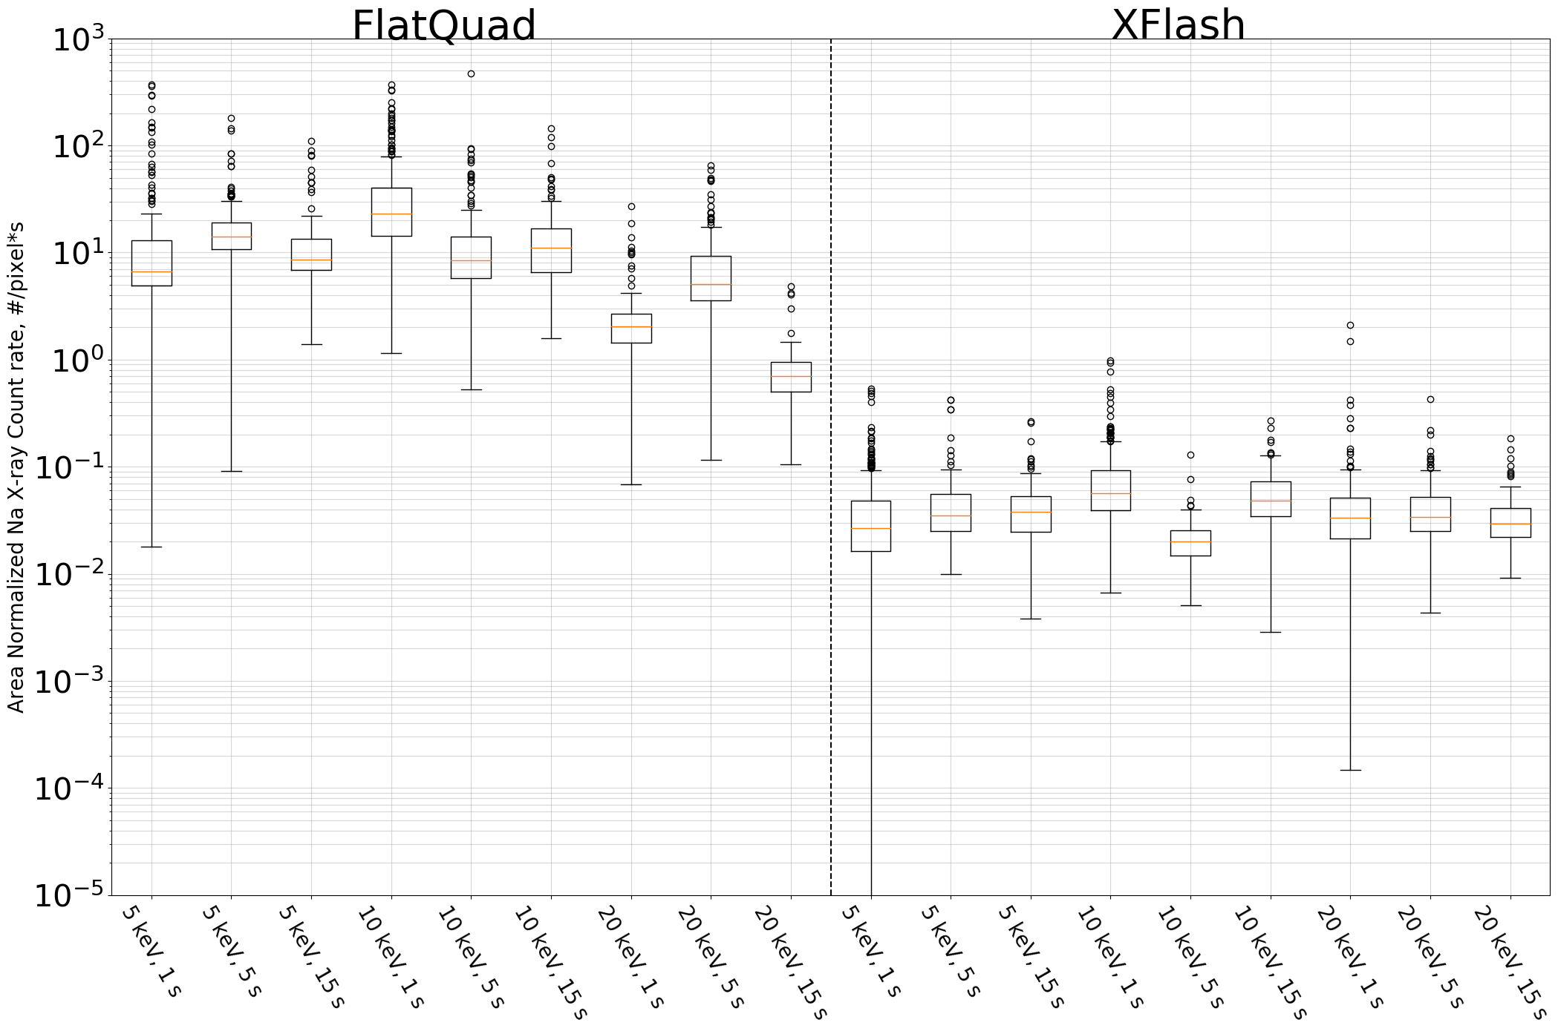

SI Figure 5. Boxplot showing the median and percentiles of the area and livetime normalized Na X-ray counts for all microscope settings with both detectors.

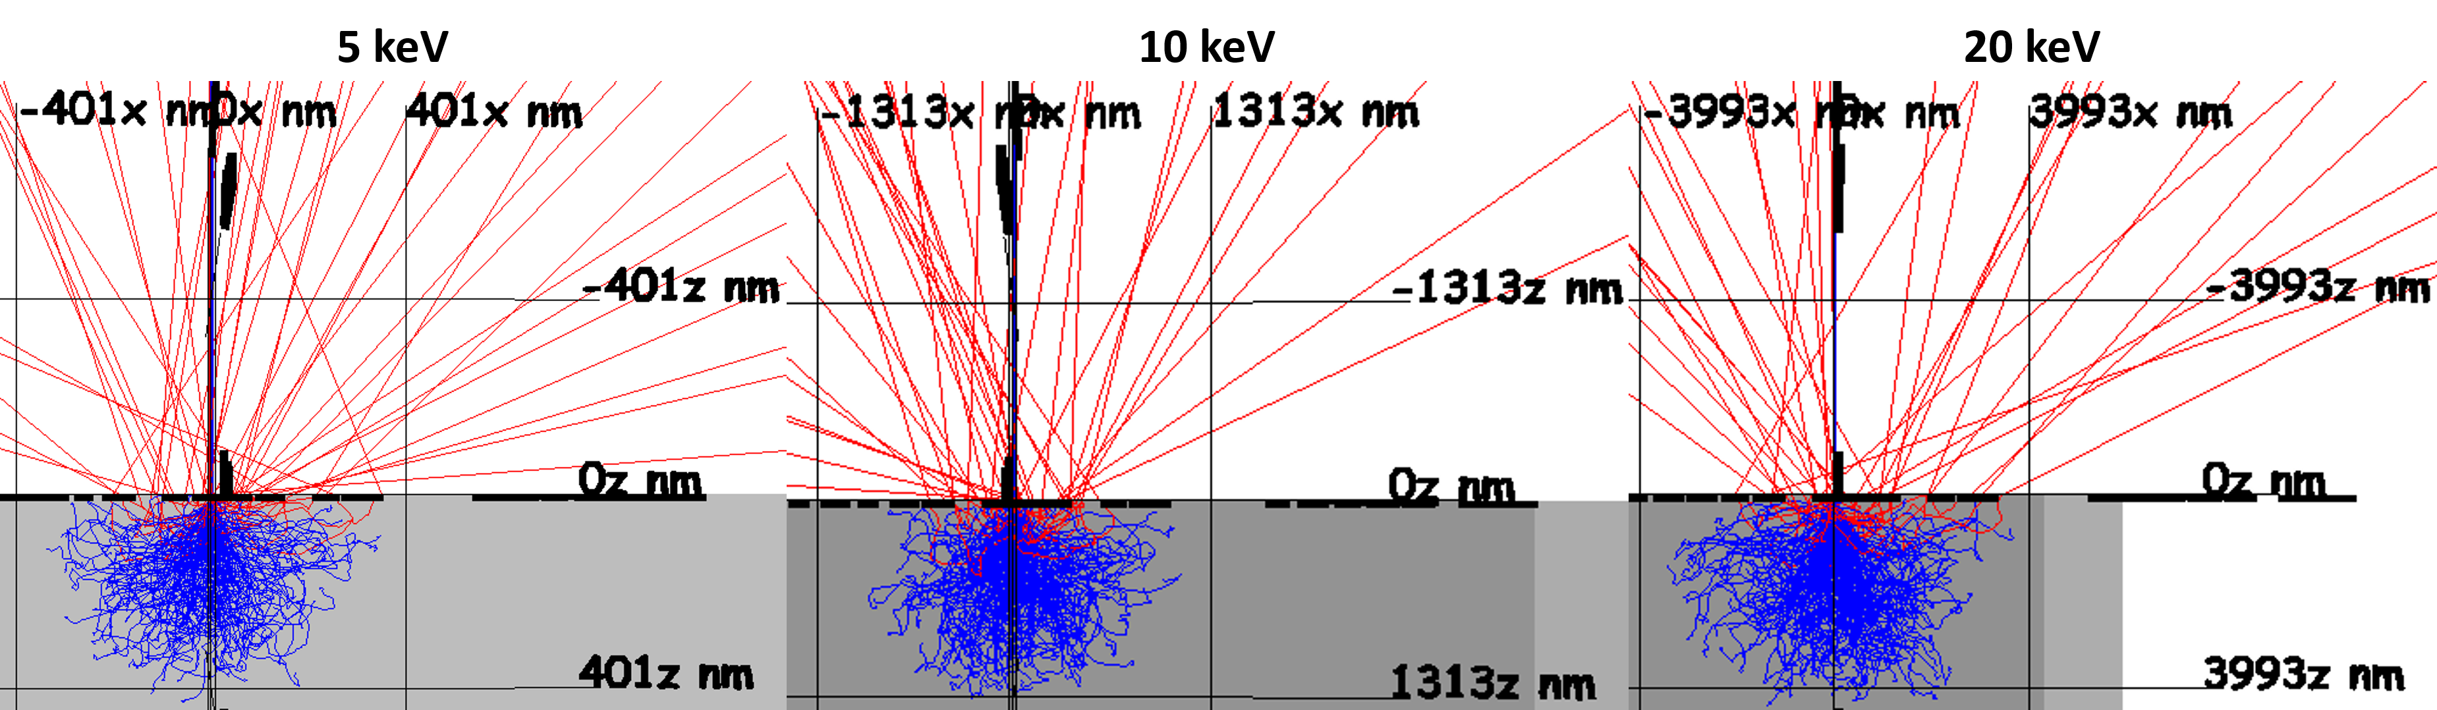

SI Figure 6. Images of simulated electron trajectories, performed with the Monte Carlo simulation software Casino v.3.3. Simulations were made for 10000 trajectories at 5 (left), 10 (middle), and 20 keV (right), with an incident beam diameter of 5 nm. The grey area represents a bulk NaCl crystal. The blue lines are electron trajectories occurring inside the bulk NaCl, while red lines correspond to backscattered electrons. It should be noted that the scales are different on the three simulations.

## Dwelltime and Livetime comparison

A comparison of beam exposure per particle for various particle sizes, when setting either a fixed livetime (feature analysis) or fixed dwelltime (mapping) is presented in the left plot of SI Figure 4. Alternatively, the beam exposure per pixel for various particle sizes, when setting either a fixed livetime or dwelltime is presented on the right.

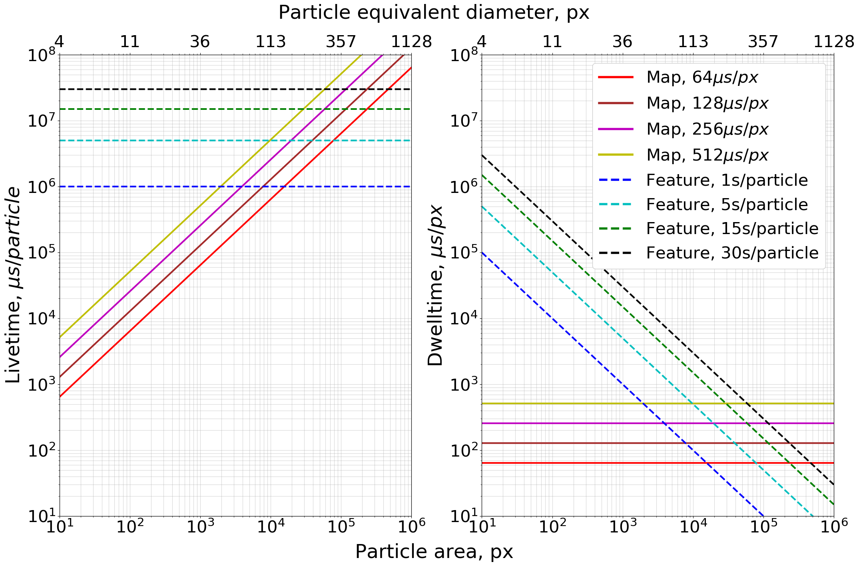

SI Figure 7. A comparison of livetimes (left) and dwelltimes (right) as a function of particle size, for different map and feature analysis settings. Particle sizes are displayed as area in pixels in the bottom x-axis and as particle equivalent circular diameter in pixels on the top x-axis.

From the livetime plot on the left it is seen that the beam exposure and therefore also X-ray yield for particles consisting of only a few pixels, is orders of magnitudes lower for maps compared to feature analysis with a fixed livetime. However, as the particle sizes increase the map will reach livetimes similar to those presented for the feature analysis. The particle sizes where maps yield more X-rays than feature analysis depend on the specific dwelltime and livetime settings, but typically lie in the range between particle areas of 2000 and 15000 pixels, corresponding to equivalent circular diameters of 50 and 140 pixels.

When comparing pixel dwelltimes on the right, it is similarly seen that the pixels in smaller particles are exposed to the electron beam for orders of magnitudes longer when using a fixed particle livetime compared to a fixed dwelltime. As a result, smaller particles are more vulnerable to beam damage for fixed livetimes, as they will be scanned more intensely during the analysis.

Overall there is a trade-off between X-ray yield and risk of beam damage, which should be carefully considered before setting up the analysis. If the composition of small particles is of interest the livetime and minimum X-ray yield settings available with feature analysis can be useful, though they bring an increased risk of beam damage. Alternatively, mapping can be performed at higher magnification, which will increase the number of pixels in the smaller particles, but will at the same time reduce the sample area covered by the analysis.

## Procedure for background subtraction

When analyzing samples by mapping, it is possible to remove the substrate X-ray contribution from individual particles by segmenting the image into two separate phases, namely a particles phase and a substrate phase, as seen in SI Figure 5. For SE images the particle phase will include all pixels with intensity above a given threshold, while the substrate phase will contain pixels below a given threshold.

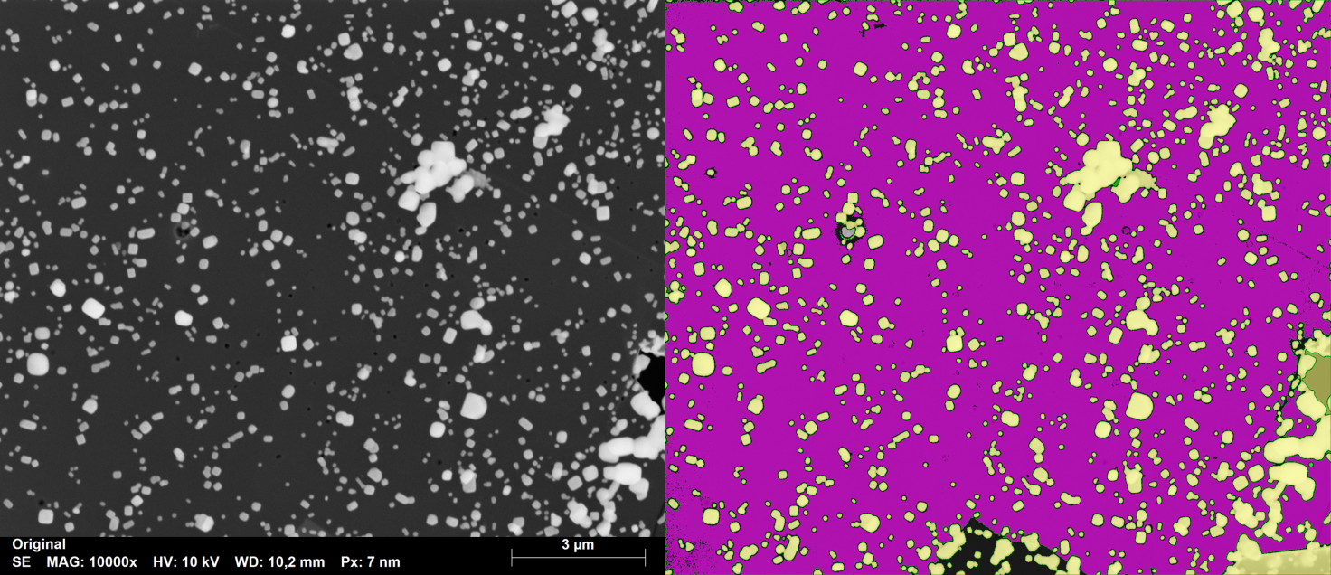

SI Figure 8. Left image shows an SE image of the NaCl sample. Right image shows the phase separated SE image, where pixels in the particle phase is yellow, while pixels in the substrate phase are magenta.

Since EDS results are available for all pixels, a spectrum corresponding to the entire substrate phase can be generated and element peak areas identified. By dividing the X-ray counts in each element peak by the area of the substrate phase in pixels, a mean substrate pixel spectrum can be obtained. If it is assumed that the substrate X-ray contribution per pixel is constant, despite it being underneath a particle, the contribution of the substrate can be removed from all particles. Here it is necessary first to scale the mean substrate pixel spectrum to match the size of the particle, by multiplying with the particle area in pixels before subtracting it from the particle spectrum. Once subtracted the X-ray counts can be converted to mass% or at% via Eq. (5). The python code for substrate subtraction used in this paper is available upon request. The code was written to function directly on results obtained with the ESPRIT Software.