Supplementary Information (SI)

Locally Condensed Water as a Solution for in-situ Wet Corrosion Electron Microscopy

Majid Ahmadi¹, Frans D. Tichelaar¹, Andreas Ihring², Michael Kunze³, Sophie Billat³, Zahra Kolahdouz Esfahani¹, Henny W. Zandbergen^{1*}
- Kavli Institute of Nanoscience, Faculty of Applied Sciences, Delft University of Technology, 2628 CJ Delft, The Netherlands
- Leibniz-IPHT, Leibniz Institut für Photonische Technologien e.V., Albert-Einstein-Str. 9, 07745 Jena, Germany
- HSG-IMIT-Institut für Mikro-und Informationstechnik der Hahn-Schickard-Gesellschaft e.V., Wilhelm-Schickard-Str. 10, 78052 Villingen-Schwenningen, Germany

TEM sample preparation
The TEM lamellae were prepared using a dual-beam Helios G4 CX focused ion beam-scanning electron microscope (FIB-SEM) equipped with EasyLiftTM nanomanipulator needle. To protect the area of interest, before preparation, a very thin layer of Pt was deposited using electron beam induced deposition (EBID) on the area of interest (AOI). Subsequently, a ~1.0 µm Pt protective layer was deposited using Ga ion beam induced deposition (IBID) on top of the e-beam Pt layer to protect the sample during TEM lamella preparation from gallium damages to the surface and Ga penetration into the TEM lamella. The chunks (with thickness of 1.0-1.5 µm) were prepared and picked up using the nanomanipulator needle from the bulk sample. Thinning the chunk to make electron transparent lamellae (with ~100nm thickness) was done while the chunk was attached to the nanomanipulator needle followed by low kV ion beam cleaning. The bulk sample and MEMS device were placed horizontally on the stage.
To transfer the lamella onto the MEMS device, the lamella needed to be parallel to the MEMS surface. By rotating the nanomanipulator needle and stage, the geometry of the lamella changes from vertical to horizontal (relative to the bulk-stage and MEMS device). The lamellae were attached to the MEMS device carefully using low kV ion beam (and mainly using e-beam mode) and detached from needle carefully to avoid damages on the SiN membrane.

Susceptibility of steel sample to the wet H₂S cracking
A commercial HCT980X uncoated steel grade from Tata Steel was additionally cold rolled in the laboratory to create samples of 0.2 mm thickness in order to make a microstructure sensitive for H₂S corrosion cracking failures. Later on, samples were cut and thinned down to ~100 µm followed by standard metallographic sample preparation methods including mechanical grinding with final polishing by 35µm to 1µm diamond pastes to minimize residual stresses due to sample preparation steps. Then, these samples were evaluated in a home-made setup to study their susceptibility to the wet H₂S corrosion cracking failures before preparing FIB samples (Fig. S1). This setup which was designed based on standard laboratory tests (ANSI/NACE MR0175/ISO15156) showed that these samples are highly sensitive to the wet H₂S cracking failures including both stress corrosion cracking (SSC) and hydrogen-induced cracking (HIC). The HIC blisters were visually observed in less than one hour exposure time to the corrosive saturated H₂S solution (See Fig. S3). The formation of iron sulfide corrosion products and consequently H-atoms penetration to the structure of steel, in this type of damages, were of particular interest and the damages were described according to the following anodic (1) and cathodic (2) reactions:

$$Fe ⟺{Fe}^{m+}{+ me}^{-} and {Fe}^{2+}+ S^{2-} ⟺FeS \left(s\right) \left(1\right)$$
$$H_{2}S ⟺2H^{+}+S^{2-} and { 2H}^{+}{+ 2e}^{-}⟺H^{ad}+ H^{ad} ⟺H_{2 \left(g\right)} (2)$$

Table S1. The measured d-spacing (from Fig. S5) and the lattice parameters of FeS (mackinawite) and iron (bcc and fcc) are listed (in Å).
Measured d-spacing in Fig. S5 (±%2) | FeS |  | Fe (bcc) |  | Fe (fcc)
d-Spacing | d-Spacing | (hkl) | d-Spacing | (hkl) | d-Spacing | (hkl)
5.08 | 5.03 | 001 | 2.02 | 110 | 2.07 | 111
3.00 | 2.97 | 101 | 1.43 | 200 | 1.79 | 200
2.29 | 2.31 | 111 | 1.17 | 211 | 1.27 | 220
1.81 | 1.84 | 200 | - | - | - | -
1.83 | 1.81 | 112 | - | - | - | -

Figure S1. Gas supply system (GSS) to purge a mixture of corrosive gas (O₂ or H₂S gas) and water vapor through the NR which is shown in Fig. 2. H₂S gas was used to do wet H₂S cracking on steel samples and oxygen gas is used to investigate the localized corrosion damages in AA2024-T3 alloys.

Figure S2. SEM images recorded using dual-beam Helios G4 CX (a) sample is titled to 52º to image blisters in better contrast (red arrows) on the surface of the corroded sample which was exposed to the H₂S saturated brine solution for about one hour, without applying any external stresses. (b) low depth surface cracks which can be pictured after milling the surface using a Ga ion beam. Two bright field TEM images (c) low magnification and (d) at higher magnification, recorded from a lamella prepared from sample shown in "a". Image in "d" recorded from red square area shown in "c". EDS analysis results in formation of porous iron sulfide layer on the surface of sample.

Figure S3. (a) SEM image taken from a TEC device after loading two TEM lamellae (white arrows) on the drilled holes (red arrows) made by a Ga ion beam. (b) Schematic of TEM lamella with a thinned area (e-transparent region) supported by the thick frame on its three sides. (c) as prepared TEM lamella on the SiN membrane with drilled hole (red square) on the membrane to make it electron transparent. Thinned area of this lamella (green area) is partially located on this hole (this sample is used for running experiments I-V, see Figs. 3-4).

Figure S4. (a) ADF STEM image from the HCT980X steel lamella after corrosion damages (experiment V, see Fig. 3g). (b-c) EDS analysis indicates intensive formation of iron sulfide products for sample. Spectrum extracted from area 1 and 2 result in the Fe:S ratio of 77:23 and 61:39 (%Wt:%Wt), respectively (scale bar is 1µm).

Figure S5. (a-b) Indexed SAED patterns recorded on areas A and B for experiment III (see Fig. 3e) show the complete formation of Mackinawite FeS on these two corroded regions, see also Table I.

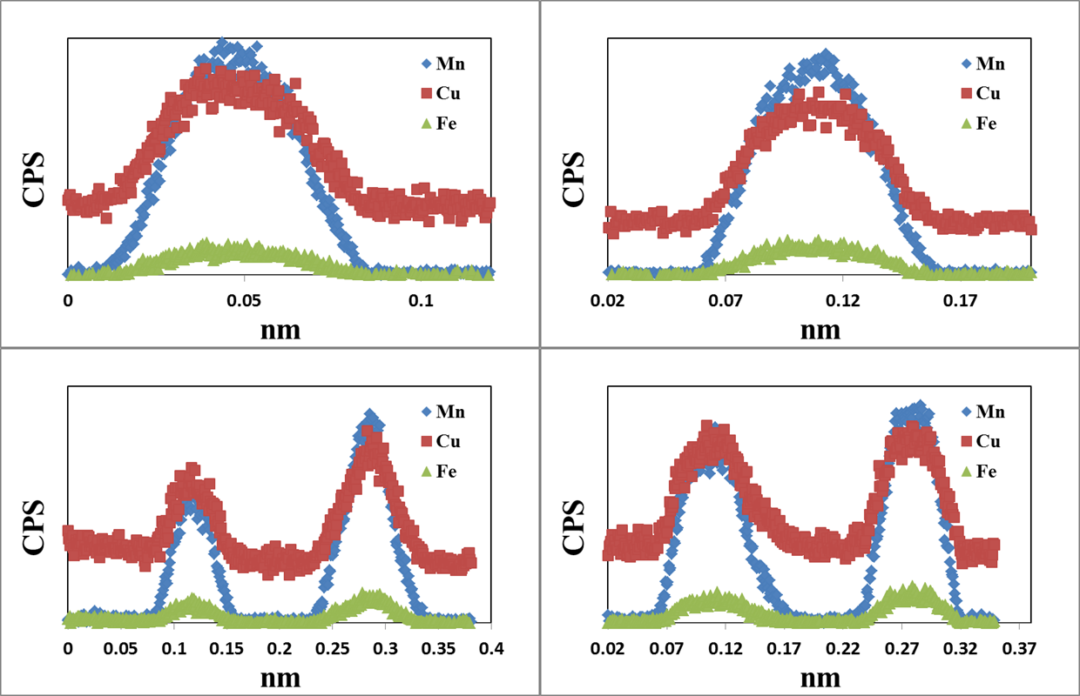
Figure S6. EDS line scans from four different α-phase IMPs in AA2024-T3 alloy used in this study before corrosion damages.

Majid.Ahmadi@Tudelft.nl, H.W.Zandbergen@Tudelft.nl
American National Standards Institute (ANSI), National Association of Corrosion Engineers (NACE), International Organization for Standardization (ISO)

