Structural properties and ELNES of polycrystalline and nanoporous Mg₃N₂
Olivia Wenzel¹*, Viktor Rein², Radian Popescu¹, Claus Feldmann², Dagmar Gerthsen¹

¹ Laboratory for Electron Microscopy (LEM), Karlsruhe Institute of Technology (KIT), Engesserstr. 7, 76131 Karlsruhe, Germany
² Institute for Inorganic Chemistry (AOC), Karlsruhe Institute of Technology (KIT), Engesserstr. 15, 76131 Karlsruhe, Germany
*corresponding author

– SUPPORTING INFORMATION –

Acknowledgment

The optical properties of nanoporous Mg₃N₂ were studied by Rein et al. 2018 (Rein et al., 2018). Results shown in Fig SI-1 and Fig SI-2 were published in the aforementioned work. We note that an additional description of the results of UV-Vis and PL spectroscopy can be found in the Supporting Information of Rein et al (2018).

Methods
Optical spectroscopy (UV-Vis spectroscopy) of the nanoporous Mg₃N₂ was performed and analyzed with a Varian Cary Scan 100 in reflectance with an Ulbricht sphere and BaSO₄ as reflectance standard. The optical band gap was derived by applying the Kubelka-Munk approach for direct band gaps by plotting the absorption (F(R))² as a function of the photon energy (Nobbs, 2008; Tauc, 1968).

Photoluminescence (PL) spectroscopy was recorded with a Horiba Jobin Yvon Spex Fluorolog 3 (Horiba Jobin Yvon, France) equipped with a 450 W Xe-lamp, double grating excitation and emission monochromator. First, the diffuse reflection of the sample was determined under excitation conditions (maximum of absorption at λ_{exc} = 363 nm). The emission was then measured at this excitation wavelength. All measurements were referenced to an empty cuvette. Corrections were made regarding the spectral power of the excitation source, the reflection behavior of the Ulbricht sphere, and sensitivity of the detector. To this concern, the FluorEssence Software Version 3.5.8.63 from Horiba Yvon Jobin GmbH was used.

Results
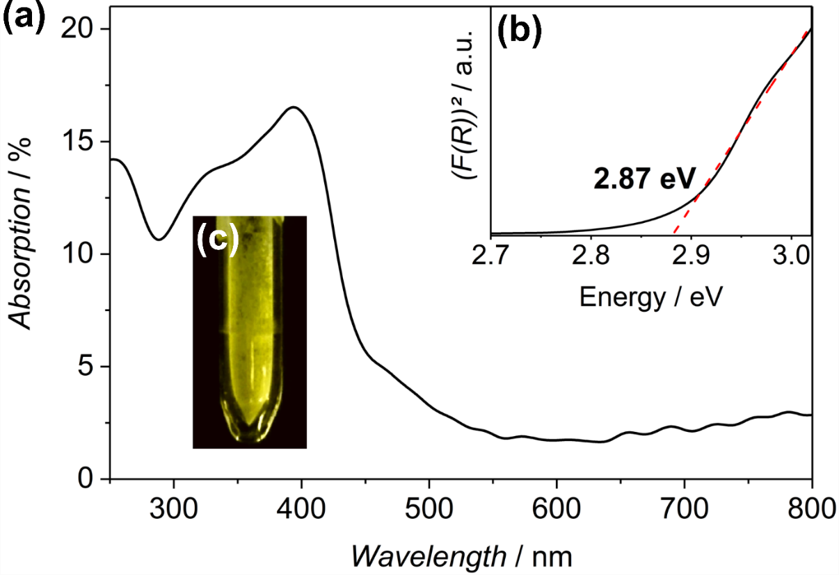
Figure SI-1 (a) UV-Vis spectrum of nanoporous Mg₃N₂ and (b) absorption plotted vs. photon energy (Tauc plot) for band gap determination. (c) shows a photograph of the sample under daylight illumination.
The UV-Vis spectrum in Fig. SI-1(a) shows a steep absorption increase between 400-450 nm in the violet-blue spectral range as reflected by the yellow color of the sample under daylight illumination (Fig. SI-1(c)). The band gap of the materials is 2.87 eV which was determined from the Tauc plot (Fig. SI-1(c)) in accordance with previously published measurements (Toyoura et al., 2005). The absorption in Fig SI-1(a) decreases towards larger wavelengths due to Urbach tailing. This is due to electron transitions into defect states between the valence and conduction band. Such Urbach tailing has been shown to correlate with structural disorder and increase with decreasing particle size (Melsheimer & Ziegler, 1985; Pejova, 2014). Defects states can also explain the non-linear absorption behavior and divergences from the linear fit marked with the dashed red line in the Tauc plot in Fig. Si-1(b).

1

Figure SI-2 Photoluminescence spectrum of nanoporous Mg₃N₂ dominated by deep red emission (600-800 nm) upon excitation at 366 nm. The insert shows the sample under daylight illumination.
The photoluminescence spectrum of a defect-free, bulk semiconductor material would be expected to show a narrow emission line at the band gap energy. This corresponds to 432 nm for Mg₃N₂ with a band gap energy of 2.87 eV (cf. Fig SI-1). The PL spectrum in Fig SI-2, however, shows a broad emission band in the red spectral region (650-850 nm) instead of the expected blue-violet emission. The broad emission band can be explained by defect states within the band gap. Excited electrons of the conduction band relax into these defect states from which the pass to the valence band. This causes a shift to lower energies, which corresponds to emission at longer wavelengths.

References

Melsheimer, J. & Ziegler, D. (1985). Band gap energy and Urbach tail studies of amorphous, partially crystalline and polycrystalline tin dioxide. Thin Solid Films 129, 35–47. https://www.sciencedirect.com/science/article/pii/0040609085900926 (Accessed September 23, 2019).
Nobbs, J. H. (2008). Kubelka-Munk Theory and the Prediction of Reflectance. Review of Progress in Coloration and Related Topics 15, 66–75. http://doi.wiley.com/10.1111/j.1478-4408.1985.tb03737.x (Accessed September 9, 2019).
Pejova, B. (2014). Optical absorption of semiconductor quantum dot solids. Semiconductor Science and Technology 29, 045007. http://stacks.iop.org/0268-1242/29/i=4/a=045007?key=crossref.7231eb4fe9d5316ade7a74dd57fc9049 (Accessed September 23, 2019).
Rein, V., Wenzel, O., Popescu, R., Gerthsen, D. & Feldmann, C. (2018). Liquid-ammonia synthesis of microporous Mg<inf>3</inf>N<inf>2</inf>showing intense red-light emission. Journal of Materials Chemistry C 6.
Tauc, J. (1968). Optical properties and electronic structure of amorphous Ge and Si. Materials Research Bulletin 3, 37–46. https://www.sciencedirect.com/science/article/pii/0025540868900238?via%3Dihub (Accessed September 9, 2019).
Toyoura, K., Goto, T., Hachiya, K. & Hagiwara, R. (2005). Structural and optical properties of magnesium nitride formed by a novel electrochemical process. Electrochimica Acta 51, 56–60. http://linkinghub.elsevier.com/retrieve/pii/S0013468605003415 (Accessed January 5, 2017).

