Supplementary Information

Approaches to Exploring Spatio-Temporal Surface Dynamics in Nanoparticles with In situ Transmission Electron Microscopy

Ethan L. Lawrence¹, Barnaby D.A. Levin¹, Benjamin K. Miller², Peter A. Crozier^{1*}

¹School for the Engineering of Matter, Transport and Energy, Arizona State University, Tempe, Arizona 85287, USA
²Gatan, Inc., Pleasanton, CA, USA.

*Corresponding author email: crozier@asu.edu
Supporting Video 1
A 200-frame, 0.5 second exposure time sequence of the CeO₂ lattice expansion and contraction event from Figure 2 is shown to highlight that the (100) surface atoms undergo a large lattice expansion and contraction. In this video, there are 200 frames and the video is displayed at 10 fps. Images are shown at 0.25 Å/pixel and with a 1-pixel radius Gaussian blur for visual clarity.

Supporting Video 2
A 200-frame, 0.5 second exposure time sequence of the CeO₂ atom migration from Figure 4 is shown to highlight that the surface atoms are migrating. In this video, there are 200 frames and the video is displayed at 10 fps. Images are shown at 0.25 Å/pixel and with a 1-pixel radius Gaussian blur for visual clarity, and are the inverted images used for analysis.

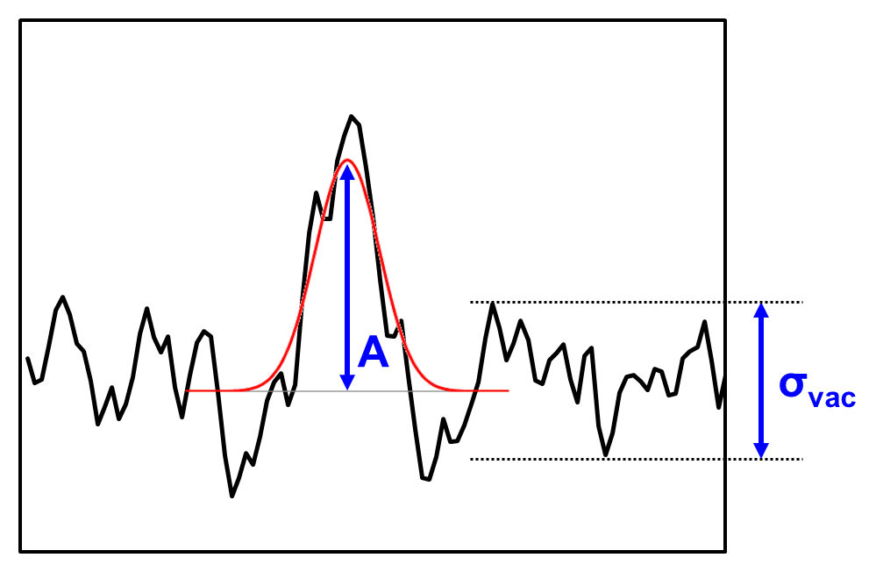
Figure S1. Gaussian fitting criteria. The black line is a representative 1D line scan of arbitrary intensity for a single 2.5 ms exposure image frame. For a Gaussian fit to be accepted, the amplitude (A) of the Gaussian fit (red curve) must be greater than 2σ_{vac} of the vacuum intensity value.
Table S1. Image Simulation Parameters.
Image Simulation Parameters
Accelerating Voltage | 300 kV
3rd order Spherical Aberration (C₃) | -0.03 mm
Chromatic Aberration (C_{c}) | 1 mm
Beam half convergence angle (α) | 0.15 mrad
Defocus (C₁) | -1 nm
Defocus spread (f) | 1 nm
2-fold (A₁) /3-fold (A₂) astigmatism | 0 nm
2nd order Coma (B₂) | 0 nm
5th order Spherical Aberration (C₅) | 3 mm
These parameters were chosen to provide a representative estimation of the experimental conditions; however, small deviations in these values do not significantly affect the results shown in Figure S2.

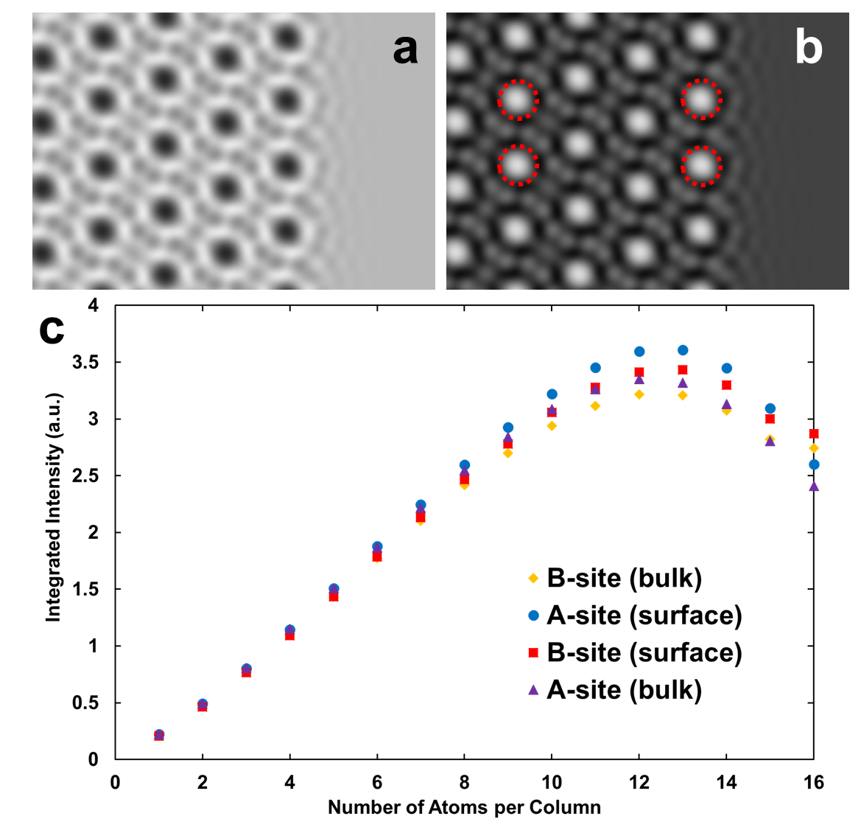
Figure S2. (a) Simulated image of (111) CeO₂ surface with 4-atom thickness. (b) Inverted image of the simulated image from (a). Red circles indicate the four different Ce atomic sites that were integrated at each thickness to form the look-up table. (c) Integrated Intensity look-up table: Calculated integrated intensities of Ce columns for different thicknesses at different atomic sites produced using a 2D Gaussian fitting procedure on simulated images. Intensity is observed to increase roughly linearly between 1 and 7 atoms in thickness, before peaking at 13 atoms in thickness and decreasing thereafter. Relatively little difference in intensity is observed between different sites (A and B, surface and bulk) until 10 atoms in thickness is reached. Intensity is given in arbitrary units.

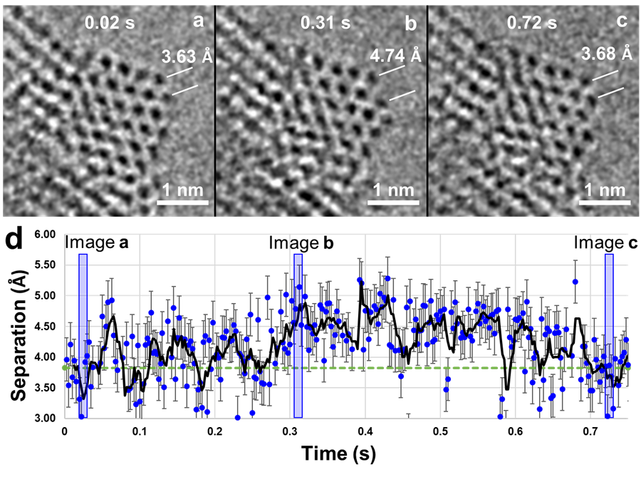
Figure S3. Local surface lattice expansion. a-c Image sequence of the CeO₂ nanoparticle with 12.5 ms exposure images (five spatially binned and Gaussian blurred 2.5 ms images summed together). Two Ce atomic columns on the (100) surface are separated by 3.63 Å at 0.02 s in a, expand to 4.74 Å after 0.31 s in b, and contract to 3.68 Å after 0.72 s in c. d Measurement of the separation of the two marked surface Ce atomic column over 0.5 s image sequence. The blue points indicate measurements from each frame, the solid black line is a 5-frame moving average trendline, and the dashed green line indicates the bulk-terminated (100) separation distance (3.825 Å). Error bars are 0.35 Å. The semitransparent blue windows represent the five image frames that were summed together to create a-c.

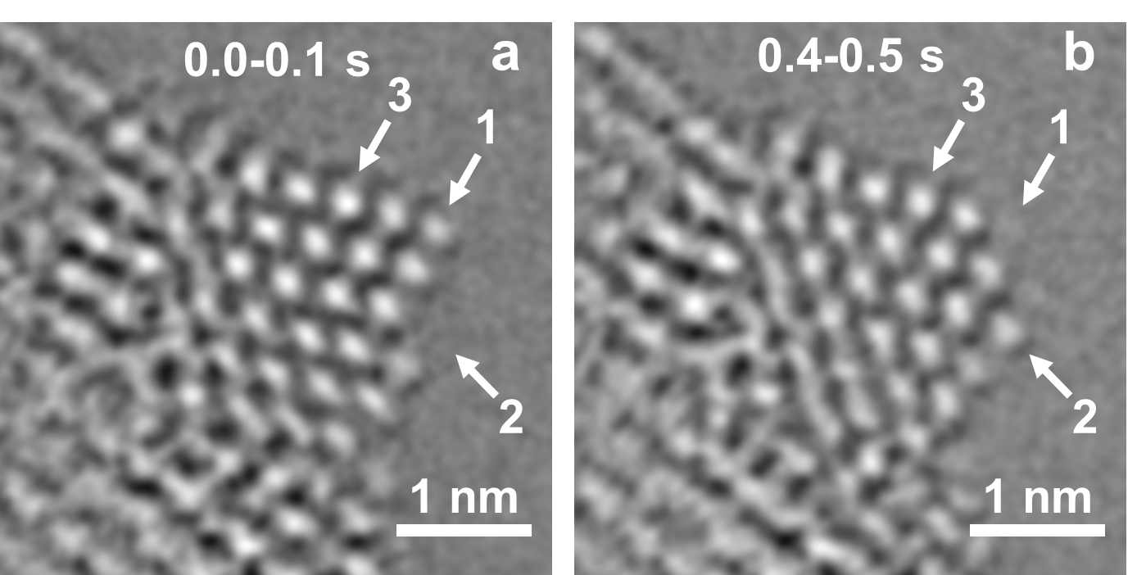
Figure S4. Atom migration. a 0.1 s exposure image (40 inverted 2.5 ms images summed together). As indicated by the “1”, “2”, and “3” labels, atoms are present at “1” and “3” but absent at “2”. b 0.1 s exposure image (40 inverted 2.5 ms images summed together). As indicated by the labels, atoms are present at “2” and “3” but are absent at “1”. Atoms have migrated during the 0.3 s between the two images.

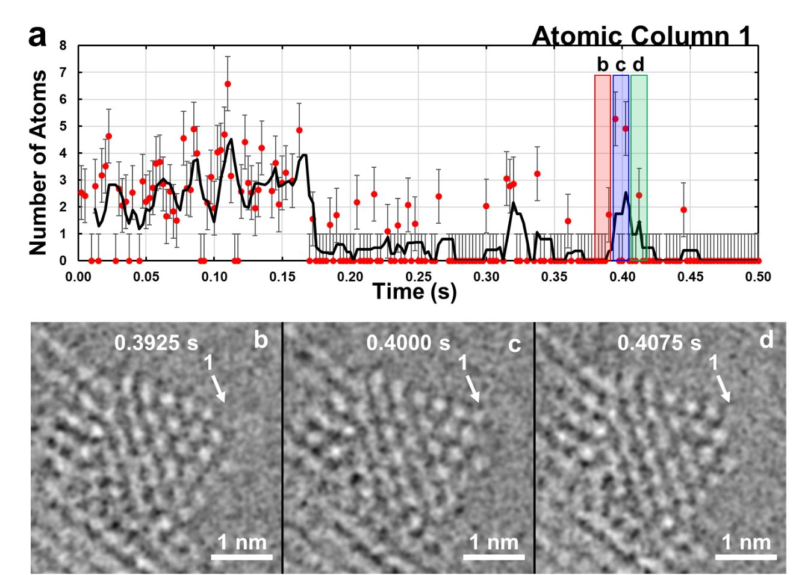
Figure S5. Fluctuation in atomic column occupancy. a number of atoms in atomic column 1. The points indicate measurements from each frame and the solid black line is a 5-frame moving average trendline. The semitransparent red, blue, and green windows represent the three image frames that were summed together to create b-d, respectively. Error bars are ±1 atom. b-d Image sequence of the CeO₂ nanoparticle with 7.5 ms exposure images of the inverted images used for MATLAB analysis (three inverted 2.5 ms images summed together). Atoms are not present in atomic column 1 in a, appear in b, and are absent in c.

