Supporting Materials

Carrier-Transport Study of Gallium Arsenide Hillock Defects

Chuanxiao Xiao,^{1*} Chun-Sheng Jiang,¹ Jun Liu,¹ Andrew Norman,¹ John Moseley,¹ Kevin Schulte,¹ Aaron J. Ptak,¹ Brian Gorman,² Mowafak Al-Jassim,¹ Nancy M. Haegel,¹ and Helio Moutinho¹

¹ National Renewable Energy Laboratory, Golden, CO 80401
² Colorado School of Mines, Golden, CO 80401
* Correspondence should be addressed to: Chuanxiao.Xiao@nrel.gov

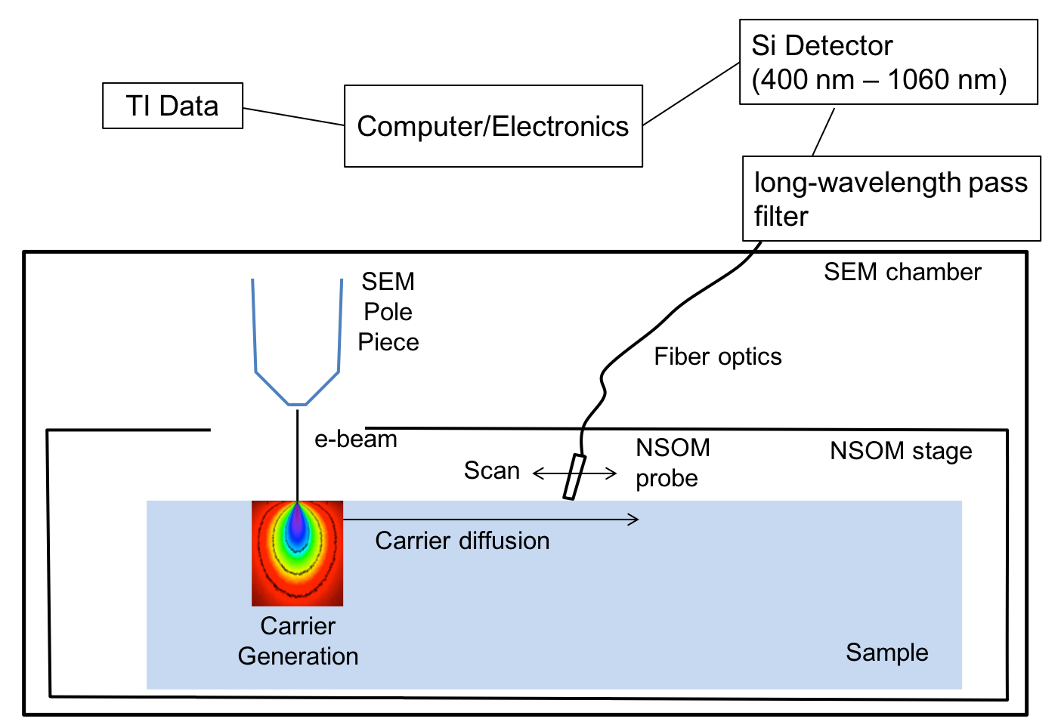
Fig. S1. Schematic of TI experimental setup.

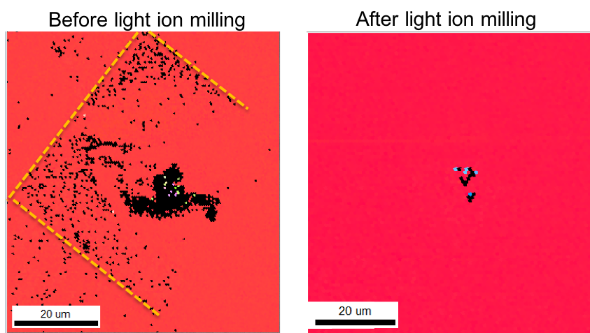
Fig. S2 EBSD images before and after the light ion milling. The yellow dash lines clearly indicate contamination on sample surface and interference with the EBSD signal. Before the light ion milling, the EBSD image was obvious affected by the previous TI scans in rectangle shape.

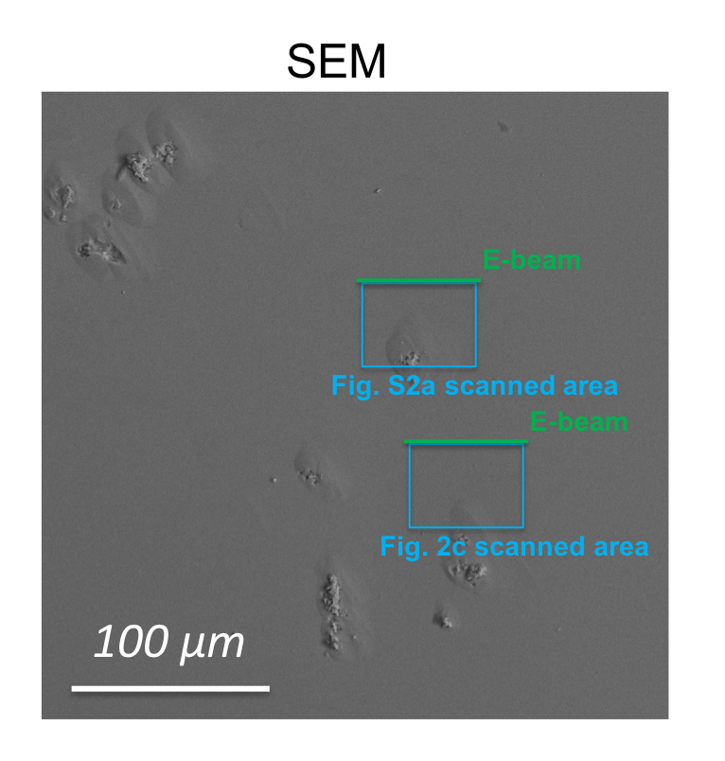
Fig. S3. Schematic of TI-scanned locations in relation to the hillocks.

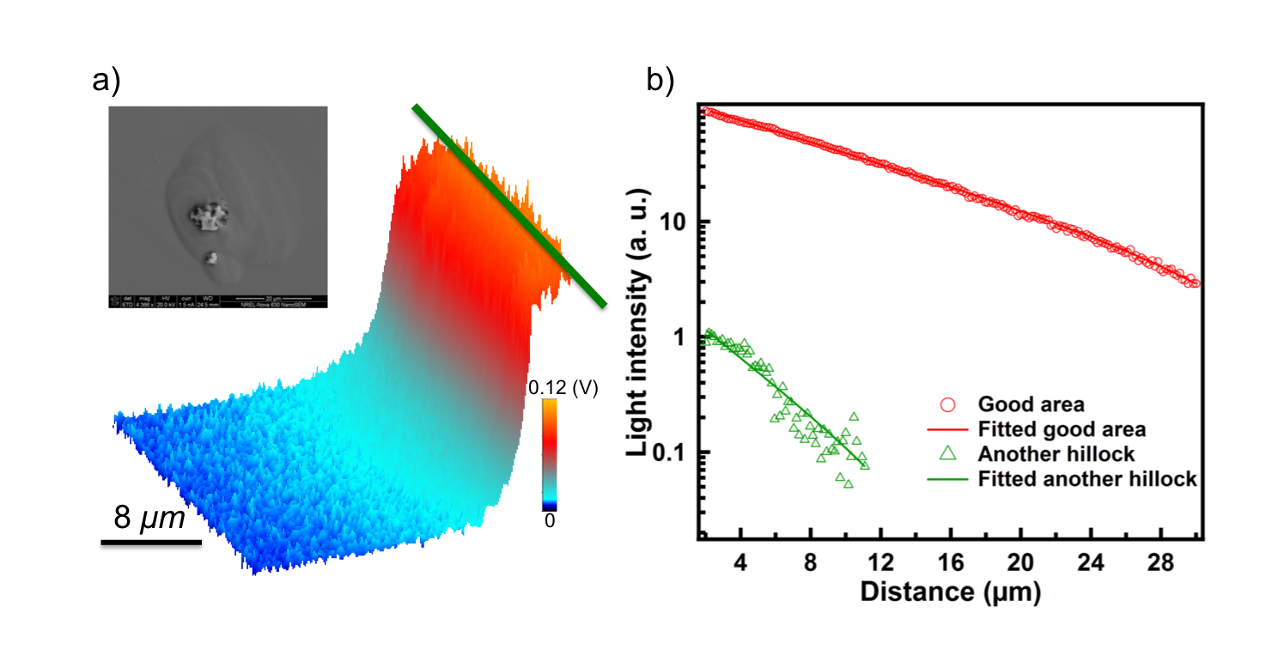
Fig. S4. a) TI mapping of another hillock area; the green line indicates the electron-beam generation, and the inset is a higher-magnification SEM image of the hillock; b) solid lines are the Matlab-fitted decay of the two TI signals in a) and reference good area in Fig. 2b; the points are raw data.

We fixed the electron beam in a spot mode and did TI on a “hillock-free area” and “hillock area”; the light intensity of the “hillock-free area” is 20 times stronger. The dark spot at the lower edge is due to probe shading of the electron beam, and we use filters to screen out the luminescence from the NSOM probe. In this case, the solution of the diffusion equation is a Bessel function (point source in quasi 2-D film). We fitted the diffusion length using the equation
$$y=k∙Besselk \left(0,\frac{x}{L_{d}}\right)+b ,$$
where Besselk is a modified Bessel function of second kind, and k, L_{d}, and b are fitting parameters: k is the scaling magnitude, L_{d} is the effective diffusion length, and b is the offset of background. The “hillock-free area” has a long diffusion length of 9.8 μm, whereas the hillock area has a diffusion length of 4.2 μm. The trend is consistent to what we reported with the e-beam in the linescan mode.

Fig. S5. TI results with electron beam at spot mode. A) A good area without any visible defects, showing a long decay; the dark region means tip shading; b) A hillock area; c) Line profiles and fitted diffusion lengths of good and hillock area.

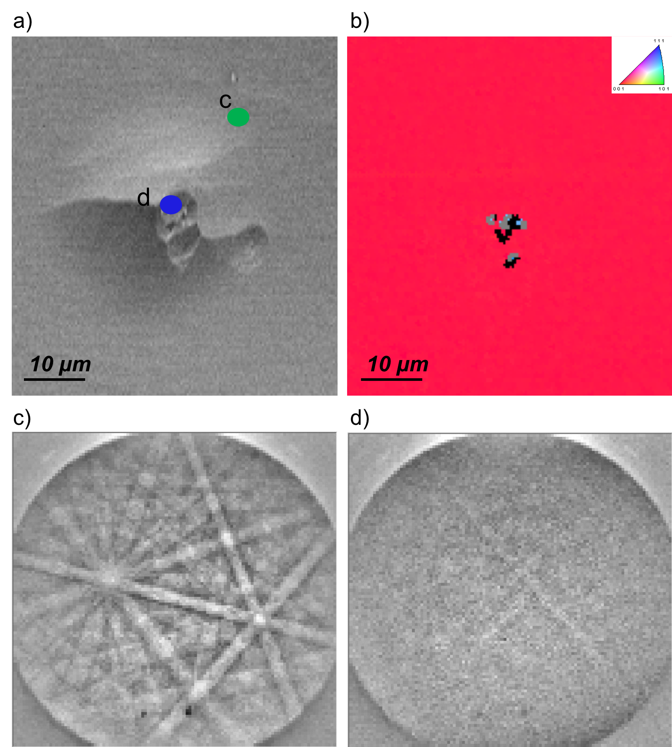
Fig. S6. a) SEM image of another hillock; b) EBSD inverse pole-figure image; c) Kikuchi pattern on the spot marked by green dot in a); d) Kikuchi pattern on the spot marked by blue dot in a).

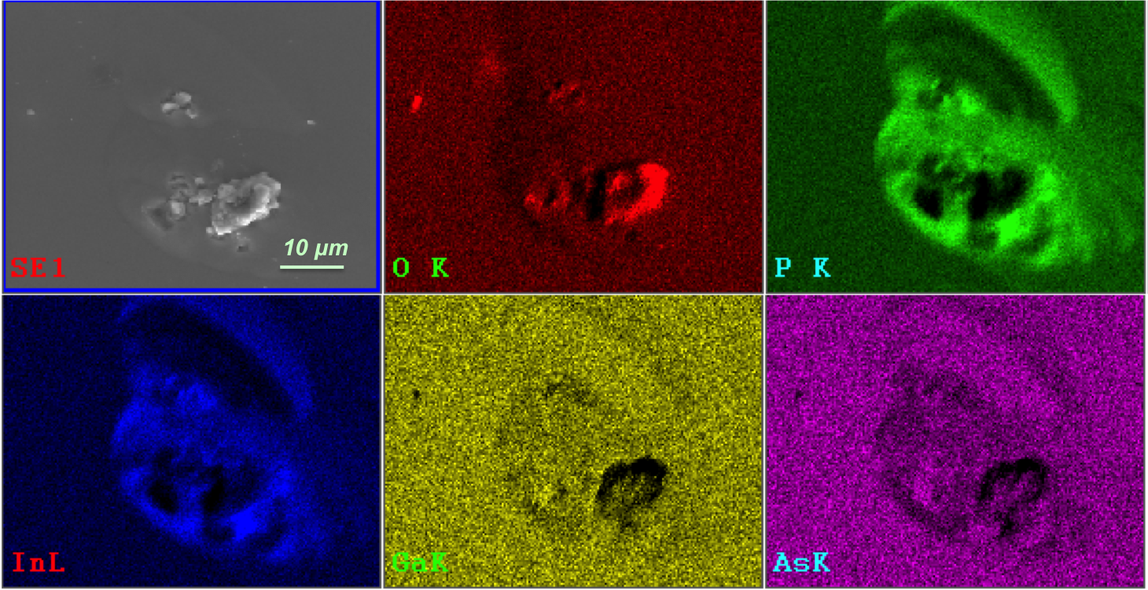
Fig. S7. EDS mapping around the hillock area studied by TI.

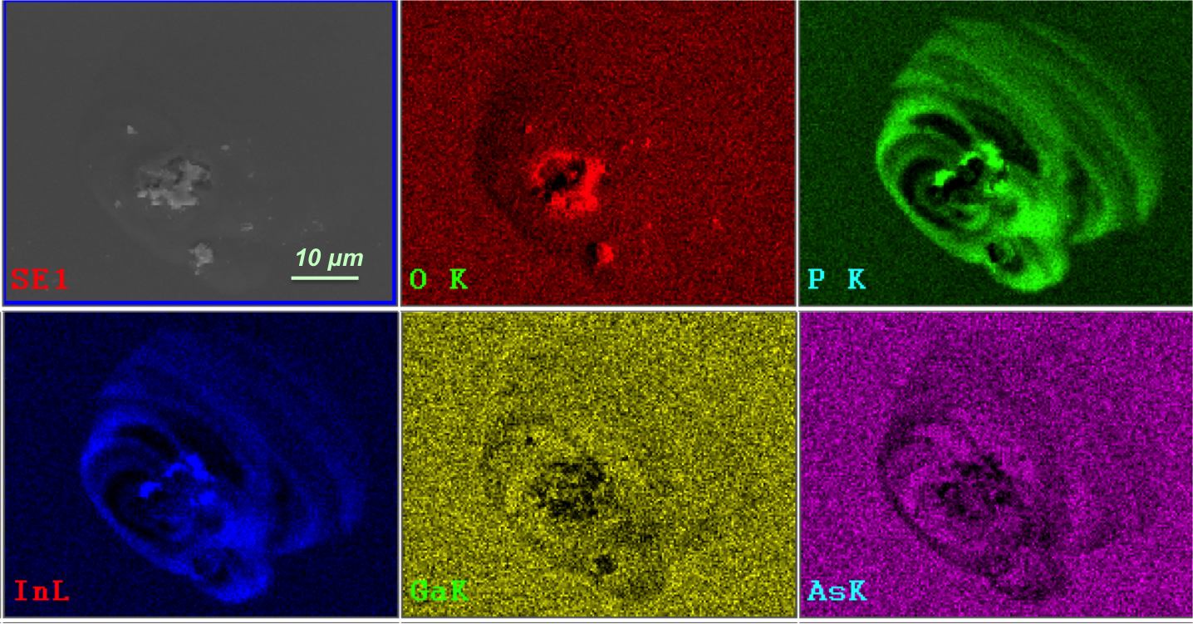
Fig. S8. EDS mapping around another hillock area studied by TI.

