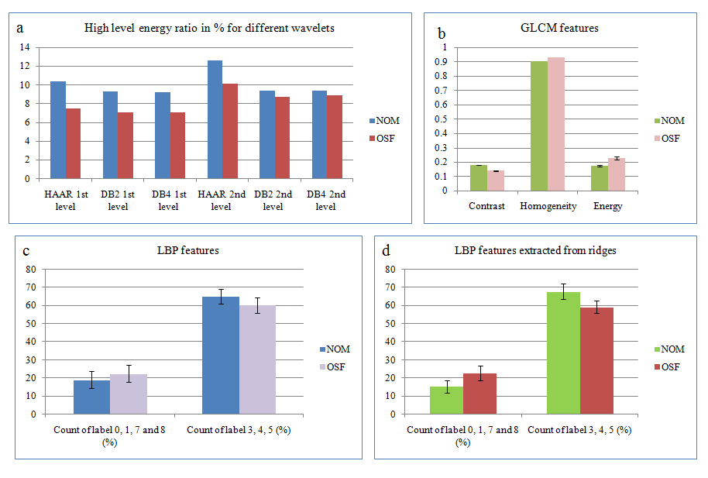

Supplementary Fig 1: Bar charts showing mean values ± standard deviation statistically significant epithelium features extracted from SEM images: (a) DWT (b) GLCM (c) LBP (d) LBP from nano-ridges

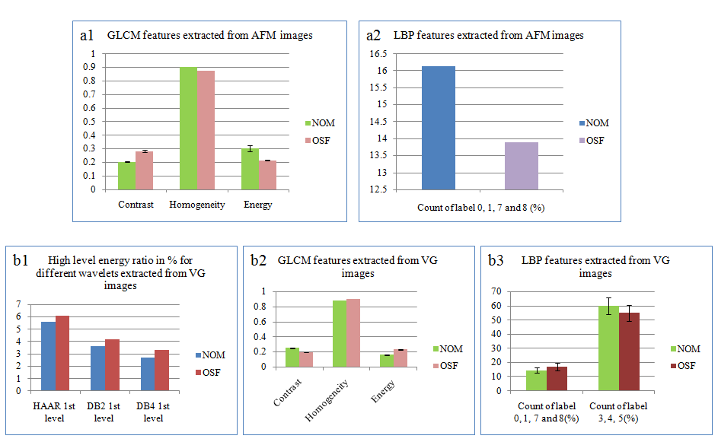

Supplementary Fig 2: Bar charts showing mean values ± standard deviation of statistically significant sub-epithelium features : (a1) GLCM and (a2) LBP from AFM; (b1) DWT, (b2) GLCM and (b3) LBP from VG images
Supplementary Table 1: Nano vs micro textural attributes of sub-epithelial connective tissue

Feature |  | NOM |  | OSF
 |  | Micro level (VG) | Nano level (AFM) | Micro level (VG) | Nano level (AFM)
Contrast |  | 0.251 | 0.204 | 0.193 | 0.283
Homogeneity |  | 0.879 | 0.906 | 0.904 | 0.875
Energy |  | 0.158 | 0.303 | 0.231 | 0.216
Count of label 0, 1, 7 and 8 |  | 14.6 | 16.13 | 17 | 13.88

