Exploring the Parameter Space of Point Spread Function Determination for the Scanning Electron Microscope – Part I: Effect on the Point Spread Function
Mandy C. Nevins¹, Kathryn Quoi², Richard K. Hailstone¹ and Eric Lifshin²
- Rochester Institute of Technology, Rochester, NY
- SUNY Polytechnic Institute, Albany, NY

Corresponding Author: Richard Hailstone
Telephone: +1 (585) 475-5988
Email: hailstone@cis.rit.edu

Supplementary Materials

S1. ImageJ Measurements of Particle Size
This section (S1) contains a table and figures that were referenced in the Materials and Methods subsection Particle Sizing and Profiling in the SEM in the article.
The following measurements were performed during the initial stages of this experiment. Only the plasma-cleaned particles on Kapton were measured (June 2018 data). The particles were re-cleaned and reimaged for the data presented in the article (January 2019 data).
Table S1-1. Particle Diameters for BSE and SE at Multiple Voltages (measured in ImageJ).
Voltage (kV) | Signal Type | Particle Diameter (nm) | COV (%) | Number of Particles Measured | Difference of SEª and BSE Mean Sizes (nm) | SE size^{b}  BSE size
20 | BSE | 24.6 ± 1.8 | 8 | 100 | 2.7 | 1.11
20 | SE | 27.3 ± 2.0 | 7 | 100 | 2.7 | 1.11
10 | BSE | 25.8 ± 2.0 | 8 | 100 | 2.3 | 1.09
10 | SE | 28.1 ± 2.6 | 8 | 100 | 2.3 | 1.09
5 | BSE | 25.6 ± 2.4 | 9 | 100 | 1.5 | 1.06
5 | SE | 27.1 ± 2.1 | 8 | 100 | 1.5 | 1.06
2 | BSE^{c} | --- | --- | --- | --- | ---
2 | SE | 28.0 ± 2.6 | 9 | 100 | --- | ---
ªThe mean SE particle size is consistently larger than the mean BSE particle size.
^{b}SE size/BSE column shows the size ratio between the two signal types.
^{c}2kV BSE was not measured due to poor contrast.
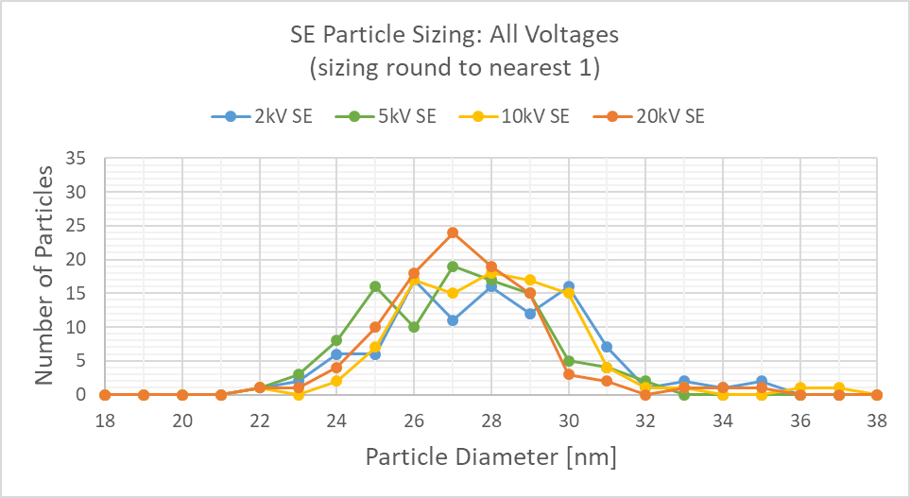
Figure S1-1. Histogram of SE Particle Diameters Measured in ImageJ. When compared to BSE in Figure S1-2, notice that the SE distributions are shifted to the right, indicating larger SE diameters. Size measurements were rounded to the nearest 1nm.

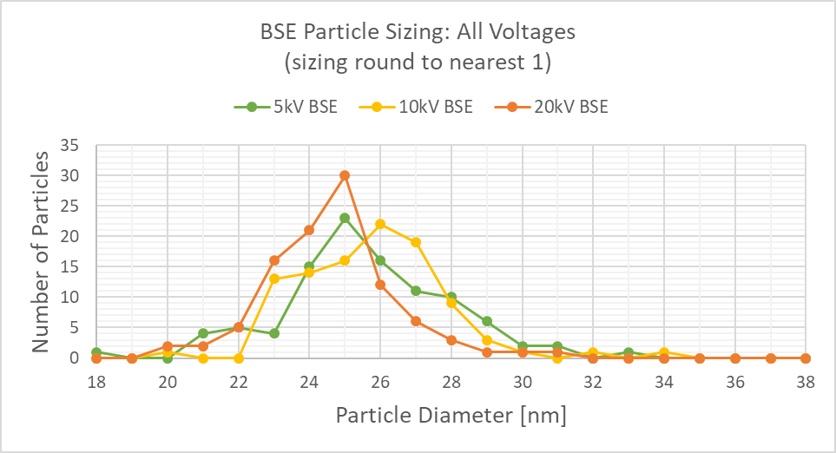
Figure S1-2. Histogram of BSE Particle Diameters Measured in ImageJ. When compared to SE in Figure S1-1, notice that the BSE distributions are shifted to the left, indicating smaller BSE diameters. Size measurements were rounded to the nearest 1nm.
S2. ISO Measurements of Particle Size
This section (S2) contains figures that were referenced in the Materials and Methods subsection Particle Sizing and Profiling in the SEM in the article.
The following measurements were performed during the initial stages of this experiment. Only the plasma-cleaned particles on Kapton were measured (June 2018 data). The particles were re-cleaned and reimaged for the data presented in the article (January 2019 data).
Measurements were made by following the protocol given in ISO 13322-1:2014 – Particle size analysis – Image analysis methods – Part 1: Static image analysis methods.
For 20kV, 10kV, and 5kV (Figs. S2-1, S2-2, and S2-3, respectively), the BSE and SE distributions were proven to have different means (µ_{BSE} ≠ µ_{SE}) using two-tailed t-tests (α = 0.001). The problem with this analysis is that the particle size distributions would shift depending on the intensity threshold chosen during the sizing process. This became a problem when comparing the particle sizes between grid and Kapton (Fig. S2-4). The mean sizes between grid and Kaptons particles would show a statistically significant difference for certain thresholds and not others. For this reason, particle profiling was used as a direct comparison of the original image data and is possibly more meaningful than reporting measured particle sizes.

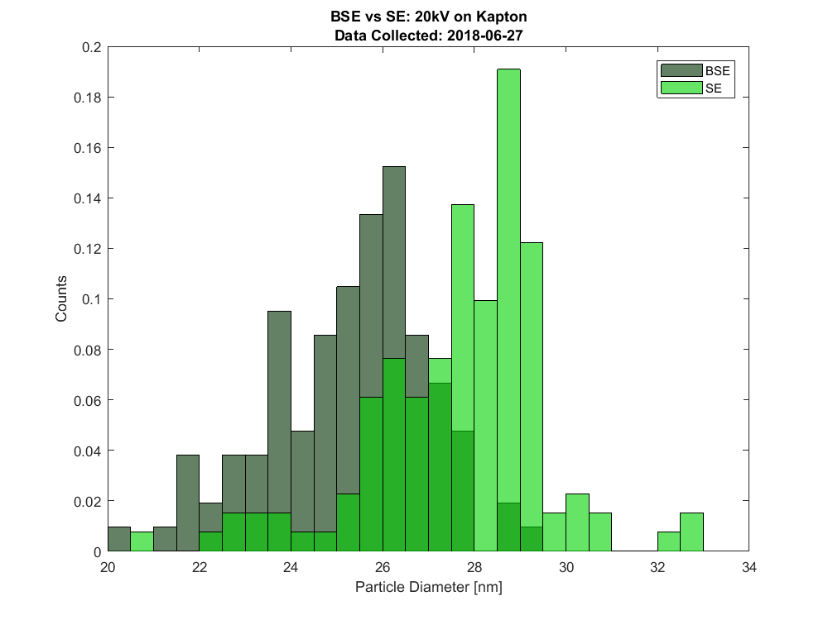
Figure S2-1. Histogram of BSE and SE Particles at 20kV Measured According to ISO Protocol. Histogram bin sizes = 0.5nm.

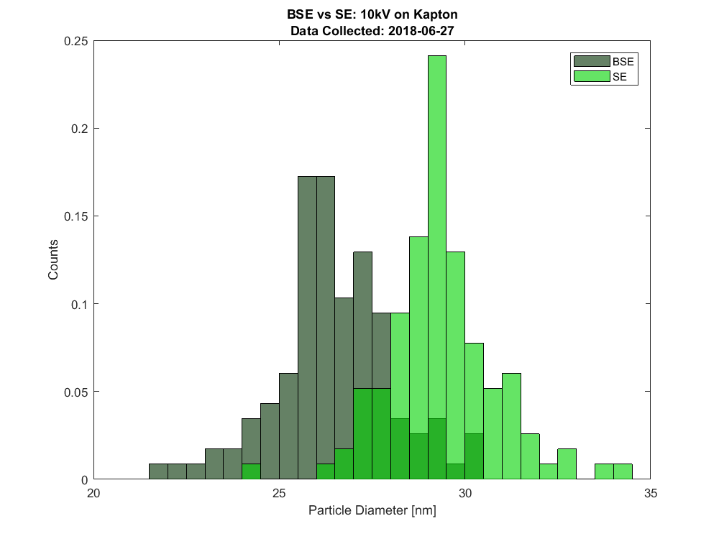
Figure S2-2. Histogram of BSE and SE Particles at 10kV Measured According to ISO Protocol. Histogram bin sizes = 0.5nm.

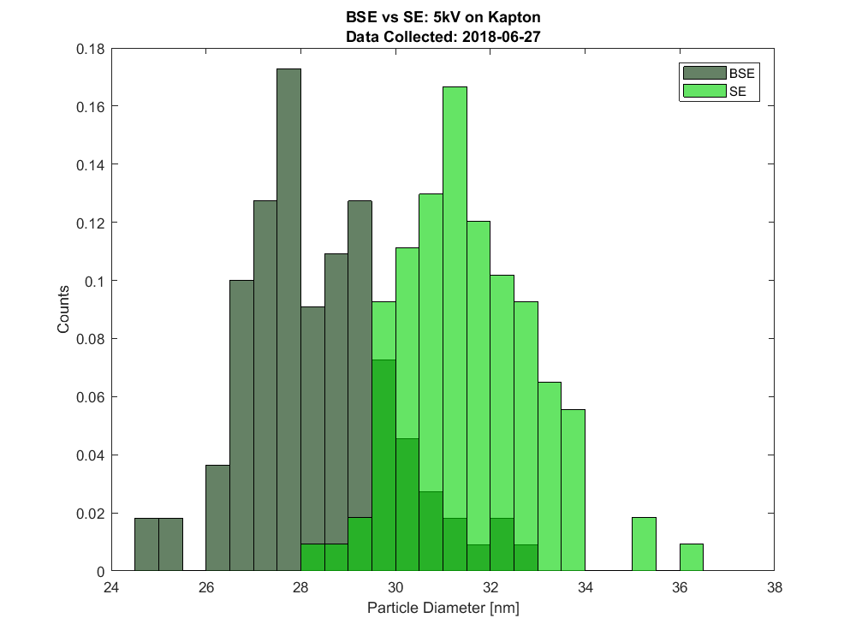
Figure S2-3. Histogram of BSE and SE Particles at 5kV Measured According to ISO Protocol. Histogram bin sizes = 0.5nm.
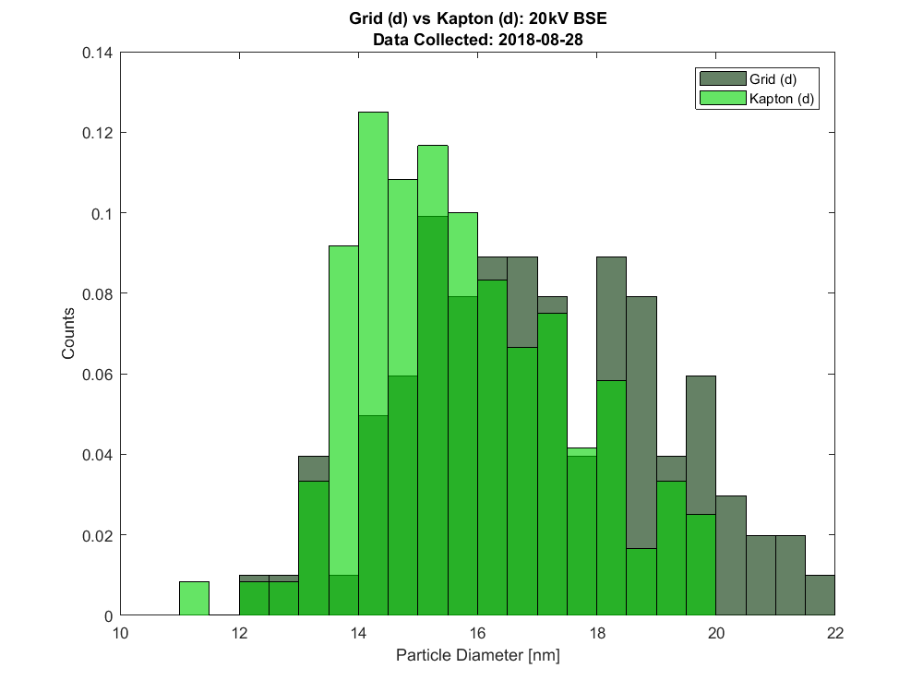
Figure S2-4. Histogram of Grid and Kapton BSE Particle Sizes at 20kV Measured According to ISO Protocol. By slight changes to threshold selection, the particle size distributions would shift enough to change the result of the two-tailed t-test regarding their mean size (µ_{BSE} ≠ µ_{SE}, α = 0.001). Histogram bin sizes = 0.5nm.

S3. PSF FWHMs for a Range of K and Background Correction (all tested voltage-signal-support cases)
These plots (S3) go along with the Results and Discussion subsection K and Background Correction and were made in the same manner as Figure 7 (in the article).
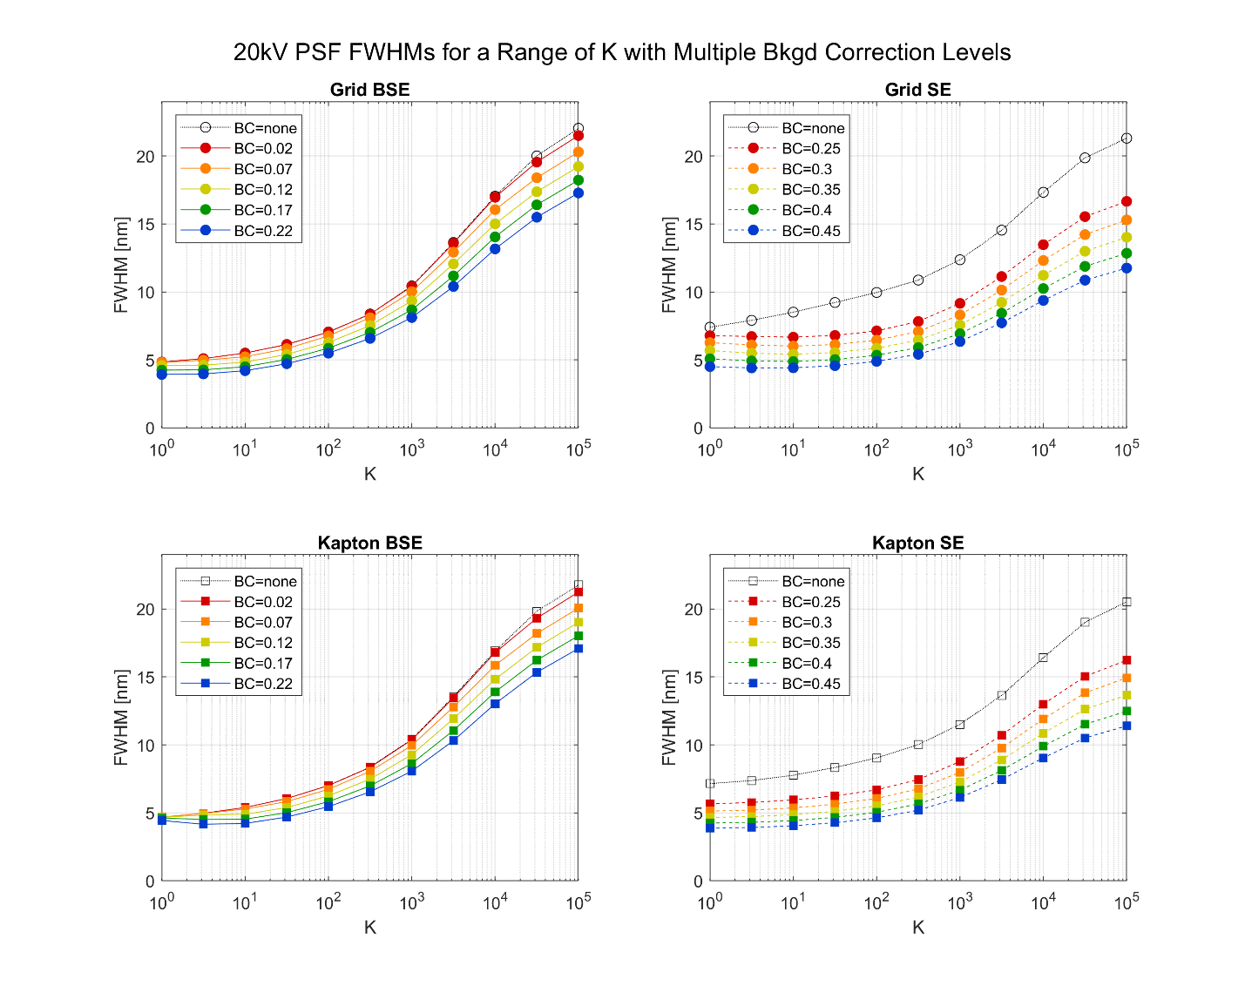
Figure S3-1. 20kV PSF FWHMs over a Range of K and Background Correction. The best representations of the PSFs were estimated at: Grid BSE, K = 3, background correction (“BC”) = 0.12; Grid SE, K = 100, BC = 0.35; Kapton BSE, K = 31, BC = 0.12; Kapton SE, K = 31, BC = 0.35. Note that the vertical axis is linear, while the horizontal axis is logarithmic.

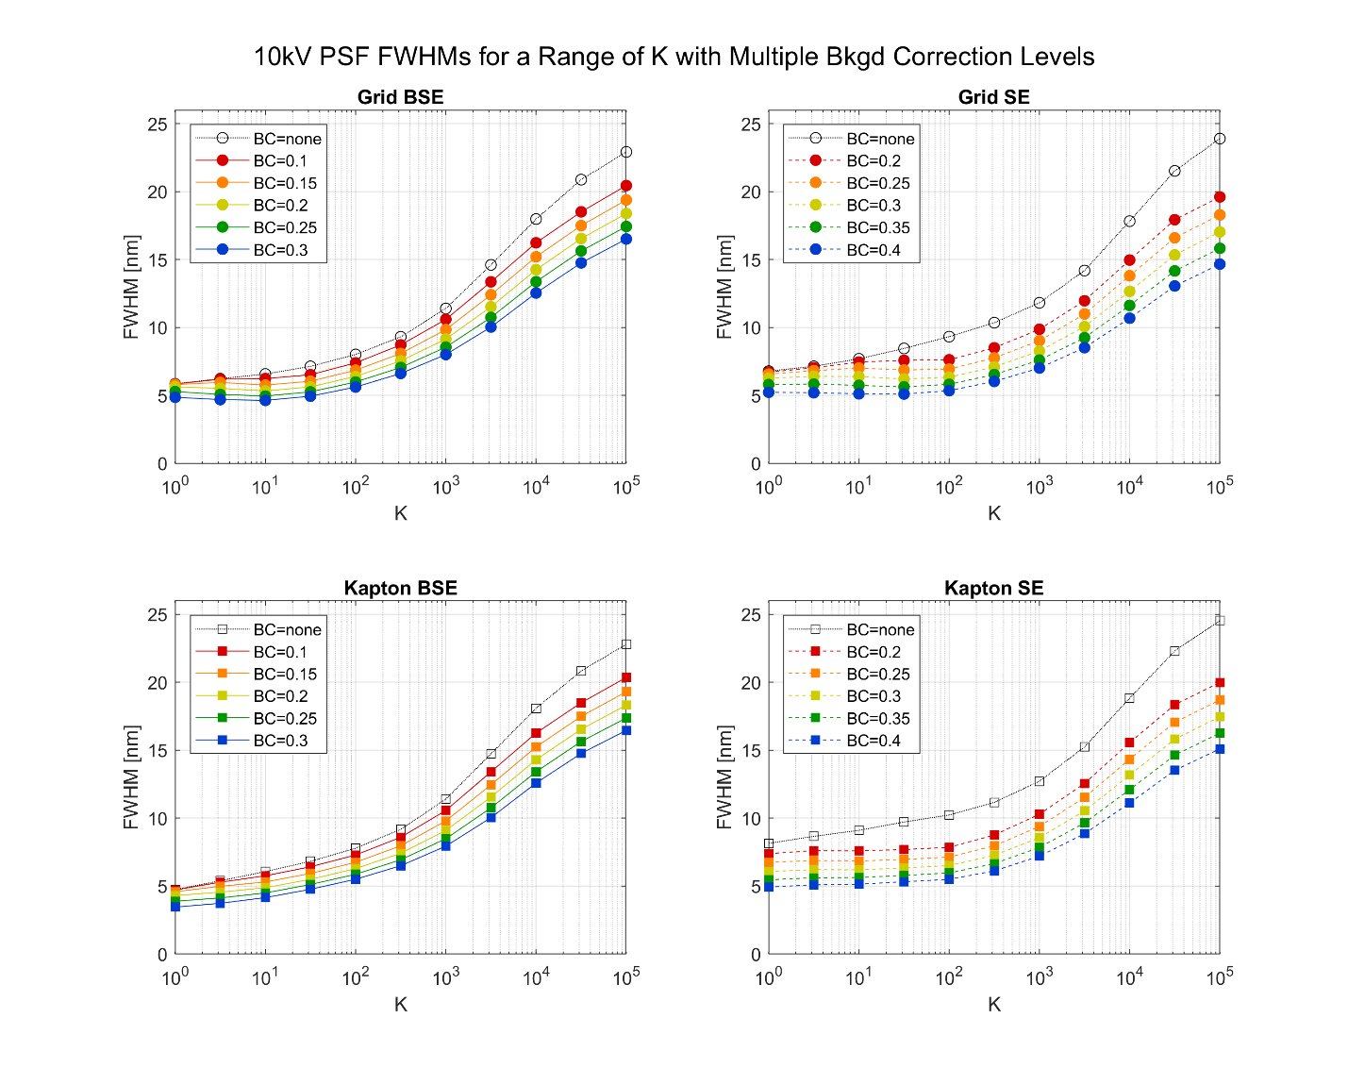
Figure S3-2. 10kV PSF FWHMs over a Range of K and Background Correction. The best representations of the PSFs were estimated at: Grid BSE, K = 10, background correction (“BC”) = 0.20; Grid SE, K = 100, BC = 0.30; Kapton BSE, K = 31, BC = 0.20; Kapton SE, K = 100, BC = 0.30. Note that the vertical axis is linear, while the horizontal axis is logarithmic.

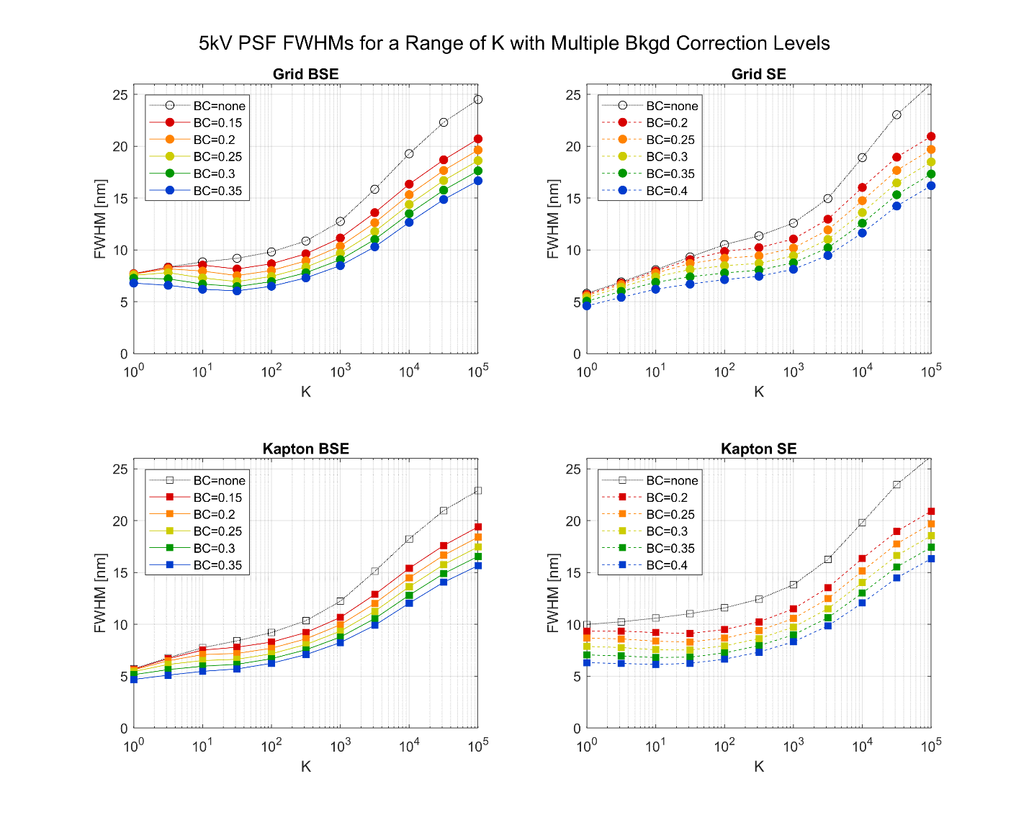
Figure S3-3. 5kV PSF FWHMs over a Range of K and Background Correction. The best representations of the PSFs were estimated at: Grid BSE, K = 100, background correction (“BC”) = 0.25; Grid SE, K = 316, BC = 0.30; Kapton BSE, K = 100, BC = 0.25; Kapton SE, K = 100, BC = 0.30. Note that the vertical axis is linear, while the horizontal axis is logarithmic.

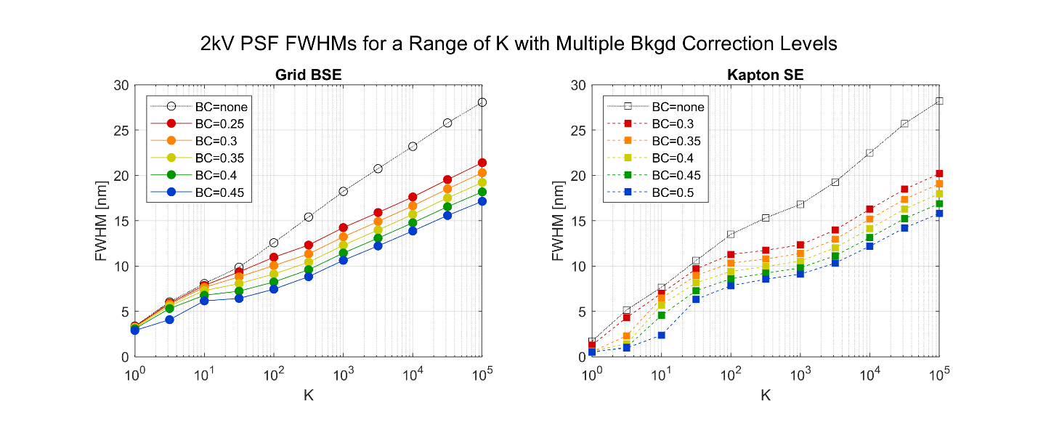
Figure S3-4. 2kV PSF FWHMs over a Range of K and Background Correction. The best representations of the PSFs were estimated at: Grid BSE, K = 1000, background correction (“BC”) = 0.35; Kapton SE, K = 1000, BC = 0.40. Grid SE and Kapton BSE image contrasts were too poor for reliable measurement. Note that the vertical axis is linear, while the horizontal axis is logarithmic.

S4. Electron Probe Sizes during Data Collection for Use in Simulating Particles
This section (S4) contains electron probe size information, which was used when creating the simulated electron images and profiles. The FWHM was calculated using the expression described in
Kološová J, Hrnčíř T, Jiruše J, Rudolf M and Zlámal J (2015) On the calculation of SEM and FIB beam profiles. Microsc Microanal 21(S4), 206-211.
where FWHM = Spot Size / 0.57 .

Table S4-1. Electron Probe Sizes.
Beam Voltage [kV] | MIRA Spot Size [nm] | FWHM (MIRA) [nm]
2 | 8.1 | 14.2
5 | 5.4 | 9.5
10 | 4.2 | 7.4
20 | 3.3 | 5.8

S5. Profiles of Simulated Particles for Comparison of BSEvsSE and GridVsKapton
This section (S5) contains figures that were referenced in the Results and Discussion subsections Data Collection Parameters: Signal Type and Data Collection Parameters: Particle Support Material in the article.
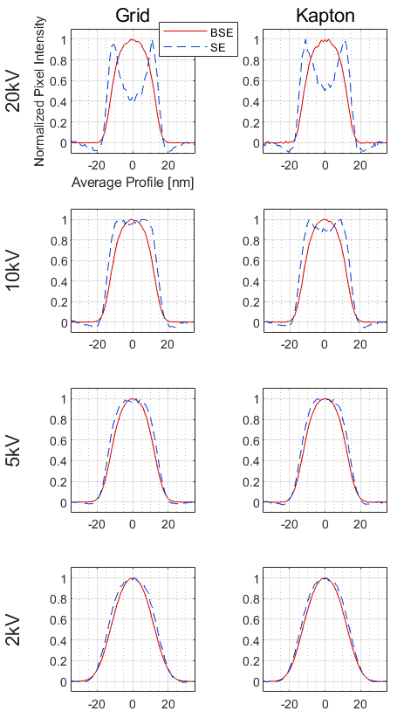
Figure S5-1. Signal Comparison using Simulated Particle Profiles. The legend in the top left plot (20kV Grid) applies to all plots. BSE and SE modes are compared at multiple voltages on both TEM carbon grid and Kapton substrate supports.
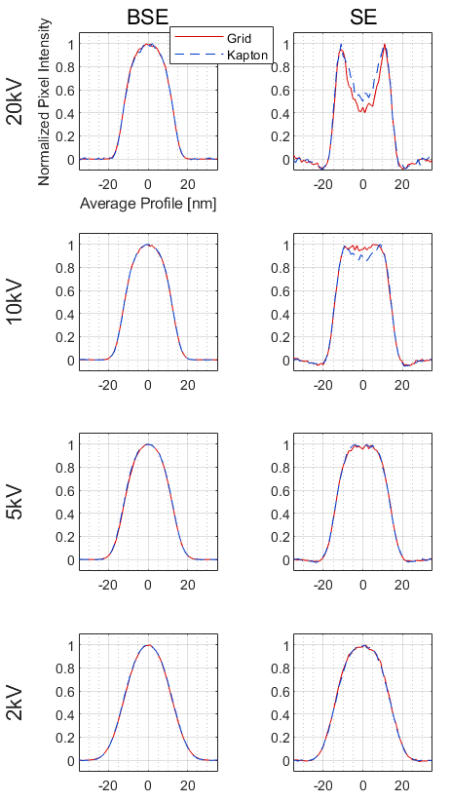
Figure S5-2. Support Material Comparison using Simulated Particle Profiles. The legend in the top left plot (20kV BSE) applies to all plots. TEM carbon grid and Kapton substrate supports are compared at multiple voltages for both BSE and SE modes.

S6. Single Particle Images and Average Profiles for Comparison of Experimental and Simulated Data on the TEM Grid
This figure in this section (S6) was referred to in the Results and Discussion subsections Data Collection Parameters: Particle Support Material in the article. The figure shown here is similar to Figure 10 in the article, which shows the experimental and simulation comparison for Kapton.
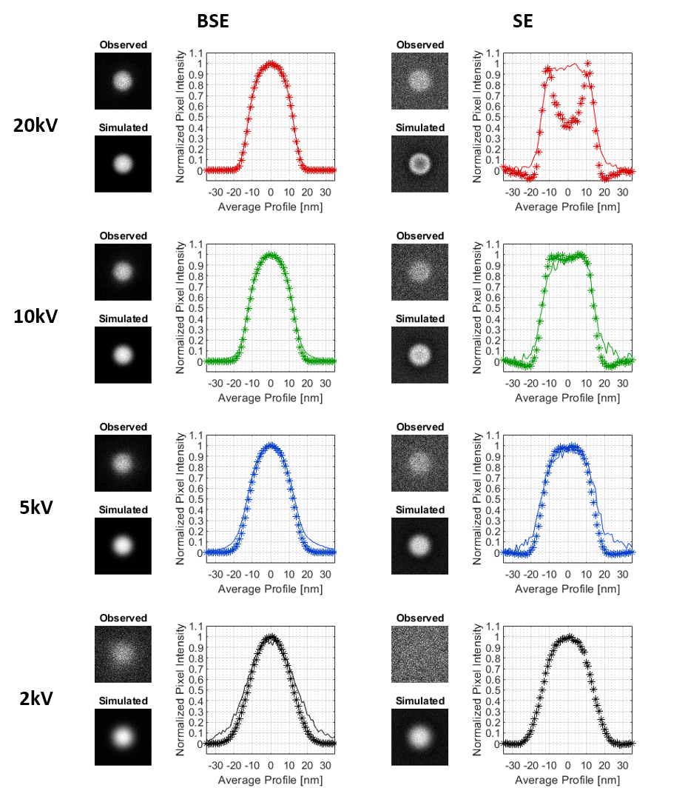
Figure S6-11. Observed and Simulated Single Particle Images and Average Profiles on Grid. Observed and simulated images for single particles are shown for each voltage-signal case to provide visual comparison of what a calibration particle would look like while imaging. The average profiles are shown to compare observation and simulation, while taking advantage of lower noise levels for simpler comparison. The solid line (–) represents the observed data, and the star line (*) represents the simulated data.

